**PROJECT REPORT**

EMPLOYEE RECORD SYSTEM

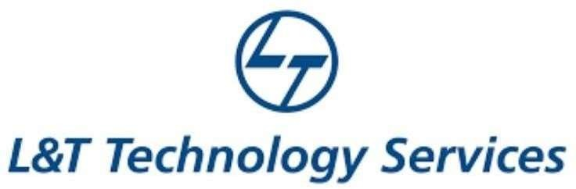

# NAME: - Bojjani Naveena

TABLE OF CONTENTS

|  |  |  |
| --- | --- | --- |
| **SERIAL No.** | **CONTENT** | **PAGE No.** |
| 1 | Introduction | 3 |
| 2 | Objective | 3 |
| 3 | Features | 3 |
| 4 | 4 W’s 1H | 4 |
| 5 | SWOT Analysis | 4 |
| 6 | Requirements | 6 |
| 7 | Architecture | 7 |
| 8 | Use case diagram | 8 |
| 9 | Expected results/Outcomes | 9 |

Introduction

# By law employers must retain certain documentation relating to their employees for specific minimum periods. These may be requested by the Workplace Relations Commission (WRC) or other bodies during inspection. It is also recommended that employers retain other documentation relating to their employees for their own benefit. In the event of a dispute it is important that the employer has supporting documentation. Below is a list of some of the main requirements and recommendations.

Objective:

* **The aim of the study is to design and implement an employee record management system that will enable Akwa Ibom State Polytechnic to record the details of its employees such that it will be easy to retrieve needed information with few button clicks. The objectives of the study are;To develop a workable employee record management system  
  To present the concept of electronic record management  
  To present the need for an employee record management system  
  To showcase the professional steps involved in creating electronic records such as an employee record management system.  
  To present how to maintain the authenticity and confidentiality of electronic records such as an employee record management system  
  To present the challenges in maintaining records  
  To present the benefits of employee record management.**

Benefits:

Traditionally, most benefits used to fall under one of the four major types of employee benefits, namely:

* Medical insurance
* Life insurance
* Retirement plans
* Disability insurance

Nowadays, however, the list of employee benefits continues to grow. We’ll take a look at different examples of employee benefits below.

* Benefits at work
* Benefits for health
* Benefits for financial security
* Lifestyle benefits

# Features:

The main features of this project include basic file handling operations; you will learn how to add, list, modify and delete data to/from file. The source code is relatively short, so thoroughly go through the mini project, and try to analyse how things such as functions, pointers, files, and arrays are implemented.

Currently, listed below are the only features that make up this project, but you can add new features as you like to make this project a better one!

* Add record
* List record
* Modify record
* Delete record
* **Who:** This Employee Record System is an application used to collect the each and every information about Employees who are working in a particular industry or office.

# What: Employee Record System is a software that helps to collect the information of an Employee like his attendece,salary etc.

* **Where:** Employee Record System is nowadays essential for large industries or software officies or any other sector.

# How: It works like a system which is used to collect the information.

# SWOT Analysis Strengths

* The system has the following key strengths;
* Data or records are highly classified to determine their degree of significance.
* There is a prescribed data/ records retrieval process that is often followed to get the record.
* There is a records disposition procedure due to the degree of importance since others are permanently kept in the archives.
* There is a records management policy key in managing the records life cycle • It has a high level of security that cannot easily be hacked into.

# Weaknesses: It is difficult to gather the information about employees when one data is lost.

# Opportunities:

* + Flexibility. Because today’s business environment is so dynamic, employees must develop skills to help them adapt to ever-changing work-related situations.
  + Communication skills. An organization is nothing without clear and concise communication. In its absence, employees are working and reworking problems, in a buddle, with NO shared knowledge, insights, or diversity.
  + Bonus: Conflict Resolution, Tactfulness, Work ethic. When working in a team, one needs to be diplomatic and tactful, to not "ruffle any feathers". At the same time, doing what's morally right, and taking on ethical positions in the workplace can generate conflict.
  + Leadership Skills. Leadership styles are diverse but to lead effectively there a few key skills that are common amongst good leaders. Leadership skills are highly valued by employers; effective leaders can motivate and help others succeed within an organization.

# [Threat: Some times it is very difficult to operate this systems.](https://www.glassdoor.com/blog/guide/areas-of-improvement/" \t "_blank)

# 



**Architecture:**

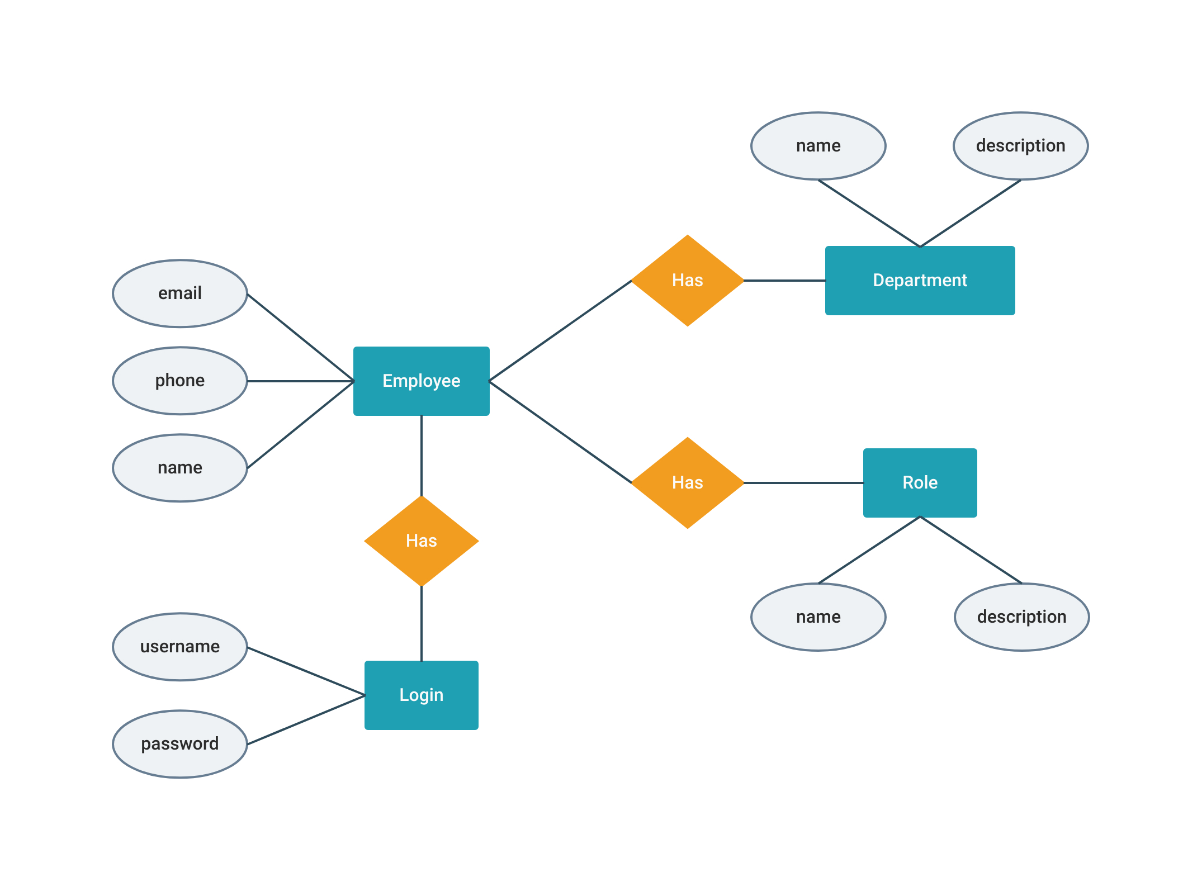

# Use Case Diagram

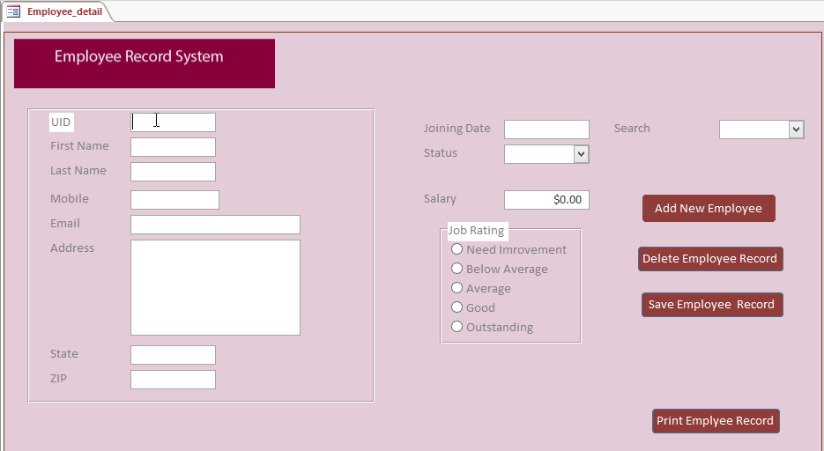

**Output Images:**

