**PROJECT -3**

1. Write a query to display the names (first_name, last_name) using alias name “First Name", "Last Name"

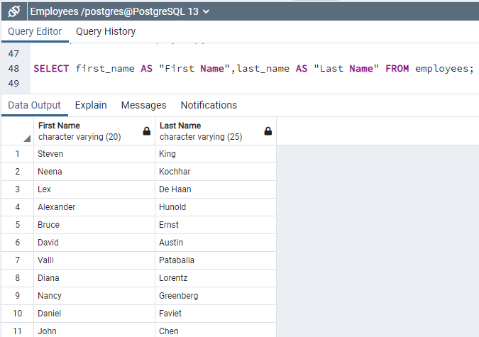

Total rows=107

2. Write a query to get unique department ID from employee table

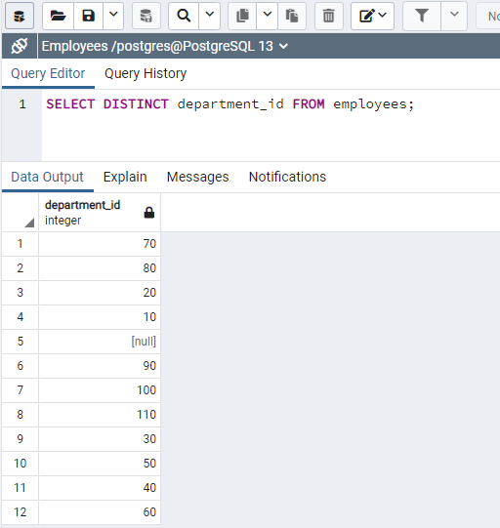

3. Write a query to get all employee details from the employee table order by first name, descending

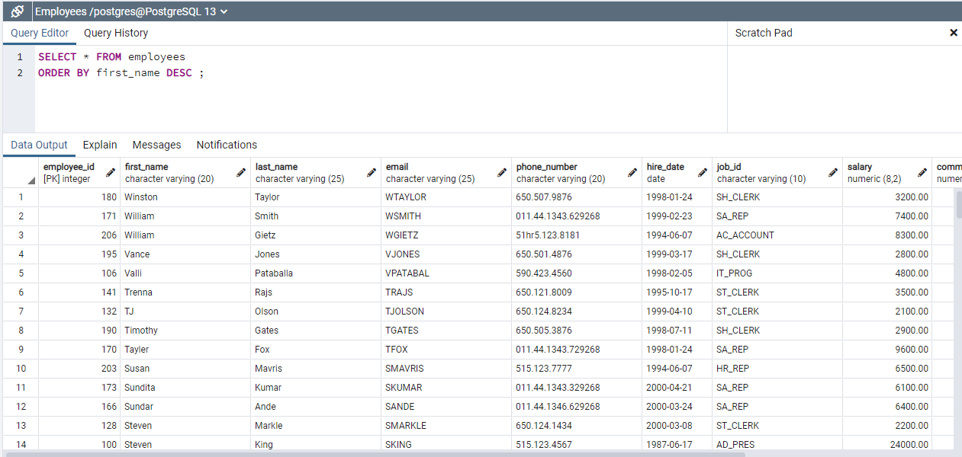

Total 11 columns

Total 107 rows

4. Write a query to get the names (first_name, last_name), salary, PF of all the employees (PF is calculated as 15% of salary)

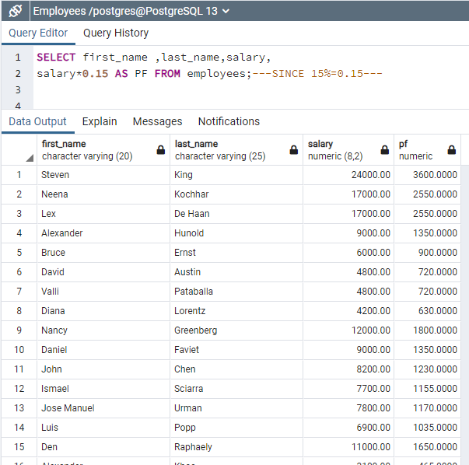

5. Write a query to get the employee ID, names (first_name, last_name), salary in ascending order of salary

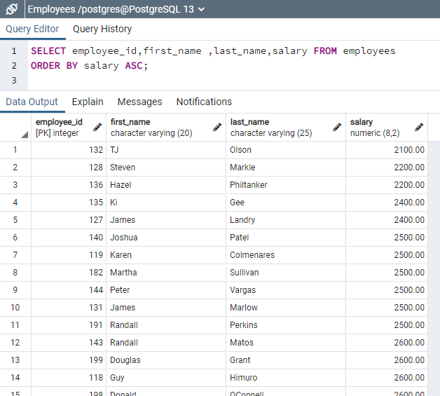

6. Write a query to get the total salaries payable to employees

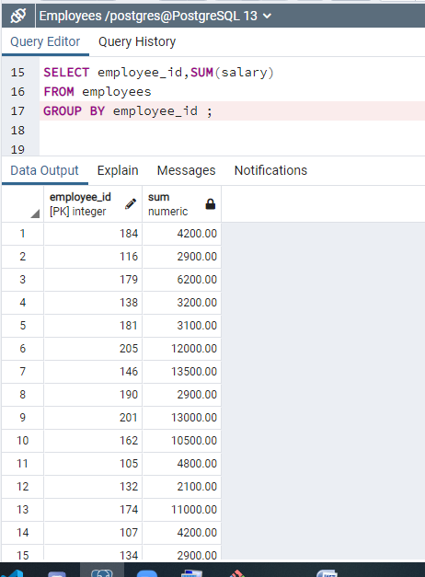

7. Write a query to get the maximum and minimum salary from employees table

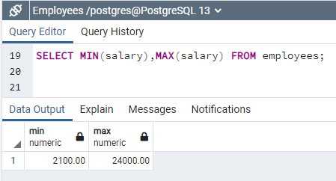

8. Write a query to get the average salary and number of employees in the employees table

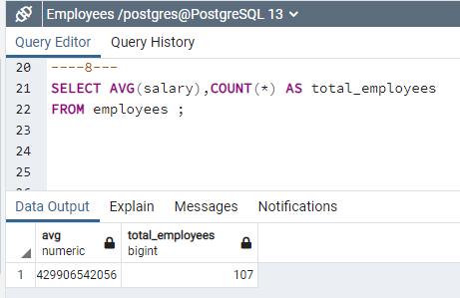

9. Write a query to get the number of employees working with the company

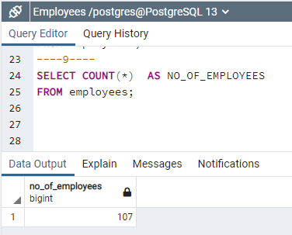

10. Write a query to get the number of jobs available in the employees table

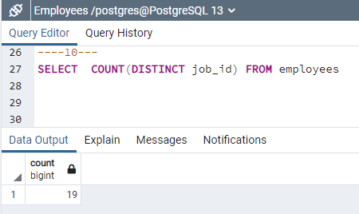

11. Write a query get all first name from employees table in upper case

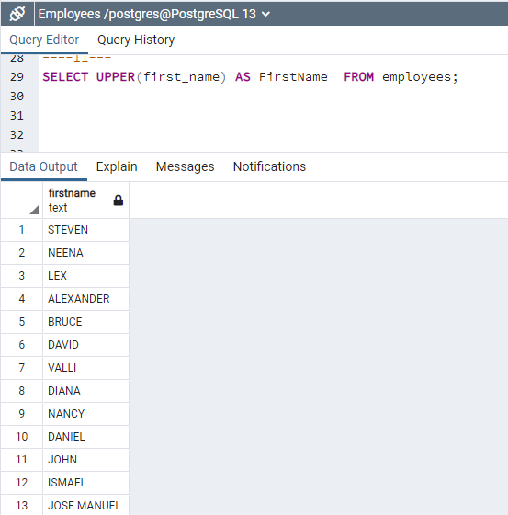

12. Write a query to get first name from employees table after removing white spaces from both side

TRIM() function is used to remove the whitespaces, we have trim functions like

LTRIM(),RTRIM(),BTRIM()

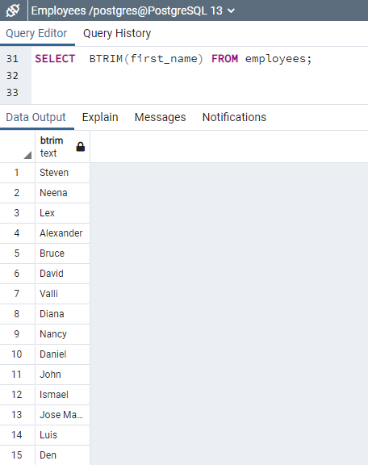

13. Write a query to get the length of the employee names (first_name, last_name) from employees table

If we want first_name and last_name separately

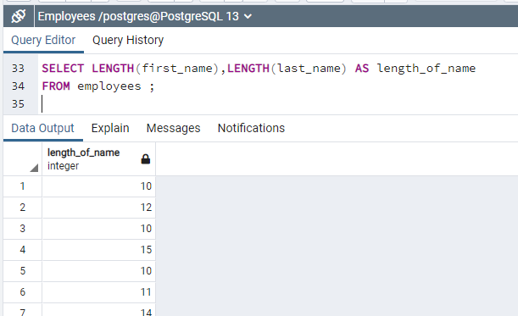

Otherwise by combining 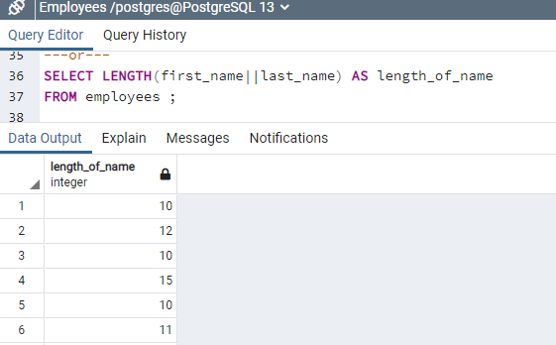

14. Write a query to display the name (first_name, last_name) and salary for all employees whose salary is not in the range $10,000 through $15,000

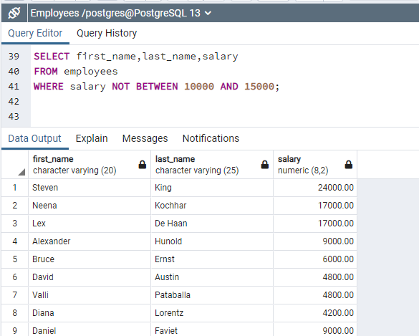

15. Write a query to display the name (first_name, last_name) and salary for all employees whose salary is not in the range $10,000 through $15,000 and are in department 30 or 100

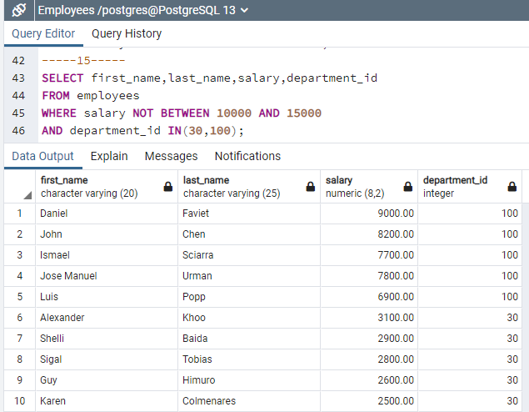

--------------RAWDATA-------------

