**ASSIGNMENT -1**

**1. What is the basic difference and similarity between a vector and a matrix?**

The basic difference of vector and matrix is, vector is single dimensional where as matrix is two dimensional vector .Vectors are written in lowercase boldface where as matrices are written in uppercase boldface.

The similarity is both the vector and matrix contain the magnitude and direction.

**2.** **What is the basic difference and similarity between a data frame and a matrix?**

Both the data frames and matrix are two dimensional in structure .The difference is, in data frames the columns may contain the elements of different data types where as the matrix contains the elements of similar data type and in matrix we can perform arithmetical operations where as data frames is used for storing data tables.

**3. Create a vector using (15, TRUE, “World”). What happened to your result?**

When we give the input as **a <-c (15, TRUE,”WORLD”)** it has taken every element as the character

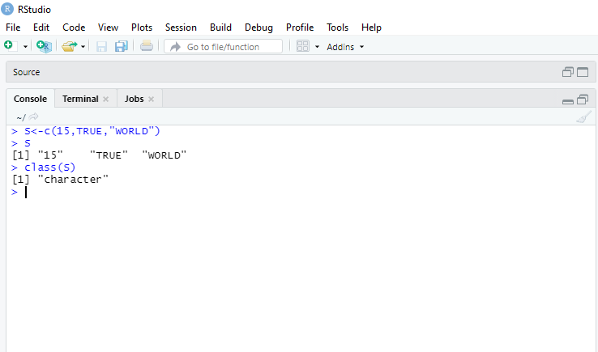

**4 .John’s score in the final semester for the three subjects are 95, 91 and 88. The subjects are Statistics, Linear Algebra, and Calculus. Using these create a vector and give names to all elements of the vector based on their subjects**.

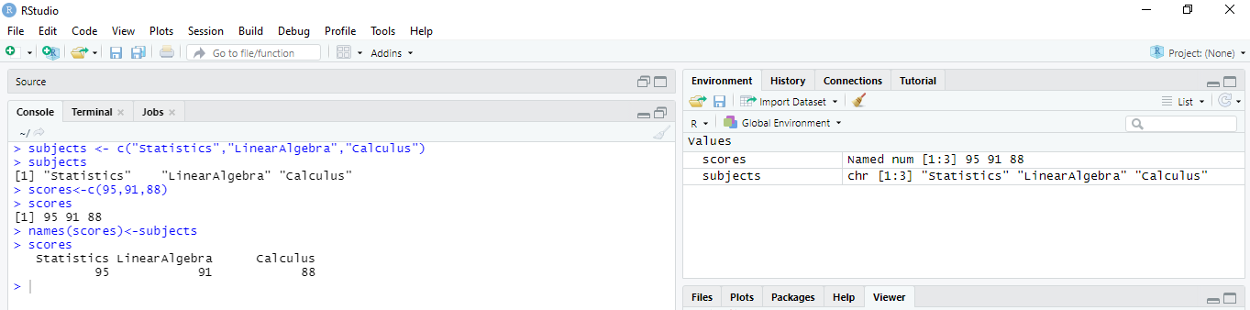

**5. Please check the data types (character or numeric) of the vector you created.**

class() is used to check the data type

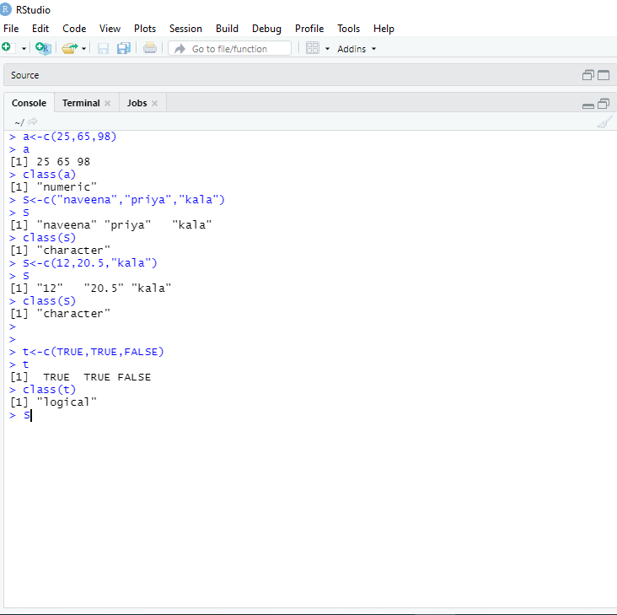

**6. You have three students in your class (choose any name you want). You must create a matrix using their score in the above mentioned subjects (question 4) Student 1 (95, 91, and 88), Student 2(96, 94, and 97), Student 3(88, 98, and 85). Create a matrix and label column and row names.**

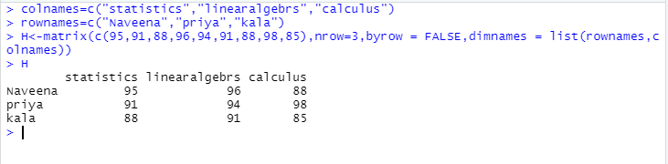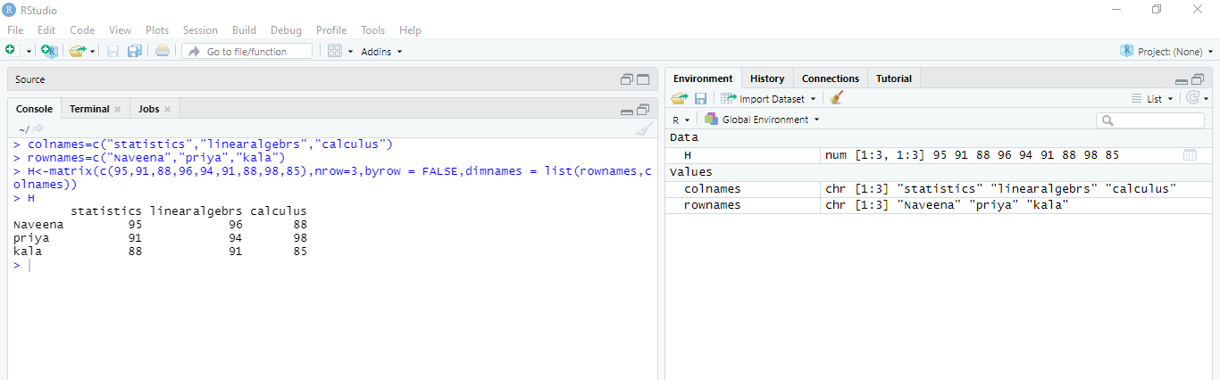

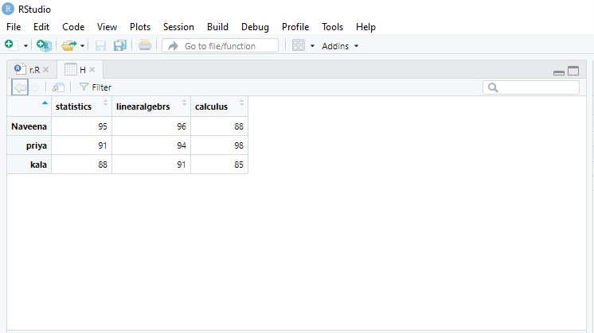

**7. Convert the created matrix into a data frame.**

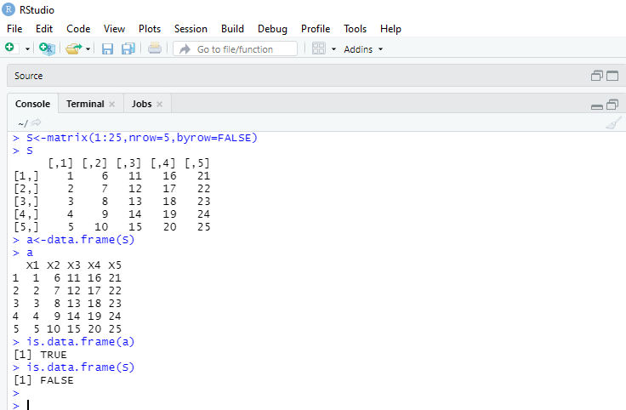

**8. Create three vectors using five countries (your choice) from the following website. The first vector should be country names, the second vector should be the total number of cases, and the third vector should contain the total number of deaths. Create a data frame using these vectors.**[**https://www.worldometers.info/coronavirus/**](https://www.worldometers.info/coronavirus/)

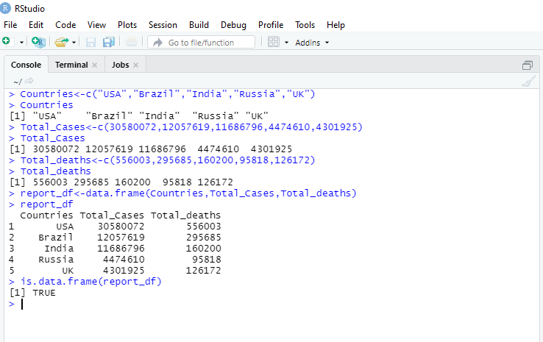

**9. Please read the mtcars data set from R. It is an built-in data set. Please check the structure of the data set. If required, please convert the data into their appropriate data types (character, logical, factor, etc). Save your results as a new data frame using a new name.**

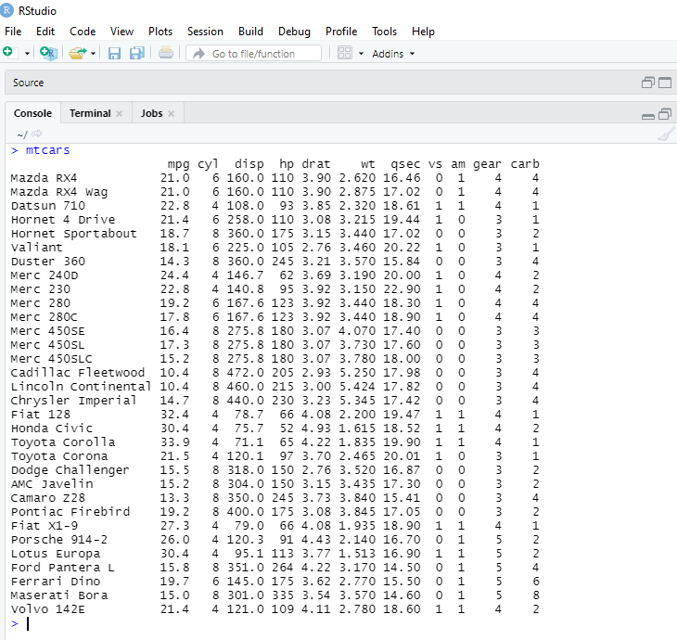

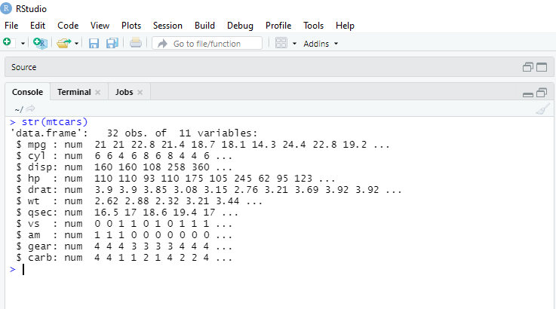

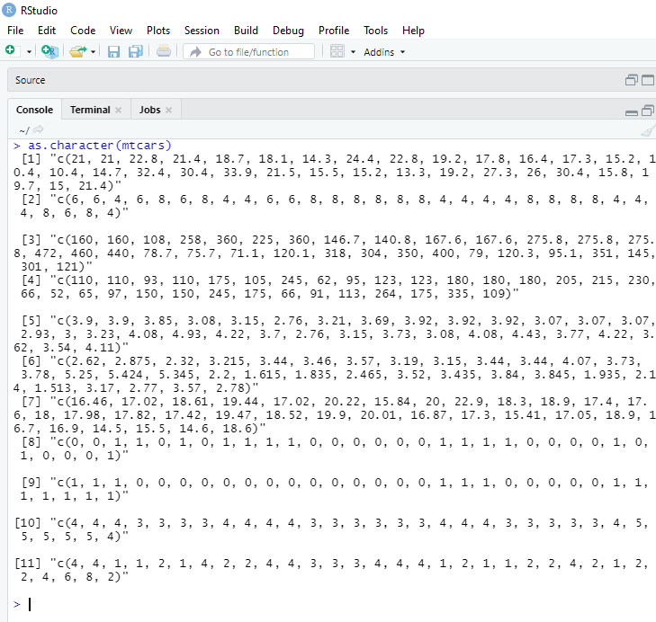

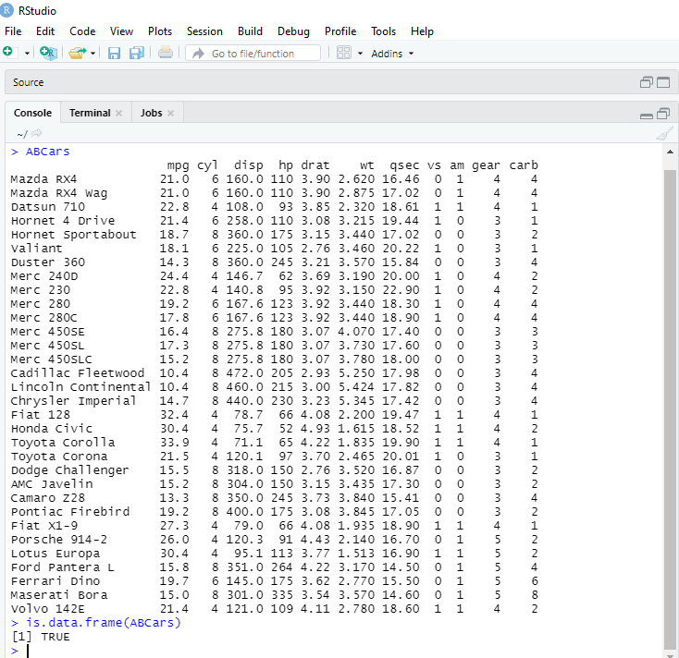

**\*source file:**



**Submitted By:**

**Naveena Koppalli.**