**ASSIGNMENT -2**

**1:** The final score of the World Cup finals of football is France  4 and Croatia 2 Please use a control structure to print the results as Team ---- Wins -----.

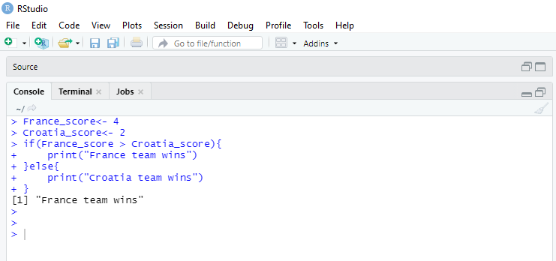

 2: The mtcars data set has several factor variables. However, R is reading them as numeric. Please convert them into factors using a for loop. Please use column 8 to 11 for the loop.

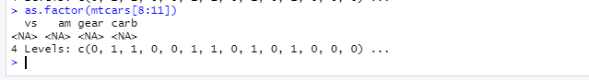

7. The data set contains date columns. All of these date columns are untidy. Please create a better formatted data set. The date should be dd/mm/yyyy in the final format. Use columns 2, 3, and 5 only.

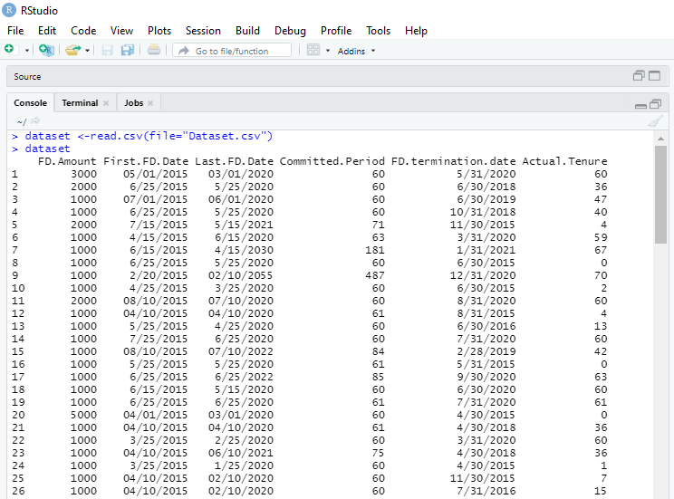

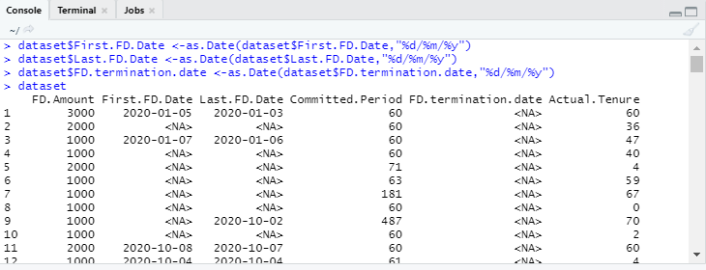

8: The date of birth column contains months in string format. Please create a tidy data column with months in numeric format. Now your data should be similar to the previous question

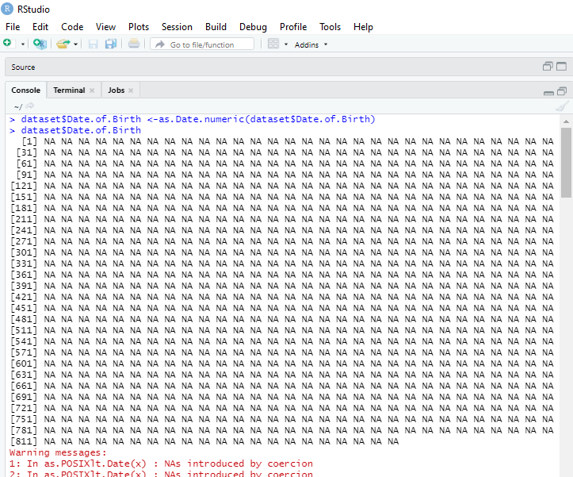

 9. Convert all dates into date format; they are currently in character variable format**.**

10: Create a new column age based on the date of birth column and the first FD column. Date format is necessary to do basic arithmetic.