**ASSIGNMENT -4**

**I. Data:** The World Values Survey is an ongoing worldwide survey that polls the world population about perceptions of life, work, family, politics, etc. The most recent phase of the survey that polled 77,882 people from 57 countries estimates that 36.2% of the world's population agrees with the statement "Men should have more right to a job than women." The survey also estimates that 13.8% of people have a university degree or higher and that 3.6% of people fit both criteria.

**Question 1:** Are agreeing with the statement "Men should have more right to a job than women" and having a university degree or higher disjoint events?

**ANS:** No, there are not disjoint events. Because 3.6% of people fit both criteria.

**Question 2:** Draw a Venn diagram summarizing the variables and their associated probabilities.

**ANS:**

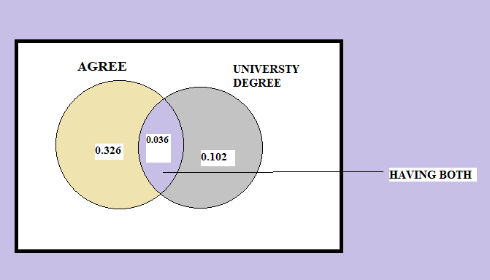

P(AGREE)=36.2%=0.362

P( HAVING UNIVERSITY DEGREE )=0.138

HAVING BOTH=P(AGREE and UNIERSITY DEGREE)=0.036

P(ONLY AGREE)=0.362-0.036=0.326

P(ONLY HAVING DEGREE)=0.138-0.036=0.102

**Question 3:** What is the probability that a randomly drawn person has a university degree or higher or agrees with the statement about men having more right to a job than women?

**ANS:**

P(AGREE OR HAVING DEGREE OR MORE)=??

P(A or B)=P(A)+P(B)-p(A and B)

=>P(AGREE)+P(HAVING DEGREE)-P(BOTH)

=>0.362+0.138-0.036

**=>0.464**

**Question 4:** What percent of the world population do not have a university degree and disagree with the statement about men having more right to a job than women?

**ANS:**

Neither AGREE nor HAVING DEGREE

=>**!**P(AGREE OR HAVING BOTH)

=>1- P(AGREE OR HAVING BOTH)

=>1-0.464

**=>0.536**

**Question 5:** Does it appear that the event that someone agrees with the statement is independent of the event that they have a university degree or higher?

**ANS:**

No there are not Independent. Because

If two events are independent then P(A and B)=P(A)*P(B)

=>P(AGREE and HAVING DEGREE)=P(AGREE)*P(HAVING DEGREE)

=>0.036=0.362*0.138

**=>0.036=0.05**

Therefore not independent

**Question 6:** What is the probability that at least 1 in 5 randomly selected people to agree with the statement about men having more right to a job than women?

**ANS:**

P( Atleast 1 agree)= !p( not agree)

!P(not agree)=1-P(agree)

=>1-0.362

=>0.638

P(Atleast 1 agree)=1-P(not agree)

=>1-0.638*5 (given 1 to 5 randomly selected people)

**=>1-0.106=0.894**

**II. Data:** As of 2009, Swaziland had the highest HIV prevalence in the world. 25.9% of this country's population is infected with HIV. The ELISA test is one of the first and most accurate tests for HIV. For those who carry HIV, the ELISA test is 99.7% accurate. For those who do not carry HIV, the test is 92.6% accurate. If an individual from Swaziland has tested positive, what is the probability that he carries HIV? Create a tree diagram to calculate the probability.

**Question 1:** If an individual from Swaziland has tested positive, what is the probability that he carries HIV?

**ANS:**

Given 25.9% are infected with HIV

Let total population =10000

=>2590 are infected with HIV

=>10000-2590=7410 are not infected with HIV

And also given that 99.7% is accurate for who carry HIV

=>2590*99.7%

=>2582(CONFORMED HIV)

=>8 remains

Given, For those who do not carry HIV, the test is 92.6% accurate

=>7410*92.6%

=>6861(not CONFORMED WITH HIV)

=>548 remains

Now,

**Total population=10000**

**Total confirmed positive=2582+548=>3130**

**Total Negative =8+6861=>6868**

There are 2582 people who have HIV and test positive, out of 3130 people who test positive overall.

**Therefore, the probability that person carries HIV is**

**2582/3130=0.824**

**TREE DIAGRAM :**

Total positive =3130

Remaining =548

Confirm negative =6861

Remaining =8

Confirm positive =2582

Not infected =

7410

HIV infected=25.9%

2590

Population=10000

**Question 2:** According to a 2013 Gallup poll, worldwide only 13% of employees are engaged at work (psychologically committed to their jobs and likely to be making positive contributions to their organizations). Among a random sample of 10 employees, what is the probability that 8 of them are engaged at work?

**ANS:**

Given n=10

13% are engaged in work=0.13

Remaing=0.87

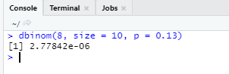

**Question 3:** Recent study: “Facebook users get more than they give”

* friend requests: 40% made, 63% received at least one
* likes: liked 14 times, had their content “liked” 20 times, on average
* messages: sent 9 messages, received 12, on average
* tags:12% tagged a friend in a photo, but 35% tagged other findings:
* 25% considered power users
* Average Facebook user has 245 friends  
  P(70 or more power user friends) = ?

**Question 4:** According to a 2014 Gallup poll, 56% of uninsured Americans who plan to get health insurance say they will do so through a government health insurance exchange. What is the probability that in a random sample of 10 people exactly 6 plan to get health insurance through a government health insurance exchange?

**ANS:**

