Code written for baby name generator was compatible to python2 interpreter. The main concept behind generating the baby name is Hidden markov chain model (HMM). It take length maximum and minimum length of the name and gender like whether it is boy or girl order of the markov. Lastly it take how many names should we displays on the above condition and gives the output

Below is the screenshot for the following: output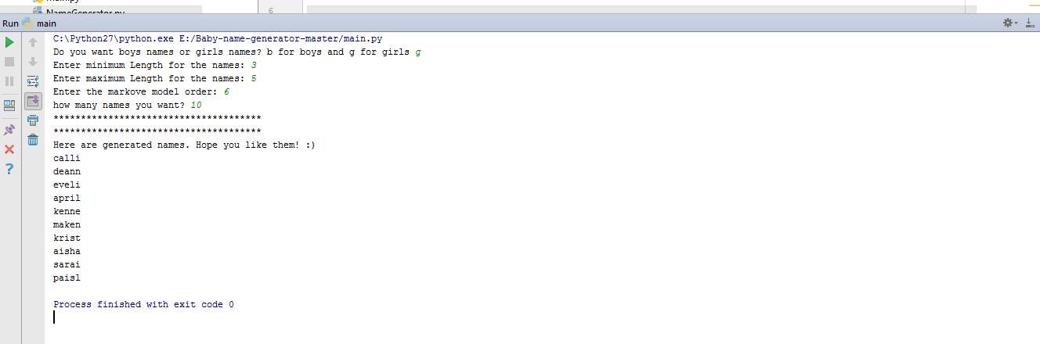

This project contains the text of number of name of girls and boys and by the **Namegenertor.py**

And process by importing the random module and process the input file.

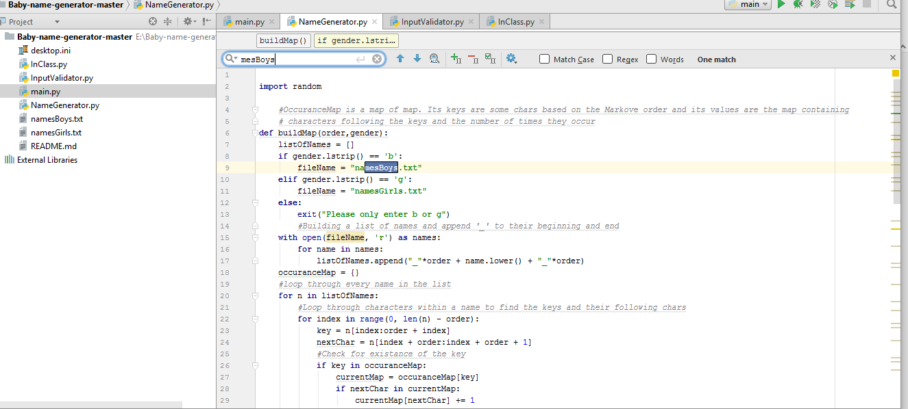

In the inputvalidator.py validates all the input we have taken .

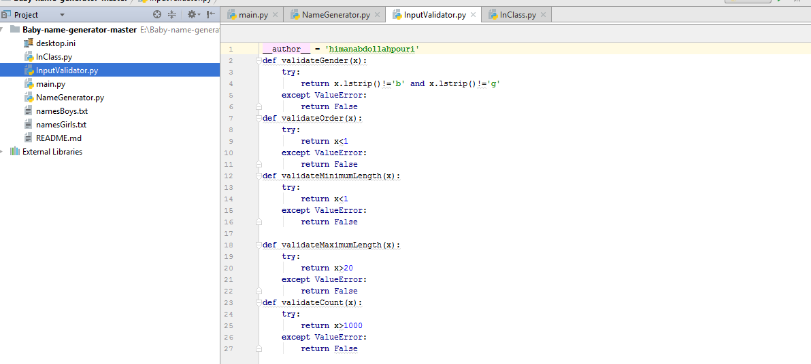

In the name we import the above two python files.

And the main.py has input taken variables.

