Problem. 2
- List the areas you would look into when it comes to data preparation.

Column name : column names should not contain spaces, special characters and the name should be in lower case

Data formats : check if given data is in appropriate format

Missing values : the “travel_campanion.5” columns can be dropped directly because all the values are empty, missing values in the other columns replaced with appropriate values.

- Highlight any data idiosyncrasies that you might have observed
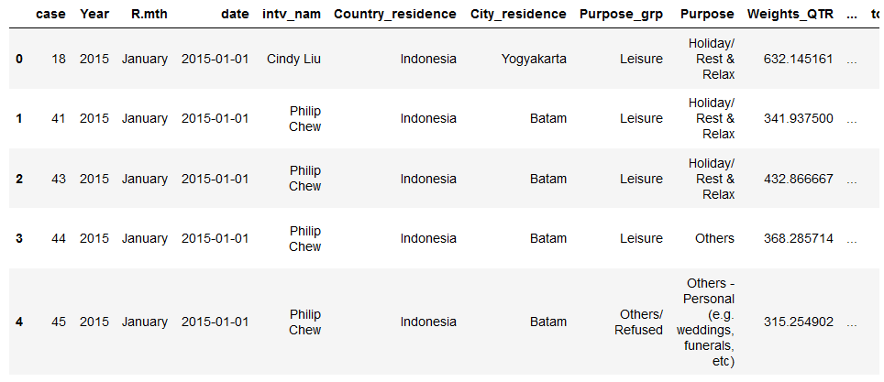

As seen above Philip Chew has been recorded to enter the country multiple times with different data against his name.

In travel companion columns we see data like children aged 40years and above which does not make sense.

Singapore is listed as value in the main hotel columns

The weight_QTR ranges from 0 to 8995 which does not classify as the valid weight criteria

- Put together a short presentation /document to tell a story about the key insights and observations, taking into consideration dataset limitations

Introduction to data:
We receive the data from census taken from ~8000 people entering singapore from Indonesia.They are further travelling into 59 different citys in the country We also have there personal data such as designation ,industry and occupation and other data like the expenditure of the person in different fields .

Granularity
Travel type. Non-Packaged, Packaged, Business Non-Packaged

Shopping: shop_$fash, shop_$jew, shop_$wat, shop_$well, shop_$food shop_$gift ,shop_$ctec ,shop_$anti ,shop_$oth ,shop_$any

Other expenses: totacc_$,totfnb_$ ,tottran_$ ,totbiz_$ totedu_$ ,totmedi_$ ,tototh_$

Insights the census can be used to track analyze and predict the movement of people through Singapore it can also tell us about the expense patterns and the accommodation preferences.

