Alfido Tech Internship
Task 2: Motor Control with PWM & Obstacle Detection
Name:
Naveena Kachakayala
Domain:
Embedded Systems
Tools Used:
- Tinkercad Circuit Simulator
- Arduino IDE

1. Objective
The objective of this project is to control the speed of a DC motor using PWM (Pulse Width Modulation) and automatically stop the motor when an obstacle is detected using an ultrasonic sensor. The system demonstrates motor control and real-time obstacle detection using Arduino.

2. Components Used
- Arduino UNO
- PING))) Ultrasonic Sensor
- DC Motor
- Motor Driver
- Breadboard
- Jumper Wires

3. Software Used
- Tinkercad Circuit Simulator
- Arduino IDE

4. Circuit Diagram
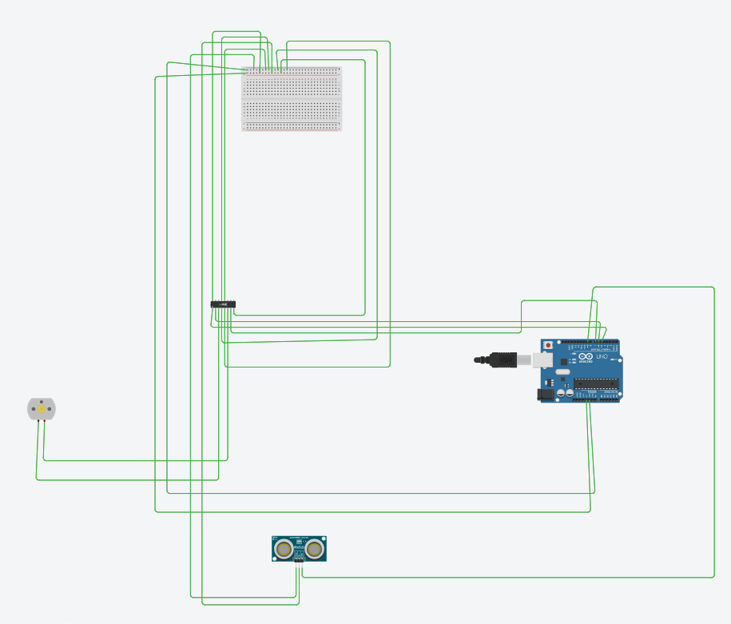

5. Working Principle
The ultrasonic sensor continuously measures the distance of nearby objects and sends the distance data to the Arduino. The Arduino processes this information and controls the DC motor using PWM. When the detected distance is greater than 20 cm, the motor runs at the specified speed. If an obstacle is detected within 20 cm, the Arduino stops the motor automatically to prevent collision.

6. Arduino Code
const int pingPin = 9;

const int ENA = 5; // PWM Pin
const int IN1 = 6;
const int IN2 = 7;

long duration;
int distance;

void setup() {
Serial.begin(9600);

pinMode(ENA, OUTPUT);
pinMode(IN1, OUTPUT);
pinMode(IN2, OUTPUT);

// Motor Forward Direction
digitalWrite(IN1, HIGH);
digitalWrite(IN2, LOW);
}

void loop() {

// PING))) Sensor
pinMode(pingPin, OUTPUT);
digitalWrite(pingPin, LOW);
delayMicroseconds(2);

digitalWrite(pingPin, HIGH);
delayMicroseconds(5);

digitalWrite(pingPin, LOW);

pinMode(pingPin, INPUT);
duration = pulseIn(pingPin, HIGH);

distance = duration / 29 / 2;

Serial.print("Distance: ");
Serial.print(distance);
Serial.println(" cm");

if (distance > 20) {
analogWrite(ENA, 180);
Serial.println("Motor Running");
}
else {
analogWrite(ENA, 0);
Serial.println("Motor Stopped");
}

delay(200);
}

7. Output Screenshots
Circuit Screenshot
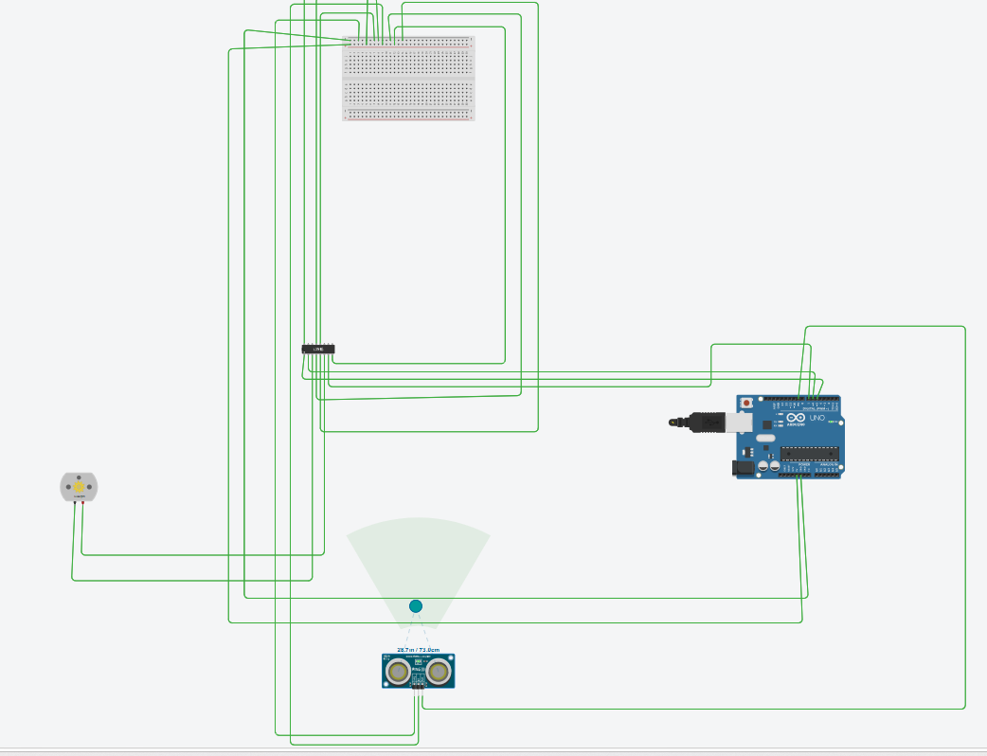
Motor Running ,Stopped Output and serial monitor ouput
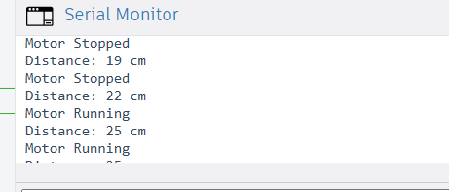
Code Screenshot
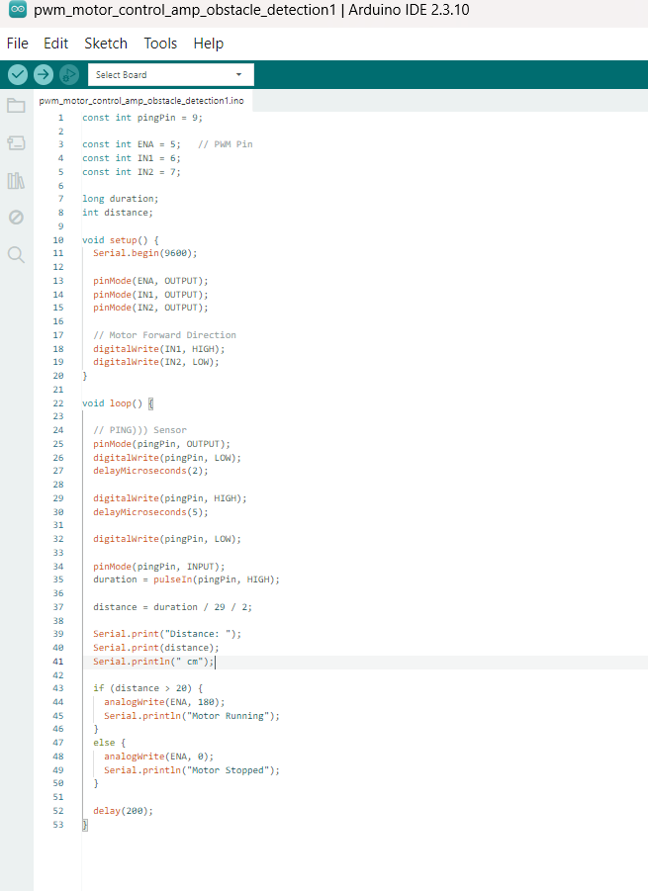

8. Results
The motor control system successfully operated using PWM speed control. The ultrasonic sensor accurately detected obstacles and automatically stopped the motor when the distance was less than or equal to 20 cm. The project worked successfully in the Tinkercad simulation environment.

9. Conclusion
This project demonstrates the fundamental concepts of embedded systems including PWM motor control, ultrasonic sensor interfacing, real-time distance measurement, and obstacle detection using Arduino. The system successfully controlled the motor and responded correctly to obstacle detection conditions.

10. GitHub Repository Link
Paste your GitHub repository link here.

11. Demo Video Link
https://drive.google.com/file/d/1cpCSayH5pAbGUbkDLubsENofEc601znJ/view?usp=sharing

