Alfido Tech Internship
Task 1: Temperature Monitoring & LCD Display
Name:
Naveena Kachakayala
Domain:
Embedded Systems
Tools Used:
• Tinkercad Circuit Simulator
• Arduino IDE
________________________________________
1. Objective
The objective of this project is to monitor temperature using an temperature sensorTMP36 and display the temperature value on a 16x2 LCD display. The measured temperature is also logged through the Serial Monitor for monitoring purposes.
________________________________________
2. Components Used
• Arduino UNO
• Temperature Sensor TMP36
• 16x2 LCD Display
• Breadboard
• Jumper Wires
________________________________________
3. Software Used
• Tinkercad Circuit Simulator
• Arduino IDE
________________________________________

4. Circuit Diagram
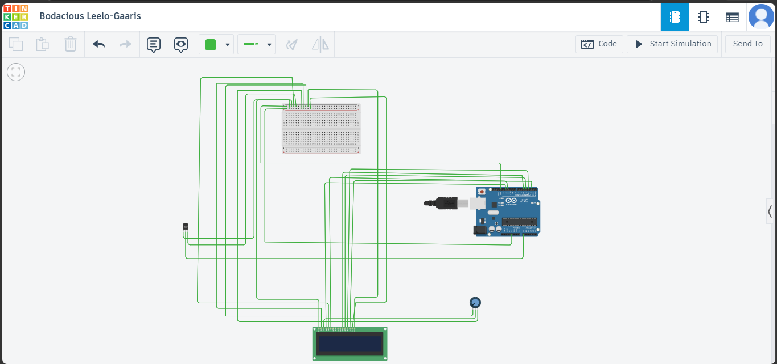

________________________________________

5. Working Principle
The TMP36 temperature sensor measures the surrounding temperature and produces an analog voltage output that varies according to the temperature. The Arduino UNO reads this analog voltage through its analog input pin and converts it into temperature values in degrees Celsius. The calculated temperature is displayed on the 16x2 LCD display and simultaneously logged on the Serial Monitor. This enables real-time temperature monitoring and display.
________________________________________
6. Arduino Code
#include <LiquidCrystal.h>

LiquidCrystal lcd(12, 11, 5, 4, 3, 2);

int sensorPin = A0;

void setup()
{
lcd.begin(16, 2);
Serial.begin(9600);

lcd.print("Temp Monitor");
delay(2000);
lcd.clear();
}

void loop()
{
int reading = analogRead(sensorPin);

float voltage = reading * (5.0 / 1024.0);

float temperatureC = (voltage - 0.5) * 100.0;

lcd.setCursor(0,0);
lcd.print("Temp: ");
lcd.print(temperatureC);
lcd.print(" C");

Serial.print("Temperature: ");
Serial.print(temperatureC);
Serial.println(" C");

delay(1000);
}
________________________________________

7. Output Screenshots
Circuit Screenshot
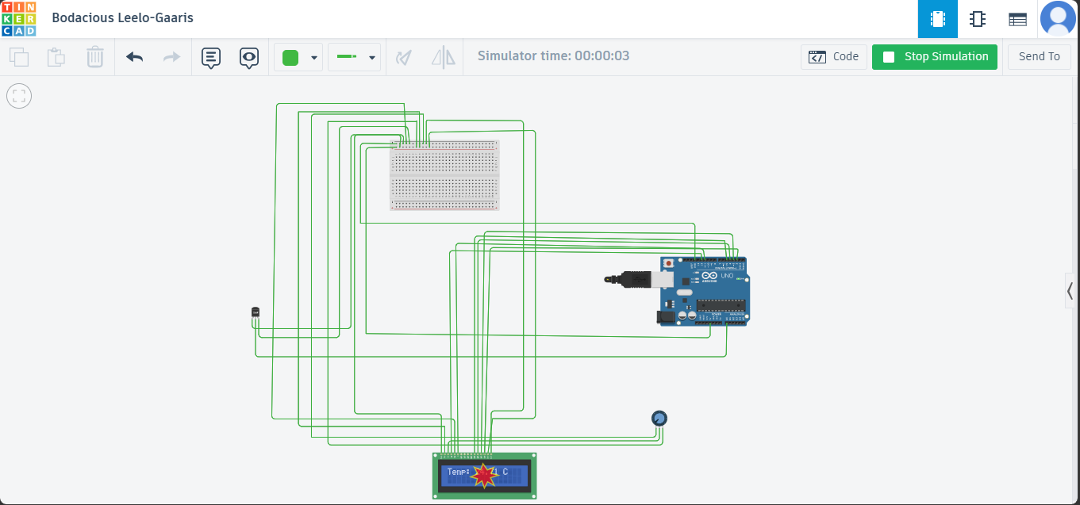

LCD Display Output
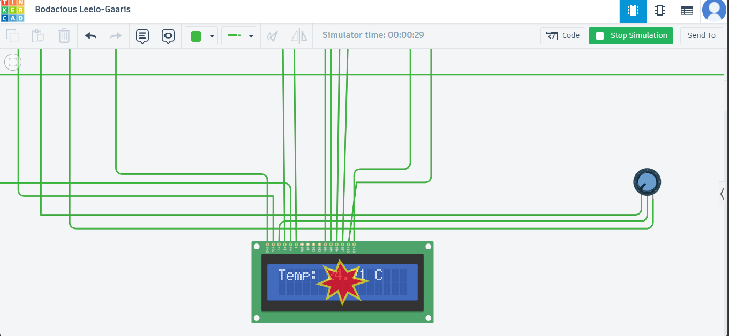

Serial Monitor Output
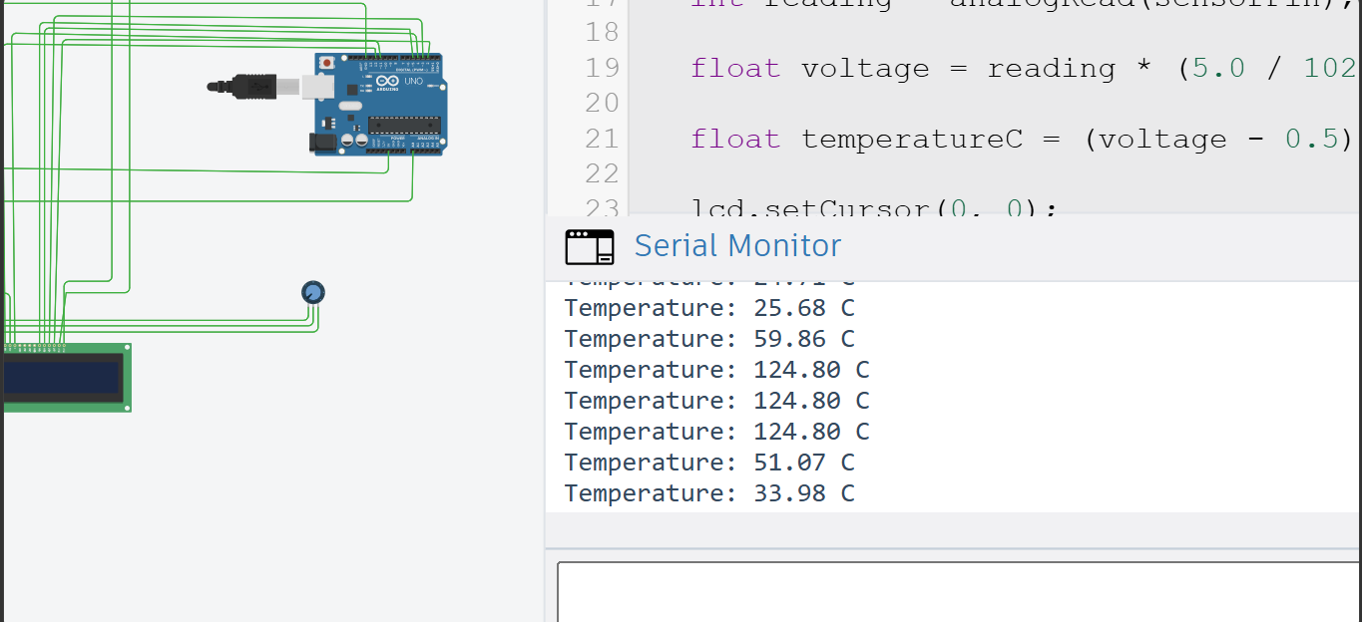
Code Screenshot
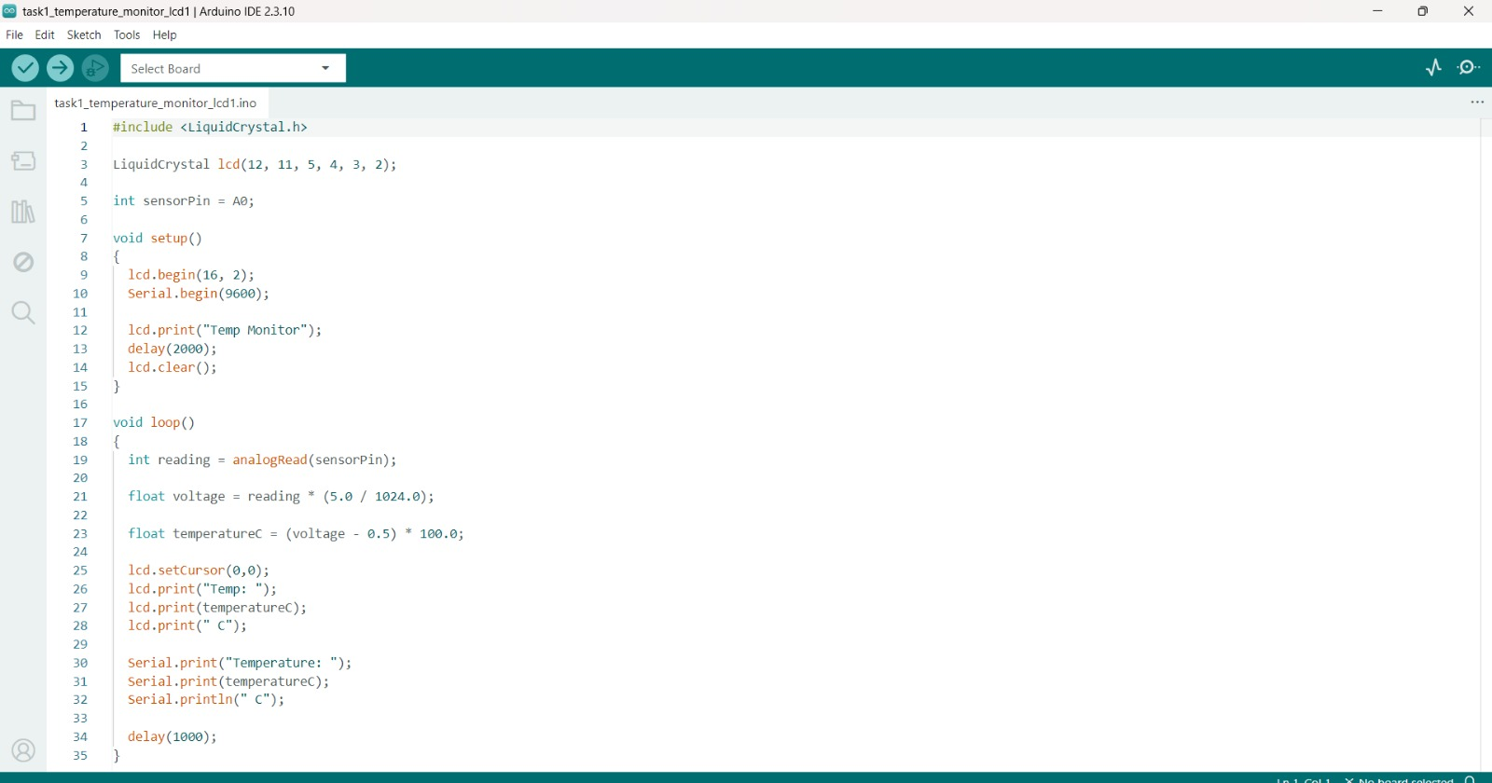
________________________________________
8. Results
The temperature monitoring system successfully measured the surrounding temperature using the TMP36 temperature sensor. The temperature readings were accurately displayed on the 16x2 LCD display and simultaneously logged through the Serial Monitor. The project was tested in the Tinkercad simulation environment and functioned as expected, providing real-time temperature monitoring.
________________________________________
9. Conclusion
This project demonstrates the basic concepts of embedded systems including sensor interfacing, analog data acquisition, LCD interfacing, and serial communication using Arduino. The system successfully monitored and displayed temperature readings in real time.
________________________________________
10. GitHub Repository Link
Paste your GitHub repository link here.
________________________________________
11. Demo Video Link
https://drive.google.com/file/d/1WSAaFM9sauh7gHuUTLk5z4L6JYCnuLPl/view?usp=sharing

