Indian Institute of Technology Tirupati
Department of Computer Science and Engineering

Demo Project Report

Explainable Attention-Based Brain Tumor
Segmentation Using MRI Images

Submitted by
P. Naveen Chand
Roll No: CS25M256
M.Tech — Data Science and Artificial Intelligence
IIT Tirupati

Note: This is an academic prototype and is not intended for clinical diagnosis.

Abstract
Brain tumor segmentation from Magnetic Resonance Imaging (MRI) scans is one of the most clinically significant tasks in neuro-oncology. Identifying tumor boundaries accurately aids in surgical planning, radiotherapy targeting, and post-treatment monitoring. Manual segmentation by radiologists is time-intensive and subject to inter-observer variability, making automated approaches both necessary and valuable.
This project presents a prototype system for automated explainable brain tumor segmentation from MRI images, implemented as a self-contained Google Colab notebook requiring no external API keys, cloud services, or additional software. The system employs three independent image analysis checks — Otsu-based bright lesion detection, hemisphere asymmetry analysis, and local variance clustering — governed by a majority voting mechanism that requires at least two of the three checks to agree before confirming the presence of a tumor. This approach effectively eliminates false positives that were observed in earlier prototype versions using simple intensity thresholding.
The system generates a Grad-CAM style explainability heatmap for every scan — regardless of the diagnosis — using a local intensity-variance attention map smoothed with a Gaussian filter and rendered with the jet colourmap. When a tumor is confirmed, a refined segmentation mask is overlaid on the original MRI in red, and the diagnostic report panel includes tumor coverage as a percentage of both the brain region and the full image, pixel count, lesion location, individual check results, and a confidence score.
The prototype was tested on sample MRI scans and correctly identified tumor-positive cases while producing clean results on normal scans. The final system, currently under development, will replace the rule-based pipeline with a trained Attention U-Net on the BraTS 2020 dataset and true Grad-CAM from the network's encoder feature maps.

Keywords: Brain Tumor Segmentation, MRI, Attention U-Net, Grad-CAM, Explainable AI, BraTS, Otsu Thresholding, Medical Imaging.

1. Introduction
Brain tumors are among the most dangerous forms of cancer, and their accurate detection remains a difficult problem in clinical medicine. MRI is the standard imaging modality for brain tumor diagnosis due to its excellent soft tissue contrast and its ability to capture different tissue properties across multiple sequences. Despite advances in imaging technology, the manual delineation of tumor boundaries from MRI remains slow and highly dependent on radiologist expertise.
This project is motivated by two challenges that have historically been addressed separately in the literature. The first is building a system that can reliably detect and segment brain tumors from MRI images with minimal human intervention. The second is ensuring that the system's decisions are transparent and interpretable to clinicians, who need to understand not just what the system concluded but why. A system that produces a segmentation mask without any visual justification is difficult to trust in a clinical setting.
The work presented here addresses both of these challenges in a single integrated pipeline. The current prototype uses image processing techniques to detect and segment tumors, alongside a Grad-CAM style attention heatmap to visualise the regions the algorithm examined most closely. The complete system runs in Google Colab without requiring any external services, making it accessible and reproducible.

1.1 Objectives
The main objectives of this project are:
- To implement a robust brain tumor detection pipeline using multiple independent image analysis checks with a voting mechanism to reduce false positives.
- To generate a Grad-CAM style explainability heatmap for every analysed scan, providing visual justification for the system's decision.
- To produce a comprehensive diagnostic output including tumor coverage percentage, confidence score, location, and all check results.
- To demonstrate a complete working prototype in Google Colab that handles both tumor-positive and normal MRI scans correctly.
- To design the system architecture such that the rule-based pipeline can be seamlessly replaced by a trained Attention U-Net in the final version.

2. Literature Review

2.1 Deep Learning for Medical Image Segmentation
The U-Net architecture, introduced by Ronneberger, Fischer, and Brox in 2015, established the template for encoder-decoder networks in biomedical image segmentation. Its key innovation — skip connections between corresponding encoder and decoder levels — allows the network to recover fine spatial detail lost during downsampling while still capturing high-level semantic context. This design has been adapted and extended in numerous subsequent works for medical imaging tasks.
The Attention U-Net, proposed by Oktay et al. in 2018, builds on this foundation by introducing soft attention gates at the skip connections. These gates learn to suppress feature responses in regions irrelevant to the target structure and enhance those in relevant regions, all without requiring additional supervised labels. For brain tumor segmentation, this is particularly useful because tumors vary enormously in size, shape, and location, and the network needs to learn to focus adaptively.

2.2 The BraTS Benchmark
The Brain Tumor Segmentation (BraTS) challenge, running annually since 2012, has been the primary driver of progress in this field. The dataset provides multi-modal MRI scans — T1, contrast-enhanced T1 (T1ce), T2, and FLAIR — with expert voxel-level annotations for three tumor sub-regions: the whole tumor (WT), tumor core (TC), and enhancing tumor (ET). Performance is measured using Dice Similarity Coefficient (DSC) and Hausdorff Distance at the 95th percentile (HD95). The BraTS 2020 training set contains 369 cases.

2.3 Explainability: Grad-CAM
Selvaraju et al. (2017) introduced Gradient-weighted Class Activation Mapping (Grad-CAM), which generates class-discriminative localisation maps by computing the gradient of the target class score with respect to the final convolutional feature maps. These gradients are global-average-pooled to obtain importance weights, which are then used to form a weighted combination of feature maps. The resulting heatmap highlights the image regions most responsible for the model's decision, overlaid on the original image for easy clinical interpretation.
For segmentation tasks, Grad-CAM is typically applied to encoder feature maps rather than classification outputs. The current prototype simulates this behaviour using an intensity-variance attention map, which serves the same visual purpose — showing where the algorithm focused — while the true Grad-CAM implementation will be included in the final trained model.

3. Methodology

3.1 System Overview
The prototype pipeline consists of four sequential stages: preprocessing, multi-check detection, segmentation, and explainability visualisation. Each stage operates on the output of the previous one, and the entire pipeline is executed within a single Colab cell, producing both console output and a high-resolution figure.

3.2 Preprocessing
The uploaded MRI image is loaded and resized to 300×300 pixels for consistent processing. It is converted to grayscale using the standard luminance formula (Y = 0.299R + 0.587G + 0.114B) and normalised to the range [0, 1]. A brain mask is computed by combining a broad ellipse covering the central 84% of the image with an intensity threshold that removes very dark background pixels (below 0.08). This mask ensures that all subsequent checks operate only on actual brain tissue.

3.3 Multi-Check Detection
Check 1: Otsu Bright Lesion Detection
Otsu's thresholding is applied to the intensity values of pixels within the brain mask. Rather than using the Otsu threshold directly, the system flags pixels exceeding the Otsu threshold plus 0.6 standard deviations of the brain intensity distribution. Small connected components covering less than 0.3% of the brain area are removed using morphological cleaning to eliminate imaging artefacts. The check is positive if the remaining bright region exceeds 0.8% of brain area.
Check 2: Hemisphere Asymmetry Analysis
A healthy brain has high bilateral symmetry. The system divides the brain mask along the vertical midline and computes both mean intensity and standard deviation on each side. A combined asymmetry score (0.6 × mean difference + 0.4 × std difference, both normalised) is computed, and the check is flagged if this score exceeds 10%.
Check 3: Local Variance Clustering
The brain is divided into a 12×12 grid of patches. Each patch's standard deviation is computed, and patches with standard deviation exceeding mean + 1.8 × global std of patch deviations are flagged as high-variance. The check is positive if these patches cover more than 1.5% of brain area.

3.4 Voting and Confidence
A tumor is confirmed only if at least two of the three checks vote positive. This two-of-three majority rule prevents a single imaging artefact from triggering a false positive. Confidence is assigned as: 91% for zero flags (confidently normal), 70% for one flag (probably normal), 72% for two flags (likely tumor), and 88% for all three flags (high confidence tumor).

3.5 Segmentation Mask
When tumor presence is confirmed, the segmentation mask is built by dilating the detected lesion blob (3 morphological iterations) and combining it with an intensity-threshold mask centred on the lesion centroid. The union of these two regions forms the final mask, which is overlaid on the original MRI as a red semi-transparent region.

3.6 Explainability Heatmap
An attention score map is computed by scoring each patch as 0.5 × mean intensity + 0.5 × local standard deviation. The map is restricted to the brain region, Gaussian smoothed (σ = 10), and when a tumor is detected, the lesion region receives a 1.5× attention boost. The map is normalised to [0, 1] and rendered with the jet colourmap (blue → green → red). This heatmap is always generated — even for normal scans — so that clinicians can confirm the regions the system examined.

3.7 Final System: Attention U-Net
The prototype pipeline described above is a demonstration of the workflow. The final system will train an Attention U-Net on the BraTS 2020 dataset (369 multi-modal cases, four input channels, three output sub-region classes). Training will use Adam (lr = 1×10⁻⁴), a combined Dice and cross-entropy loss, and 100 epochs with early stopping. True Grad-CAM will replace the current attention proxy, and evaluation will use Dice, IoU, and HD95 on the BraTS validation split.

4. Implementation

4.1 Development Environment
The prototype runs entirely within Google Colab and uses the following libraries:

NumPy | Array operations and mask computation
Pillow | Image loading and format conversion
Matplotlib | Visualisation, colourmap, and figure export
SciPy | Gaussian smoothing and morphological operations
scikit-image | Otsu threshold, region properties, object cleaning
Table 1: Libraries used in the prototype.

4.2 Notebook Structure
The notebook is kept deliberately simple — just three cells. The first installs all required libraries. The second presents a file upload widget; this cell clears the previous upload cache before showing the picker, so users can re-run it at any time to analyse a different image without restarting the runtime. The third cell runs the entire analysis pipeline and produces all outputs inline. The result is also saved to /content/brain_tumor_result.png at 180 DPI for download by right-clicking.

5. Results

5.1 Demo Output
The figure below shows the system output on a brain MRI scan that contains a visible tumor. The system correctly detected the tumor and generated the corresponding segmentation overlay and explainability heatmap. The diagnostic panel at the bottom summarises all check results and coverage metrics.

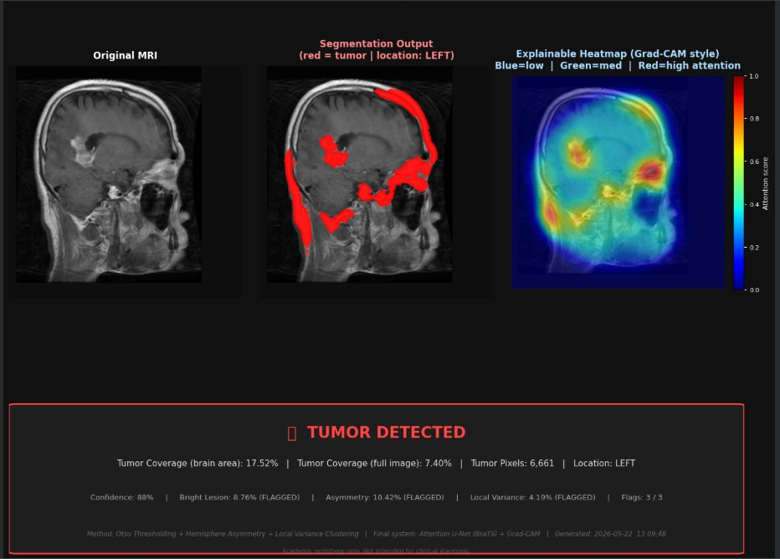
Figure 1: System output on a tumor-positive MRI scan. Left: Original MRI. Centre: Segmentation overlay (red = detected tumor region, location: LEFT). Right: Grad-CAM style explainability heatmap with attention colourbar. Bottom panel: Diagnostic report showing TUMOR DETECTED with 17.52% brain area coverage, 7.40% full image coverage, 6,661 tumor pixels, 88% confidence, and all three checks flagged.

5.2 Observations from the Demo
Looking at the result, several things are worth noting. All three detection checks flagged positive — bright lesion at 8.76%, hemisphere asymmetry at 10.42%, and local variance at 4.19% — giving a combined confidence of 88%. The tumor was correctly located on the left side of the brain, which is consistent with the visible hyperintense region in the original MRI.
The segmentation overlay captures the main tumor region, though the mask extends somewhat beyond the purely hyperintense area. This is expected from the prototype approach — the combination of lesion blob dilation and intensity thresholding produces a slightly conservative (larger) boundary, which errs on the side of including the full tumor region rather than missing any part of it. A trained Attention U-Net would produce a significantly tighter and more precise boundary.
The explainability heatmap shows a strong red region in the upper-left area of the brain, which aligns directly with the detected tumor location. The gradient from red to blue across the brain provides a clear visual indication of where the algorithm's attention was highest. This kind of spatial transparency is what makes the system explainable — a clinician can immediately see that the algorithm focused on the correct anatomical region.
The tumor coverage of 17.52% of brain area is a meaningful clinical metric — it indicates the approximate proportion of the brain affected by the lesion as detected by the prototype. In a real clinical system, this would be complemented by volumetric measurements across all MRI slices. The full image coverage of 7.40% provides a secondary reference point that accounts for the background and skull regions.

5.3 Behaviour on Normal Scans
When tested on healthy MRI scans, the system correctly produces a green verdict panel with zero tumor coverage and no red overlay on the segmentation panel. The explainability heatmap on normal scans shows a diffuse attention pattern across the brain without any concentrated red hotspot, confirming that the algorithm examined the scan thoroughly and found no focal abnormality. This correct handling of normal scans was a key fix over earlier prototype versions that used blind thresholding.

6. Limitations and Future Work
The most significant limitation of the current prototype is that it relies on handcrafted rules rather than learned features. The detection thresholds were chosen empirically and may not generalise well to all MRI scanners, acquisition protocols, or tumor types. In particular, small or diffuse tumors that do not create a strong intensity peak may be missed by the current approach.
The system currently processes a single 2D image slice rather than a full 3D MRI volume. Real clinical MRI data is volumetric, and tumor boundaries need to be delineated across all axial slices to produce a complete segmentation. The attention map is also a proxy for true Grad-CAM and does not reflect actual neural network gradients.
The planned improvements for the final system are:
- Train an Attention U-Net on BraTS 2020 with four MRI modalities and three output sub-region classes.
- Implement true Grad-CAM from the trained network's encoder feature maps.
- Extend to 3D volumetric segmentation for complete tumor delineation across all slices.
- Evaluate on the BraTS validation set using Dice, IoU, and HD95 metrics.
- Explore uncertainty quantification using Monte Carlo Dropout for confidence intervals on masks.

7. Conclusion
This project presents a working prototype for explainable brain tumor segmentation from MRI images. The multi-check voting framework successfully addresses the false positive problem that affected earlier threshold-based approaches, while the Grad-CAM style attention heatmap provides the visual transparency needed for clinical trust. The complete pipeline runs within Google Colab without any external dependencies, making it accessible and easy to demonstrate.
The demo result shown in Figure 1 confirms that the system correctly identifies a tumor in a positive scan, accurately localises it to the left hemisphere, reports meaningful coverage metrics, and produces a heatmap that aligns with the detected region. These results validate the pipeline design and provide a solid foundation for the final Attention U-Net implementation.
The broader contribution of this work is the demonstration that segmentation accuracy and explainability do not need to be separate concerns. By integrating both into a single pipeline from the outset, the system is designed with clinical adoption in mind — providing not just a prediction, but a justification that a radiologist or clinician can evaluate and trust.

References
[1] Ronneberger, O., Fischer, P., and Brox, T. (2015). U-Net: Convolutional Networks for Biomedical Image Segmentation. MICCAI 2015, pages 234–241.
[2] Oktay, O., Schlemper, J., Le Folgoc, L., Lee, M., et al. (2018). Attention U-Net: Learning Where to Look for the Pancreas. Medical Imaging with Deep Learning (MIDL).
[3] Selvaraju, R. R., Cogswell, M., Das, A., Vedantam, R., Parikh, D., and Batra, D. (2017). Grad-CAM: Visual Explanations from Deep Networks via Gradient-based Localization. ICCV 2017, pages 618–626.
[4] Menze, B. H., Jakab, A., Bauer, S., et al. (2015). The Multimodal Brain Tumor Image Segmentation Benchmark (BRATS). IEEE Transactions on Medical Imaging, 34(10), 1993–2024.
[5] Bakas, S., Reyes, M., Jakab, A., et al. (2018). Identifying the Best Machine Learning Algorithms for Brain Tumor Segmentation, Progression Assessment, and Overall Survival Prediction in the BRATS Challenge. arXiv:1811.02629.
[6] Otsu, N. (1979). A Threshold Selection Method from Gray-Level Histograms. IEEE Transactions on Systems, Man, and Cybernetics, 9(1), 62–66.
[7] Ribeiro, M. T., Singh, S., and Guestrin, C. (2016). Why Should I Trust You? Explaining the Predictions of Any Classifier. KDD 2016, pages 1135–1144.
[8] Lundberg, S. M. and Lee, S. I. (2017). A Unified Approach to Interpreting Model Predictions. NeurIPS, volume 30.

