Data Analytics with AI
Combined Project Report — Masterclass 1 to 4
AICTE | IBM SkillsBuild Internship 2026 — BharatCares

1. Project Overview
This project follows the full data-analyst workflow taught across four masterclasses: turning raw e-commerce data into a clean dataset, exploring it for business insights, building a churn-prediction model, and analyzing a separate retail dataset for business decisions.

2. Masterclass 1 — Data Cleaning
The raw dataset (2,000 transactions) contained impossible dates, mixed currency formatting, negative quantities, inconsistent region/category casing, duplicates, and missing values. After cleaning: 1,926 valid transaction rows remained.
- Removed 23 exact duplicate rows
- Dropped 24 rows with impossible/unreadable dates
- Standardized region and category text casing
- Stripped currency symbols/text from Revenue
- Corrected negative quantities; filled missing values with median/group-median
Deliverables: a clean dataset, a full data dictionary (9 original + 6 derived columns), and a 5-question business shortlist spanning Sales, Product, Customer, and Region.

3. Masterclass 2 — Exploratory Data Analysis
Key findings from the 5 required visualizations:
- Highest revenue month: April 2026 (₹14,257,198); lowest: September 2026 (₹2,671,823)
- Electronics is the dominant category (₹58,999,410), more than 3x the next category, Furniture (₹18,472,291)
- Repeat customers made up 325 of 413 unique customers (~79%), against 88 new customers
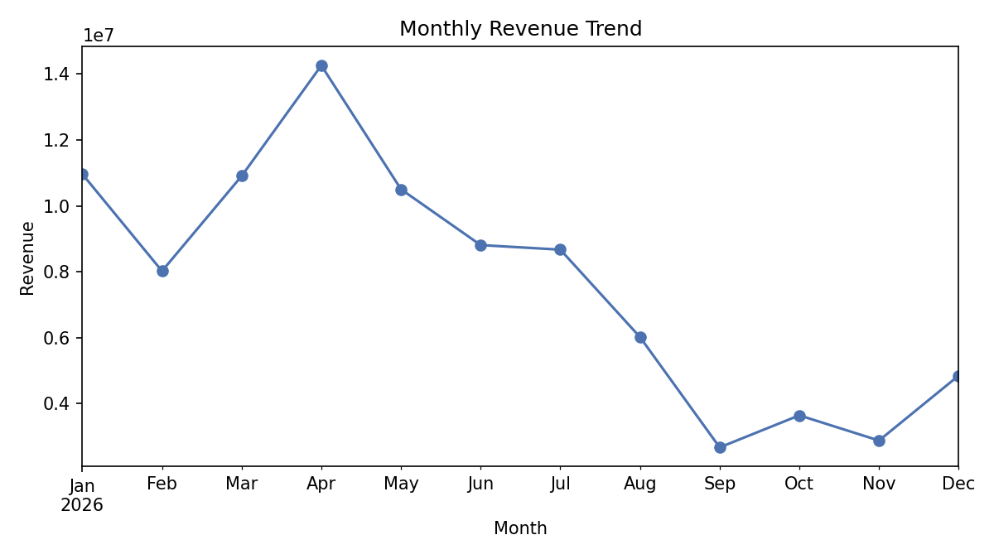
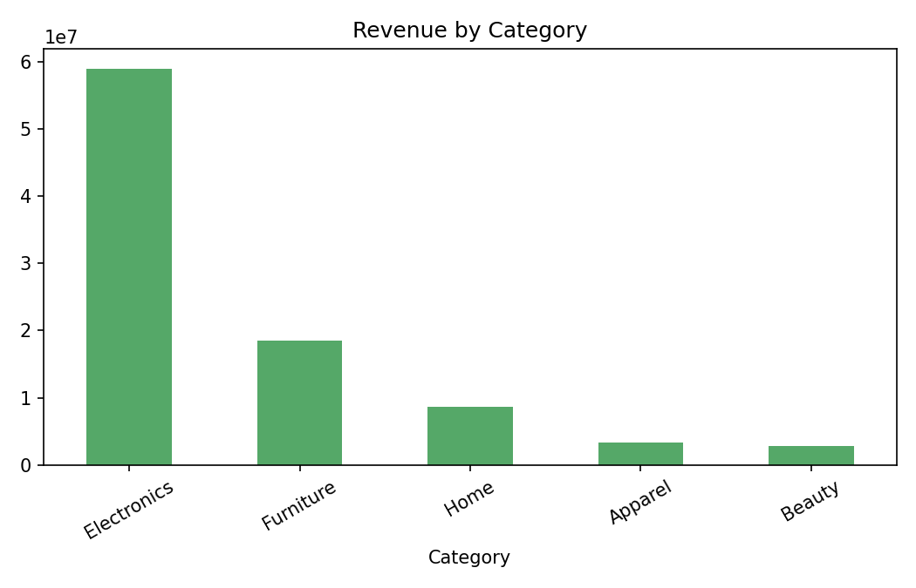
Insights were framed as associations, not proven causes (e.g. "Electronics dependency is associated with revenue concentration risk"), with hypotheses phrased using may/might/could, and recommendations tied directly to each insight — following the association-vs-causation discipline from the masterclass.

4. Masterclass 3 — Churn Prediction Model
RFM (Recency, Frequency, Monetary) features were built from a historical window (before 1 June 2026), while the churn label was computed from a later window — keeping the model leakage-safe, since the label was never derived from the features themselves.
- Churned customers were defined as those with no purchase at all in the future window
- A logistic regression model (class-weight balanced) was trained on Recency, Frequency, Monetary, and Avg Order Value
- Test-set performance: Accuracy 58.90%, Precision 34.29%, Recall 63.16%
- Confusion matrix: 31 true negatives, 23 false positives, 7 false negatives, 12 true positives
The trained model was then applied to the full customer base to produce a churn-probability score and a Low/Medium/High risk label for every customer: 120 Low Risk, 219 Medium Risk, and 22 High Risk.
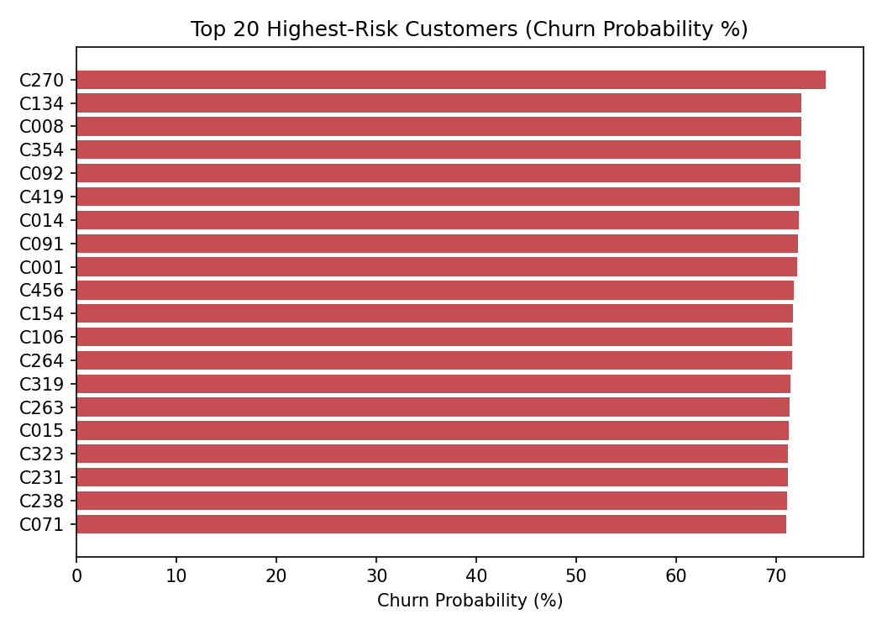

5. Masterclass 4 — Supermarket Sales Analysis
A separate 500-transaction supermarket dataset was analyzed to answer 6 specific business questions:
- Highest-selling product: Cheese (₹27,906.30)
- Best-performing branch: Branch C, Mumbai (₹72,469.45)
- Top category: Beverages (₹56,108.24)
- Most popular payment method: UPI (127 transactions)
- Member vs. Normal average spend: ₹483.14 vs. ₹497.07 — essentially no difference
- Average customer rating: 3.99 / 5
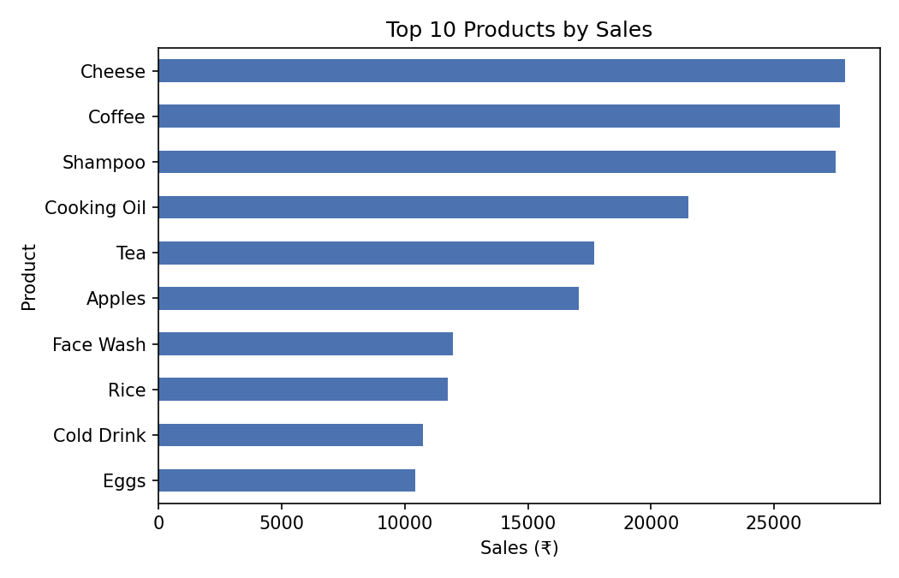
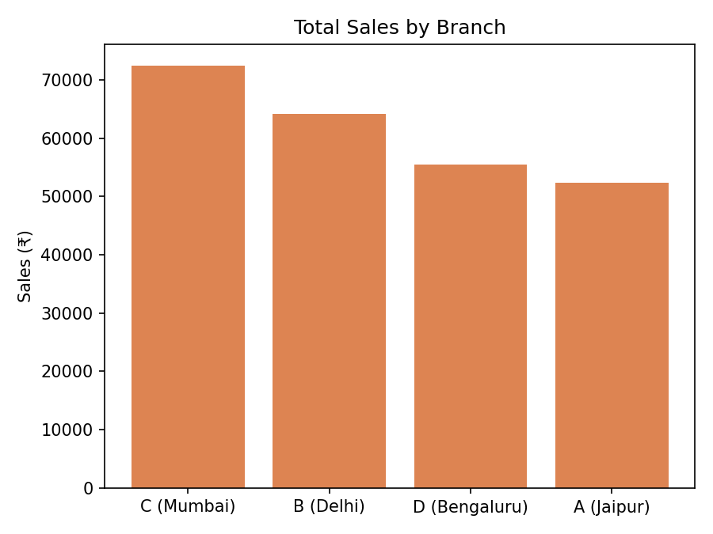

6. Overall Business Decisions
- Stock more of the top-performing products and categories across both datasets
- Investigate why certain months/branches outperform others and replicate what's working
- Build cash reserves and off-peak campaigns to smooth revenue volatility
- Use the churn risk table to prioritize retention outreach for High and Medium risk customers
- Audit product catalogs to eliminate blank/unlabeled SKUs that obscure true performance

7. Conclusion
Across all four stages — cleaning, exploration, prediction, and business analysis — this project demonstrates the complete data-analyst workflow: converting messy raw data into a trustworthy foundation, extracting insights disciplined by the association-vs-causation principle, building a leakage-safe predictive model, and translating outputs into concrete, realistic business actions.

