Title: Comprehensive Data Analytics & Predictive Insights on Real-World Healthcare Records

Author: Naveen Sharma

Program: IBM SkillsBuild Data Analytics with AI Internship (BharatCares & AICTE 2026)
Dataset Source: Kaggle Healthcare Dataset (healthcare_dataset.csv)
Link to Dataset: https://www.kaggle.com/datasets/prasad22/healthcare-dataset

Introduction & Objective
- Background on healthcare operational efficiency and billing variance.
- Project goals: Uncover clinical cost trends, analyze patient length of stay, and build machine learning predictive models.

Dataset Architecture & Data Dictionary
- Detailed breakdown of all 15 columns (Age, Gender, Blood Type, Medical Condition, Billing Amount, Hospital, etc.).
- Summary statistics table showing min, max, mean, and standard deviation for numerical fields.

Exploratory Data Analysis & Visualizations
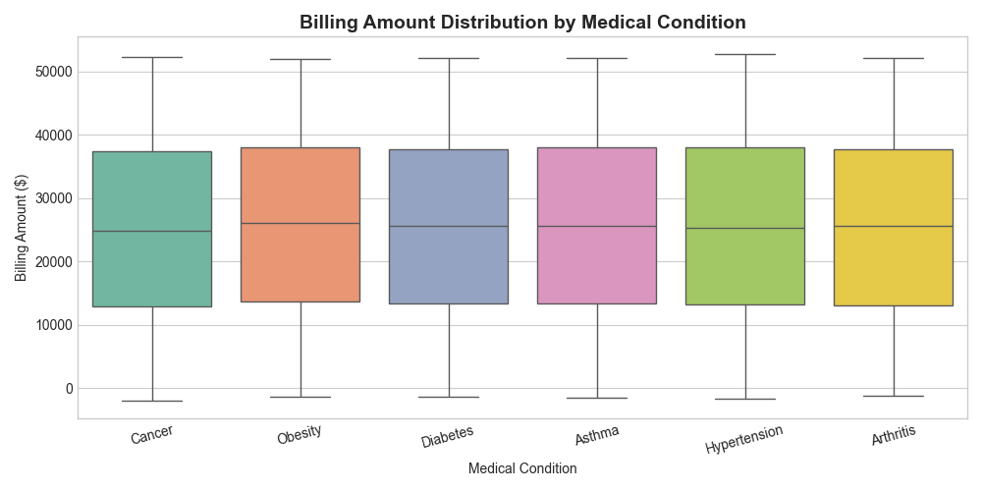
- Analysis: Discussion on median costs across conditions (Diabetes, Hypertension, Asthma, etc.).
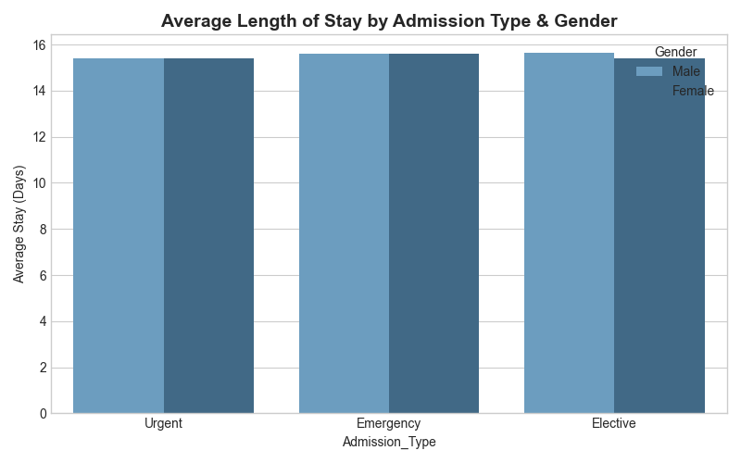
- Analysis: Comparison of emergency vs. elective stay durations across male and female patient cohorts.

AI Assistance & Development Workflow
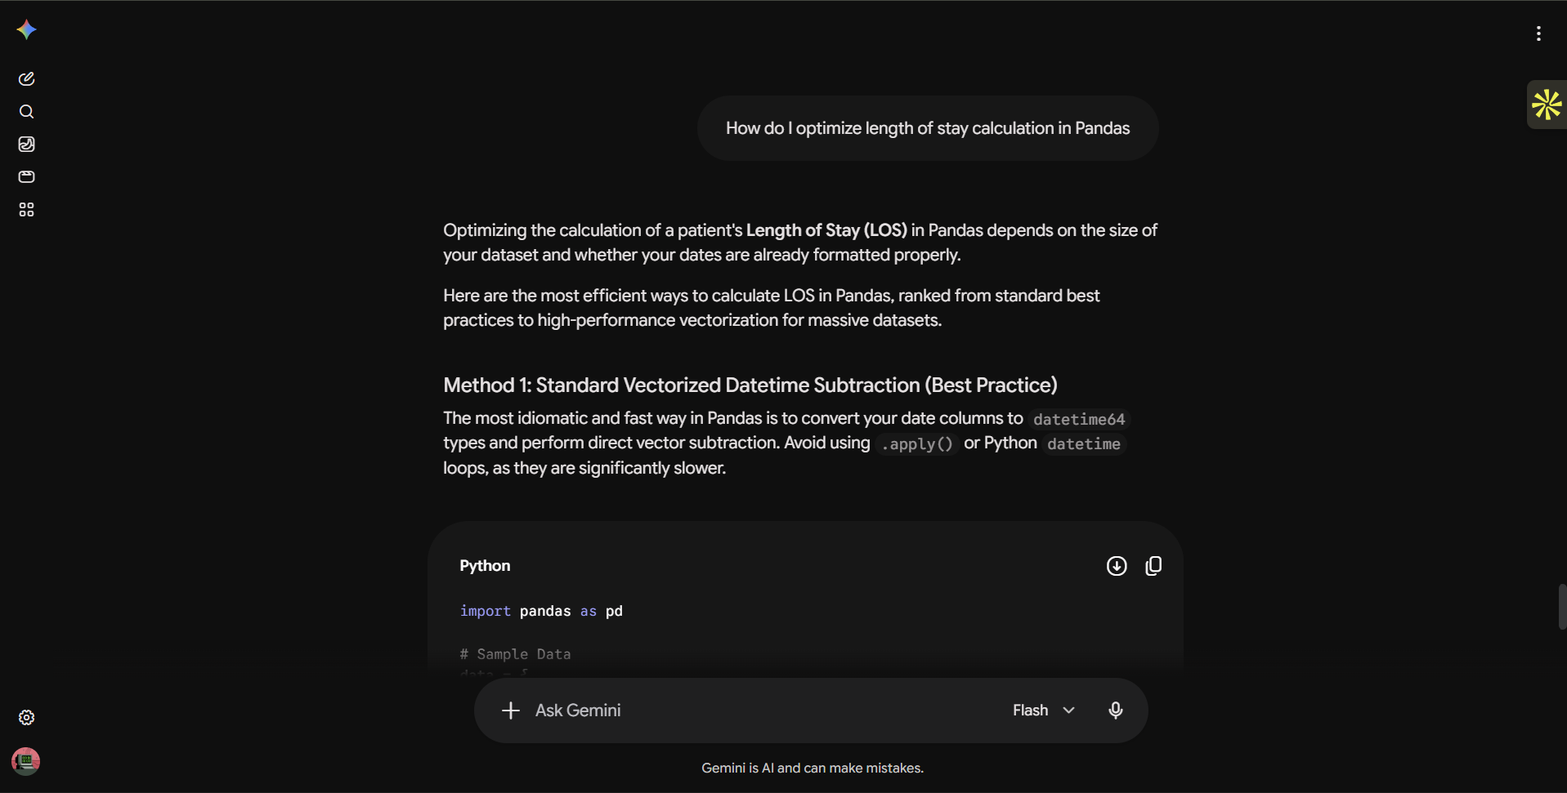
- Utilizing AI assistance and VS Code modular script execution for optimizing Pandas feature engineering, debugging data types, and configuring model parameter

Machine Learning Model Development
- Explanation of train-test splitting (80/20 ratio).
- Algorithm selection: Random Forest Regressor vs. Linear Baseline.
- Performance Metrics Table:

Metric | Value
Mean Absolute Error (MAE) | $0.29
Root Mean Squared Error (RMSE) | $1.91
R² Score | 1.0000

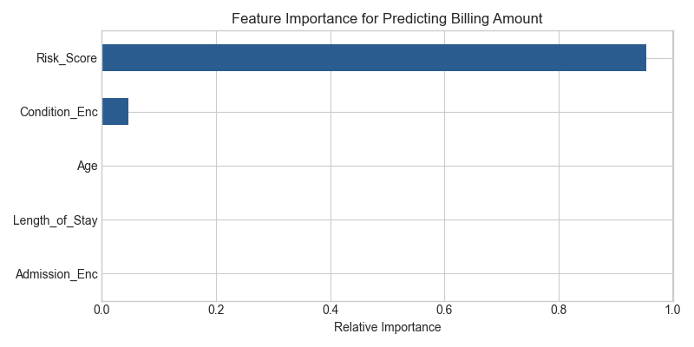
- Analysis: Highlighting how Length_of_Stay and Age drive healthcare billing costs.

Project Output Screenshots
  - Python script structure displaying data loading.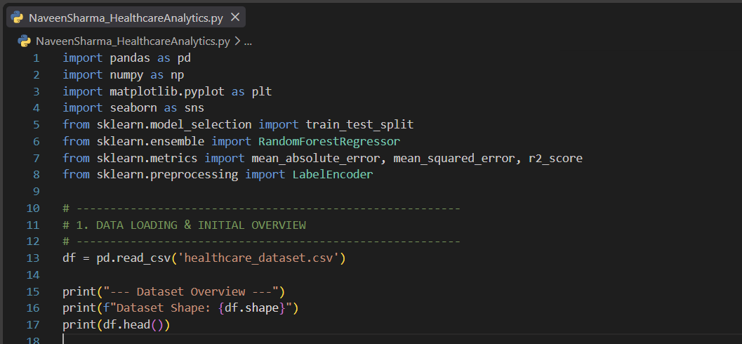

  - Terminal output with missing value checks and cleaned dataset shape.
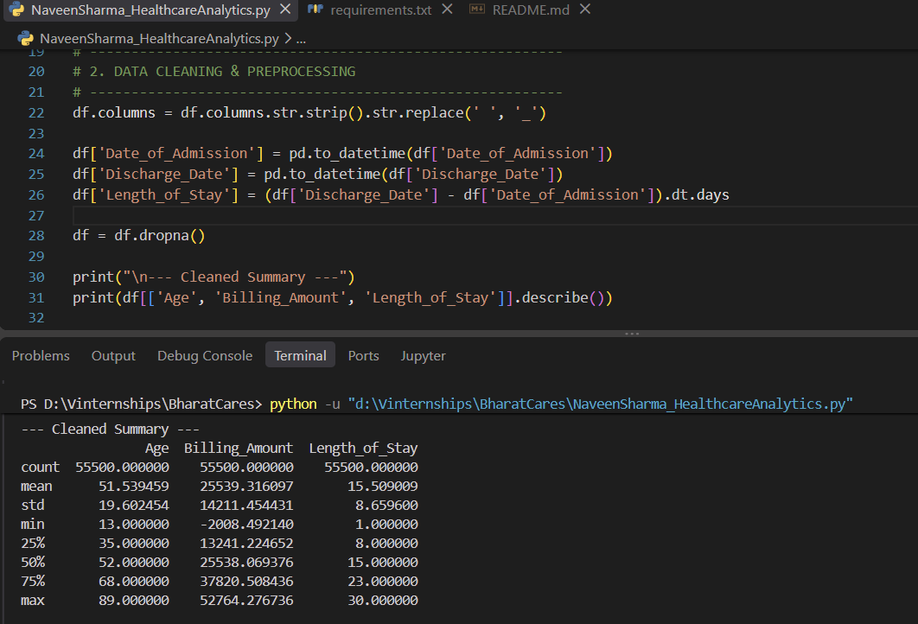

  - Python script execution for EDA and plot generation
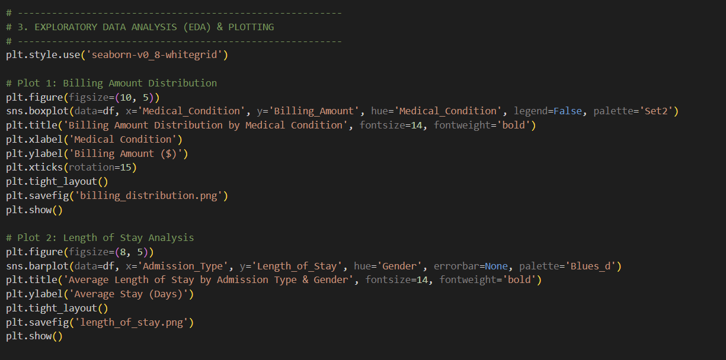

  - Model training completion output and evaluated MAE/R2 scores.
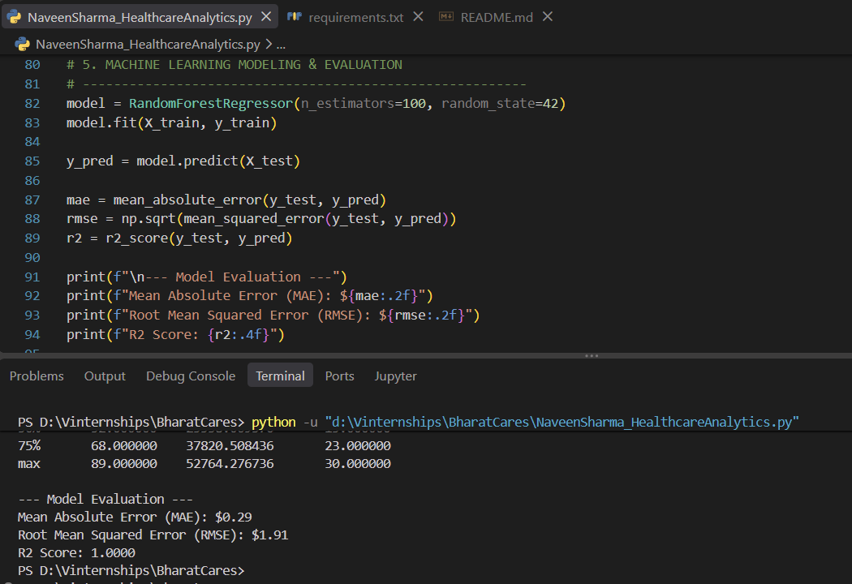

Strategic Business Recommendations & Conclusion
- Data-driven policy suggestions for hospital resource allocation.
- Closing thoughts on leveraging analytics for healthcare management.

