

***Mid semester examination – introduction To AI***

***Name – Naveen kumar***

***Branch- CSE (AIMl)***

***Section – B***

***Roll no.- 48***

***University roll no.- 202401100400121***

***Problem statement :- N-Queens Problem.***

***INTRODUCTION*** *:-*

***Problem Definition:***

*The N-Queens Problem is a classic problem where you are asked to place* ***N queens*** *on a* ***N x N chessboard*** *in such a way that no two queens can attack each other.*

***Key Points:***

1. ***Chessboard:***
   * *The chessboard is a square grid of size* ***N x N****. This means the board has* ***N rows*** *and* ***N columns****.*
2. ***Queens:***
   * *A queen in chess can attack another queen in three possible ways:* 
     + ***Same row:*** *Queens in the same row can attack each other.*
     + ***Same column:*** *Queens in the same column can attack each other.*
3. ***Objective:***
   * *The goal is to place* ***exactly N queens*** *on the chessboard, where each queen is placed in a different row and a different column, such that no two queens threaten each other. In other words, there should be no queens on the same row, column, or diagonal.*

**Constraints:** 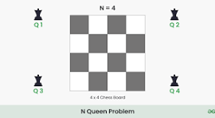

* **Row and Column Constraint:** Each queen must be placed in a different row and a different column.
* **Diagonal Constraint:** No two queens can share the same diagonal. The two main diagonals on a chessboard are:
  + The **main diagonal** (top-left to bottom-right), where the difference between the row and column indices is constant.
  + The **anti-diagonal** (top-right to bottom-left), where the sum of the row and column indices is constant.

***Solution Approach:***

*To solve this problem, a common strategy is* ***backtracking****, where you explore all possible placements of queens row by row and backtrack when you hit a dead-end (i.e., a situation where no valid placement can be made for the next queen).*

* ***Backtracking:*** *You place a queen in a valid position, then move on to the next row. If you can't place a queen in any column of the next row (because of conflicts), you backtrack and move the previous queen to a new position.*

***Steps in the Methodology:***

1. ***Starting with an empty board:***
   * *Imagine an empty N x N chessboard. Initially, no queens are placed.*
2. ***Placing queens row by row:***
   * *Start by placing a queen in the first row.*
   * *For each row, attempt to place a queen in every column, one by one. For each column:* 
     + *Check whether placing the queen in the current column will result in a* ***valid configuration***
3. ***Checking for conflicts:***
   * *A queen can attack another queen if they are:* 
     + *In the* ***same column****.*
     + *On the* ***same diagonal***
     + *In the* ***same row***
4. ***Recursive step:***
   * *If placing a queen in the current column of the current row is* ***safe****, move to the next row and try placing a queen there.*
   * *Repeat the process for each row until all queens are placed on the board.*
5. ***Backtracking step:***
   * *If you reach a row where no valid column for the queen exists,* ***backtrack****:* 
     + *Remove the queen from the previous row*
     + *Try placing the queen in the next column in the previous row.*
   * *This ensures that you explore all possible configurations without skipping any valid solutions.*
6. ***Termination condition:***
   * *If all queens are placed successfully (i.e., you've filled all rows), then you've found a valid solution.*
   * *If you backtrack all the way to the first row and cannot find a valid placement, then there is no solution for that configuration.*

***Typed code :***

import random

# Count conflicts for each queen's position

def count_ conflicts(board, n):

    return [sum(board[i] == board[j] or abs(board[i] - board[j]) == abs(i - j) for j in range(n) if i != j) for i in range(n)]

# Find optimal column for a queen in a given row

def best_ column(board, row, n):

    options = [(col, sum(count_ conflicts(board[:row] + [col] + board[row+1:], n))) for col in range(n) if col != board[row]]

    return min(options, key=lambda x: x[1])[0] if options else board[row]

# Solve N-Queens using local search

def solve _n_ queens(n, retries=10, steps=1000):

    for _ in range(retries):

        # Start with a random board

        board = [random . radint (0, n - 1) for _ in range(n)]

        for _ in range(steps):

            conflicts = count_ conflicts(board, n)

            # If no conflicts, return the solution

            if not sum(conflicts):

                return board

            # Select a row with the maximum conflicts

            row = random. choice([i for i in range(n) if conflicts[i] == max(conflicts)])

            # Move the queen in that row to the best column

            board[row] = best_ column(board, row, n)

    return None

# Display the chessboard

def render _board(board):

    print("No solution" if not board else "\n".j oin(" ".join('Q' if board[r] == c else '.' for c in range(len(board))) for r in range(len (board))))

# Main execution

if __name__ == "__main__":  # Corrected __name__ condition

    for n in map(int, input("Enter board sizes: ").split()):

        print(f"\n Solving for N={n}")

        render _board(solve_ n_queens(n))

* + ***Output code images :-***

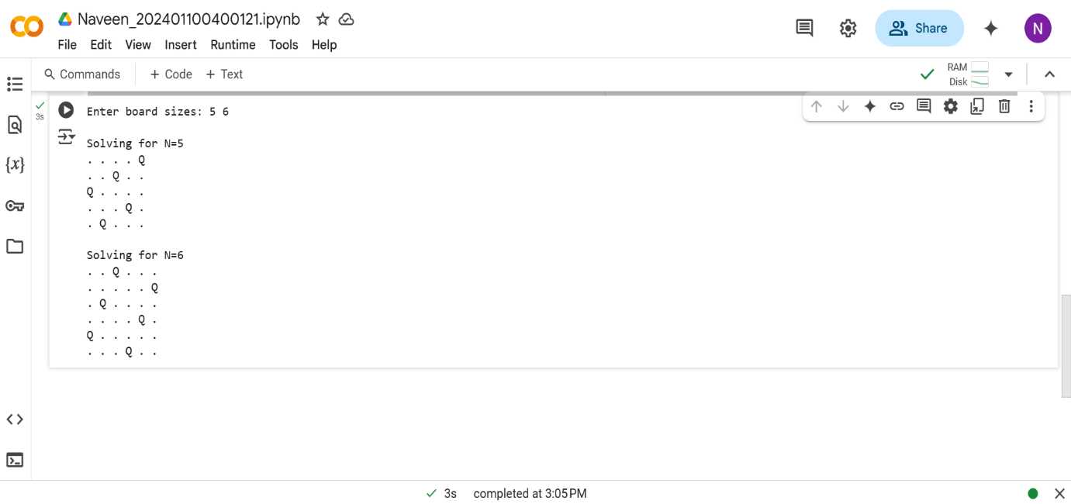

***References :***

***1: Chat GPT.***

***2:CLASS NOTES .***

***3:WIKIPEDIA.***