NAVEEN D A  Register Number: 723724205033  naveensoniya14@gmail.com | +91 6374141521  https://github.com/naveenda-2007 | https://www.linkedin.com/in/naveen-d-a-1570793b0?utm_source=share_via&utm_content=profile&utm_medium=member_android | https://leetcode.com/u/Naveen_D_A/ | 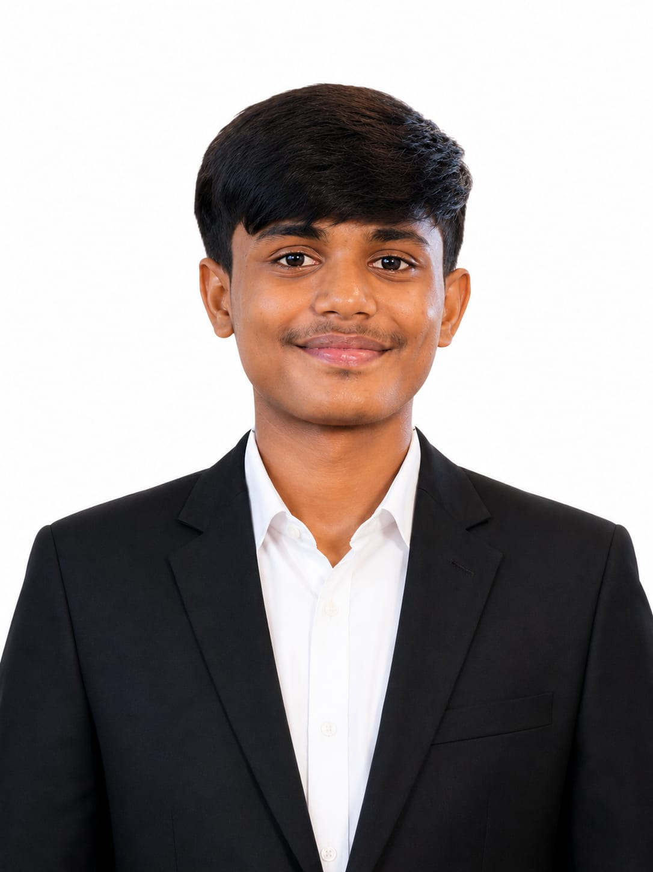

CAREER OBJECTIVE
Information Technology fresher with a strong academic foundation and a genuine interest in software development, programming, and data analytics. Eager to apply problem-solving ability and adaptability to real-world projects, learn emerging technologies, and contribute effectively to an organization while continuing to grow as a developer.
EDUCATION
B.Tech – Information Technology CGPA: 9.32 (up to 4th Semester)
VSB College of Engineering Technical Campus, Coimbatore 2024 – 2028
HSC – Model School, Sankari, Salem 2023 – 2024 | 82%
SSLC – Model School, Sankari, Salem 2021 – 2022 | 80%
TECHNICAL SKILLS
Programming Languages: Java, C, Python (Basic)
Web Technologies: HTML, CSS, JavaScript, PHP (Basic)
Database: MySQL, DBMS (Basic)
Core Concepts: Object-Oriented Programming (Basic), Data Structures & Algorithms (Currently Learning)
Tools & Software: IntelliJ IDEA, Visual Studio Code, XAMPP, Microsoft Excel, Android Studio (Basic)
PROJECT
SmartCalci
- Developed a calculator application that performs standard arithmetic calculations with a simple, user-friendly interface.
- Focused on clean layout and ease of use to ensure smooth interaction for end users.
- Built as a hands-on project to strengthen understanding of core programming logic and UI design fundamentals.
CERTIFICATIONS
- NPTEL – Cloud Computing
- NPTEL – Internet of Things (IoT)
- NPTEL – Machine Learning
- Infosys Springboard – Introduction to Python
- Infosys Springboard – Introduction to Java
JOB SIMULATIONS
- Tata – GenAI Powered Data Analytics Job Simulation, Forage
- Deloitte – Data Analytics Job Simulation, Forage
TECHNICAL ACTIVITIES & EVENTS
- Participated in coding contests and programming-related activities to build problem-solving skills.
- Attended technical workshops to gain exposure to new tools and concepts.
- Took part in college-level technical events, engaging with peers on IT-related topics.
SOFT SKILLS
Problem Solving • Adaptability • Teamwork • Communication • Creativity and Innovation
LANGUAGES
Tamil • English

