Patient Information
Patient ID: PT-2026-0456 Name: John Doe Age: 34 years Gender: Male Date of Visit: 12-Mar-2026

Medical History

The patient has a known history of hypertension diagnosed in 2020 and reports an allergy to penicillin. He is currently taking Amlodipine ⁵ mg once daily for blood pressure management. His family history reveals that his father has diabetes and his _{mother} has hypertension.
- APPLE
- MANGO
- BANANA
- yELLOW
- gREEN

Clinical Findings
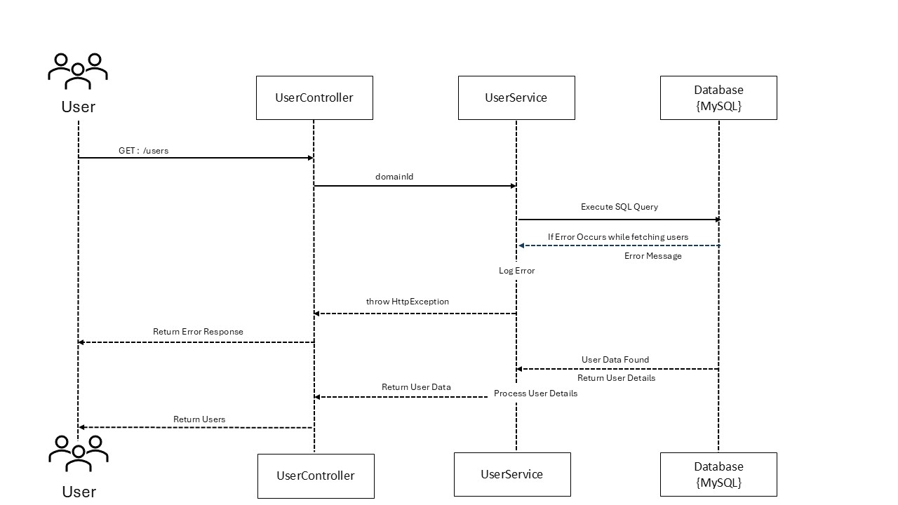On examination, the patient’s blood pressure was recorded at 145/95 mmHg, with a heart rate of 88 bpm and a body temperature of 98.6°F. Physical examination indicated mild swelling in the lower limbs. Laboratory investigations showed a hemoglobin level of 13.5 g/dL and a fasting blood glucose level of 110 mg/dL.

Diagnosis & Treatment Plan
Based on the clinical findings, the patient was diagnosed with Stage 1 hypertension. The treatment plan includes increasing the dosage of Amlodipine to 10 mg daily, adopting a low-sodium diet, and engaging in regular physical activity for at least 30 minutes per day. A follow-up visit has been scheduled after four weeks to monitor progress.

A | E | I | M
B | F | J | N
C | G | K | O
D | H | L | P
- ONE
- TWO
- THREE
- FOUR

