Q.1) The concept of laissez faire economy refers to kajhdsg kdh haks dgksdjh kaj hdgkasd kjha dskgh kds kasdh gks hdk
$$)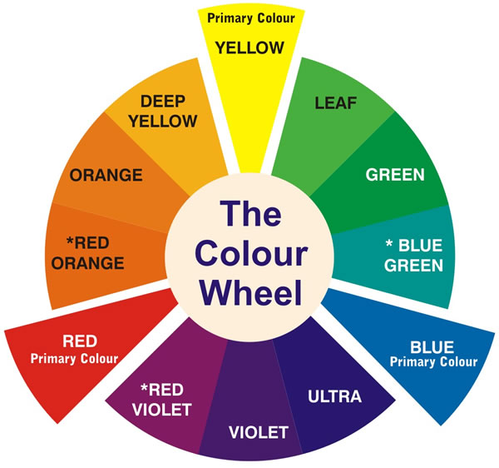
a) Government control over the allocation of all factors of production.
*b) Non-interference by the government and free functioning of demand and supply forces in the market
c) The customers take all the decisions regarding production of all the commodities.
d) Private sector takes all the decisions for price determination of various commodities produced

##) explanation of the question
#*#)

Q.2) Which of the following is likely to be most inflationary in its impact.
a) Repayment of public debt
b) Borrowing from the public to finance a budget deficit
c) Borrowings from banks to finance a budget deficit
*d) Creating new money to finance a budget deficit

Q.3) Which were the suggestions given by Keynes to pull out the economy from Great Depression:
1) the capitalistic order to assimilate the goals of the socialistic economy.
2)The essential goods and services were made available by the state ‘free-of-cost’ giving people more spare money to create demand for the goods and services.
Which of the above statements is/are correct?
$$)
*a)1 only
b)2 only
c)Both 1 and 2
d)None

##) explanation of the question
#*#) 

