Q.1) A 100 ml flask contains 30% acid solution. What quantity of the solution should be replaced with 12% acid solution so that the resultant solution contains 21% acid?
[QIMAGE] 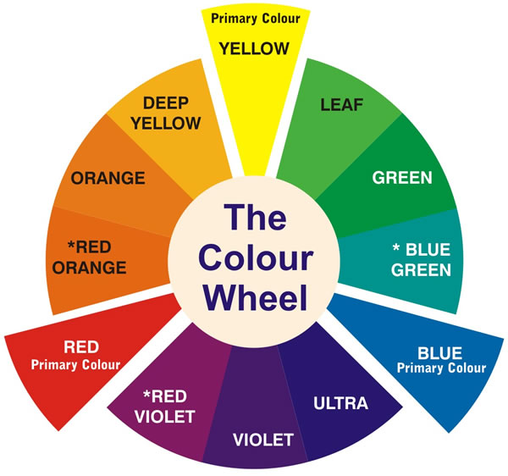
[1] 60ml
*[2] 50ml
[3] 10ml
[4] 44ml
[MARKS] 2
[QUESTION TYPE] MC
[NEGATIVE MARKS] 0.25
[EXPLANATION] Let x ml of the solution
[EIMAGE] 

Q.2) 2.49 + 2.50 = ___ ?
*[1] 4.9_5.0
[2] 5.9_5.0
[3] 9.9_5.0
[MARKS] 1
[NEGATIVE MARKS] 0
[QUESTION TYPE] MC
[EXPLANATION] 4.99

Q.3) 2.49 + 2.50 = ___ ?
[QIMAGE] 
*[1] 4.9_5.0
[2] 9.5_5.0
[3] 9.9_5.0
[MARKS] 1
[NEGATIVE MARKS] 0
[QUESTION TYPE] MC
[EXPLANATION] 4.99
[EIMAGE] 

