Instructions for using this template:
- Supported Question type are:
- Multiple Choice: “MC”
- Single Choice: “SC”
- Fill Blanks: “FB”
- First cell of a row(not case sensitive) defines what type of content is in the row.
- Valid data for first cells are:
- Question
- Explanation
- Type
- Option
- Marks
- Option Row:
  - Second cell contains the option
  - Third cell defines if the option is correct or not. Options marked with “correct” in the third cell will be considered correct options.
- Marks Row:
  - Second cell contains total marks of the question.
  - Third cell contains negative marking in percentage of question marks. For example if value set 50, and total marks for the question is 2, then 1 mark will get deducted for the wrong answer.

Structions for Fill-in-the-Blank (FB) Question Template
- A blank/answer in a fill-in-the-blank question is denoted by ##answer##, where answer is the correct value for that blank.
- A question may contain multiple blanks/answers.
- Options may be provided for filling the blanks using the Options row, but they are not mandatory.

Question | What is the value of x in the equation 3x+5=20?
Explanation | This question uses concepts of simple linear equations.
Type | SC
Option | 3 | Incorrect
Option | 5 | Correct
Option | 7 | Incorrect
Option | 9 | Incorrect
Marks | 2 | 0

Question | Which of the following numbers are prime numbers?
Explanation | A prime number is a number greater than 1 that has no positive divisors other than 1 and itself.
Type | MC
Option | 5 | Correct
Option | 11 | Correct
Option | 15 | Incorrect
Option | 32 | Incorrect
Marks | 2 | 50

Question | What is the name of this famous monument shown in the picture?  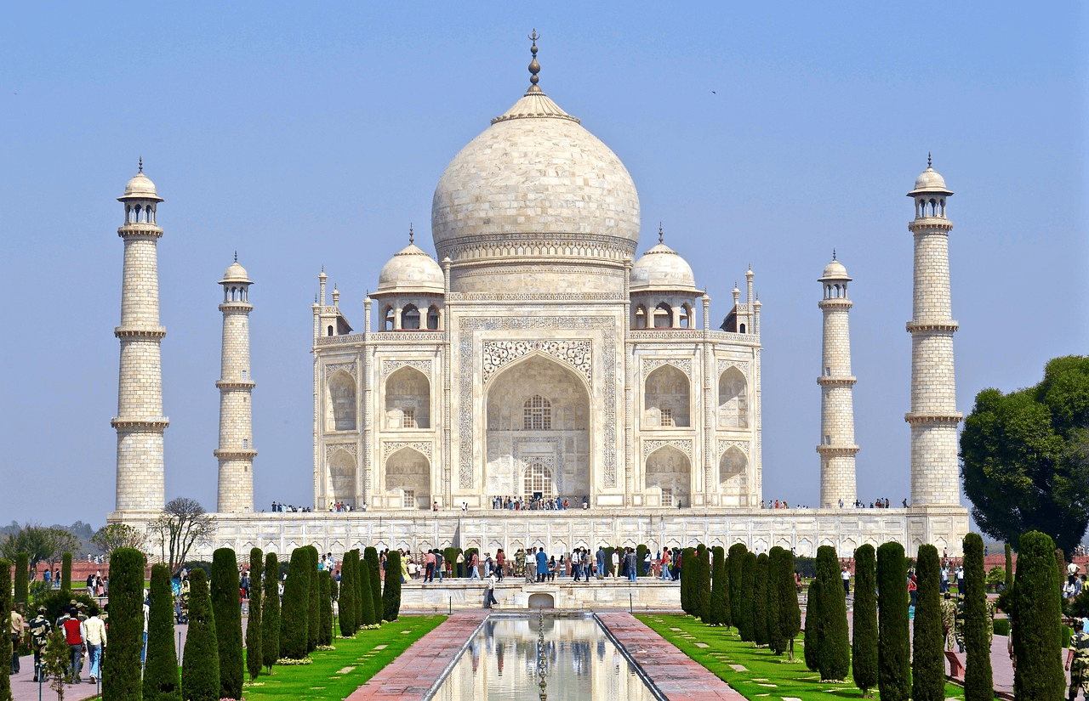
Explanation | The monument is one of the most iconic structures in India and attracts millions of tourists every year.  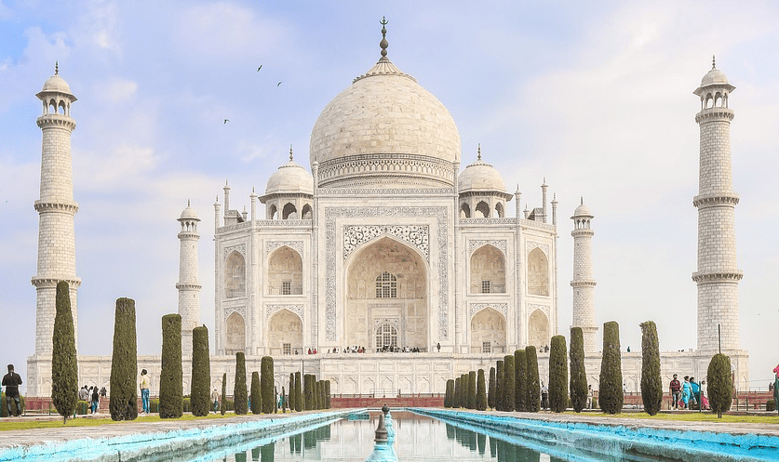
Type | SC
Option | Red Fort | Incorrect
Option | Taj Mahal | Correct
Option | Qutub Minar | Incorrect
Option | India Gate | Incorrect
Marks | 2 | 50

Question | A triangle has ##3## sides and ##3## angles.
Explanation | A triangle is a basic geometric shape that always has three sides and three angles. This property defines all triangles, regardless of their type.
Type | FB
Marks | 2 | 0

Question | India gained independence in ##1947## and became a republic in ##1950##.
Explanation | This is a basic general knowledge question about India's independence and the year it became a republic.
Type | FB
Option | 1947

Question | 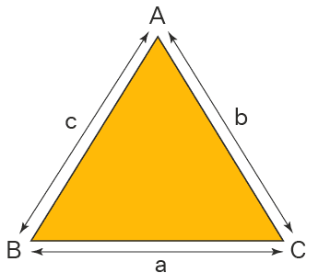  A triangle has ##3## sides and ##3## angles.
Explanation | A triangle is a basic geometric shape that always has three sides and three angles. This property defines all triangles, regardless of their type.  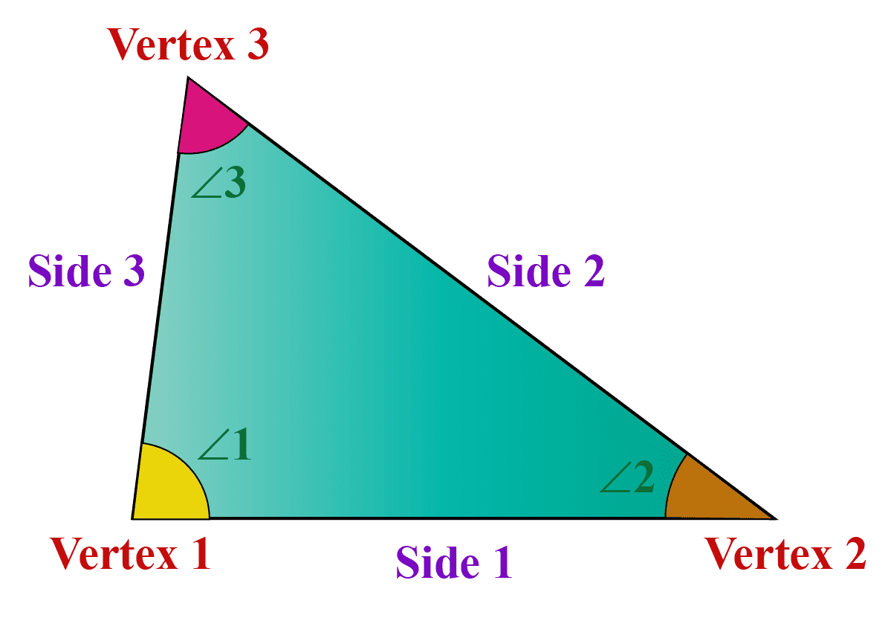
Type | FB
Marks | 2 | 0

