COMPUTER NETWORKS — PHASE 1
ProtocolX
Project Analysis Report
A four-host private network service platform: private DNS, TLS-terminating reverse proxy, round-robin load balancing, HTTP caching, packet analysis and failover.
Item | Detail
Repository | github.com/naveendhaterwal/ProtocolX
Reviewed commit | 3f40986 (branch main)
Report date | 5 October 2026
Team | Naveen (Mac 1), Aditya (Mac 2), Shagun (Mac 3), Archit (Mac 4)
Scope | Static review of configuration, source, certificate and archived evidence. The live deployment was not re-run.

Contents
1. Executive Summary
2. Repository Overview
3. Architecture
4. Component Analysis
5. Objective Traceability
6. Strengths
7. Findings and Recommendations
8. Team and Contributions
9. Conclusion
Appendix A. Evidence File Index

1. Executive Summary
ProtocolX is a four-host private service platform running on a shared Wi-Fi LAN (10.7.0.0/19). It chains together private DNS (dnsmasq), a TLS-terminating reverse proxy and round-robin load balancer (nginx), two independent Node.js backends, client-side cache headers, packet-level verification with Wireshark, and a live failover test.
Overall assessment: the project meets its stated objectives. Each of the eight functional phases has matching configuration in the repository and corresponding evidence (terminal transcripts, a packet capture and screenshots). The design is small, readable, and uses no third-party runtime dependencies.
Area | Status | Notes
Private DNS | Complete | app.protocolx.test resolves to 10.7.12.189; verified with dig and dscacheutil
HTTPS / TLS | Complete | TLS 1.3 negotiated, SAN matched, verified without curl -k
Load balancing | Complete | Strict A/B alternation observed over 4–6 request runs
Caching | Complete (client-side) | Cache-Control: public, max-age=10; no proxy_cache
Packet analysis | Complete | 3.8 MB .pcapng plus 5 screenshots (DNS, TCP, TLS)
Failover | Complete | Three-stage demo; no failed requests during backend outage
Documentation | Strong, with defects | Detailed README; portability and accuracy issues (Section 7)
Final submission | Open | Demo video and form submission still unchecked

Key findings. A hard-coded certificate path from another user's machine in nginx.conf; file:///Users/n2/... links in the README that are dead on GitHub; start_dns.sh not deploying the repository's dnsmasq.conf; and no explicit failover tuning in nginx.

2. Repository Overview
Metric | Value
Branch / remote | main tracks origin/main; two feature branches on origin
Commits | 17 across all branches (including 3 merged pull requests)
Contributors | 4 team members (6 git identities)
Application code | 68 lines of JavaScript in 2 files
Config / scripts | nginx.conf (47 lines), dnsmasq.conf, openssl.cnf, start_dns.sh
Evidence | 4 transcript files, 2 screen recordings, 1 pcapng (3.8 MB), 8 PNG screenshots
Dependencies | None (Node.js http and os standard library only)

Directory layout
backend/backend-a, backend-b Node.js services (ports 3001, 3002)
dns/dnsmasq.conf Private DNS configuration
nginx/nginx.conf Edge proxy, TLS, load balancing, caching header
tls/ openssl.cnf + public certificate (key is gitignored)
scripts/start_dns.sh dnsmasq launcher + macOS resolver setup
evidence/A..D Verification artefacts per area
docs/ Project report

3. Architecture
Mac 1 (10.7.7.218) Mac 2 (10.7.12.189) Mac 3 / Mac 4
client + dnsmasq --DNS--> nginx :80 -> 301 -> :443 (TLS)
--HTTPS-> upstream protocolx_backends ---> Backend A 10.7.16.69:3001
---> Backend B 10.7.13.247:3002

Request flow
- The client resolves app.protocolx.test through local dnsmasq (scoped via /etc/resolver/test).
- The client opens TCP port 443 to the edge; TLS 1.3 terminates at nginx.
- nginx proxies plain HTTP to the next upstream in round-robin order; the backend's X-Backend header is returned to the client.
- /api/status additionally receives Cache-Control: public, max-age=10.

Design strengths: clean separation of concerns across hosts; clients never see backend addresses; a single DNS name decouples users from topology.

4. Component Analysis

4.1 Private DNS
- address=/app.protocolx.test/10.7.12.189 with bind-interfaces limits listening to loopback and the LAN address; no-resolv with explicit upstreams avoids resolver loops. Choosing .test (RFC 2606 / 6761) is correct.
- Evidence shows status NOERROR, the aa flag set and the expected answer, via both the system resolver and the LAN address.
- Observation: sections 1 and 3 of dns_verification.txt (config syntax test, listening sockets) contain no real output.
- Live re-check on 5 Oct 2026: the private server still answers correctly (Figure 1), while Google public DNS (8.8.8.8) returns NXDOMAIN for the same name (Figure 2). This demonstrates why the private resolver is required for the .test namespace.
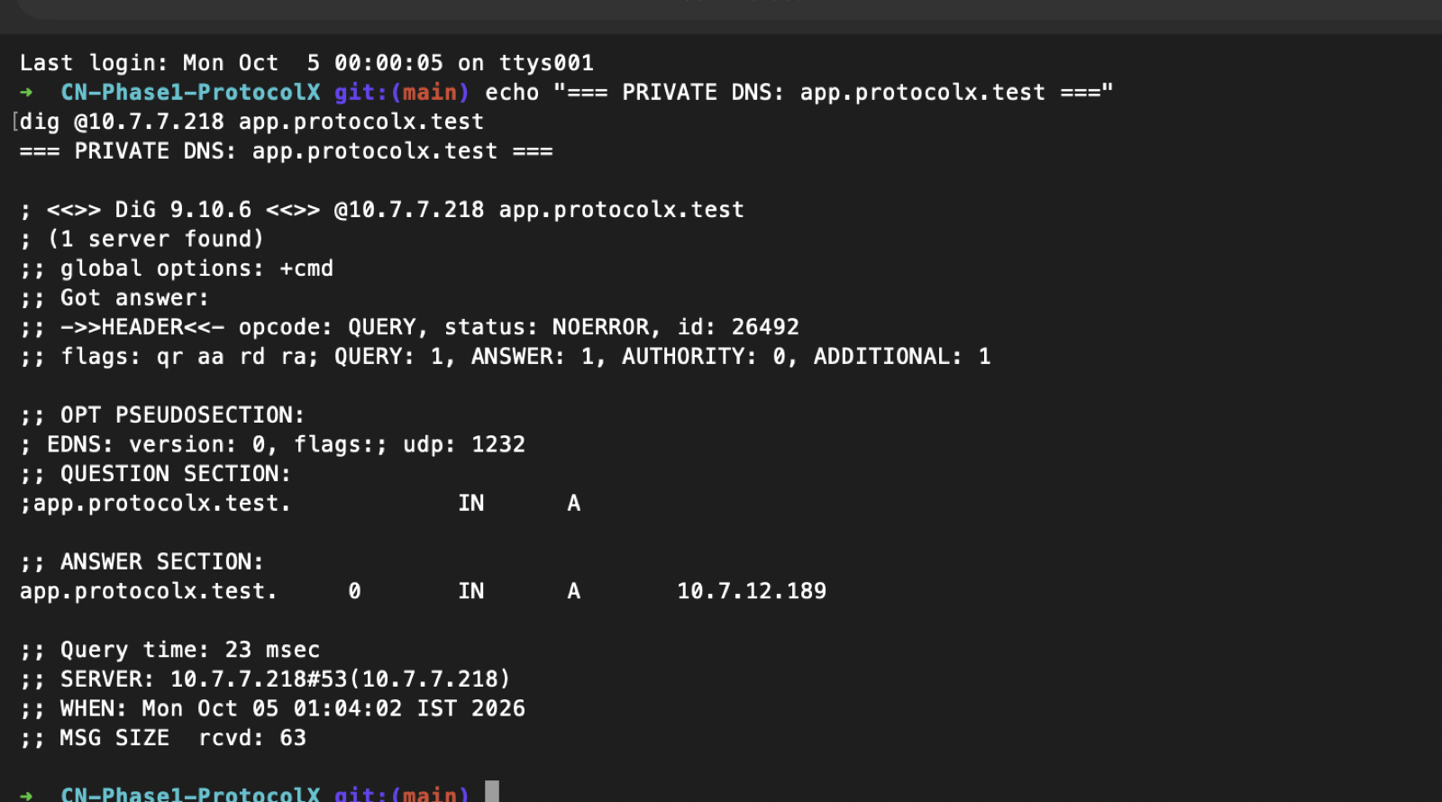
Figure 1. dig @10.7.7.218 app.protocolx.test: NOERROR, aa flag, A record 10.7.12.189 (evidence/E-terminal-captures/screenshots)
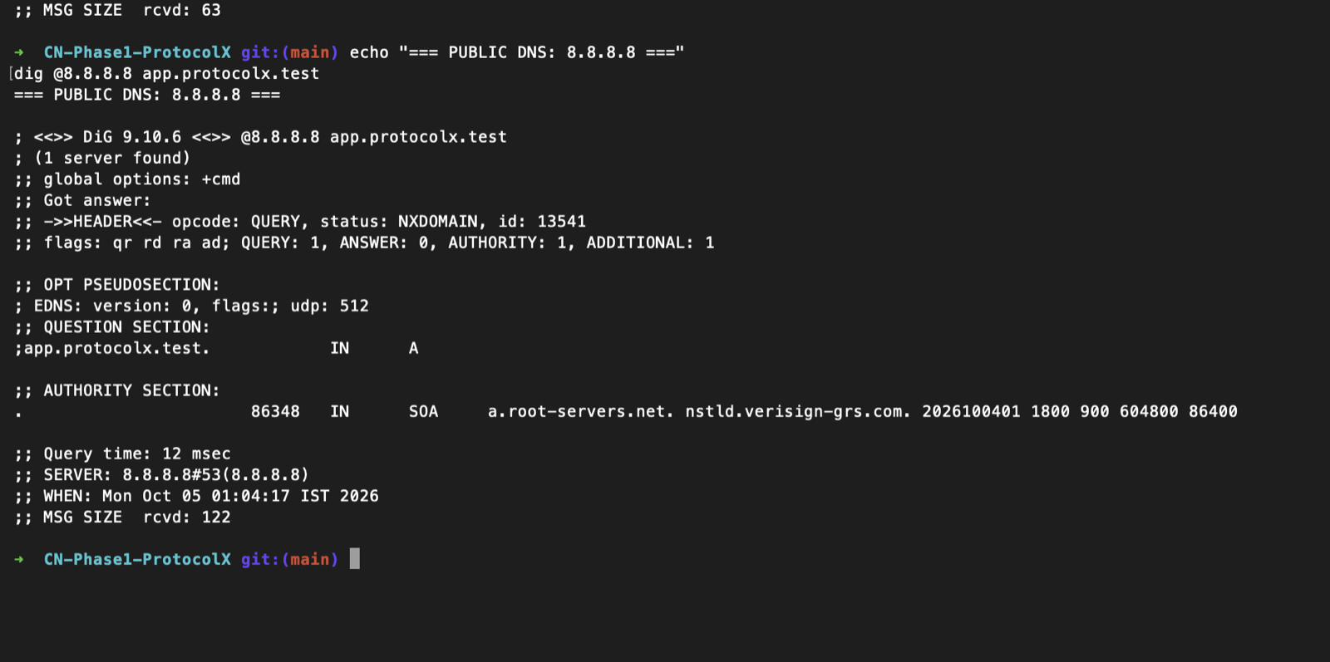
Figure 2. dig @8.8.8.8 app.protocolx.test: NXDOMAIN, so public DNS cannot resolve the private name

4.2 Edge proxy and load balancer
- Port 80 returns 301 to HTTPS; port 443 enables TLS 1.2/1.3; proxy_connect_timeout 2s bounds failover delay; standard X-Real-IP and X-Forwarded-* headers are set.
- Load balancing is nginx's default round-robin with no weights, max_fails, fail_timeout or keepalive. This is acceptable for the demo (see Section 7).
- /api/status uses proxy_method GET so HEAD requests return data. / does not, and backends handle only GET, so curl -I https://app.protocolx.test/ returns 404 (visible in the HTTPS evidence file).
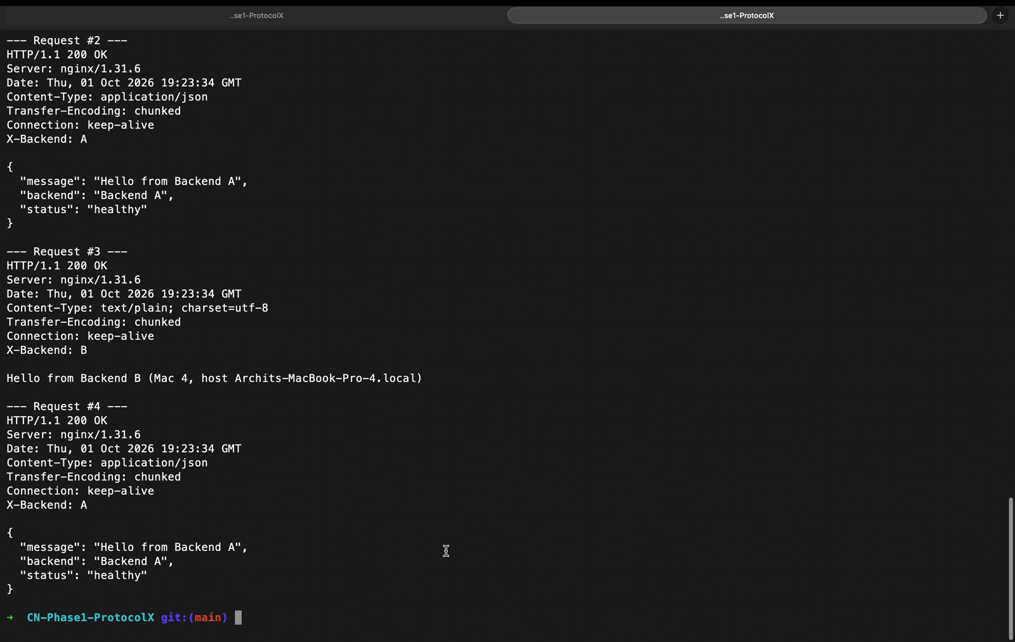
Figure 3. Requests 2 to 4 through nginx alternate between Backend A and Backend B (frame from the recorded walkthrough of https_lb_verification.txt)

4.3 TLS
Verified independently from the committed certificate:
Property | Value
Subject / Issuer | CN=app.protocolx.test (self-signed)
Key / signature | RSA 2048-bit / SHA-256
Subject Alternative Name | DNS:app.protocolx.test
basicConstraints | CA:FALSE
Validity | 1 Oct 2026 to 1 Oct 2027

The private key is excluded by .gitignore (*.key) and is not in the repository, which is correct practice. The leaf certificate is installed directly as a trust root on the client; this works on macOS and avoids curl -k, although a small private CA issuing the leaf would be the more conventional design.
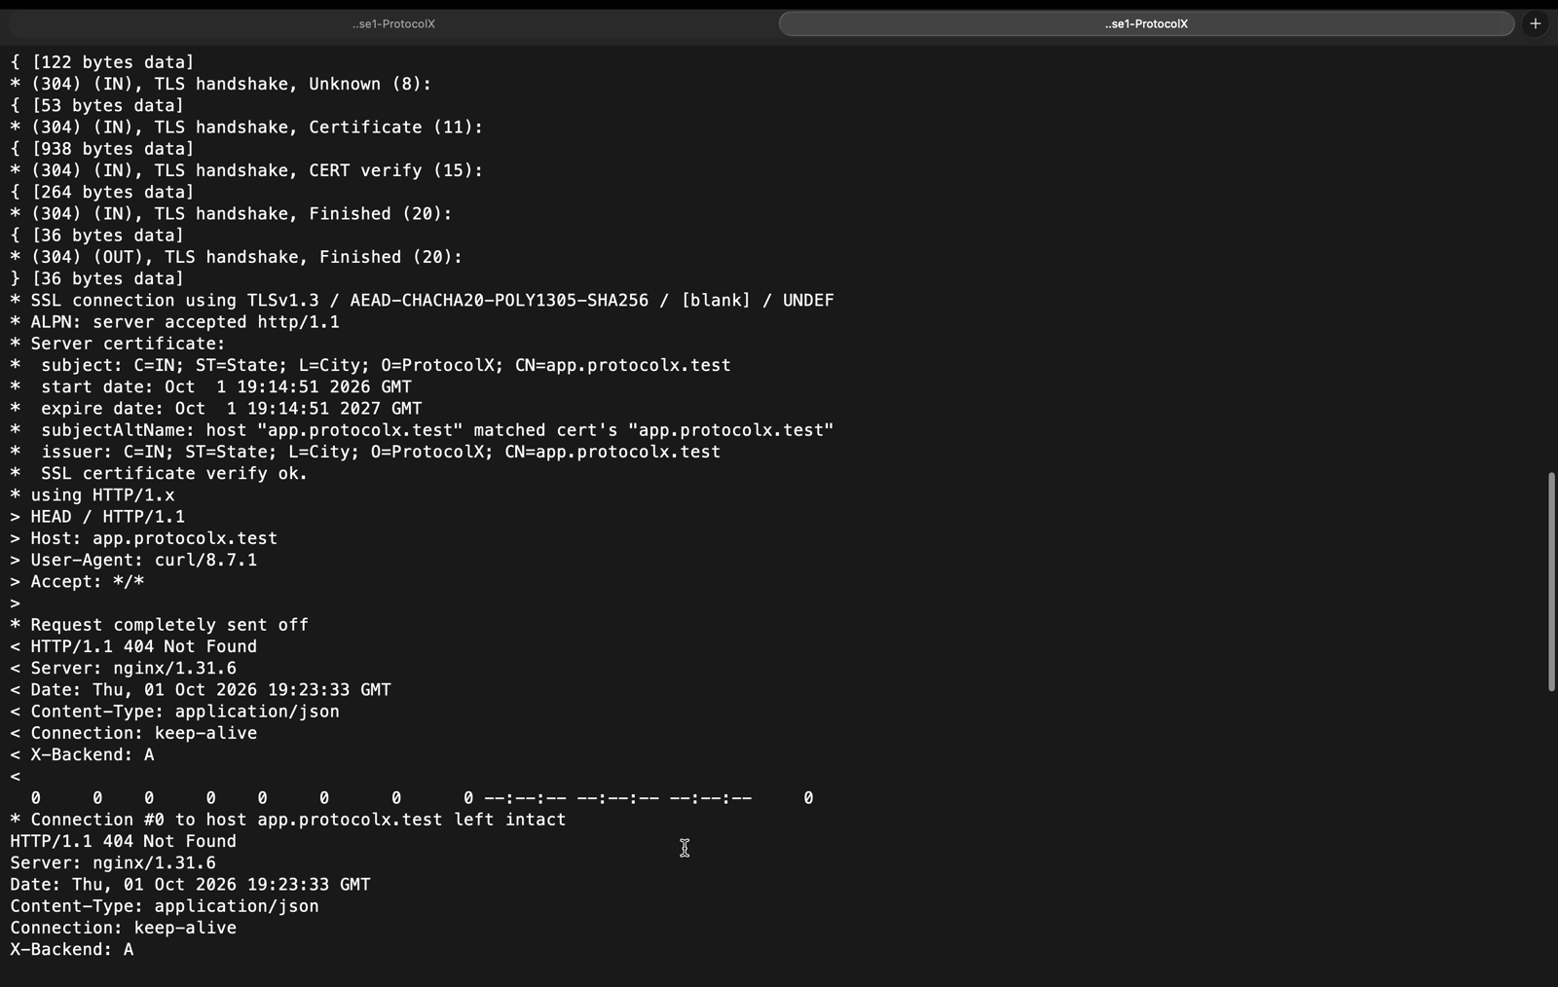
Figure 4. Strict curl handshake: TLSv1.3, SAN matched, "SSL certificate verify ok" without -k (recorded walkthrough of https_lb_verification.txt)

4.4 Backends
Both backends are minimal and syntax-valid (node --check passes), bind 0.0.0.0, set X-Backend, serve / and /api/status, and return 404 otherwise. They are inconsistent with each other: Backend A returns JSON at / and does not log requests, while Backend B returns plain text, logs every request, hard-codes its port and has no package.json. The /api/status JSON schemas also differ.

4.5 Caching
Caching is header-only and is correctly documented as client-side (no proxy_cache). Evidence confirms the header on 200 responses. nginx add_header applies only to 2xx/3xx responses unless "always" is given, so error responses carry no cache directive.
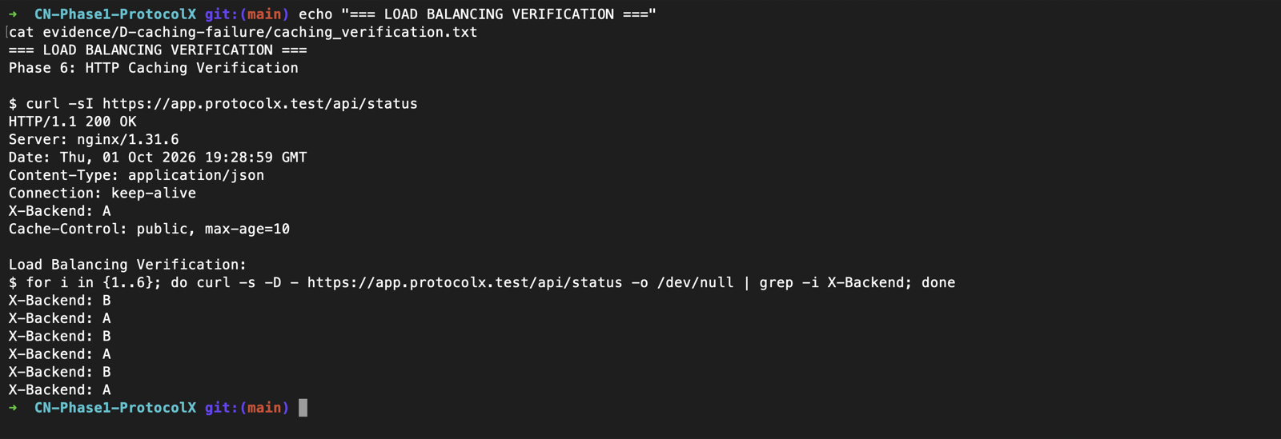
Figure 5. Cache-Control: public, max-age=10 on /api/status, followed by six alternating X-Backend values

4.6 Packet capture
protocolX.pcapng (3.8 MB) and the Wireshark screenshots document the DNS exchange, the TCP session to port 443 and the TLS 1.3 handshake. The README's note that the certificate is encrypted under TLS 1.3 (RFC 8446) is accurate: after Server Hello, the screenshots show only Change Cipher Spec and Application Data records. The screenshots were read individually for this report; the capture file itself could not be inspected (tshark not installed).
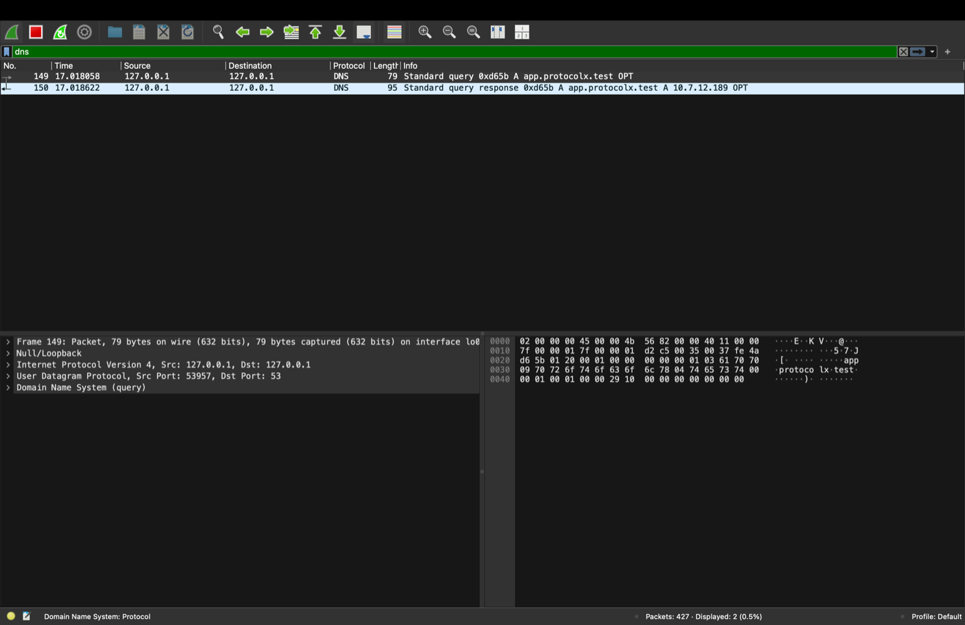
Figure 6. Display filter "dns": query 0xd65b for app.protocolx.test (frame 149) and its response A 10.7.12.189 (frame 150), 2 of 427 packets
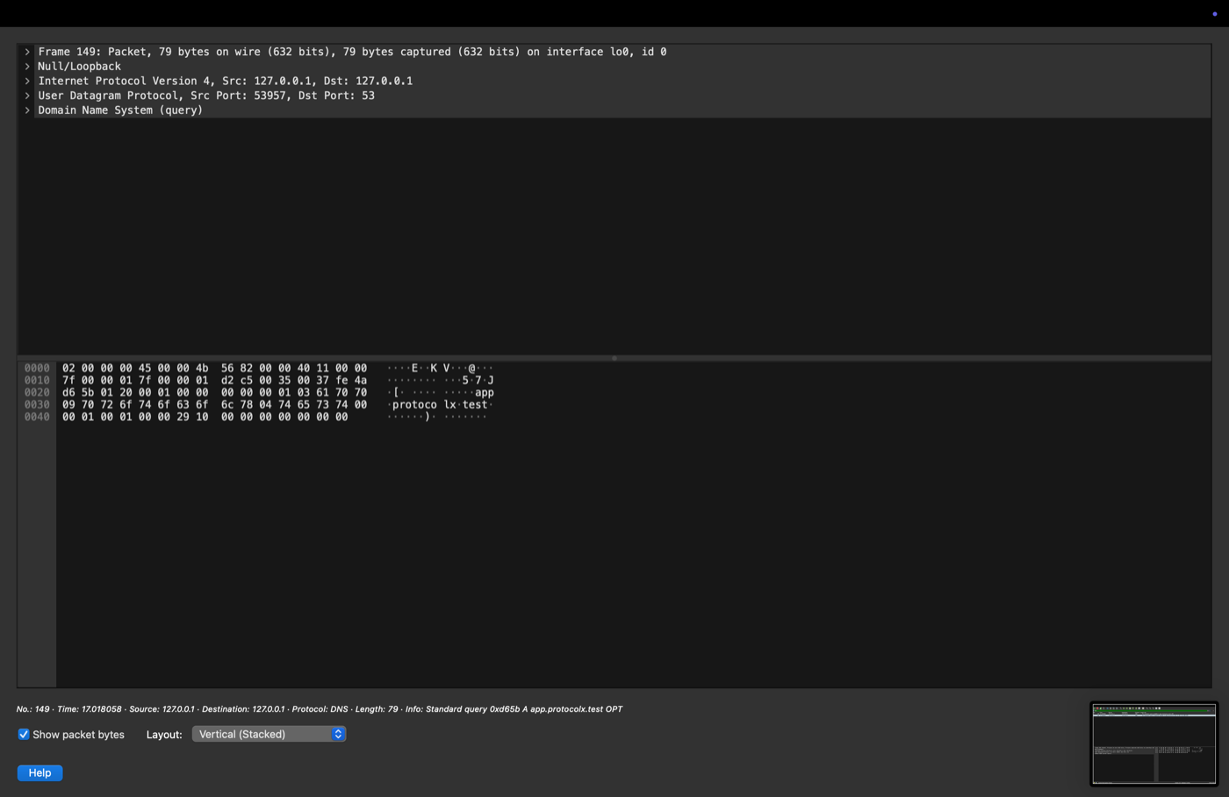
Figure 7. Frame 149, DNS query: UDP 53957 to port 53, 79 bytes, QNAME app.protocolx.test visible in the hex pane
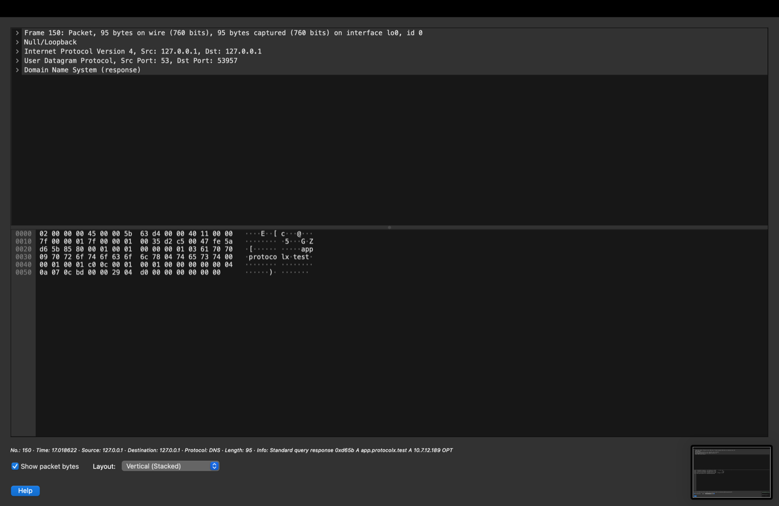
Figure 8. Frame 150, DNS response: UDP 53 to port 53957, 95 bytes, carrying the A record
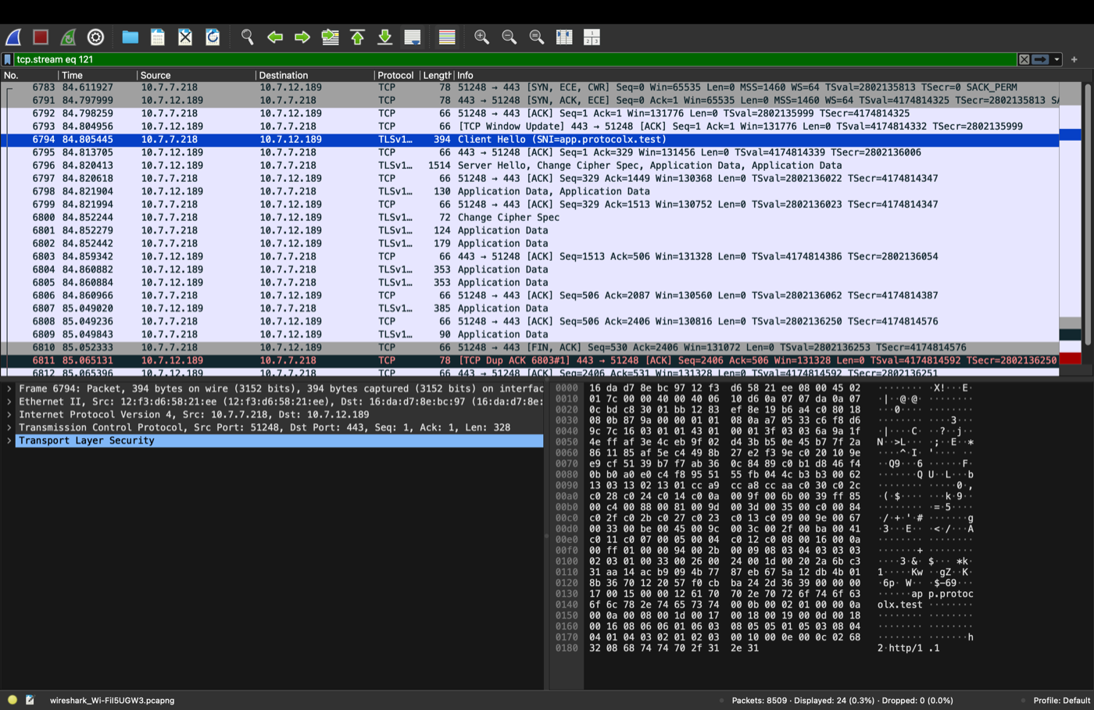
Figure 9. Filter "tcp.stream eq 121": SYN and SYN-ACK from 10.7.7.218 to 10.7.12.189:443, then Client Hello with SNI=app.protocolx.test (frame 6794)
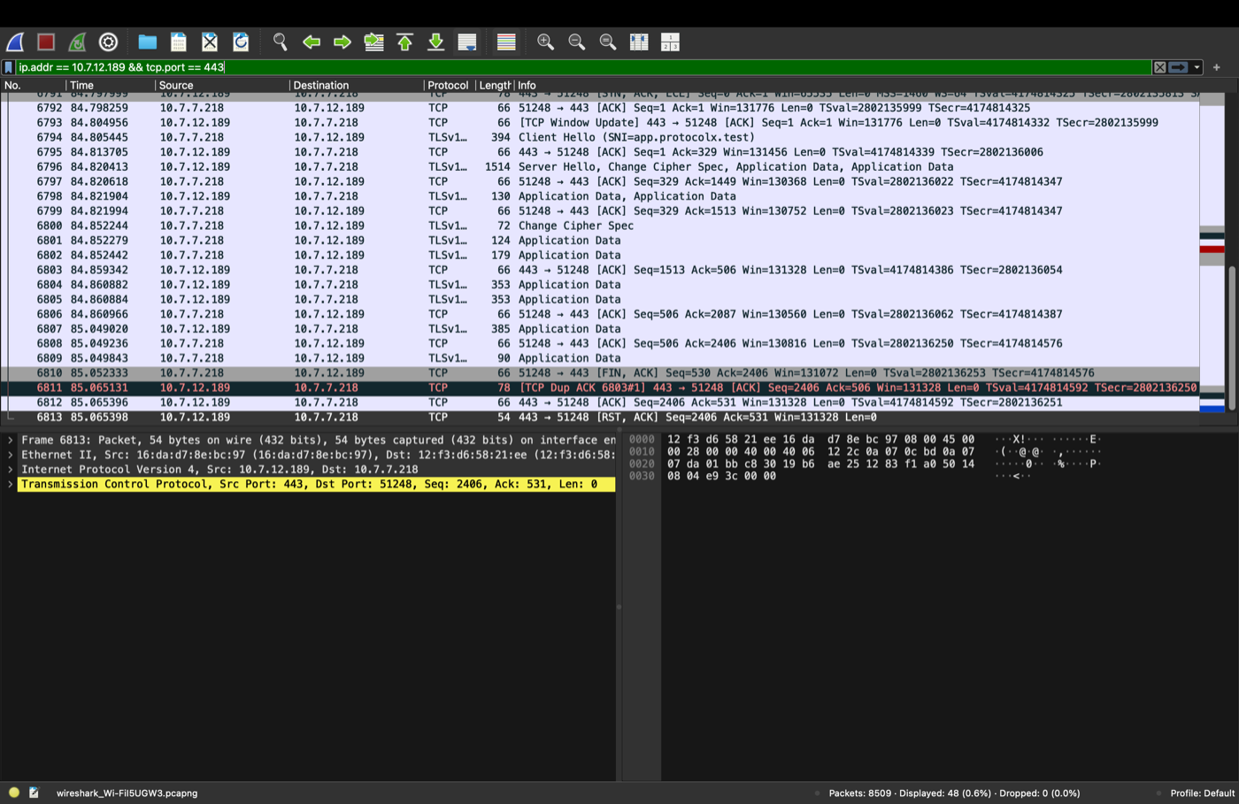
Figure 10. Filter "ip.addr == 10.7.12.189 && tcp.port == 443": Server Hello, encrypted Application Data, then FIN/ACK and RST/ACK closing the session (48 of 8509 packets, 0 dropped)
Two observations. (1) The DNS frames are on the loopback interface (127.0.0.1, interface lo0), and the TCP frames show source 10.7.7.218 (Mac 1), so these captures appear to have been taken on Mac 1, whereas the README attributes the capture to Mac 4. (2) The README says the DNS query goes to 10.7.7.218:53; the screenshot shows 127.0.0.1:53, the first nameserver in the macOS resolver file. Both should be reconciled in the README.

4.7 Failure demonstration
The transcript shows: baseline A/B alternation, Backend B stopped (Connection refused), six consecutive requests served by Backend A with 200 OK, Backend B restarted, and alternation resumed. This validates nginx's default passive failover on a refused connection. It demonstrates a clean process stop; a host crash or network partition was not tested and would add the 2-second connect timeout to each affected request.
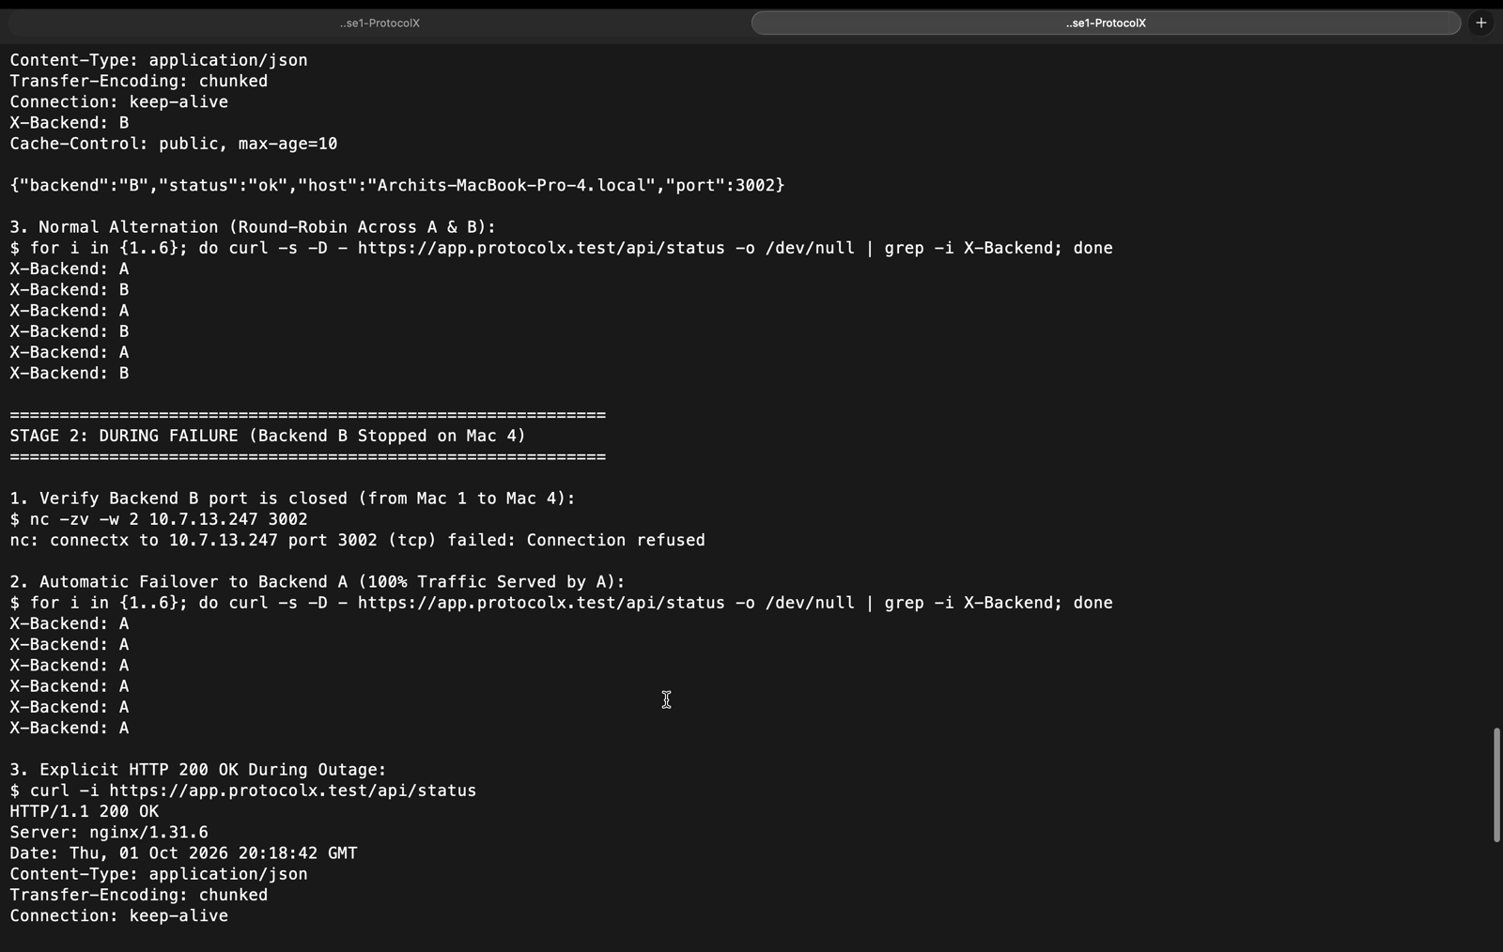
Figure 11. Stage 2: port 3002 refused, then six consecutive requests all served by Backend A with 200 OK (recorded walkthrough of failure-demo.txt)
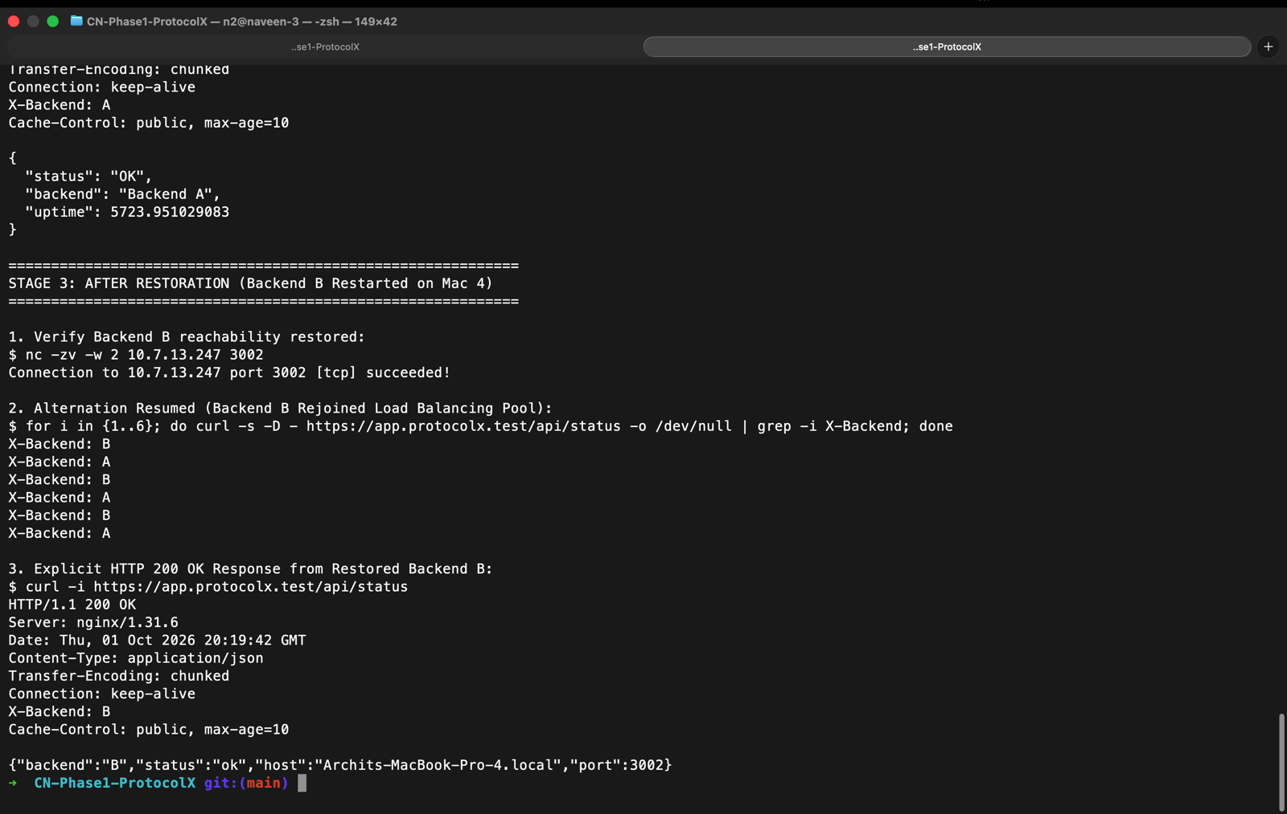
Figure 12. Stage 3: Backend B restored and A/B alternation resumes
Note: the two recordings and the terminal screenshots replay the saved evidence text files in a terminal (cat and scrolling) rather than re-running the tests live; the only live command re-run is the dig check in Figures 1 and 2.

5. Objective Traceability
# | Objective | Implementation | Evidence | Met
1 | LAN discovery / connectivity | IP inventory in README | README; nc checks in failure demo | Yes
2 | Private DNS for .test | dnsmasq.conf, /etc/resolver/test | dns_verification.txt; DNS screenshots | Yes
3 | Reverse proxy decoupling | nginx plus DNS abstraction | https_lb_verification.txt | Yes
4 | HTTPS without -k | Self-signed SAN cert in System Keychain | verify ok; TLSv1.3 | Yes
5 | Round-robin load balancing | upstream protocolx_backends | A/B/A/B outputs (3 files) | Yes
6 | Caching semantics | Cache-Control header | caching_verification.txt | Headers only
7 | L3/L4/L7 packet inspection | Wireshark on Mac 4 | .pcapng; 5 screenshots | Yes
8 | Failover resilience | Default nginx passive checks | failure-demo.txt | Yes

6. Strengths
- Every objective is backed by committed, reproducible evidence rather than assertion.
- Zero-dependency, easily auditable code; secrets handled correctly (key ignored).
- Strict TLS verification demonstrated honestly, without insecure flags.
- README includes an architecture diagram, request flow, per-machine setup, an end-to-end verification sequence and a repeatable failure procedure.
- Healthy collaboration workflow: feature branches and merged pull requests for the nginx work.

7. Findings and Recommendations
Ranked by impact on a reader or grader reproducing the project.
# | Severity | Finding | Recommendation
1 | High | nginx.conf points ssl_certificate and ssl_certificate_key to /Users/flexer/Documents/Projects/CN/ProtocolX/tls/..., another user's absolute path. The README shows a /path/to/... placeholder, so the two disagree and the committed config will not start on any other machine. | Use a placeholder or relative path, or document the required edit. Keep README and config identical.
2 | High | README contains 12 file:///Users/n2/Desktop/CN/... links, which are dead on GitHub. | Replace with relative links (tls/app.protocolx.test.crt, evidence/...).
3 | Medium | start_dns.sh starts dnsmasq with /opt/homebrew/etc/dnsmasq.conf but never copies dns/dnsmasq.conf there, while the README says the script deploys the configuration. | Copy the repo config into place before launching, and check the script runs as root.
4 | Medium | Failover relies on nginx defaults: no max_fails, fail_timeout, proxy_next_upstream or proxy_read_timeout. A hung (not refused) backend would stall requests. | Set explicit values and extend the demo with a network-partition case.
5 | Medium | Backends accept GET only; HEAD / yields 404 through the proxy. | Handle HEAD in both backends, or document it.
6 | Medium | The Wireshark captures appear to come from Mac 1 (client 10.7.7.218, DNS on loopback 127.0.0.1), but the README says they were taken on Mac 4 and that the DNS query goes to 10.7.7.218:53. | Correct the README to match the captures, or re-capture on the intended host.
7 | Low | Backends differ in response shape, logging, port configuration and packaging. | Align to one template; add package.json to B; add logging to A.
8 | Low | Evidence gaps: empty dnsmasq syntax-test output and placeholder socket listing; timestamps mix UTC and IST. | Re-capture dnsmasq --test and the port 53 listener; note timezones.
9 | Low | No hardening: backends listen on all interfaces and receive plaintext; no HSTS; default cipher policy; certificate expires 1 Oct 2027. | Document as accepted lab scope; optionally bind to the LAN IP, add HSTS, schedule renewal.
10 | Low | Housekeeping: "Conclusion-" heading typo; empty folders and .gitkeep files; six git identities for four people; a stale evidence copy and empty mac* folders exist above the repo (untracked). | Fix the typo; add a .mailmap; remove stray folders.
11 | Info | Final-submission items (demo video, Google Form) are unchecked. | Complete before the deadline.

Suggested hardening for finding 4
upstream protocolx_backends {
server 10.7.16.69:3001 max_fails=2 fail_timeout=10s;
server 10.7.13.247:3002 max_fails=2 fail_timeout=10s;
}
...
proxy_next_upstream error timeout http_502 http_503;
proxy_read_timeout 5s;

8. Team and Contributions
Member | Machine | Role | Repository evidence
Naveen | Mac 1 | Coordination, DNS, trust setup, failure demo | DNS commit, keychain/HTTPS verification, README, evidence
Aditya | Mac 2 | nginx, TLS, load balancing, caching | Pull requests #1 to #3 (Phases 4, 5, 6)
Shagun | Mac 3 | Backend A | "Add Backend A"
Archit | Mac 4 | Backend B, Wireshark | "Add Backend B"; Phase 7 capture

Commit counts by git identity: naveendhaterwal 8, Naveen Kumar 3, RajAditya7777 3, Archit Mamodiya 1, Shagun Vishnoi 1, shagunvishnoi 1. Contributions from Mac 3 and Mac 4 are small in line count, but each owns a distinct, required component.

9. Conclusion
ProtocolX delivers a coherent, observable demonstration of DNS, TCP, TLS, reverse proxying, load balancing, caching headers and fault tolerance on real hardware, and its evidence supports every claim made. The remaining work is polish rather than substance: fix the two portability defects (nginx certificate path and README links), make the DNS script deploy the repository config, harden and extend the failover test, and finish the submission artefacts. With those changes the repository would be reproducible by a third party in one pass.

Appendix A. Evidence File Index
Evidence added or reviewed for this report. Paths are relative to the repository root. Video files cannot be embedded in a Word document, so frames from them appear in Figures 3, 4, 11 and 12.
File | Content
evidence/E-terminal-captures/screenshots/dig_private_dns_10.7.7.218.png | dig against the private DNS server (Figure 1)
evidence/E-terminal-captures/screenshots/dig_public_dns_8.8.8.8_nxdomain.png | dig against 8.8.8.8, NXDOMAIN (Figure 2)
evidence/E-terminal-captures/screenshots/caching_and_load_balancing_verification.png | Cache-Control header and A/B alternation (Figure 5)
evidence/E-terminal-captures/recordings/https_tls_lb_verification_walkthrough.mov | 8.6 s scroll through https_lb_verification.txt
evidence/E-terminal-captures/recordings/failover_demo_walkthrough.mov | 7.4 s scroll through failure-demo.txt
evidence/C-wireshark/ss/dns/ (3 files) | Wireshark DNS query and response (Figures 6 to 8)
evidence/C-wireshark/ss/tls-tcp/ (2 files) | Wireshark TCP and TLS handshake (Figures 9 and 10)
evidence/C-wireshark/protocolX.pcapng | Raw packet capture, 3.8 MB

