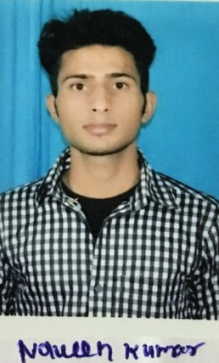

**Naveen Sharma**

Jiyamau, Near 1090, Chauraha

Lucknow (226010)

Email: [ns30994@gmail.com](mailto:ns30994@gmail.com)

Mobile: 8208400442

**PROFESSIONAL PROFILE**

I consider myself a responsible, creative, with initiative and punctuality, I accept with pleasure the challenges and goals that your organization could assign me, with good handle of the interpersonal relationships, ability to work in teams, ability to work under high pressure, so as to solve problems efficiently and achieve the goals set by the company and my work group.

**ACADEMIC DETAILS**

|  |  |  |  |
| --- | --- | --- | --- |
| **QUALIFICATION** | **BOARD** | **YEAR** | **PERCENTAGE** |
| MCA | AKTU | 2017 | 70 |
| BCA | C.V RAMAN | 2014 | 60.11 |
| 12th | UP | 2011 | 60 |
| 10th | UP | 2009 | 59.50 |

**PROJECT DETAILS**

**Title** :Online multiple banking

**Description** :This project is developed for online banking where user can open account in multiple banks

and transfer money from one account to another account. This is similar to online banking as we do in real life.

**Duration** : 3 months

**Role** : Developer

**Team Size** : 2

**Front End** : JAVA

**Back End** : SQL

**FIELD OF INTERESTS**

* Software Engineering

**TECHNICAL SKILLS**

* Programming Languages: Core Java, HTML
* Database : SQLite
* Operating Systems : Windows Series, Android
* Software Tools: MS Office

**EXPERIENCED**

* 3 Months as a Junior Android Developer at Logimetrix Techsolution PVT. LTD. and still working.

**STRENGTH**

* Self Motivative
* Hard Worker

**HOBBIES**

* Sports(Cricket) , Reading books

**PERSONAL PROFILE**

* Name : Naveen Sharma
* Father’s Name : Raja Ram Sharma
* Date of Birth : 30-9-1994
* Gender : Male
* Marital Status : Single
* Languages : English, Hindi
* Address : Vill-Umri , PO-Antu , Ditt-Pratapgarh

U.P

**DECLARATION**

I hereby declare that the above written particulars are true to the best of my knowledge and belief.

**Place:**

**Date:**