**ASSESSMENT PROJECT 4**

**Git Project:**

Task1:

Create a repository in github

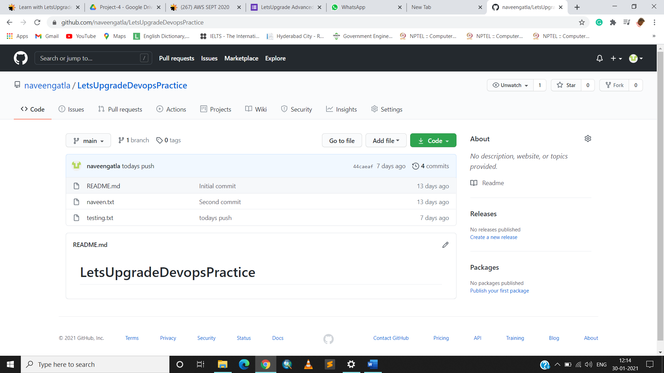

● Git init

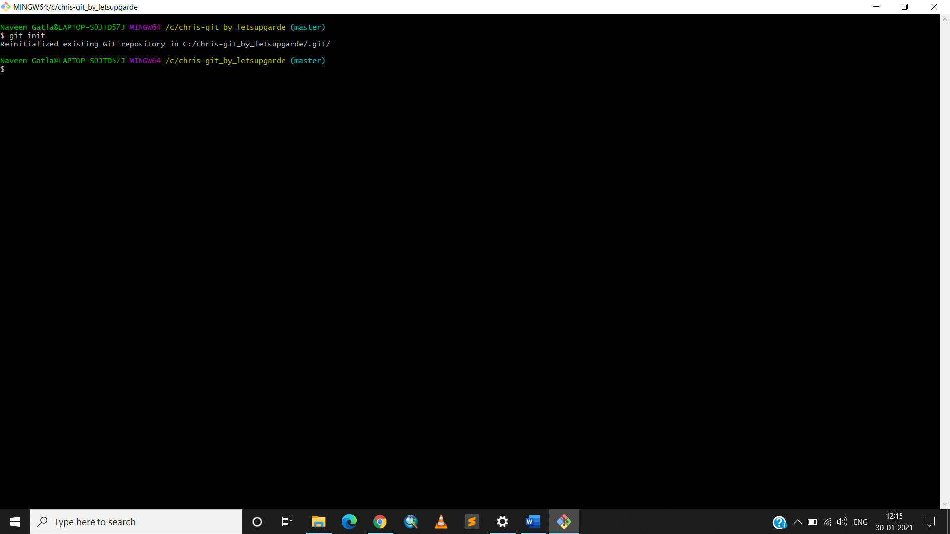

● Both config commands

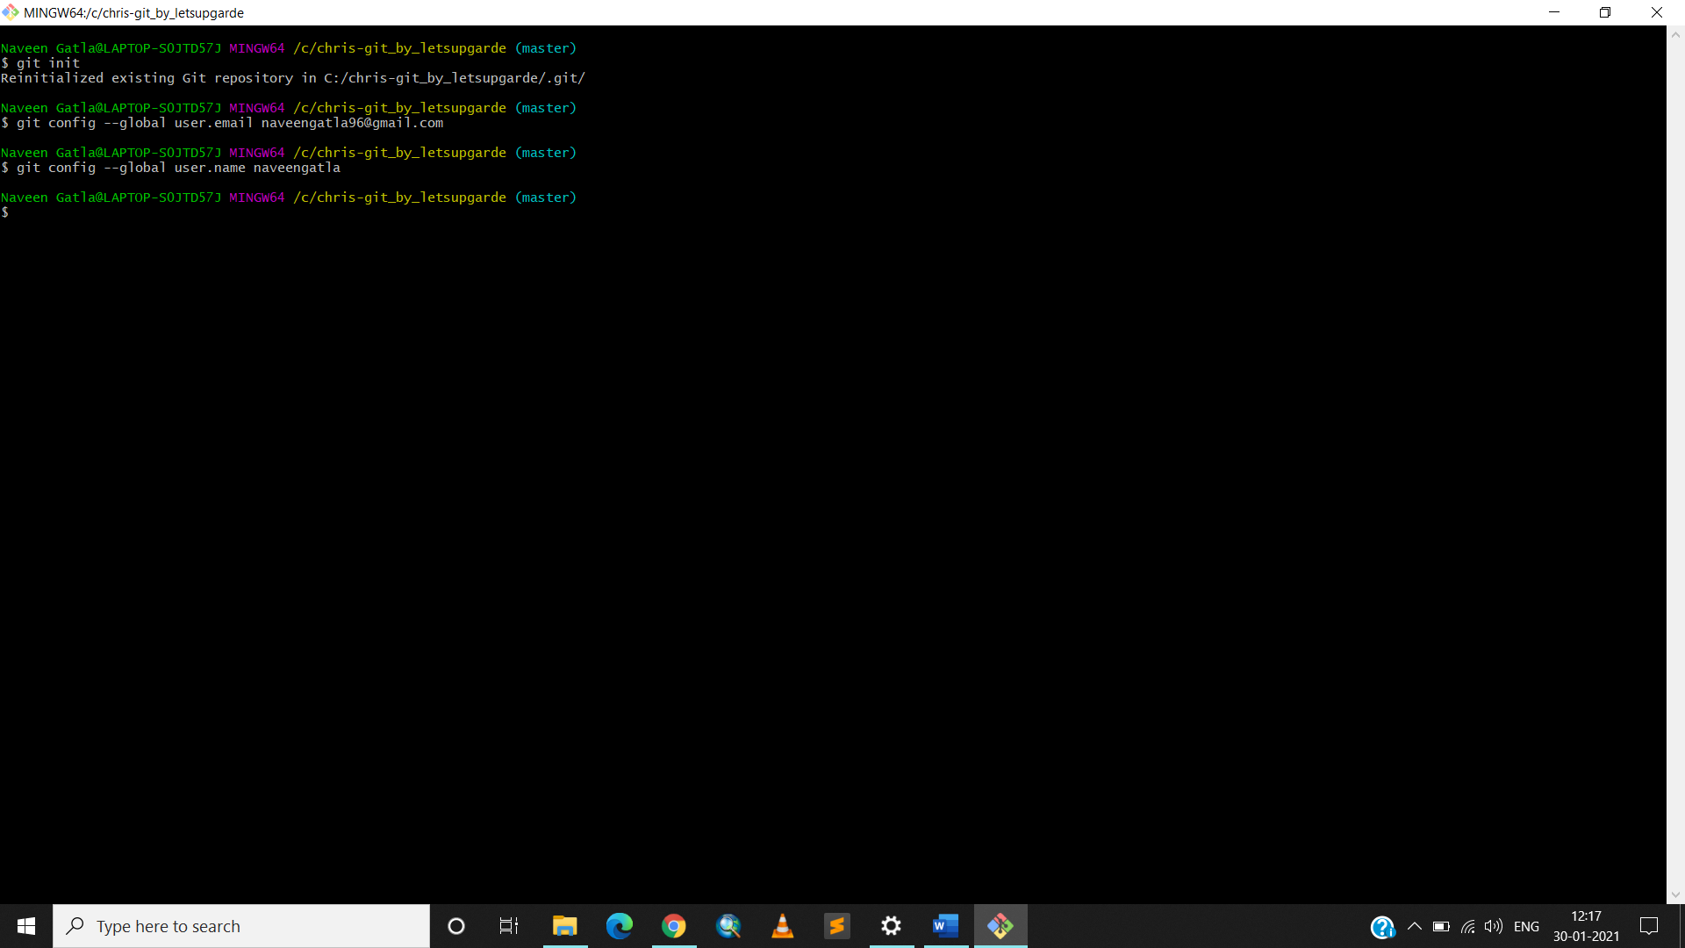

Task2: open git bash and clone contents from remote repository

● clone

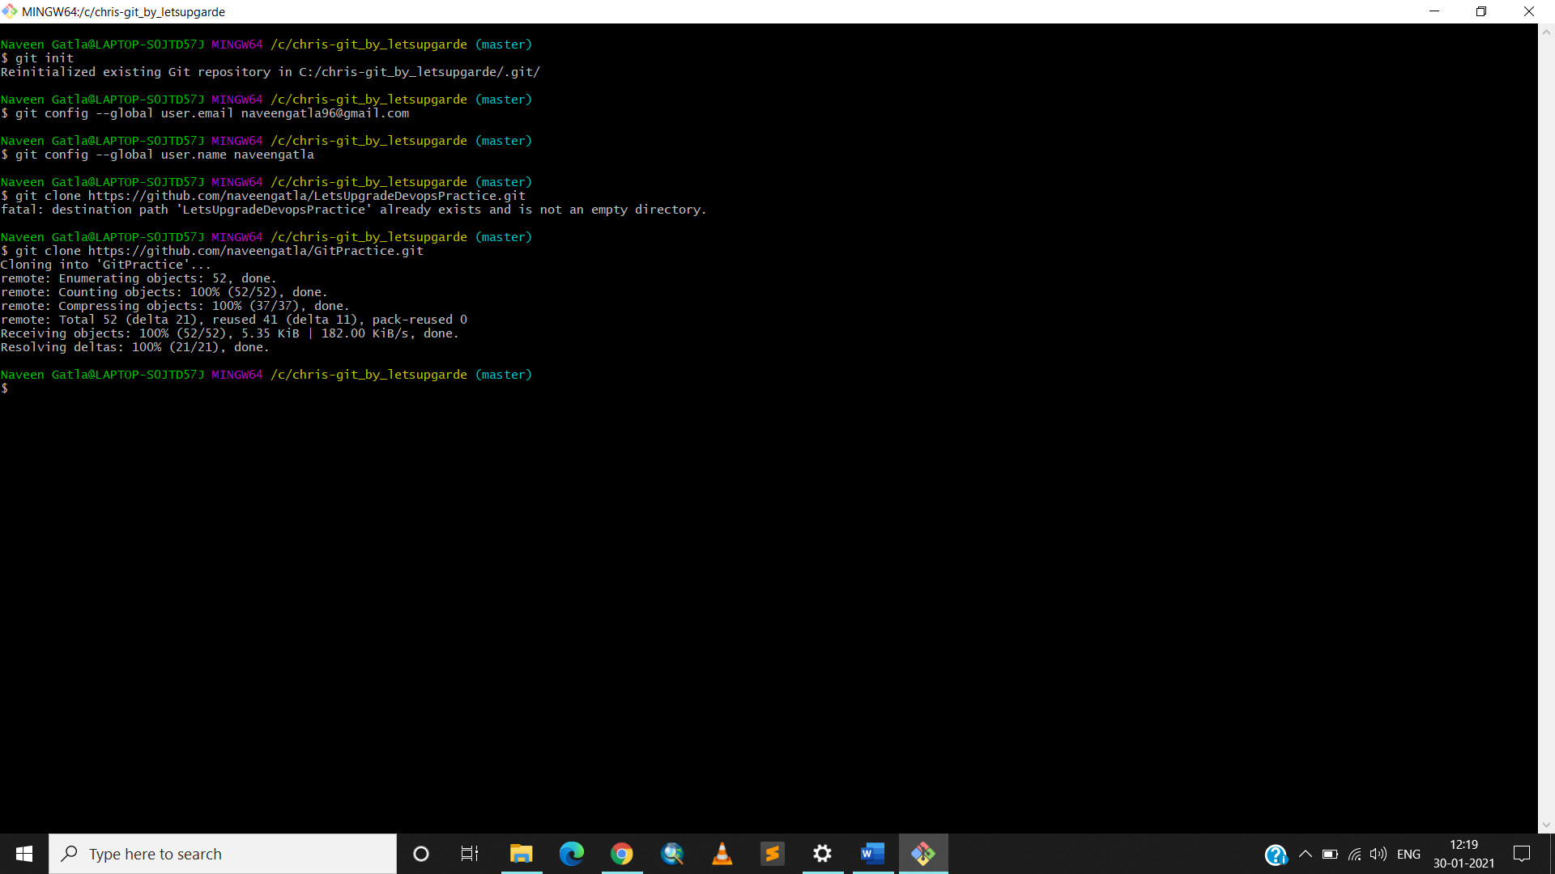

● show the folder in local repository

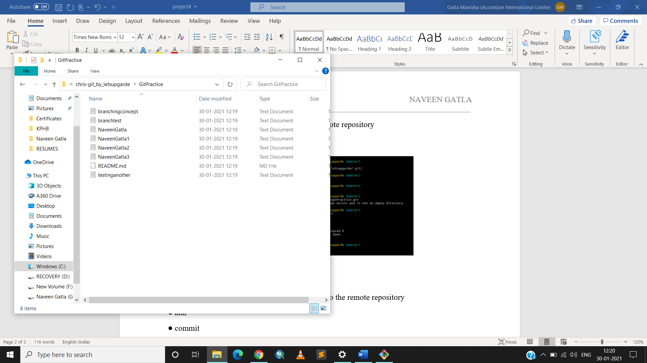

Task3: create a file in the local space and push it to the remote repository

● add

● commit

● push successful

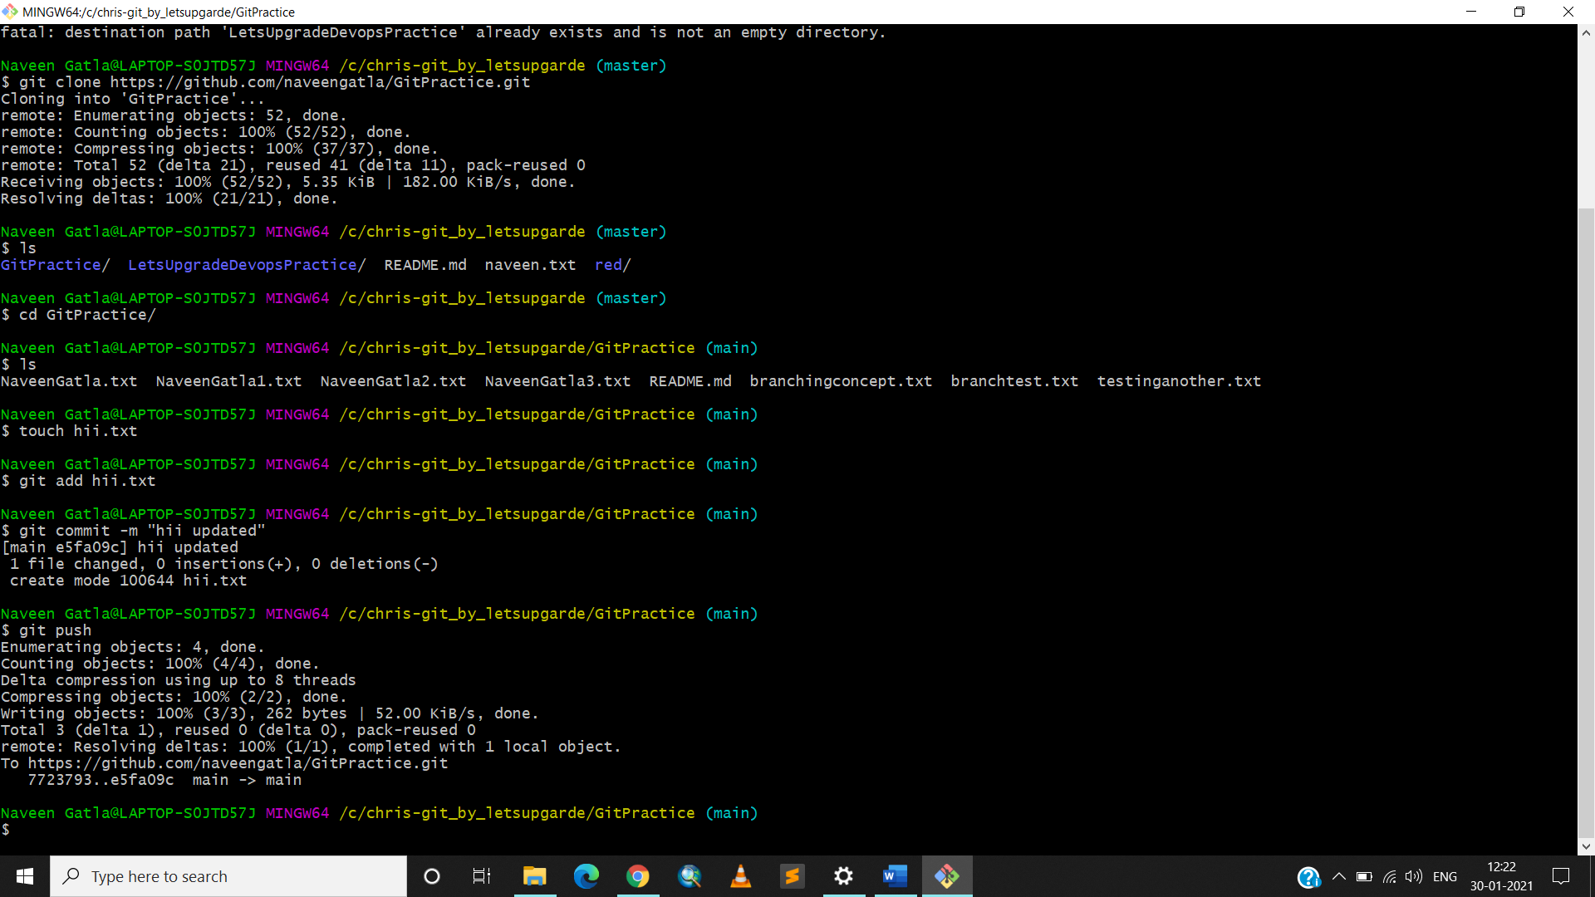

● show the file in remote repository

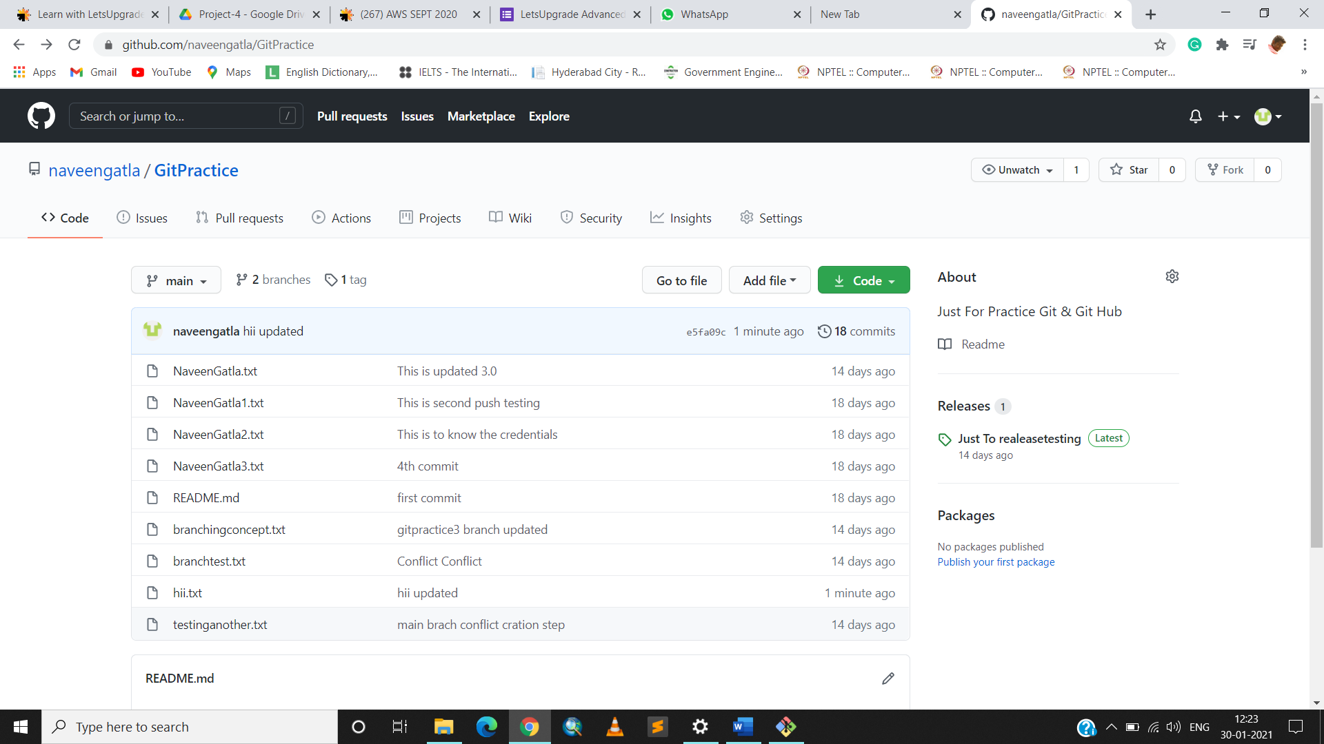

Task4: Branching and merging

Execute all commands and add screenshots

Git branching:

● git branch

● git branch branchname

● git checkout branchname

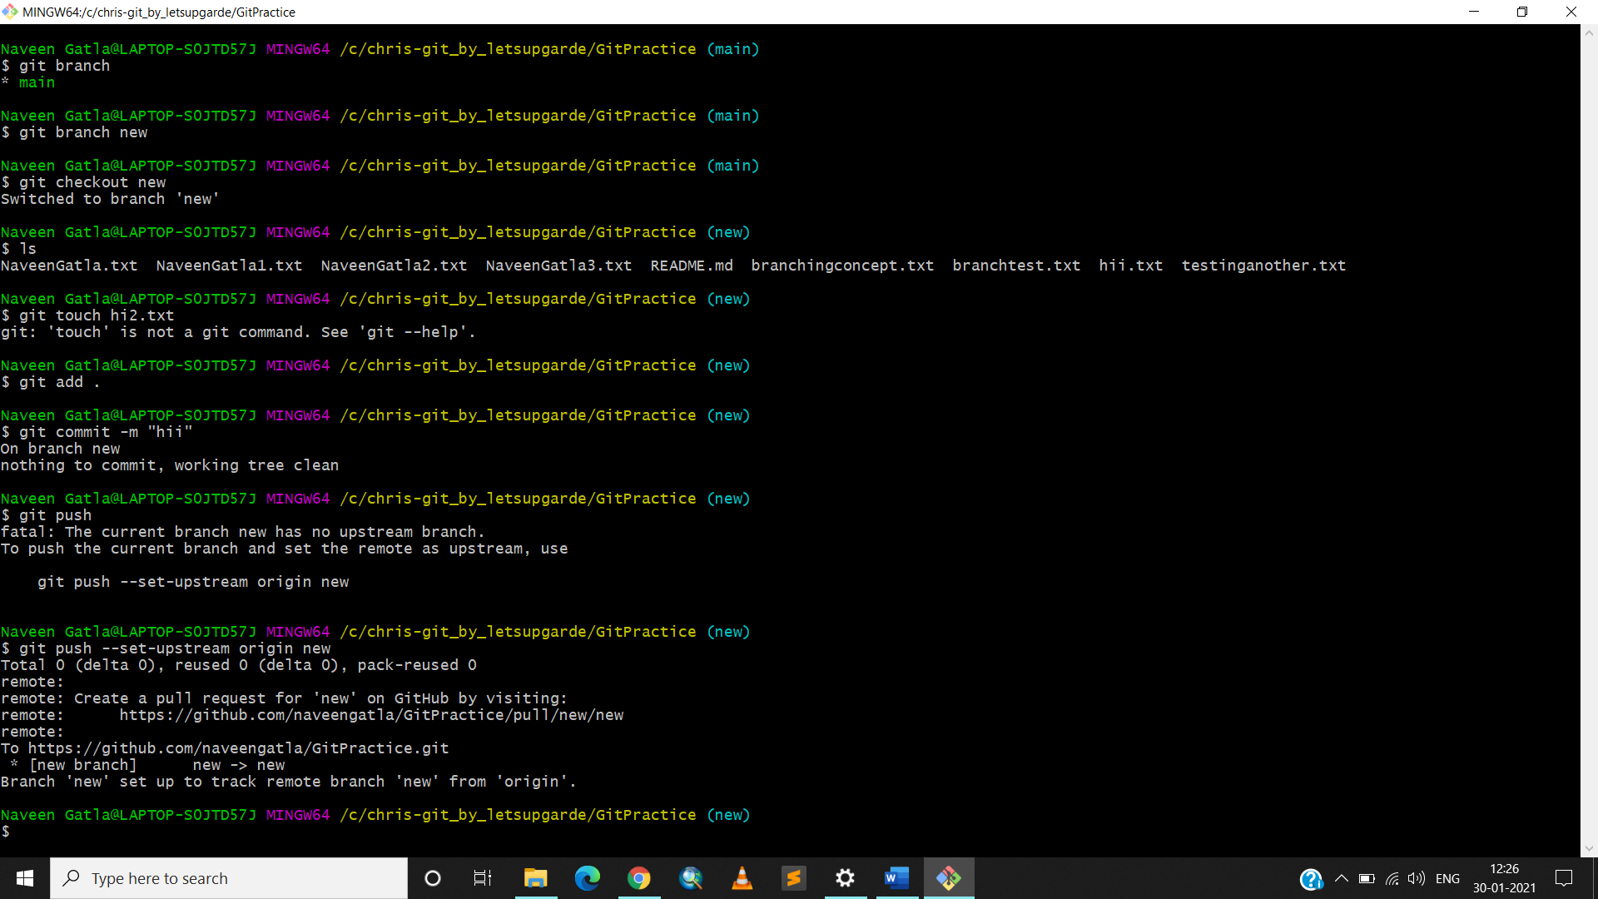

● git merge branchname

● git branch -d branchname

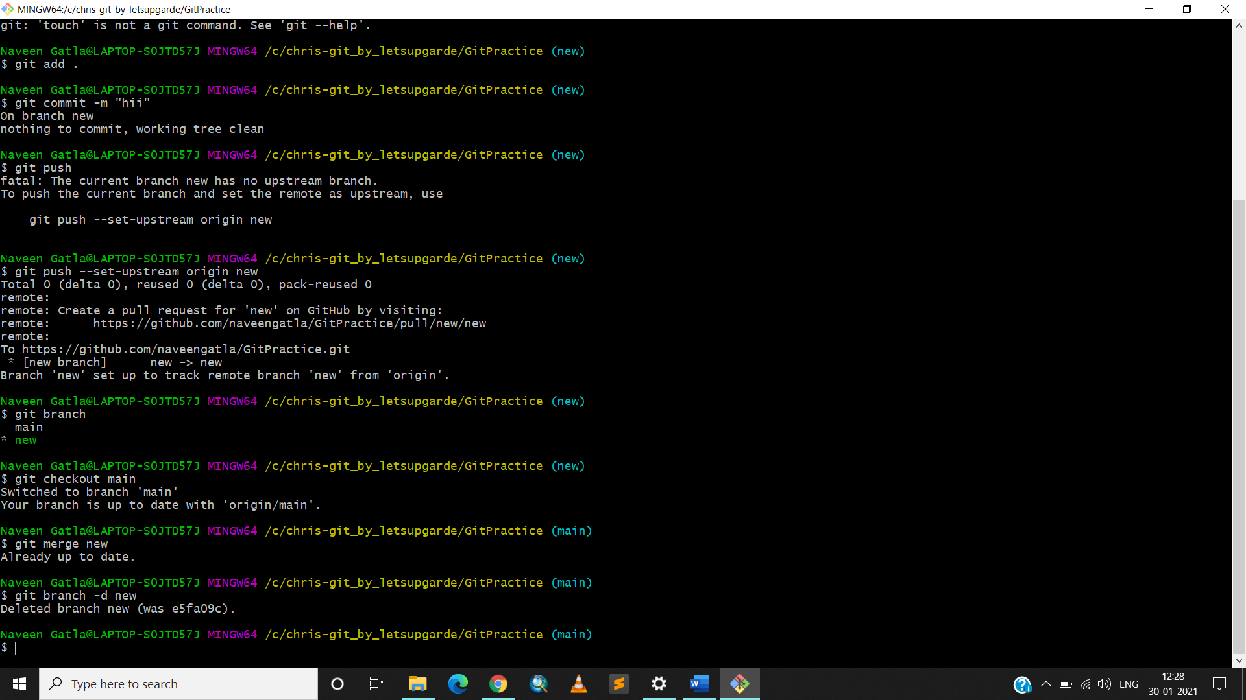

● git branch -D branchname

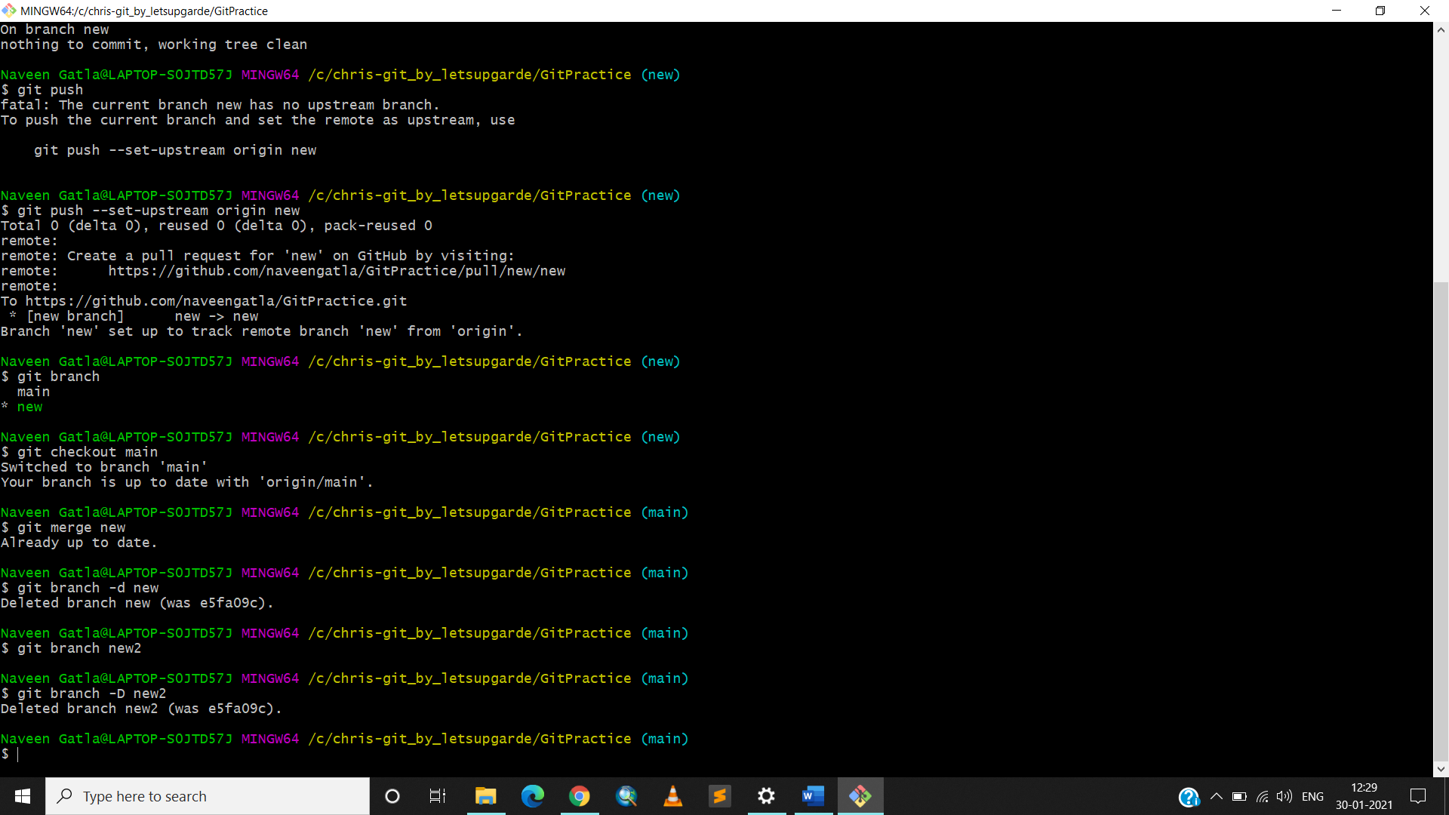

● git checkout -b branchname

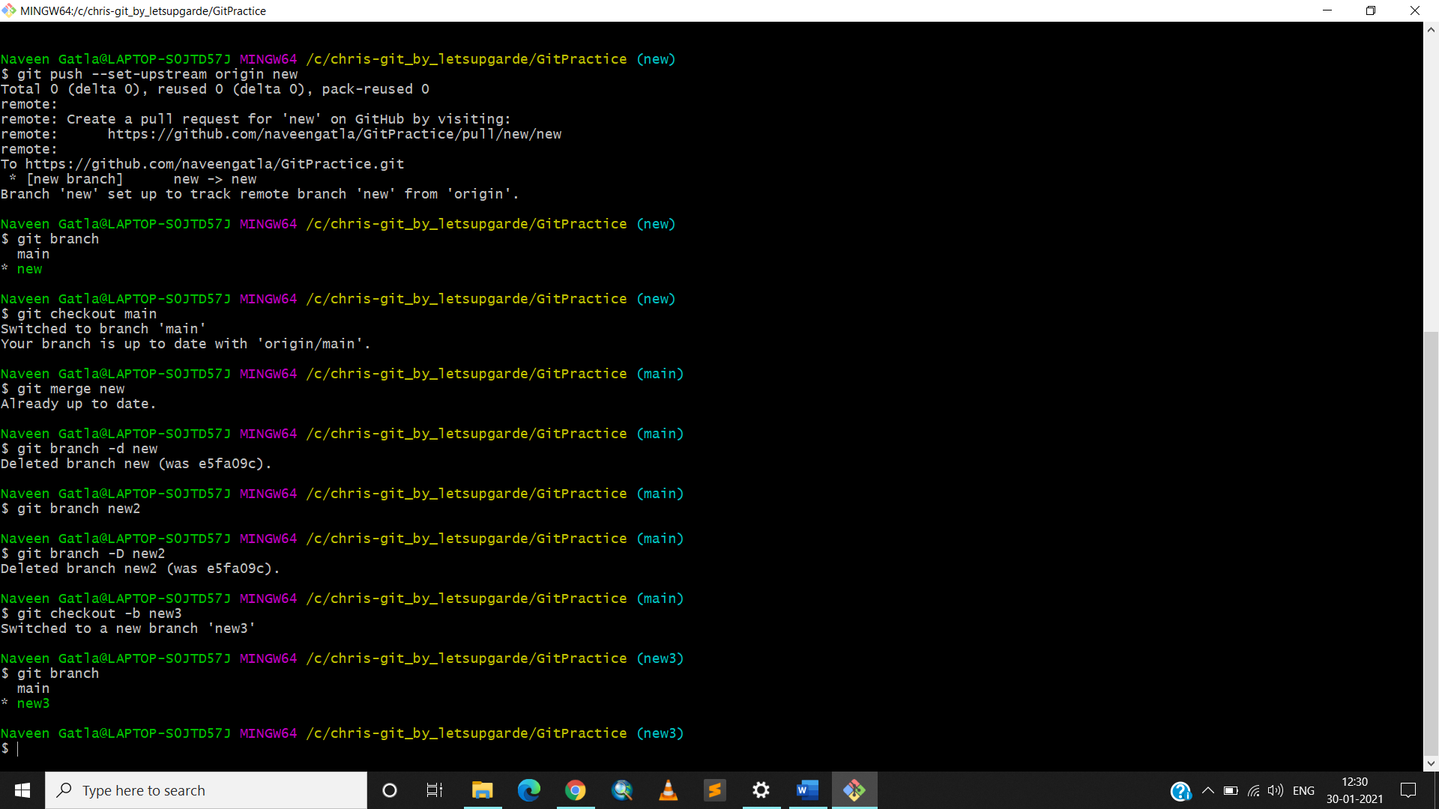

● git log

