Instructions :

1. Navigate to the emilessurvey folder and run ‘npm install’
2. After the dependencies have all been installed, run ‘npm start’
3. This opens the application.

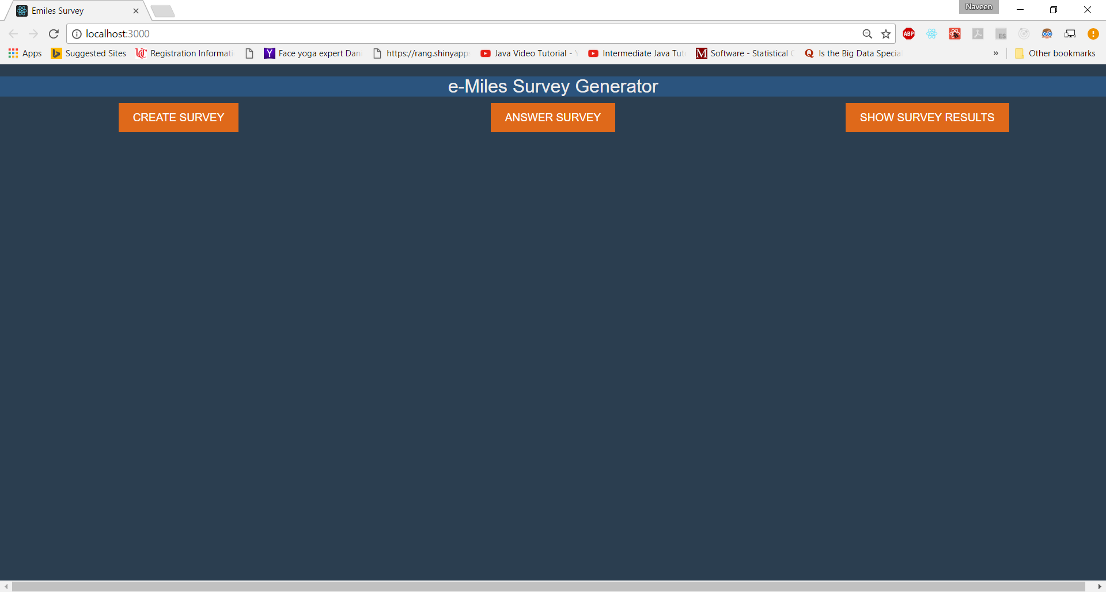

Click on ‘Create Survey’

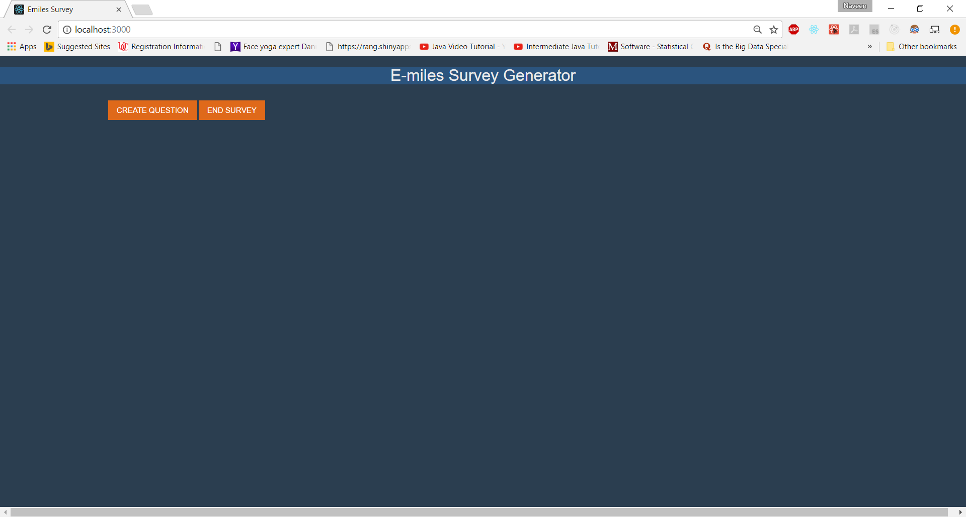

Click on Create Question

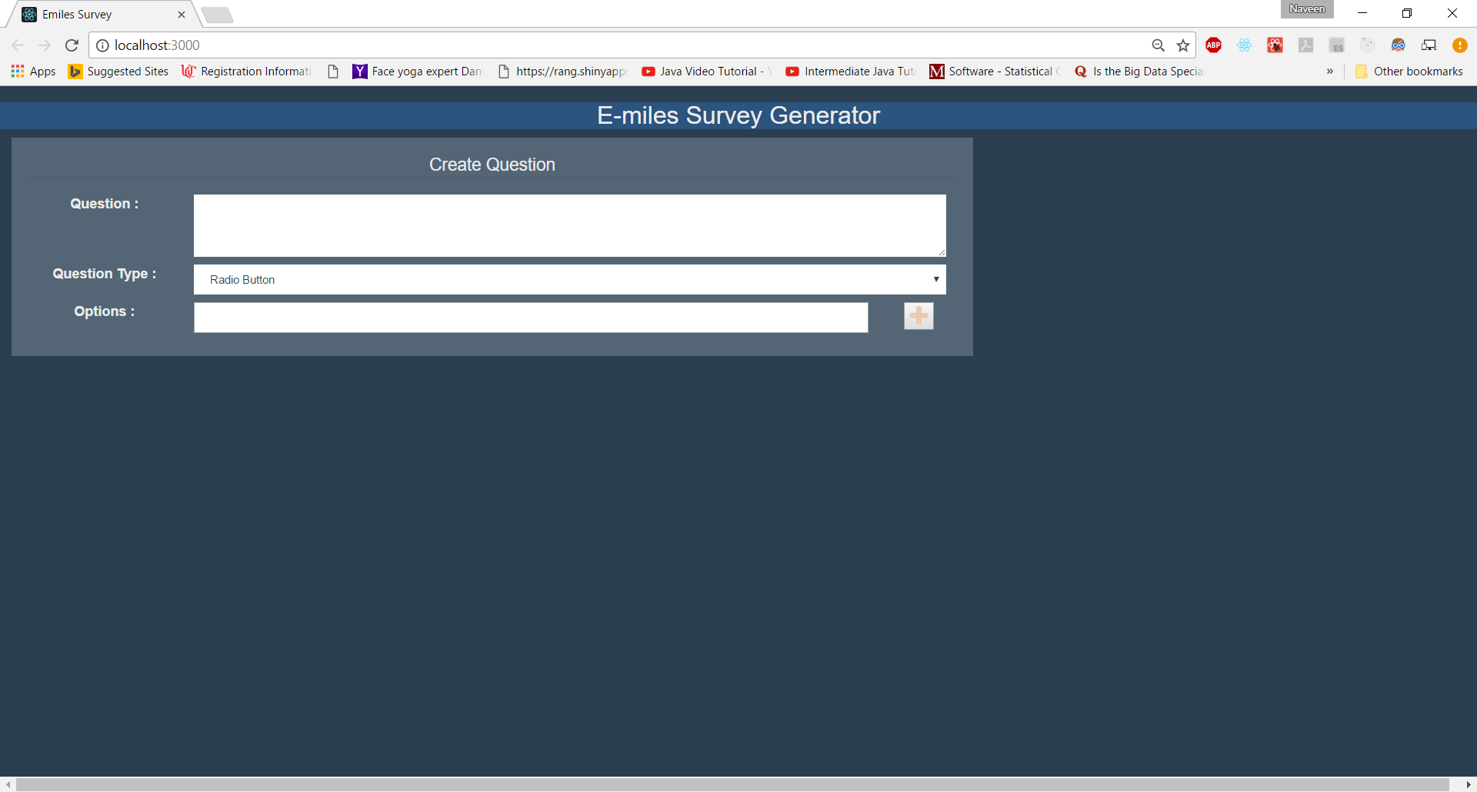

If the question type is either ‘Radio Button’ or ‘Check Box’ or ‘Drop Down’, options need to be provided by clicking the ‘+’ button.

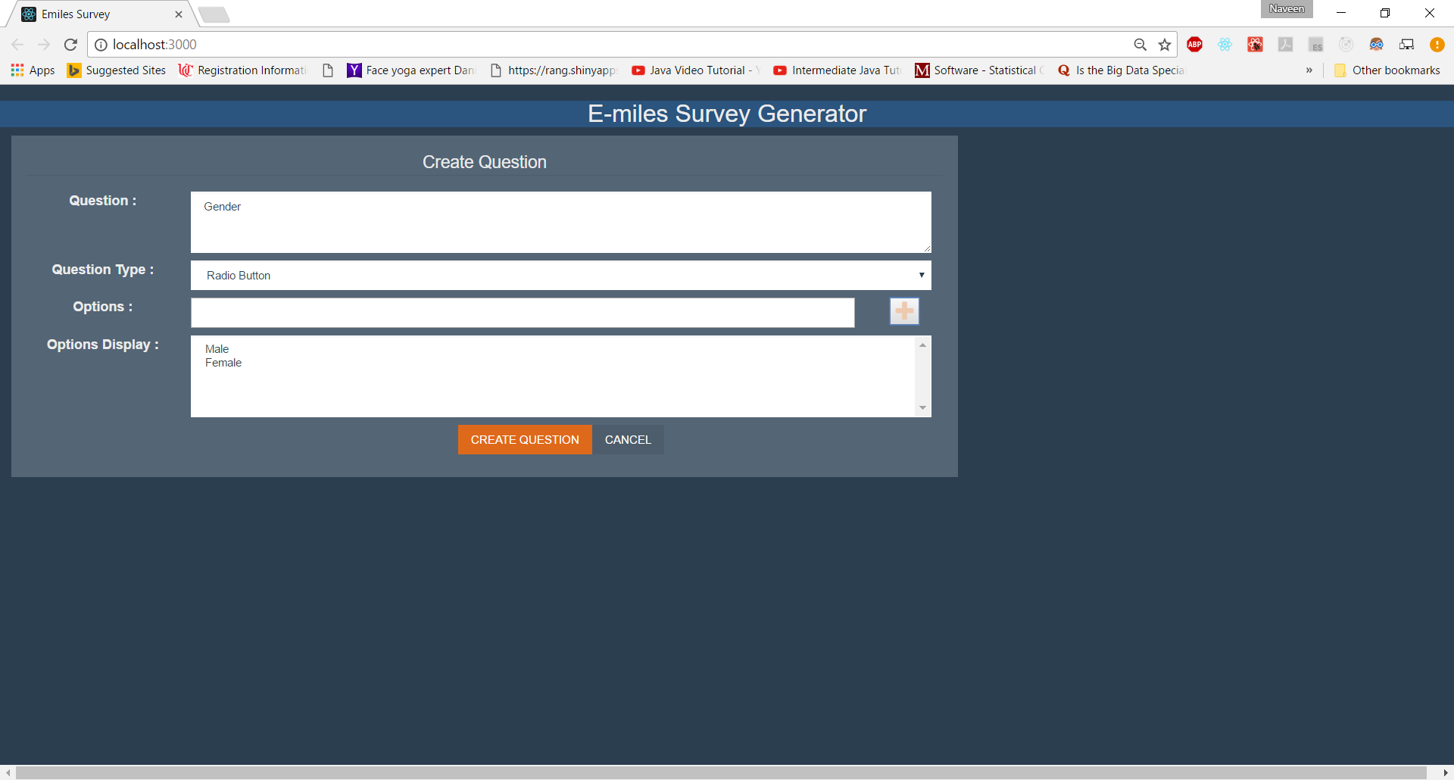

Then click on Create Question. This takes the user back to the Create Question page.

Any number of questions can be created. Once all the questions have been created, ‘End Survey’ button needs to be clicked.

On clicking the ‘Answer Survey’ button, the questions will be presented to the user.

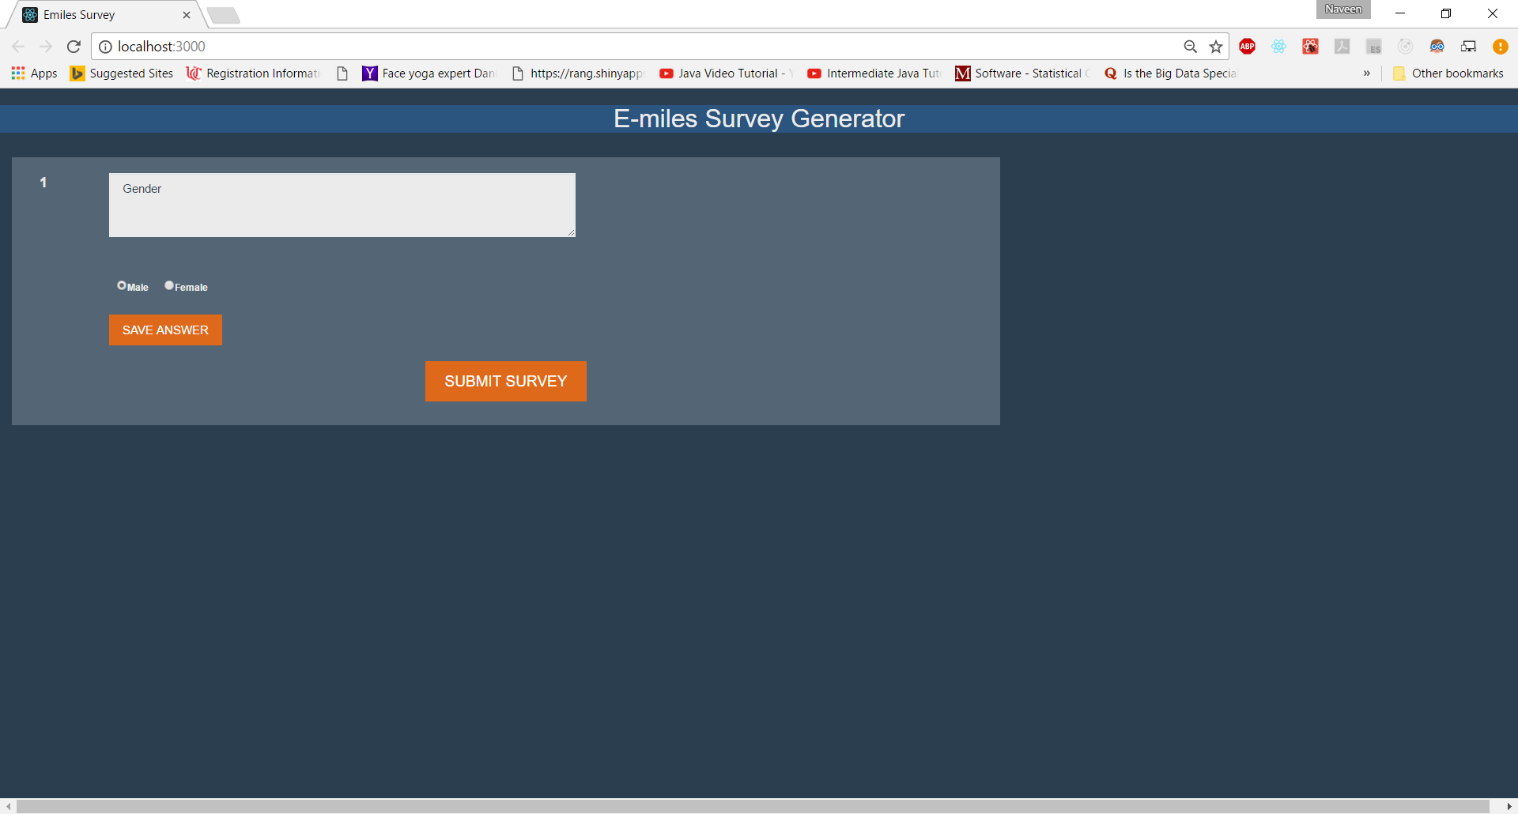

The user needs to click on ‘Save Answer’ for every question.

Once the user clicks ‘SUBMIT SURVEY’, the results of the survey will be displayed.