Steps to execute show clock timer code in Windows:-

1. Download Ruby on Rails

a. Go to http://rubyinstaller.org/downloads/

b. Download "Ruby 1.9.3-p551" which would be listed under RubyInstallers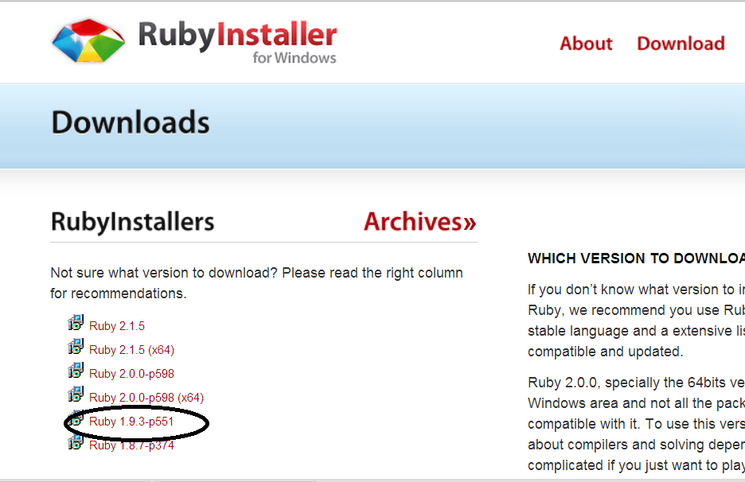

c. Download "DevKit-tdm-32-4.5.2-20111229-1559-sfx.exe" which would be listed under DEVELOPMENT KIT

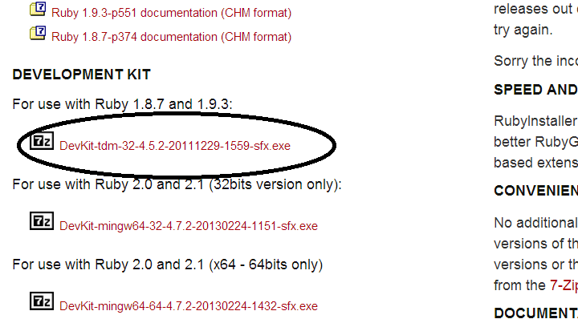

2. Refer to the following link for going through the installation process https://forwardhq.com/help/installing-ruby-windows

3. Install the executable file "Ruby 1.9.3-p551". This will create a folder named "Ruby" in your C: drive.

4. Next extract the "DevKit-tdm-32-4.5.2-20111229-1559-sfx.exe" into your C: drive into a folder C:\DevKit.

5. Open windows command prompt and enter the following commands

> chdir C:\DevKit

> ruby dk.rb init

> ruby db.rb install

This installs devkit in your system.

6. Download the Show Clock Timer code from <https://github.com/spsangeeta/ShowClockTimer> by using the option “Download ZIP”.

7. Extract the contents of the folder into your C: drive.

8. Again open windows command prompt and go into the recently downloaded “ShowClockTimer” folder.

9. Execute the following command.

> rails server

10. Open chrome browser and type in the following URL

[localhost:3000](mailto:localhost:3000)

11. The main page of the application will be displayed. The application is now executing from the local machine.

12. To make any edits to the existing code you may download from the following link <http://www.aptana.com/products/studio3/download.html>

13. Import the code as a new project into Aptana Studio and make the edits.