# Time-Aware & Quiet-Hours Messaging — Final Dossier

Date: 2025-08-22 | Author: Naveen G. | Version: Final v1

## Executive Summary

This dossier proposes a lightweight, privacy-first enhancement to WhatsApp that reduces accidental off-hours pings and improves cross-timezone conversations. It introduces a compact time-awareness UI (local-time chip), recipient-owned Quiet Hours, scheduled delivery (“Deliver at 7:00 am their time”), and an optional Urgent setting that respects OS Focus/DND.

## Product Requirements (Concise)

• Optional local-time chip below contact name (recipient-shared IANA timezone).

• Recipient-owned Quiet Hours; if inside that window, default to “Deliver at 7:00 am their time” with a one-tap override.

• Optional “Urgent” toggle that only requests higher notification priority; OS Focus/DND and recipient rules still apply.

• Lightweight: client adds a minimal not_before timestamp; servers already queue ciphertext (store-and-forward).

## Privacy by Design

The feature is strictly opt-in and shares only a coarse timezone (IANA ID, e.g., “America/Chicago”) and an on/off indicator for Quiet Hours. No precise location, travel history, device DND/Focus state, or exact sleep schedule is ever exposed. The local-time chip is computed on-device from a cached timezone string, avoiding extra network calls. Messages remain end-to-end encrypted; scheduling adds only a minimal not_before timestamp as metadata. Data collection is minimized to timezone, a boolean “has quiet hours,” and the scheduled UTC send time.

Residual-risk mitigations: to avoid pattern-of-life leakage, scheduled sends can include a small random jitter (±5–10 minutes), and the exact Quiet Hours window is never revealed to senders—only the computed delivery time. Timezone changes default to user-confirmed updates and are not broadcast. While the server must see the intended send time via not_before, this is less sensitive than content and comparable to existing delivery timestamps; document this in the privacy notice and include clear delete/export controls.

## Group Messaging (Design)

Default behavior: per-recipient fan-out scheduling — deliver now to awake/unknown members; queue for sleeping members until their Quiet Hours end.

Sender preview: “Sends now to N; queued for M (by ~7:00 am local).” Only aggregate counts; no member lists or exact quiet windows.

Sender options: 1) Per-recipient (recommended) 2) Mentions-first 3) Majority-awake threshold 4) Send to all now 5) Wait-for-all (rare).

Mentions & Urgent: if an @mention is asleep, default to deliver at their morning; optionally mark Urgent (OS Focus/DND still decides).

Edge cases: replies from awake members appear for sleepers in the morning; disappearing messages’ timers start on delivery; add ±5–10 min jitter.

## UI Design (Clean & Accessible)

Composer uses a compact schedule chip (“Deliver 7:00 am”) and a “Send+” button with chevron. The chevron opens a bottom sheet with large, readable rows: Send now, Respect Quiet Hours (recommended), and Urgent. Tap targets ≥48dp (Android)/44pt (iOS); bottom-sheet rows ≥56dp; copy uses clear titles/subtitles; Dynamic Type supported; high contrast maintained.

Composer — “Send+” with chevron & compact schedule chip

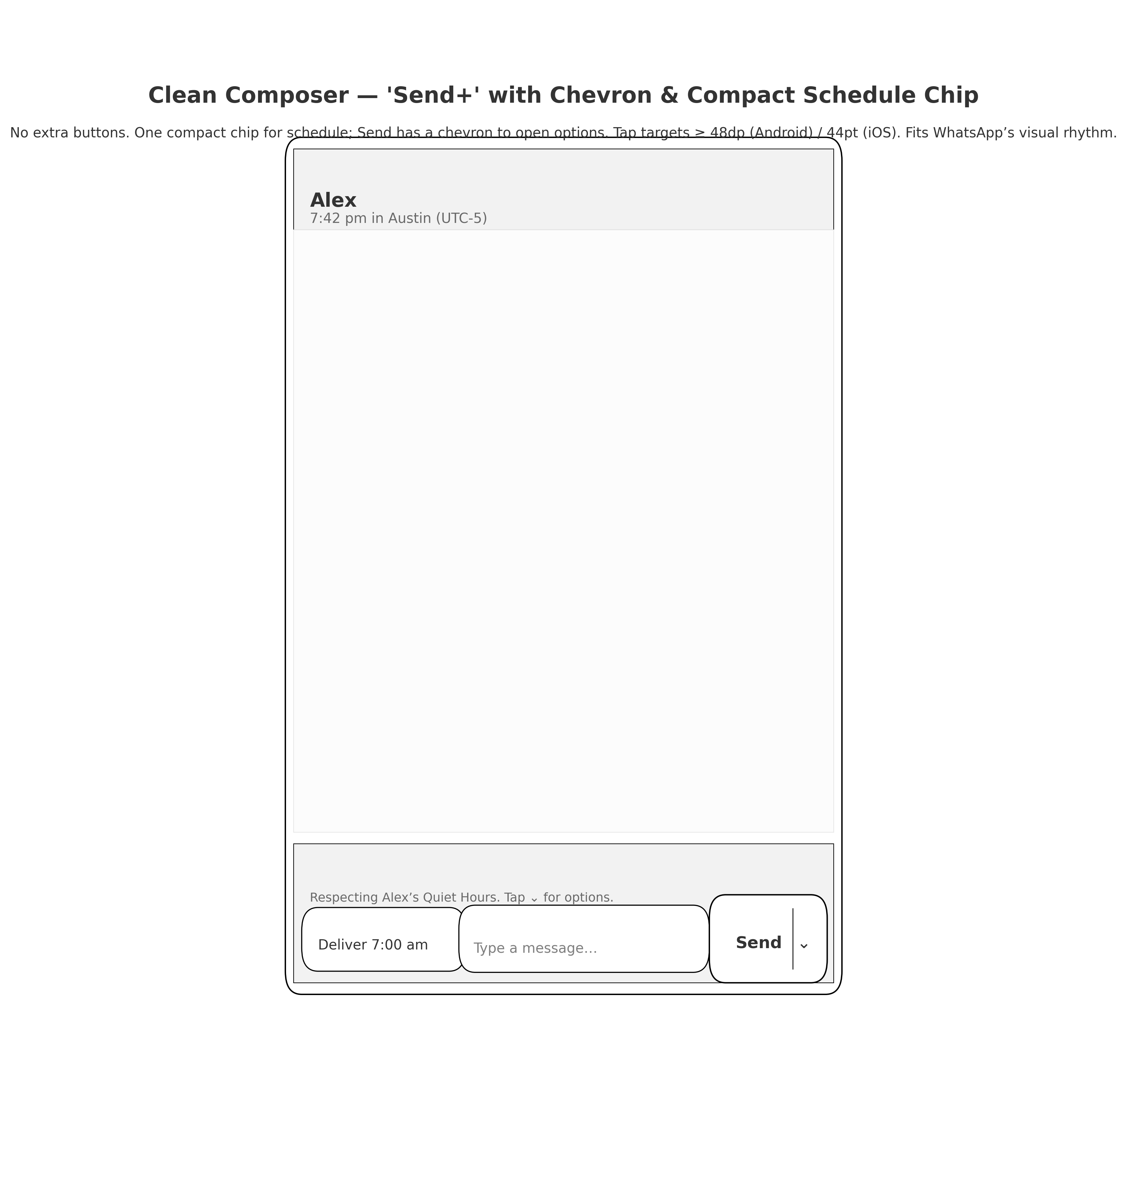

Bottom sheet — Large-tap “Send options”

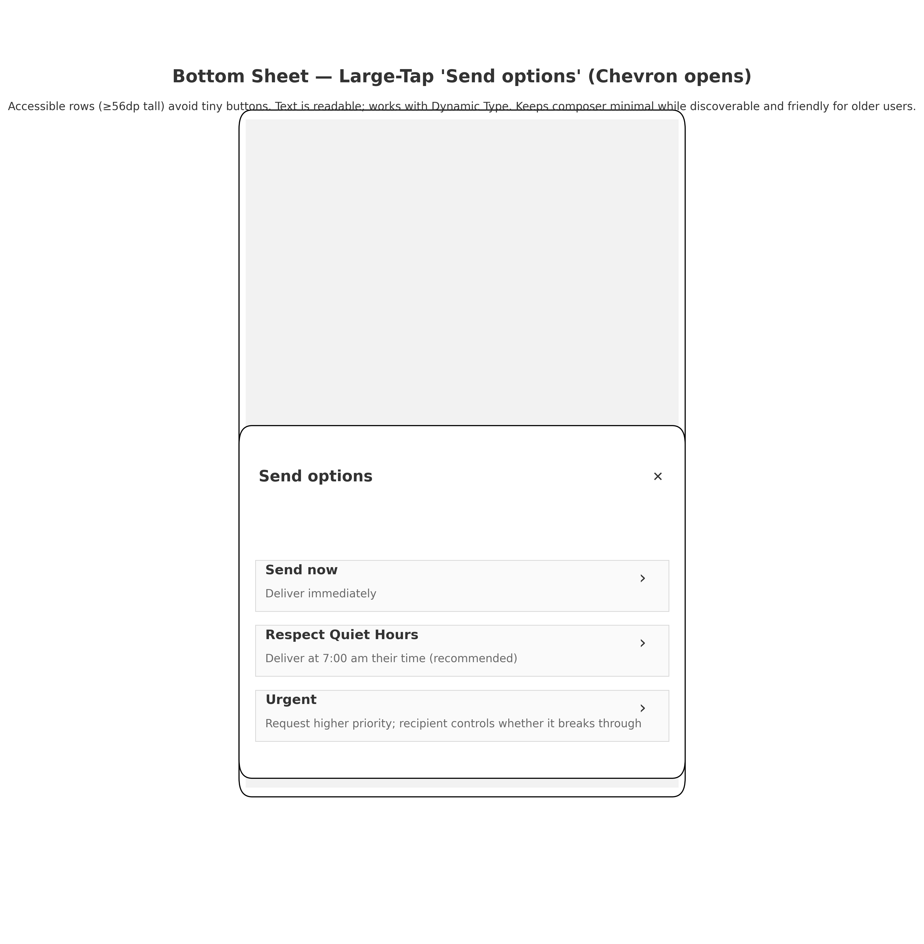

## Value & Experiment Plan

Primary outcomes (targets for A/B):

• ↓ Off-hours deliveries (22:00–07:00 local) by ~30% in treated cohorts.

• ↓ Mutes/blocks following late-night sends.

• ↑ Sender satisfaction (micro-NPS) and ↑ reply likelihood within 24h for cross-timezone chats.

• ↓ Support contacts about unwanted night notifications.

Experiment notes:

• Rollout phases: (1) Time chip (2) Quiet Hours (3) Scheduled send + Urgent.

• Guardrails: clear copy that OS Focus/DND rules still apply; no quiet-window exposure; +/− jitter; opt-in timezone.

• Telemetry: counts only (non-content); per-option selection rates; scheduled→sent conversion.

## Attachments & References

Included in the bundle:

• WhatsApp_Time_Aware_Messaging_PRD_clean.pdf

• WhatsApp_Time_Aware_Messaging_PRD_clean.docx

• WhatsApp_Time_Aware_Messaging_PRD_UI_Mock.png

• WhatsApp_TimeAware_Feature_Brief_Privacy_v2.docx

• WhatsApp_TimeAware_Cover_Email_Pro_Privacy.txt

• WhatsApp_TimeAware_UI_Spec_Clean_Accessible.docx

• Clean_Composer_SendPlus.png

• Bottom_Sheet_Send_Options.png

• WhatsApp_UI_Alternatives_Clean_Accessible.pdf

Cover email (with privacy note) is provided as a TXT for easy paste.