# Time‑Aware & Quiet‑Hours Messaging — UI Specification

Date: 2025-08-22 | Author: Naveen G. | Version: UI Spec v1 (Clean & Accessible)

## 1. Overview

This spec defines a compact, WhatsApp-consistent UI for time‑aware messaging. It replaces persistent option buttons with a compact schedule chip and a “Send+” button containing a chevron that opens a bottom sheet with large tap targets. The design minimizes visual footprint while maintaining accessibility for older and low‑dexterity users.

## 2. Components & Patterns

2.1 Composer components:

|  |  |  |
| --- | --- | --- |
| Component | Location | Purpose |
| Schedule chip | Composer (left, inline) | Shows scheduled delivery time when active; tap to edit/remove scheduling. |
| Message field | Composer (center) | Primary text input; unchanged from WhatsApp baseline. |
| Send+ (chevron) | Composer (right) | Primary send action; chevron opens bottom sheet of options. |

2.2 Bottom sheet (“Send options”):

• Rows (≥56dp) with Title + Subtitle; right caret for affordance.

• Options: Send now · Respect Quiet Hours · Urgent (request higher priority; OS/recipient control applies).

## 3. Accessibility & Sizing

|  |  |  |  |
| --- | --- | --- | --- |
| Element | Min target (Android) | Min target (iOS) | Typography |
| Send main tap area | ≥48dp | ≥44pt | Label 14–16sp/pt, bold |
| Send chevron tap | ≥48dp | ≥44pt | Icon size ≥14pt |
| Schedule chip | ≥44dp | ≥44pt | Body 13–14sp/pt |
| Bottom sheet rows | ≥56dp height | ≥56pt height | Title 15–17, Subtitle 12–13 dimmed |

Notes: Support Dynamic Type/Font scaling; maintain contrast ≥ 4.5:1 for body text. Provide VoiceOver/TalkBack labels and hints.

## 4. Interactions & States

4.1 Schedule chip states:

• Hidden — Default when no scheduling is active.

• Visible/Active — Shows “Deliver 7:00 am” (recipient’s local time). Tap to open scheduling control (edit/remove).

• Error — If scheduling fails (e.g., out of window), show brief toast and revert to “Send now.”

4.2 Send+ with chevron:

• Tap “Send” — Sends immediately using current mode. If within recipient Quiet Hours and “Respect Quiet Hours” is selected, queue with not_before timestamp.

• Tap chevron — Opens bottom sheet “Send options.” Persist last choice per contact.

4.3 Bottom sheet options & copy:

|  |  |  |
| --- | --- | --- |
| Option | Title copy | Subtitle copy |
| Send now | Send now | Deliver immediately |
| Respect Quiet Hours | Respect Quiet Hours | Deliver at 7:00 am their time (recommended) |
| Urgent | Urgent | Request higher priority; recipient controls whether it breaks through |

Helper text (composer, first 2–3 uses): “Respecting Alex’s Quiet Hours. Tap ⌄ for options.”

## 5. Privacy UX Hooks

• Timezone is recipient‑shared and can be turned off in Privacy. Show a small clock badge on profile when enabled.

• Do not reveal exact Quiet Hours; only show computed delivery time.

• Allow recipients to mute/downgrade “Urgent” from the chat info sheet.

## 6. Edge Cases & Empty States

• Unknown timezone: hide chip; first send in off‑hours shows prompt: “Ask to share timezone?” (optional, respectful).

• Travel/timezone change: if recipient timezone changes, recompute delivery time silently; chip updates on open.

• Conversation window constraints (Business): if message cannot be sent later, surface non‑blocking notice and default to “Send now.”

• Undo scheduled: snackbar “Scheduled for 7:00 am — UNDO” for 5s.

## 7. Metrics & Telemetry (non‑content, privacy‑safe)

• Count of sends during 22:00–07:00 local (pre/post).

• Option selection rates (Send now / Respect Quiet Hours / Urgent).

• Scheduled → Sent conversion (drop from user edits/cancellations).

## 8. Visual References

Composer — “Send+” with chevron & compact schedule chip

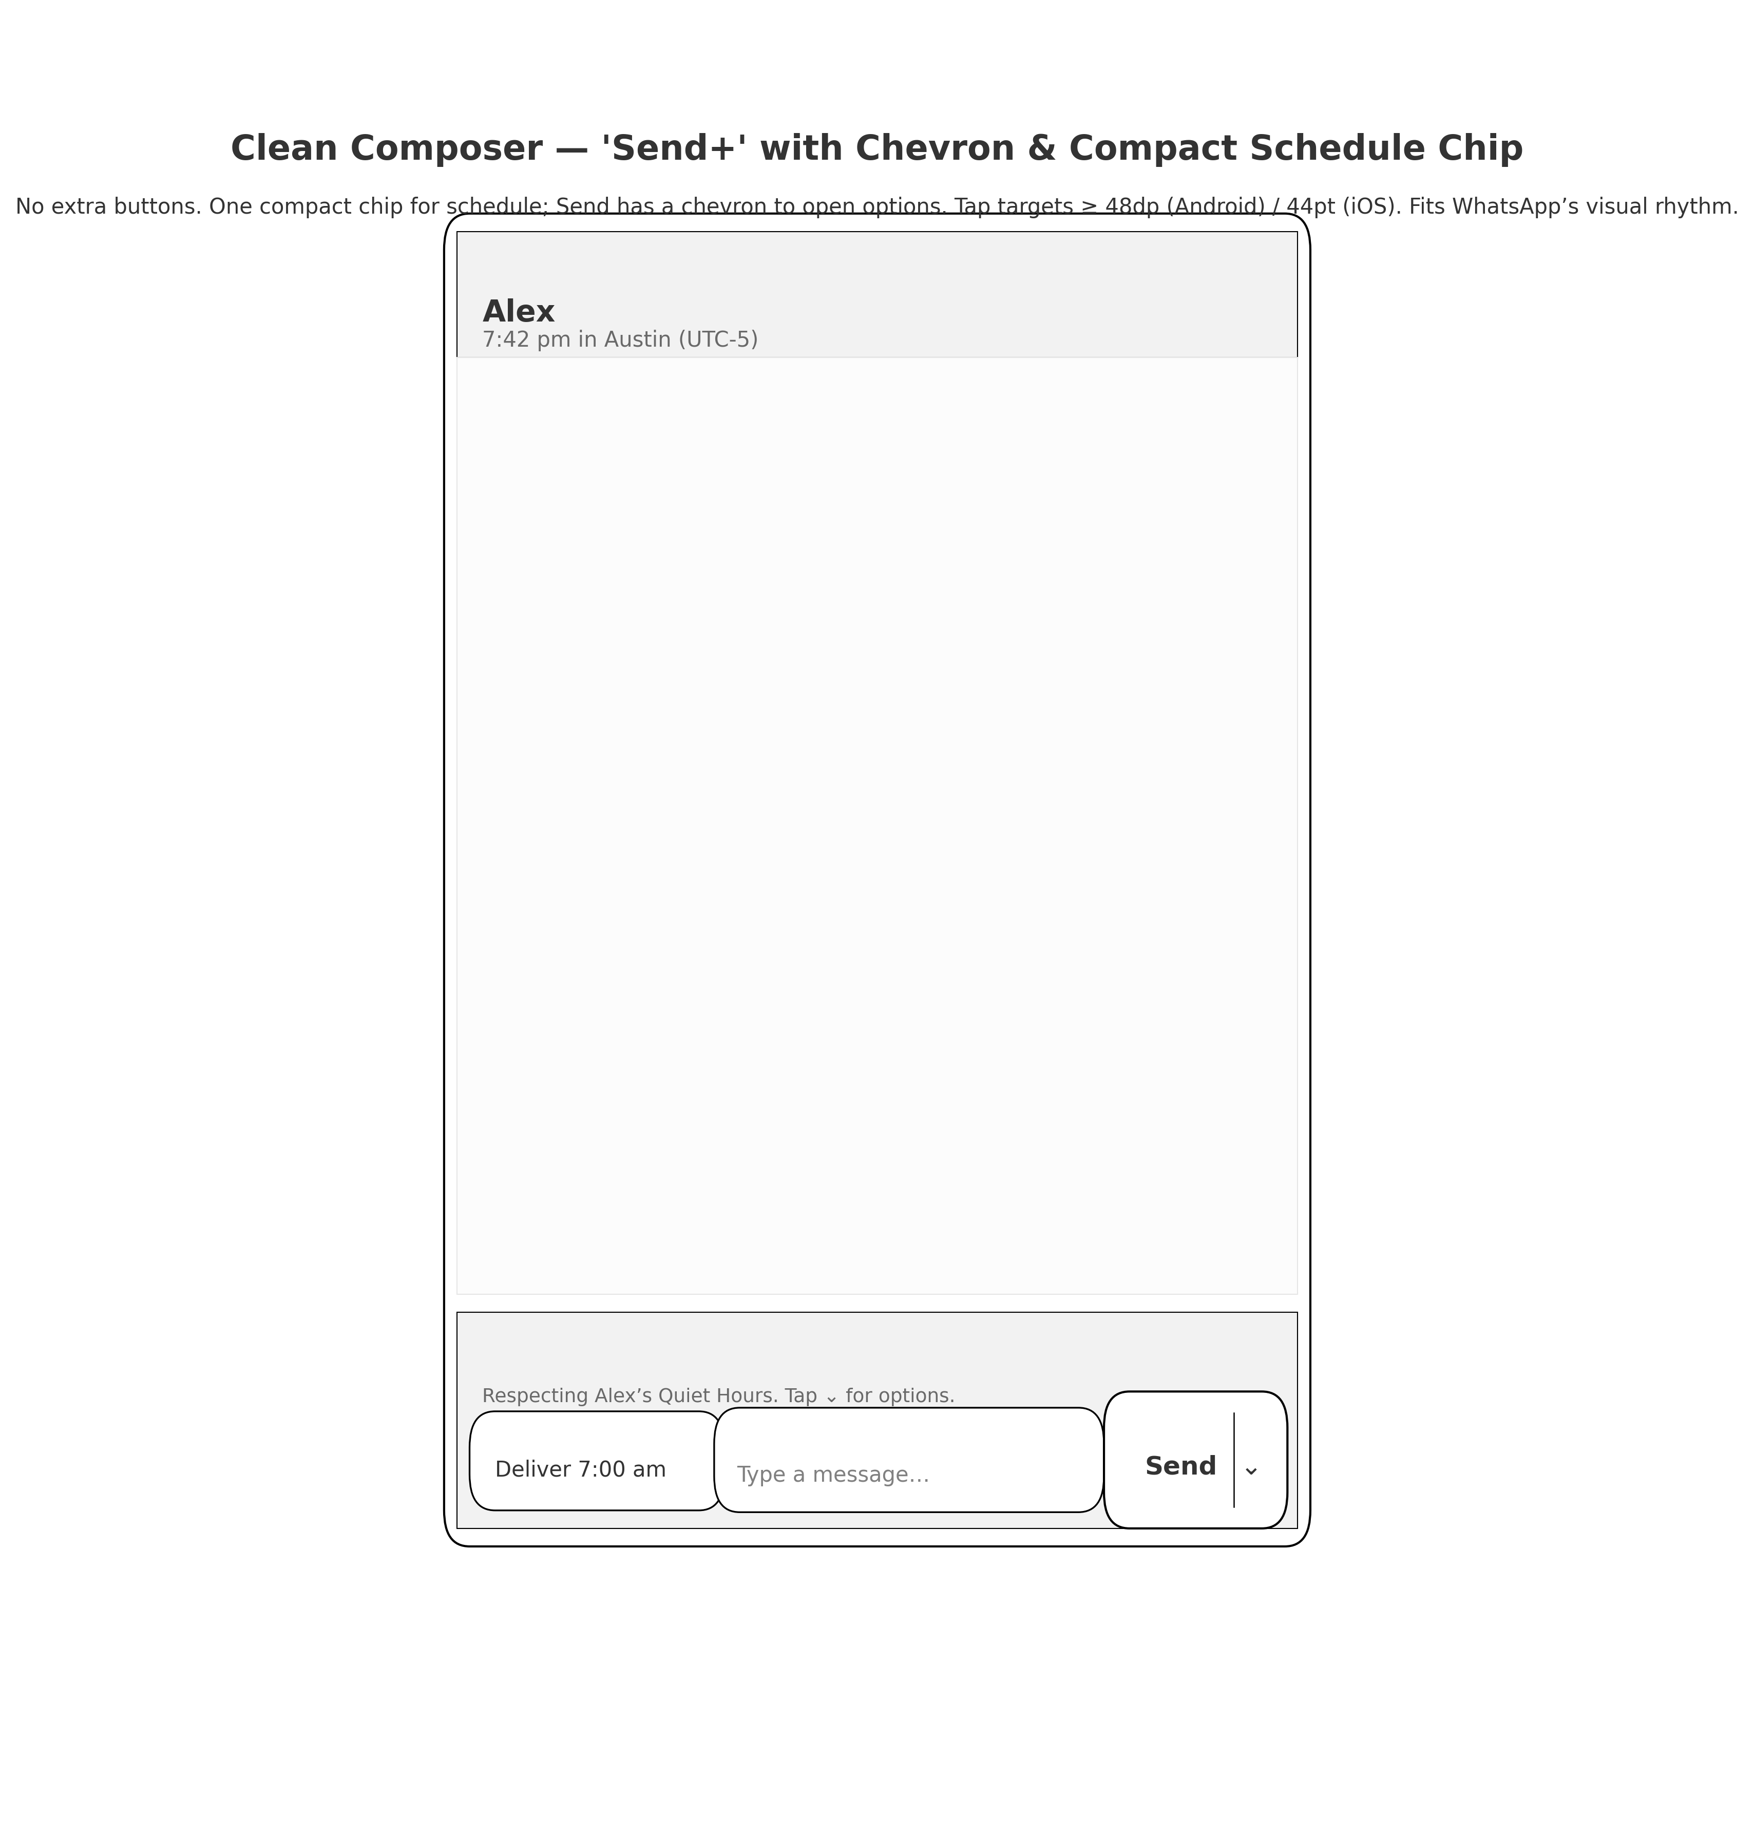

Bottom sheet — Large‑tap “Send options”

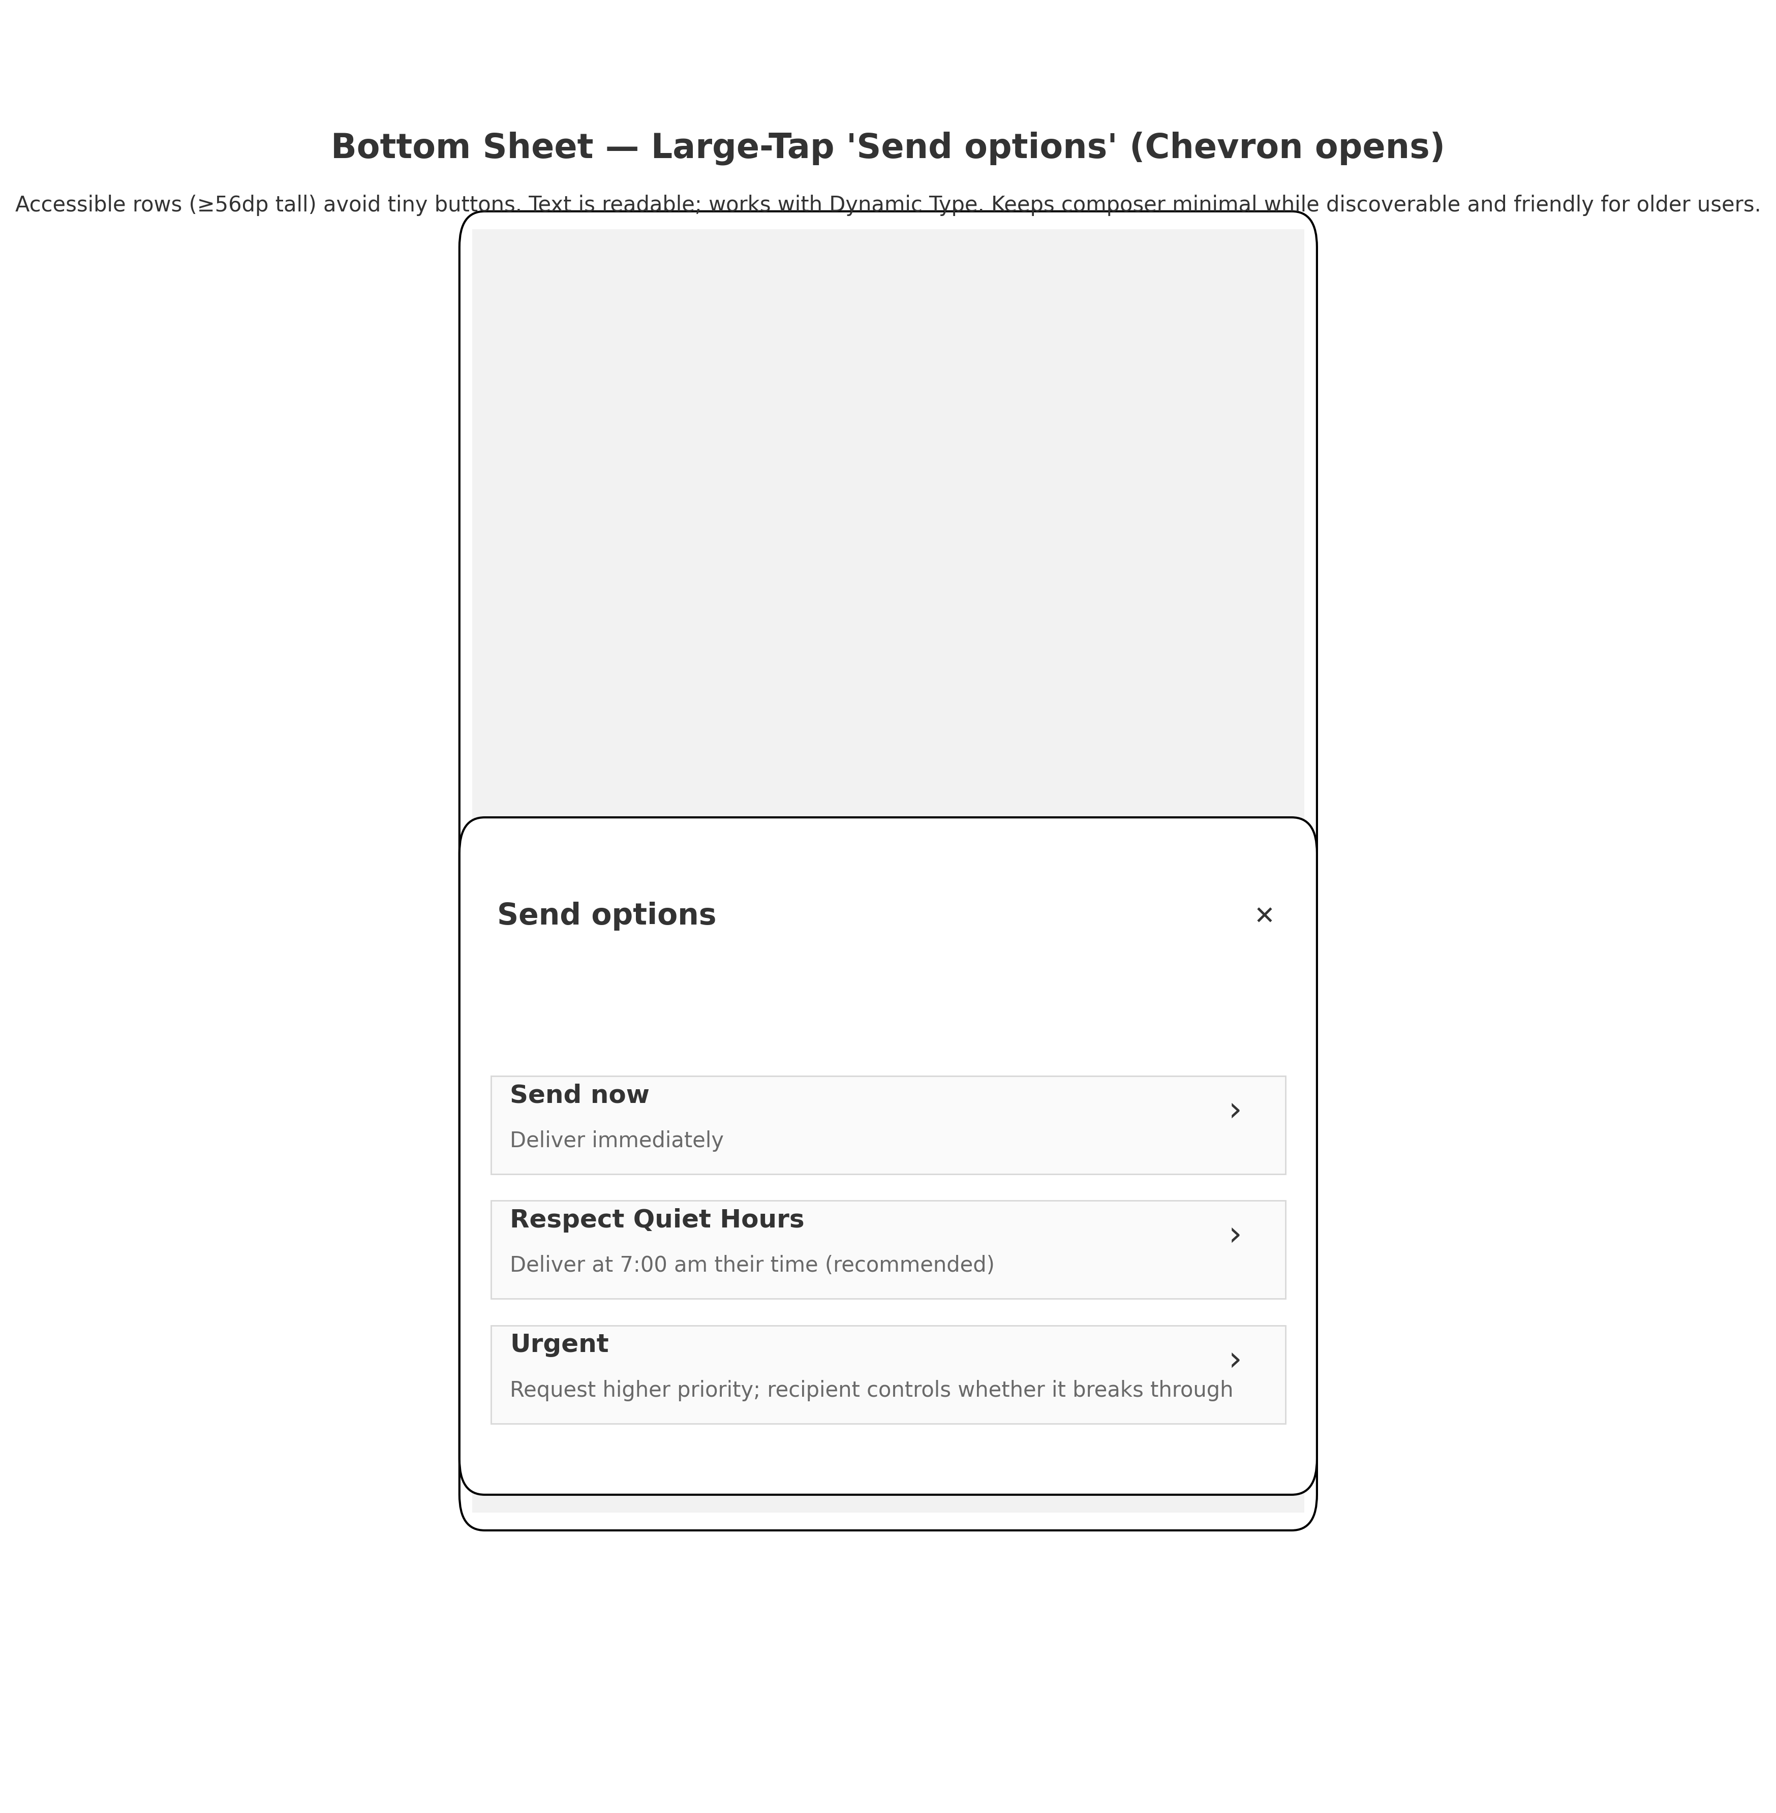

## 9. Deliverables

• UI Spec (this document)

• Clean PRD (previous attachment)

• UI mocks (PNG + PDF)