Solar Panel Centerline Detection
Objective: Design and implement a method that detects tracker centerlines from these images. Your solution should demonstrate a clear technical approach, evidence of experimentation, and thoughtful analysis of the results. You may define "detection" and "accuracy" in a way you consider appropriate for this problem.
Approach:
Train a deep learning model to predict solar panel centerlines from the images. This could be posed as a segmentation problem where centerline of solar panel is the class of interest and the rest is background. Given the dataset contains only 670 paired images and label, training a deep learning model from scratch would not be feasible. To handle this issue, the approach exploits pre-trained vision models from the open-source domain.
- Label Preparation: Rasterize the red lines from the SVG format and dilate it slightly like 3-4 pixel wide to construct a binary class map for centerline detection
- Model Architecture Choice: U-Net is widely successful for segmentation task. Additionally, a CNN based model, inspired from Vision Transformers has also been considered called ConvNeXt.
        - U-Net with ResNet34 pre-trained on ImageNet data
        - U-Net with ResNet50 pre-trained on ImageNet data
        - DeepLabV3 with ResNet50 pre-trained on ImageNet data
        - ConvNeXT model
- Loss Function: Dice Loss + Binary Cross Entropy Loss
- Post Processing:
- Threshold probability map and skeletonize the predicted lines
- Fit a straight line
- Compute vision and geometric eval metrics: IoU, Precision, Recall, F1 and Mean Perpendicular Distance Error, Mean Angular Error, Mean Row Precision, Mean Row Recall, and Mean Row F1 Score.

Experiments and Results
The solar panel images were directly used as inputs for the model and the output was pre-processed as described above. The model takes the input image and predicts the class map and this class map is later post-processed to compute geometric metrics.
Definition of Geometric Metrics:
- Mean Perpendicular Distance Error: The error in distance between the predicted and actual line
- Mean Angular Error: The error in the angle of the predicted and actual line
- Mean Row Precision: Number of correctly predicted lines out of all the predicted lines
- Mean Row Recall: Number of correctly retrieved lines out of all the correct lines

As described above, there were multiple models considered to solve the problem, and the table below present a model configuration used for experiments for clarity.
 | ResNet34 | ResNet50 | ConvNeXt Tiny
U-Net | ✅ | ✅ | ✘
DeepLabV3 | ✘ | ✅ | ✘
ConvNeXt | ✘ | ✘ | ✅

The total dataset contained 670 paired images, and it was split into train/val/test with 0.8/0.1/0.1 ratio. The model was evaluated on the test dataset, and the results are presented below. The model was evaluated using both computer vision metrics and geometric metrics, however, I only present geometric metrics here as they have more meaningful interpretation for the given problem as opposed to vision metrics. The geometric metrics described above are computed for each test example and to create the leaderboard for comparing model performance average across all metrics was computed.
Geometric Metrics:
 | ConvNeXT | DeepLabV3 (ResNet50) | U-Net (ResNet34) | U-Net (ResNet50)
Avg. Mean Perpendicular Distance | 1.3406 | 1.6179 | 1.8293 | 1.8445
Avg. Mean Angular Error | 0.23 | 0.389 | 0.3609 | 0.3062
Avg. Mean Row Precision | 0.6118 | 0.5523 | 0.5685 | 0.5734
Avg. Mean Row Recall | 0.5733 | 0.5735 | 0.5708 | 0.5733
Avg. Mean Row F1 | 0.5795 | 0.5593 | 0.5578 | 0.5598

Visualization
I selected the last 5 images from the test dataset and plotted them for all the models. The first column is the ground truth, the second column is model prediction, and the last one is the error comparison between the predicted and observed mask label.
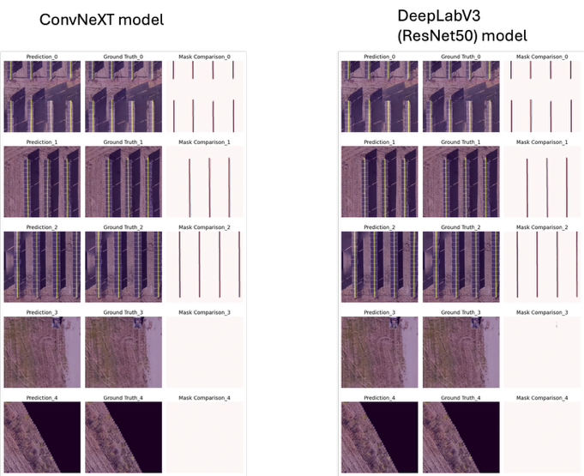
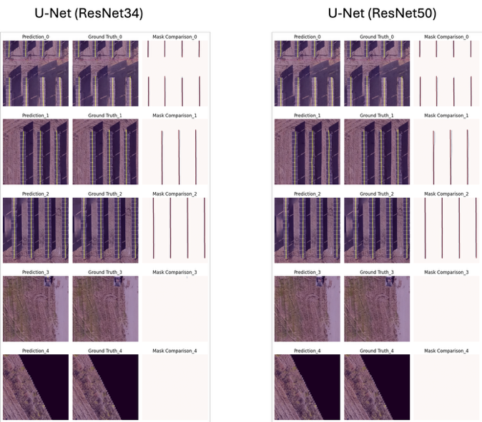

Conclusion:
Given the dataset is small, I started with a pre-trained encoder on the ImageNet dataset and showed experimental results for 4 models. The performance metrics can be further improved by hyperparameter tuning and data augmentation techniques like synthetic data generation. I did experiment with a trivial data augmentation technique commonly used in computer vision; however, it resulted in model performance degradation and hence it was not incorporated in the final model training. Overall, all the models perform similar with ConvNeXt showing the best performance in terms of Avg. Mean Perpendicular Distance and Avg. Mean Angular Error. Further, there are other approaches that could also be considered and they could not be explored due to time constraints, however they are discussed in the future work.
Future Directions
- Synthetic Data Generation: Given the image are for solar panels and has natural image characteristics, a heuristic based method can be used where classical computer vision methods can help generate large-scale images of solar panels on background of images with grasses or dry ground. The solar panel images can be modeled as black or grey arrays with multiple orientation and different lighting conditions. Nonetheless, this method would only generate relatively simpler dataset and to further enhance complexity of synthetic data, generative models can be considered. Stable Diffusion or Flux based models that are fine-tuned on some real dataset could potentially be a good alternative to generate large-scale and high variance realistic looking dataset.
- Leveraging Generating Models like MAE and DiNO: Extract the embedding from these models and train a custom light-weight decoder to translate the embeddings into segmentation mask. During training of decoder, the encoder can be frozen and thus it would not require huge compute or training dataset for task adaptation.
- Process the labels as (angle, distance from origin, and line length) instead of binary mask: In the current approach, the model is trained to predict binary mask. Since these centerlines are thinner, this pose a challenge in model learning of these lines. To mitigate this issue, an alternative approach could be considered where the centerlines are modeled as a function of angle, distance from left origin of the image, and the length. This way the model is trained to learn the pattern in the 2D space directly about the geometrical representation of the image, however, this approach need to be designed carefully so that model does not overfit with respect to this representation.
- Augment data meaningfully: Classical computer vision data augmentation techniques were considered and it did not come useful for model training and therefore it was discarded. However, the other data augmentation methods can be explored where images can be analyzed in details to understand how can we adjust contrast or noise to increase the variance in training dataset. This would need detail analysis to further improve model performance.

