**CO-3 PROGRAMS**

**1.Design modules and packages – builtin and user defined packages.**

**MATH PROGRAM**

*import* math

print("The value of pi:",math.pi)

*import* math *as* m

print("The value of pi is :", m.pi)

*from* math *import* pi,sqrt

print("The value of pi is : ", pi)

print("The square root of 4 is : ", sqrt(4))

print(math.cos(90))

print(math.sin(90))

print(math.tan(90))

**OUTPUT**

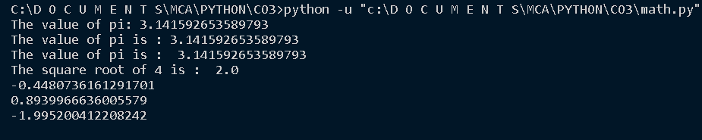

**CALENDAR PROGRAM**

*import* calendar

mm = int(input("Enter Month : "))

yy = int(input("Enter Year : "))

print(calendar.month(yy,mm))

print(calendar.calendar(1999))

**OUTPUT**

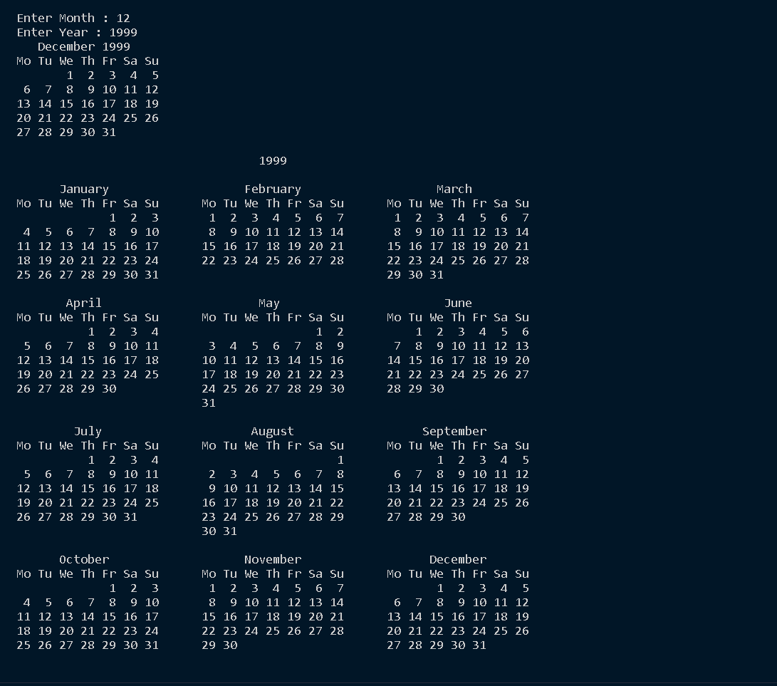

**TIME PROGRAM**

*import* time

print("Current time in sec : ",time.time())

print("Current time : ",time.ctime())

print("Current time after 30 sec : ",time.time()+30)

t = time.localtime()

print("Time : ", t)

print("Current Year :", t.tm_year)

print("Current Month :", t.tm_mon)

print("Current Day :", t.tm_mday)

print("Current Hour :", t.tm_hour)

print("Current Weekday :", t.tm_wday)

print("Day of year :", t.tm_yday)

**OUTPUT**

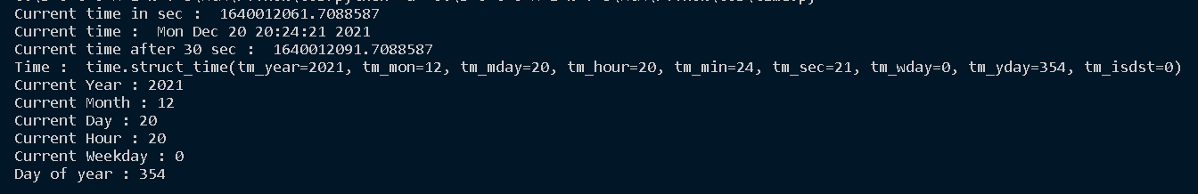

**DATETIME PROGRAM**

*import* datetime

t=datetime.time(22,56,44)

print(t)

print("Hour : ", t.hour)

print("Minute : ", t.minute)

print("Second : ", t.second)

print("==============================")

d = datetime.date.today()

print(d)

td = datetime.timedelta(days=2)

print(td)

d2 = d+td

print("After adding two days :",d2)

print("d2-d",d2-d)

print("d2>d",d2>d)

d1 = datetime.date.today()

t1 = datetime.time(12,44,56)

print("Date and Time : ",d1, t1)

**OUTPUT**

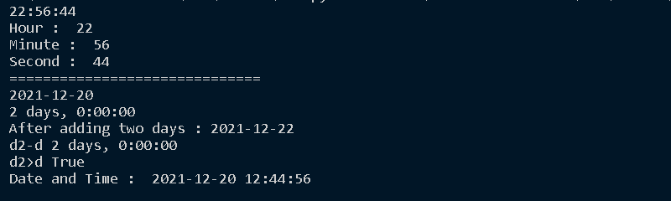

**STATISTICS PROGRAM**

*import* statistics

# *Calculate average values*

print("Mean : ",statistics.mean([1, 3, 5, 7, 9, 11, 13]))

print("Mean : ",statistics.mean([1, 3, 5, 7, 9, 11]))

print("Mean : ",statistics.mean([-11, 5.5, -3.4, 7.1, -9, 22]))

print("===============================")

# *Calculate middle values*

print("Median : ",statistics.median([1, 3, 5, 7, 9, 11, 13]))

print("Median : ",statistics.median([1, 3, 5, 7, 9, 11]))

print("Median : ",statistics.median([-11, 5.5, -3.4, 7.1, -9, 22]))

print("===============================")

# *Calculate the mode*

print("Mode :",statistics.mode([1, 3, 3, 3, 5, 7, 9, 11]))

print("Mode :",statistics.mode([1, 1, 3, -5, 7, -9, 11]))

print("Mode :",statistics.mode(['red', 'green', 'blue', 'red']))

print("===============================")

# *Calculate the variance from a sample of data*

print("Varience :",([1, 3, 5, 7, 9, 11]))

print("Varience :",statistics.variance([2, 2.5, 1.25, 3.1, 1.75, 2.8]))

print("Varience :",statistics.variance([-11, 5.5, -3.4, 7.1]))

print("Varience :",statistics.variance([1, 30, 50, 100]))

print("===============================")

# *Calculate harmonic mean*

print("Hermonic mean",statistics.harmonic_mean([40, 60, 80]))

print("Hermonic mean",statistics.harmonic_mean([10, 30, 50, 70, 90]))

print("-=-=-=-=-=-=-=-=-=-=-=-=-=-=-=-")

**OUTPUT**

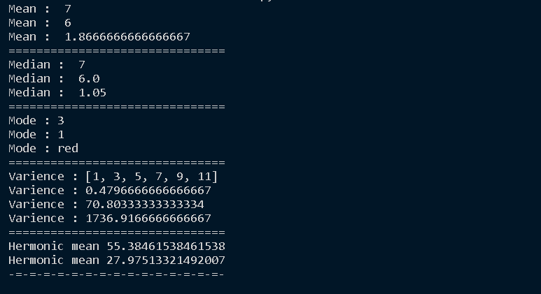

**RANDOM PROGRAM**

*import* random

print(random.random())

print("===============================")

mylist = ["apple", "banana", "cherry"]

random.shuffle(mylist)

print(mylist)

print("===============================")

random.seed(10)

print(random.random())

print("===============================")

mylist = ["apple", "banana", "cherry"]

print(random.choice(mylist))

print("===============================")

print(random.randrange(3, 9))

**OUTPUT**

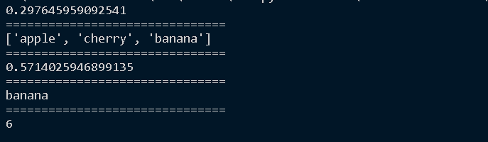

**PACKAGE PROGRAM**

circle.py

def *area*(r):

    print("AREA OF CIRCLE:",3.14* r * r)

def *perimeter*(r):

    p=2*3.14*r

    print("PERIMETER OF CIRCLE",p)

rectangle.py

def *area*(x,y):

    print("AREA OF RECTANGLE:",x*y)

def *perimeter*(x,y):

    p=2*(x+y)

    print("PERIMETER OF RECTANGLE",p)

co3questions.py

*from* graphics *import* circle,rectangle

x=int(input("enter the length of rectangle"))

y=int(input("enter the breadth of rectangle"))

rectangle.area(x,y)

rectangle.perimeter(x,y)

z=int(input("enter the radius of circle"))

circle.area(z)

circle.perimeter(z)

**OUTPUT**

