CO1 PROGRAMS

1. Familiarizing Text Editor, IDE, Code Analysis Tools etc // Use any IDE

IDE stands for Integrated Development Environment. It’s a coding tool which allows you to write, test, and debug your code in an easier way, as they typically offer code completion or code insight by highlighting, resource management, debugging tools,… And even though the IDE is a strictly defined concept, it’s starting to be redefined as other tools such as notebooks start gaining more and more features that traditionally belong to IDEs.

Comparison between IDLE and Thonny

Thonny is built for education and you can download the latest version from the Thonny website. The download options are at the top right. Thonny looks quite different to IDLE - it has different panels for the editor, the shell and the variables watcher plus (show view) lots of other options as well. It has a powerful debugger built in and other tools which let you manage packages and plugins.

The Idle editor comes built-in with Python and is the one that many tutorials use by default. It's a fine, basic, editor that also has a Python shell built in for interactive programming.When you start Idle up, you get the shell window. This allows you to execute python commands and see the results immediately without having to create a program. This can be useful for trying things out.

2. Display future leap years from current year to a final year entered by user.

s=int(input("enter start year:"))

e=int(input("enter end year:"))

if(s<e):

print("leap years are:",end=" ")

for i in range(s,e):

if i%4==0 and i%100!=0:

print(i,end=" ")

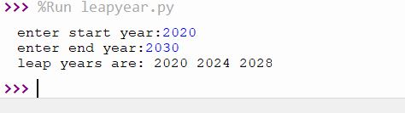

3.**List comprehensions:**

* **Generate positive list of numbers from a given list of integers**

list1 =[-10,20,35,-67,70]

re=[num for num in list1 if num>=0]

print(re)

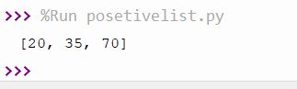

* **Square of N number**

n=int(input("enter the limit"))

l=[i**2 for i in range(0,n+1)]

print("square are ",l)

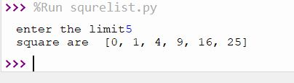

* **Form a list of vowels selected from a given word**

string=str(input("enter the string"))

print("original string:",string)

print("vowels are:",end=" ")

for i in string:

if i in 'aeiouAEIOU':

print([i],end=" ")

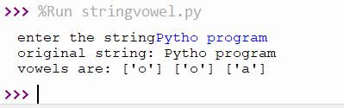

* **List ordinal value of each element of a word (Hint: use ord() to get ordinal values)**

w=input("Enter a word:")

print("Ordinal values corresponding to each element is:")

for i in w:

print(i,end=":")

print(ord(i),end=" ")

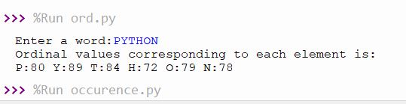

**4. Count the occurrences of each word in a line of text.**

str1 = input("Enter a string : ")

wordlist = str1.split()

count= []

for w in wordlist:

count.append(wordlist.count(w))

print("count of the occurrence:" + str(list(zip(wordlist, count))))



**5. Prompt the user for a list of integers. For all values greater than 100, store ‘over’ instead**

n=[]

s=int(input("Enter a limit:"))

print("Enter {s} values")

for i in range(0,s):

n.append(int(input()))

print("\nThe list after assinging:\n")

for i in range(0,len(n)):

if n[i]>=100:

print("over")

else:

print(n[i])

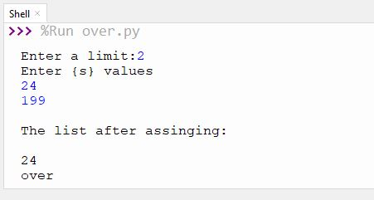

**6. Store a list of first names. Count the occurrences of ‘a’ within the list**

a_list = ["a", "b", "a"]

occ = a_list.count("a")

print("count of occurrences of a :",occ)

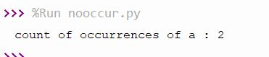

7. **Enter 2 lists of integers. Check (a) Whether list are of same length (b) whether list sums to same value (c) whether any value occur in both**

lst=[1,3,5,7,9,11,34]

lst1=[5,13,45,7,20,65,1]

s=int(0)

c=int(0)

if len(lst)==len(lst1):

print("Lists are of same length")

else:

print("Lists have different length")

for i in range(0,len(lst) and len(lst1)):

s=s+lst[i]

c=c+lst1[i]

if(s==c):

print("equal sum")

else:

print("not same sum")

print("Elements that matched are:")

l=[]

for i in range(0,len(lst)):

for j in range(0,len(lst1)):

if lst[i]==lst1[j]:

l.append(lst[i] and lst1[j])

else:

continue

print(l)

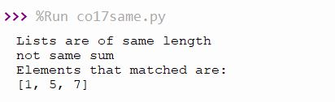

8.**Get a string from an input string where all occurrences of first character replaced with ‘$’, except first character. [eg: onion -> oni$n]**

str1="malayalam"

char = str1[0]

str1 = str1.replace(char, '$')

str1 = char + str1[1:]

print(str1)

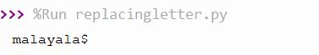

**9.Create a string from given string where first and last characters exchanged. [eg: python -> nythop]**

str = input("Enter a string : ")

new_str = str[-1:] +str[1:-1] + str[:1]

print("New string : ",new_str)

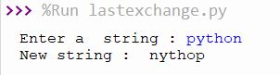

**10.Accept the radius from user and find area of circle.**

r = float(input ("Enter radius of the circle : "))

result=3.14 * r**2

print ("The area of the circle: ", result)

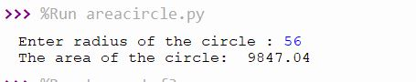

**11. Find biggest of 3 numbers entered**

x = int(input("Enter 1st number: "))

y = int(input("Enter 2nd number: "))

z = int(input("Enter 3rd number: "))

if (x > y) and (x > z):

largest = x

elif (y > x) and (y > z):

largest = y

else:

largest = z

print("The largest number is",largest)

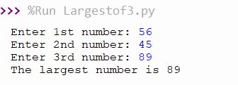

**12.Accept a file name from user and print extension of that**

str= input("Enter filename : ")

file=str.split(".")

print("Extension of the file is : " + file[-1])

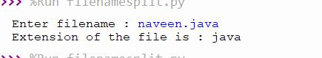

**13.Create a list of colors from comma-separated color names entered by user.Display first and last colors.**

a=[]

for i in range(3):

b=input("enter the color:")

a.append(b)

print(a)

print(a[0])

print(a[2])

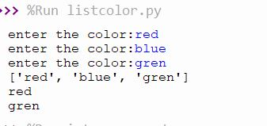

**14.Accept an integer n and compute n+nn+nnn**

n = int(input("Enter a number : "))

x = int("%s" % n)

y = int("%s%s" %(n,n))

z = int("%s%s%s" %(n,n,n))

print ("n+nn+nnn:",x+y+z)

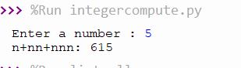

**15.Print out all colors from color-list1 not contained in color-list2.**

color_list_1 = set(["White", "pink", "Red","Blue"])

color_list_2 = set(["Red", "Green","pink"])

print(color_list_1.difference(color_list_2))

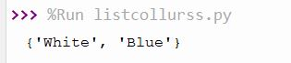

**16.Create a single string separated with space from two strings by swapping the character at position 1.**

a="python"

b="java"

p1=a[0]

p2=b[0]

c=b[0]+a[1:len(a)]+" "+a[0]+b[1:len(b)]

print(c)

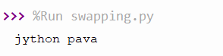

**17.Sort dictionary in ascending and descending order.**

import operator

d = {1: 2, 3: 4, 4: 3, 2: 1, 0: 0}

print('Original dictionary : ',d)

sorted_d=sorted(d.items(), key=operator.itemgetter(1))

print('Dictionary in ascending order by value ',sorted_d)

sorted_d =dict(sorted(d.items(), key=operator.itemgetter(1),reverse=True))

print('Dictionary in descending order by value : ',sorted_d)

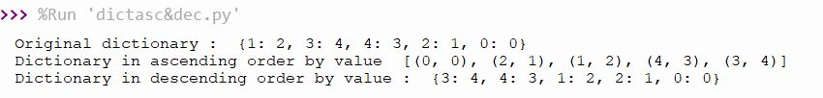

**18.Merge two dictionaries**

d1 ={ 'a': 100, 'b': 200}

d2 ={'x' : 300, 'y': 200}

print ("Dict ionary 1=:", d1)

print ("Dictionary 2-: ", d2)

d =d1. copy ()

d.update (d2)

print ("Merged Dictionary: ", d)

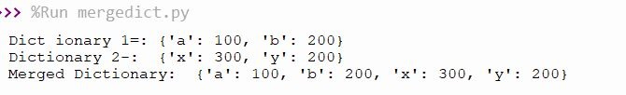

**19.Find gcd of 2 numbers.**

x= int(input("Enter 1st number: "))

y= int(input("Enter 2nd number: "))

i = 1

while(i <= x and i <= y):

if(x % i == 0 and y% i == 0):

gcd = i

i = i + 1

print("GCD :", gcd)

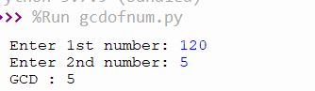

**20.From a list of integers, create a list removing even numbers.**

num = [7,8, 120, 25, 44, 20, 27]

print( "Original list:",num)

num = [x for x in num if x%2!=0]

print("list after removing Even numbers:",num)

