CO2 PROGRAMS

1. **Program to find the factorial of a number**

n=int(input('Enter a number : '))

f=1

for i in range(1,n+1):

f=f*i

print ('Factorial of ',n, '=',f)

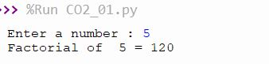

**2.Generate Fibonacci series of N terms**

n = int(input("Enter the limit : "))

a = 0

b = 1

sum = 0

count = 1

print("Fibonacci Series :",end= " ")

while(count <= n):

print(sum, end = " ")

count += 1

a = b

b = sum

sum = a + b

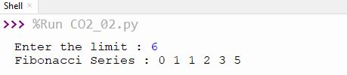

**3.Find the sum of all items in a list**

list1 = [10, 20, 30, 40, 50]

total = sum(list1)

print("Sum of list : ",total)

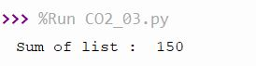

**4.Generate a list of four digit numbers in a given range with all their digits even and the number is a perfect square.**

from math import sqrt as s

for i in range(1000,10000):

if s(i)==int(s(i)) and i%2==0:

print(i,end=" ")



**5.Display the given pyramid with step number accepted from user**

rows = int(input("Enter the number of rows: "))

for i in range(1, rows+1):

for j in range(1,i+1):

print(i * j, end=' ')

print()

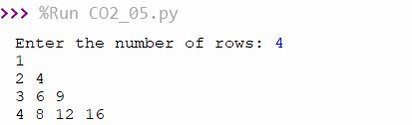

**7.Add ‘ing’ at the end of a given string. If it already ends with ‘ing’, then add ‘ly’**

str=input("enter a string:")

print("inputed string is : ",str)

if(str.endswith("ing")):

str=str+'ly'

else:

str=str+'ing'

print("the formated string is :",str)

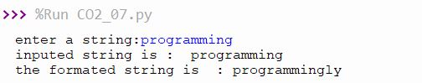

**8.Accept a list of words and return length of longest word.**

a=[]

n= int(input("Enter the number of elements in list : "))

for x in range(0,n):

element=input("Enter element "+ str(x+1) )

a.append(element)

max1=len(a[0])

temp=a[0]

for i in a:

if(len(i)>max1):

max1=len(i)

temp=i

print("Longest Word : ",temp)

print("Length of longest word : ",max1)

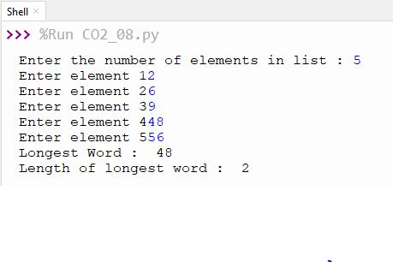

**9.Construct following pattern using nested loop**

n= int(input("Enter the limit:"))

for i in range(n):

for j in range(i):

print ('* ', end="")

print('')

for i in range(n,0,-1):

for j in range(i):

print('* ', end="")

print('')

