**PYTHON**

**CO-5 PROGRAMS**

**1. Write a Python program to read a file line by line and store it into a list**

f1=open("secfile.txt","w")

f1.write("This is my first file in python.\n want to work with files \n This is my third line")

f1=open("secfile.txt","r")

ff=f1.readlines()

print(ff)

**OUTPUT**

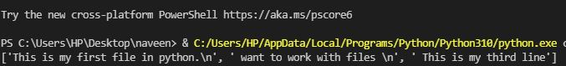

**2. Python program to copy odd lines of one file to other**

f1=open("secfile.txt","r")

ff=f1.readlines()

with open("odd.txt","w") as f2:

    for x in range(0,len(ff)):

        if(x%2!=0):

            f2.write(ff[x])

**OUTPUT**

