Understanding the Timing of Eruption End using a Machine Learning Approach to Classification of Seismic Time Series

In this paper author using various machine learning such as Random Forest, SVM, Logistic Regression and Gaussian Process Classifier to predict volcano eruption timing. To implement this project author has used two volcano mountains dataset but this dataset he has not publish on internet and it’s not available on internet so I am using volcano eruption dataset from KAGGLE website and this dataset saved inside ‘Dataset’ folder.

Below screen shots showing some details on dataset and this dataset contains seismic magnitude and if its value greater than 6 then it will consider as volcano is about to erupt.

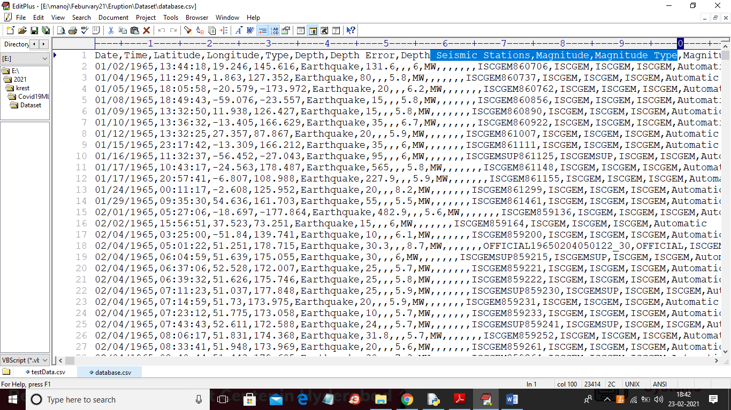

In above dataset screen shot first row contains dataset column names and other rows are the values. Author using above dataset to train all machine learning algorithm and then applying test data on trained model to calculate classification accuracy. In this paper author using 80% dataset records to train Machine Learning algorithms and 20% record to calculate its classification accuracy.

About algorithms you can read from base paper.

SCREEN SHOTS

To run project double click on ‘run.bat’ file to get below screen

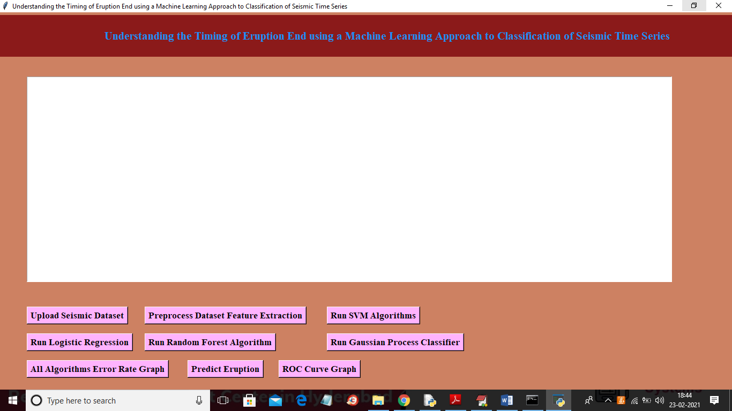

In above screen click on ‘Upload Seismic Dataset’ button to load dataset

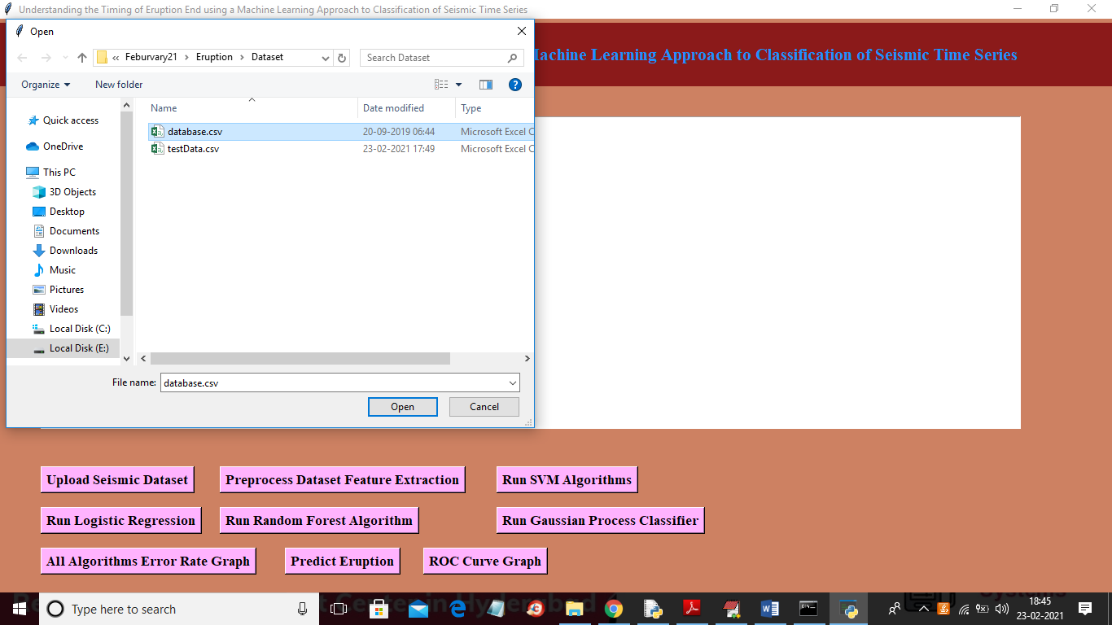

In above screen selecting and uploading ‘database.csv’ file and then click on ‘Open’ button to load dataset and to get below screen

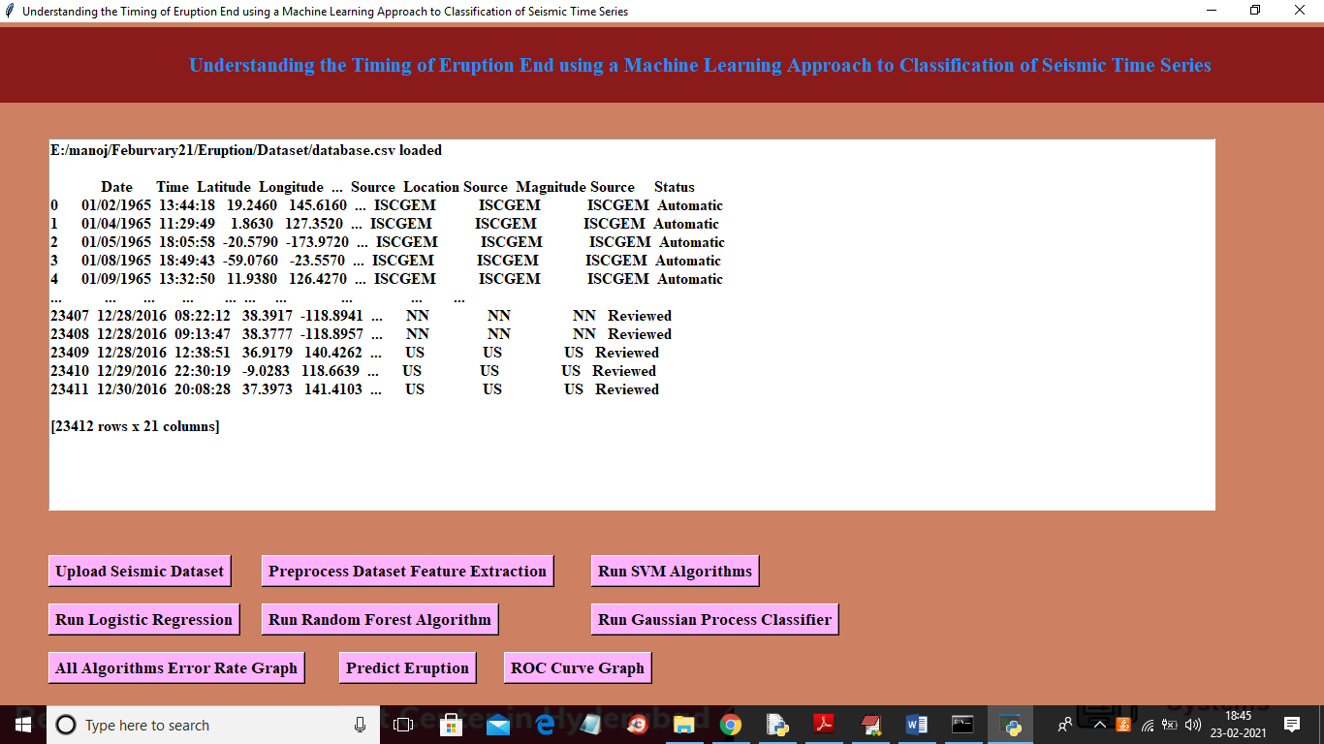

In above screen dataset loaded and displaying few records from dataset and in above dataset we can see there is string values and we need to replace string values with numeric values and then replace missing values with 0 so click on ‘Preprocess Dataset Feature Extraction’ button to convert dataset into normalize format

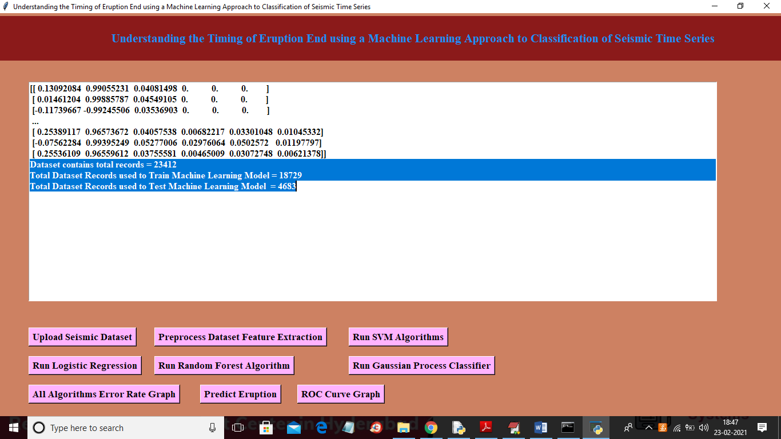

In above screen all records converted to numeric values and then we can see application contains total 23412 records and then application using 18729 records to train machine learning algorithms and 4683 records to test them. Now both train and test data is ready and now click on ‘Run SVM Algorithm’ button to train SVM model with above dataset

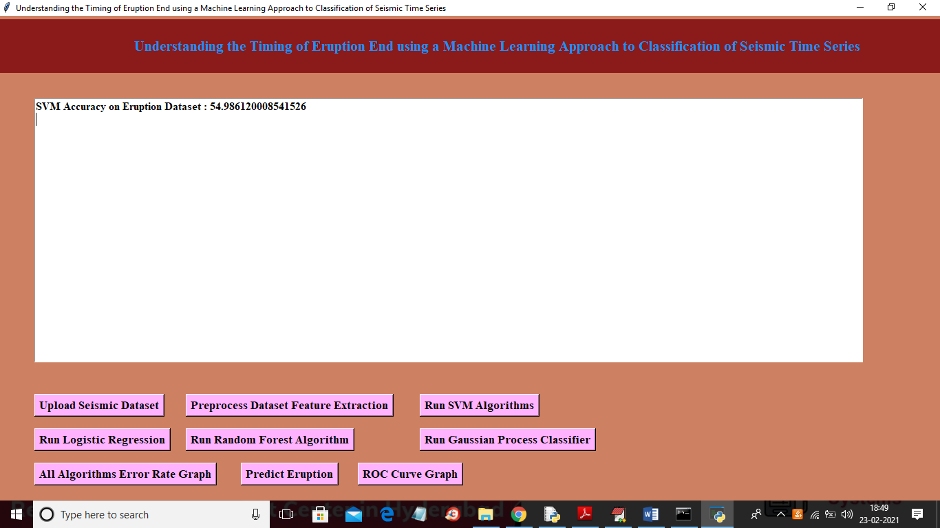

In above screen SVM model is trained and its accuracy is 54% and now click on ‘Run Logistic Regression’ button to get its accuracy

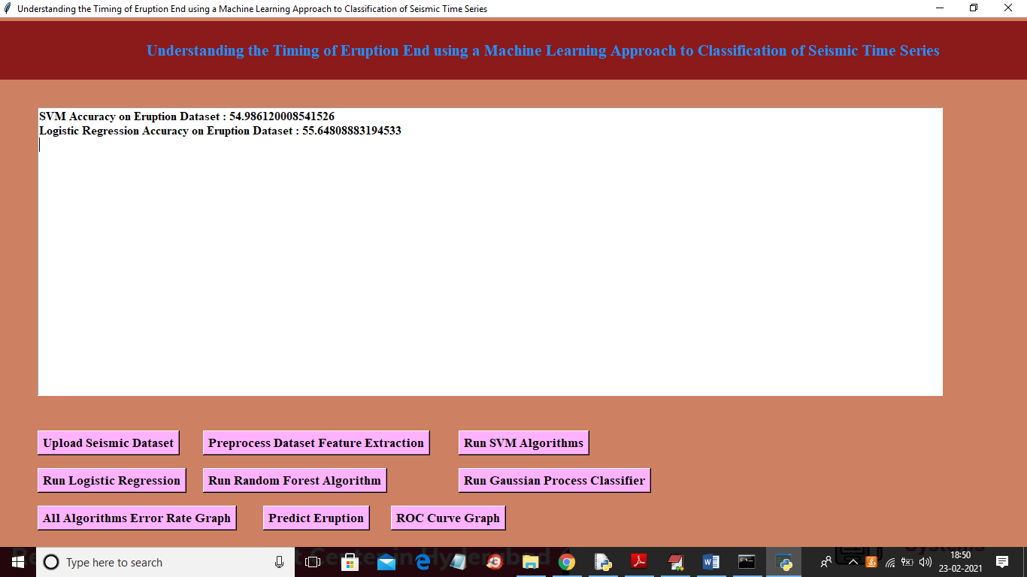

In above screen logistic regression got 55% accuracy and now click on ‘Run Random Forest Algorithm’ button to get its accuracy

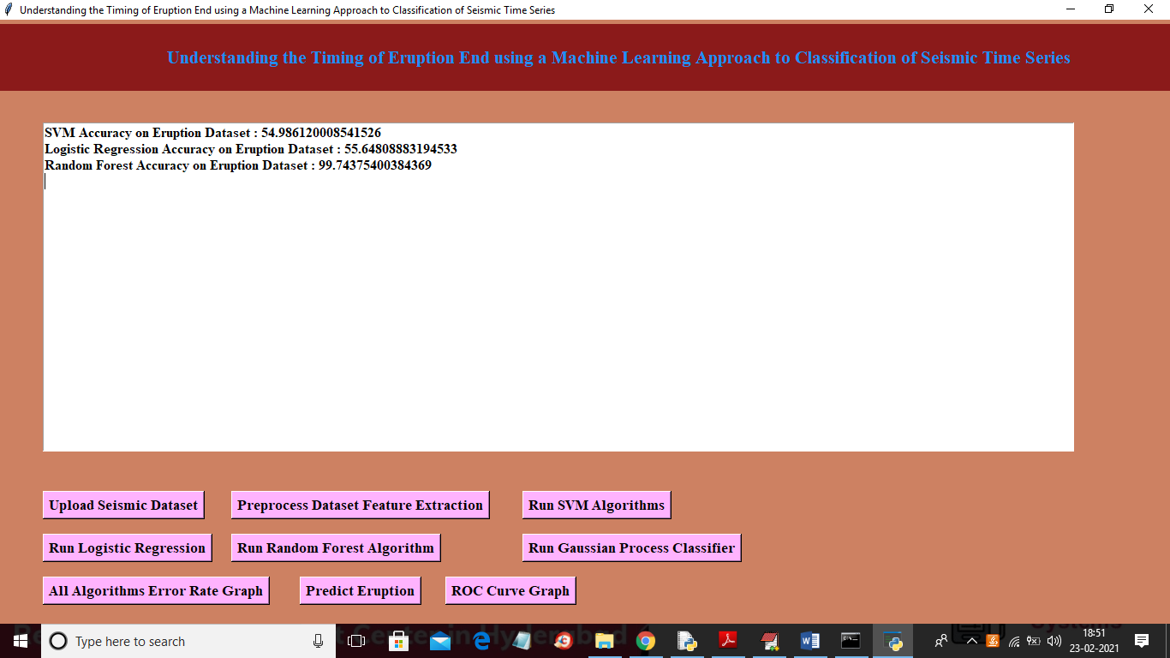

In above screen random forest got 99.74% classification accuracy and now click on ‘Run Gaussian Process Classifier’ button to get its accuracy

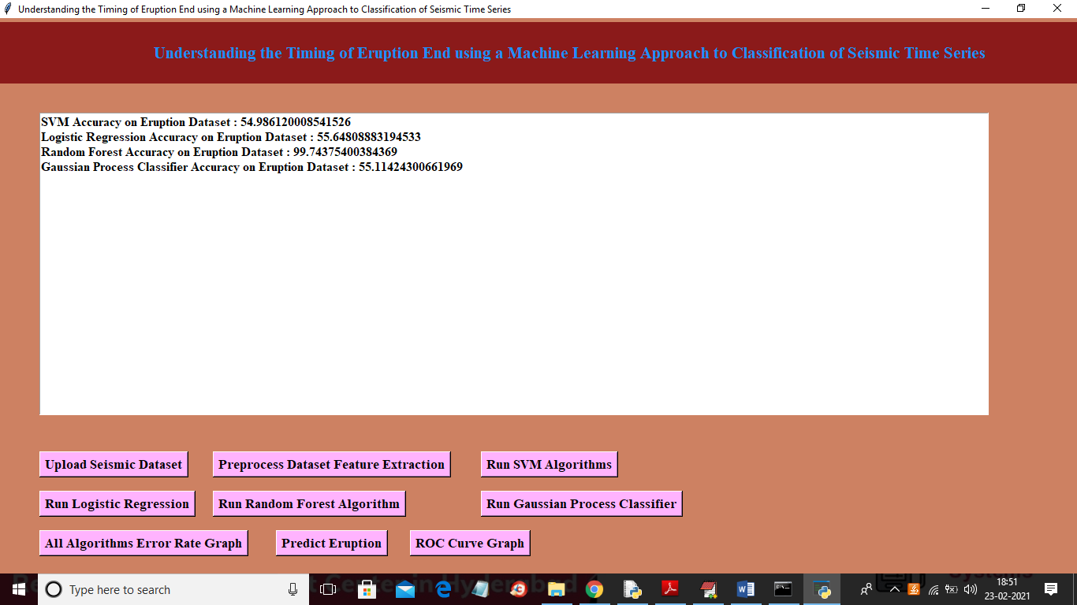

In above screen Gaussian process got 55% accuracy and now click on ‘All Algorithm Accuracy Graph’ button to get below graph

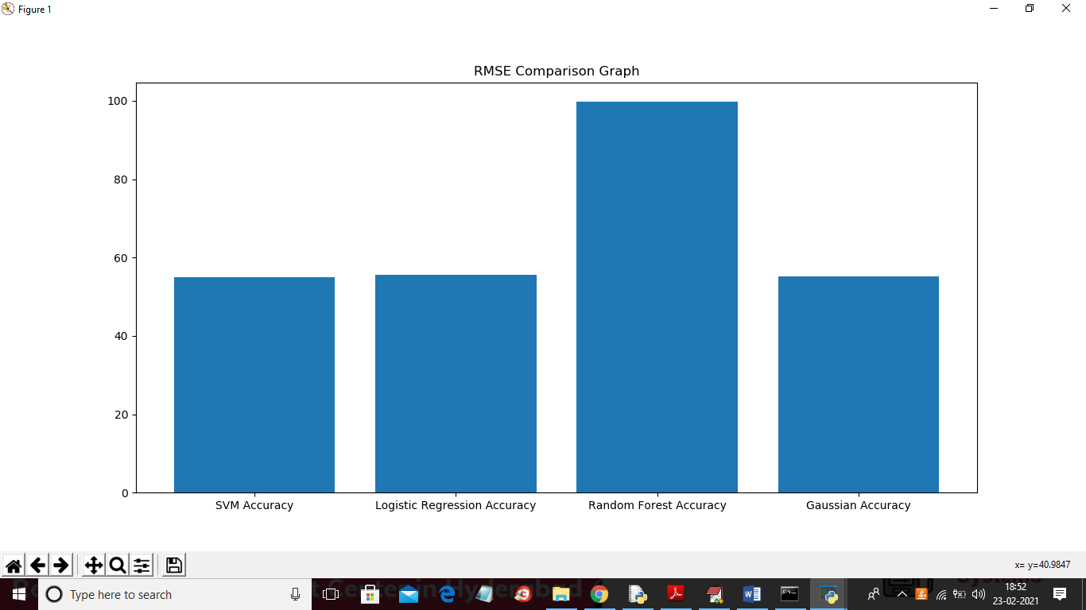

In above graph x-axis represents algorithm name and y-axis represents accuracy of those algorithms and from above graph we can conclude that Random Forest is giving better result. Now click on ‘Predict Eruption’ button and then upload test file and then application detect eruption activity from that uploaded time data

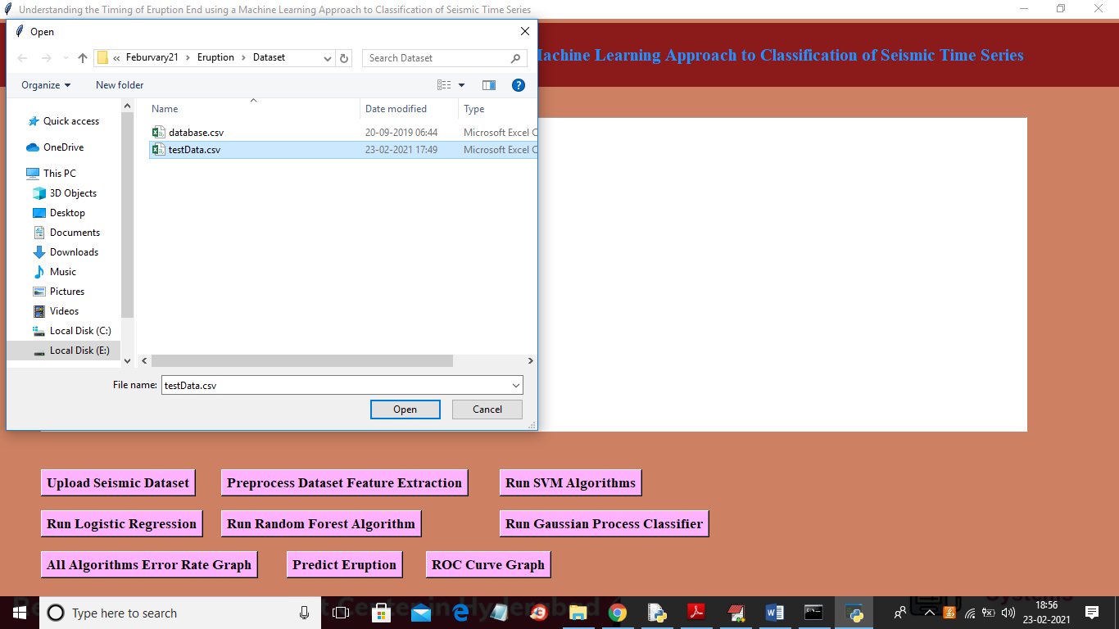

In above screen selecting and uploading ‘testData.csv’ file and then click on ‘Open’ button to get below result

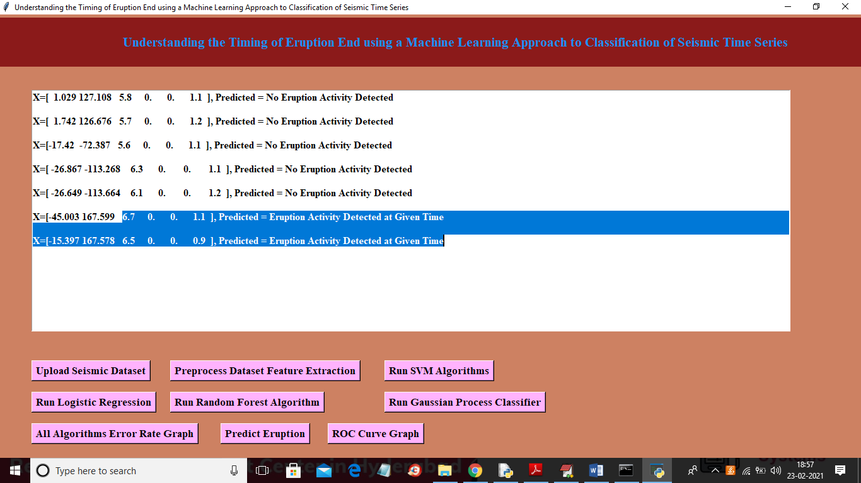

In above screen in square brackets we can see volcano test data and after square bracket we can see predicted result as ‘No eruption detected’ or ‘eruption detected’. In above screen we can see when classifier see magnitude value >=6.5 then it is classifying that record time as ‘eruption activity detected’