OpenLakehouse: A Canonical Interoperability Layer for AI Agent Access to Multi-Platform Lakehouse Data
2026-07-06

Summary
OpenLakehouse is an open-source Python reference implementation of the Canonical Lakehouse Model (CLM), an architectural pattern for giving AI agents uniform, governed access to data across heterogeneous lakehouse platforms. Existing approaches require agents to handle each platform’s API, namespace model, and permission system directly — coupling agent code to vendor-specific details that change independently. The CLM addresses this by defining three canonical domains — metadata, query results, and authorization decisions — into which any platform’s native responses are translated before reaching the agent.
OpenLakehouse exposes these canonical models through a Model Context Protocol (MCP) server (Anthropic 2024) that translates platform-native responses into CLM data structures implemented as Pydantic (Colvin and Pydantic Contributors 2024) models. AI agents invoke the same MCP tools and receive the same canonical response structures regardless of the underlying lakehouse platform.
Version 1 ships with adapters for Databricks (Unity Catalog and SQL Warehouse) (Databricks 2023) and AWS (Glue Data Catalog and Athena) (Amazon Web Services 2017). A documented LakehouseAdapter interface allows new platforms to be integrated without modifying the MCP server, CLM models, or agent code.

Statement of Need
Enterprise AI agents increasingly query data distributed across heterogeneous lakehouse platforms (Armbrust et al. 2021). Each platform exposes a different API surface: Databricks Unity Catalog uses a 3-level namespace and a synchronous DB-API cursor; AWS Glue and Athena use a flat database namespace and an asynchronous start-poll-fetch model; Snowflake, Google BigQuery, and Apache Spark (Zaharia et al. 2016) each add further variations.
Connecting an agent to multiple platforms directly requires per-platform response parsers, platform-specific branching on every tool call, and separate permission models. This coupling grows linearly: each additional platform adds an MCP endpoint, a response parser, and a governance configuration, with changes required in both server and agent code.
Unlike deploying one MCP server per platform, OpenLakehouse presents a single canonical interface that eliminates platform-specific parsing and governance logic from AI agents. Platform-specific logic is encapsulated in adapter classes, so agents always receive the same canonical response types — CanonicalCatalog, CanonicalSchema, CanonicalTable, CanonicalTableSchema, and CanonicalQueryResult — regardless of the underlying platform. Adding a new platform requires no changes to the agent integration code.
The intended users are data engineers and AI practitioners building agents over multi-vendor data estates. No existing open-source MCP server provides governed, multi-platform lakehouse access with a unified canonical response model.

Features
- Canonical Lakehouse Model. Metadata, query results, and authorization decisions are normalized into strongly typed Pydantic v2 models. Agents consume a consistent response schema regardless of which platform serves the data.
- Unified MCP interface. Five platform-independent tools — list_catalogs, list_schemas, list_tables, describe_table, and run_query — cover the full data discovery and query workflow. Tool signatures and response shapes are stable across platform changes.
- Supported platforms. Version 1 ships production adapters for Databricks (Unity Catalog + SQL Warehouse) and AWS (Glue + Athena). A Snowflake stub demonstrates the extension contract.
- Governance. A built-in policy engine enforces read-only, role-based access control with default-deny semantics. Policy is evaluated against a canonical resource scope before any adapter call, so governance cannot be bypassed. Authorization decisions carry structured reason codes for auditability.
- Extensibility. A new platform requires one adapter class implementing LakehouseAdapter and minor configuration edits — no changes to MCP tools, canonical models, or agent code.

Canonical Lakehouse Model
The CLM covers three domains:
- Metadata — catalogs, schemas, and tables are normalized into CanonicalCatalog, CanonicalSchema, and CanonicalTable objects, regardless of the platform’s namespace hierarchy.
- Query Results — output is wrapped in CanonicalQueryResult, carrying column definitions, typed rows, pagination metadata, and execution context.
- Authorization — decisions are returned as CanonicalAuthorizationDecision objects with structured reason codes, decoupling policy from platform permission systems.
Each adapter translates platform-native responses into canonical models via stateless mapper functions. Agents never receive raw platform output.
Platform | Native Namespace | Canonical Model
Databricks | catalog.schema.table | CanonicalTable
AWS Glue | database.table | CanonicalTable
Snowflake | schema.table | CanonicalTable

Implementation
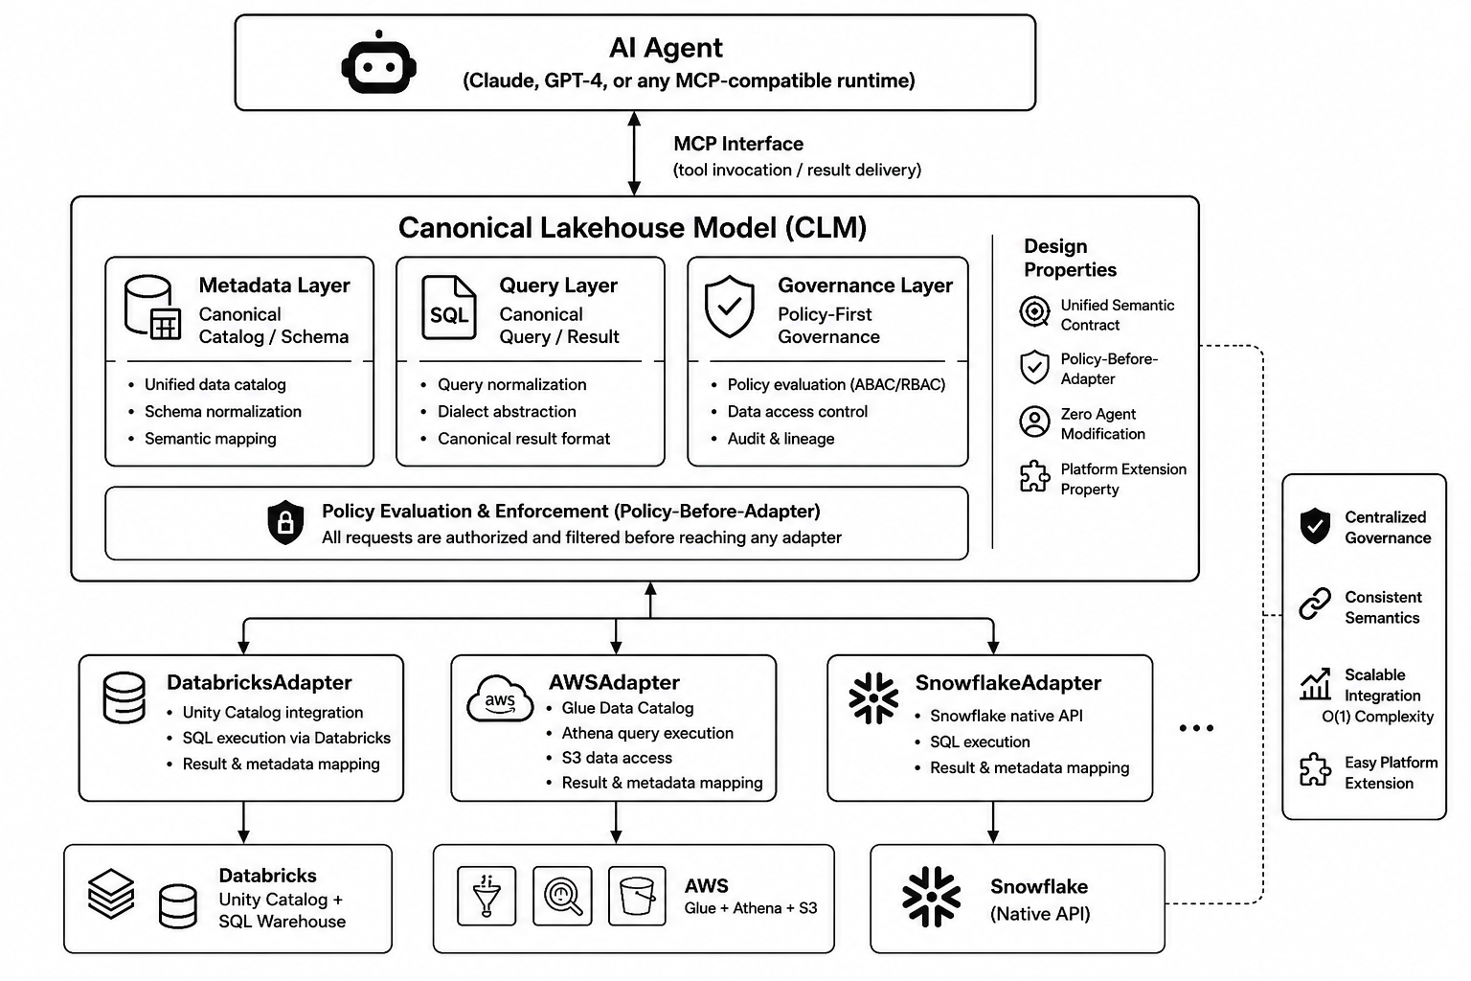
OpenLakehouse architecture. AI agents communicate through a single MCP interface backed by the CLM. Platform adapters translate native metadata and query results into canonical models, while policy evaluation occurs before adapter invocation to enforce consistent governance across all supported platforms.
OpenLakehouse is implemented across five packages — core, adapters, policy, identity, and server — wired together via FastMCP (Lowin 2024). The key design invariant is that the policy engine evaluates every request against a canonical resource scope before any adapter method is called, ensuring governance cannot be bypassed regardless of which platform is targeted.

Demonstration
The experiments/canonical_interface_demo.py script issues the same run_query MCP tool invocation against Databricks, AWS Athena, and a Snowflake stub, then compares the resulting CanonicalQueryResult objects. The invocation is identical for every platform:
raw = adapter.execute_query("SELECT 1 AS n", catalog=catalog, schema=schema)
result = query_result_to_canonical(raw, adapter.name, adapter.platform)
# result: CanonicalQueryResult — same four-field envelope for all platforms
Table 1 shows the output. The first five fields are structurally identical across platforms; the final two carry expected per-platform values within the same canonical envelope.
query_id=null for Databricks reflects a v1 connector limitation; the field is present in the schema. Athena returns scalar values as strings ("1" rather than 1); coercion is outside the CLM v1 scope.
Field | Databricks (live) | AWS Athena (live) | Snowflake (stub)
columns[0].name | "n" | "n" | "n"
columns[0].data_type | INTEGER | INTEGER | INTEGER
rows[0] | [1] | ["1"] | [1]
pagination.row_count | 1 | 1 | 1
pagination.truncated | False | False | False
execution.platform | "databricks" | "aws" | "snowflake"
execution.query_id | null | UUID | null
The Snowflake stub was created without modifying any core module, confirming that the adapter interface supports extension without affecting existing behavior.

Testing and Validation
The package includes 89 unit tests requiring no live cloud credentials. AWS tests run against moto (Moto Contributors 2024), an in-memory Glue/Athena mock; Databricks tests use pytest-mock to patch WorkspaceClient and databricks.sql.connect. The suite tests/unit/test_tools.py verifies the policy-before-adapter invariant: for each denied scenario, a mock adapter asserts none of its methods are called.
Five validation experiments in evaluation/ cover live Databricks and AWS environments: metadata conformance (100%, 8/8 operations), query result shape conformance (100%, 2/2 platforms), governance enforcement (100%, 8 authorization scenarios), agent coupling reduction (2→1 endpoints, 2→0 platform branches in agent code), and adapter extension (verified via the Snowflake stub).

Future Work
Planned adapters include Snowflake, Google BigQuery, Azure Fabric, and Apache Spark. Planned features include semantic metadata discovery, lineage-aware context retrieval, integration with enterprise identity providers (Azure Active Directory, Okta), and fine-grained column-level access control with audit logging.

Acknowledgements
The authors thank the developers and maintainers of FastMCP, Pydantic, moto, and the Model Context Protocol ecosystem for the foundational libraries that made this work possible.

References
Amazon Web Services. 2017. “AWS Glue: Serverless Data Integration Service.” https://aws.amazon.com/glue/.
Anthropic. 2024. “Model Context Protocol Specification.” https://modelcontextprotocol.io.
Armbrust, Michael, Ali Ghodsi, Reynold Xin, and Matei Zaharia. 2021. “Lakehouse: A New Generation of Open Platforms That Unify Data Warehousing and Advanced Analytics.” In 11th Annual Conference on Innovative Data Systems Research (CIDR 2021). https://www.cidrdb.org/cidr2021/papers/cidr2021_paper17.pdf.
Colvin, Samuel, and Pydantic Contributors. 2024. “Pydantic: Data Validation Using Python Type Hints.” https://docs.pydantic.dev.
Databricks. 2023. “Unity Catalog: Fine-Grained Governance for the Lakehouse.” https://www.databricks.com/product/unity-catalog.
Lowin, Jonathan. 2024. “FastMCP: The Fast, Pythonic Way to Build MCP Servers and Clients.” https://github.com/jlowin/fastmcp.
Moto Contributors. 2024. “Moto: Mock AWS Services.” https://github.com/getmoto/moto.
Zaharia, Matei, Reynold S. Xin, Patrick Wendell, Tathagata Das, Michael Armbrust, Ankur Dave, Xiangrui Meng, et al. 2016. “Apache Spark: A Unified Engine for Big Data Processing.” Communications of the ACM 59 (11): 56–65. https://doi.org/10.1145/2934664.

