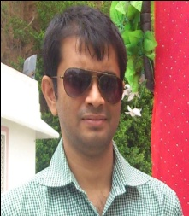Anup Nandi

PhD

Handling Publication Committee

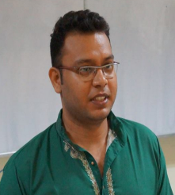Avinash Singh Rathore

PhD

Web Management Committee

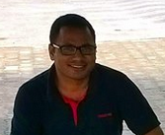Vijay Bhaskar Semwal

PhD

Publicity & Membership Committee

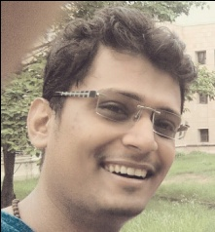Anush Bekal

PhD

Technical Event Management Committee