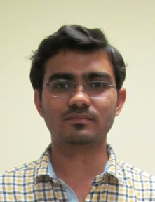**Prateek Katare**

M.Tech

**Email:**prateek.katare@gmail.com

Chairperson

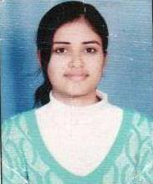**Neha Sakhuja**

M.Tech

**Email:** nehasakhuja2812@gmail.com

Vice Chairperson

### https://mi.iiita.ac.in/images/imi2012007.jpgShobhit Singh

M.Tech

**Email:** shobhit96@gmail.com

Secretary

### https://mi.iiita.ac.in/images/imi2012013.jpgRadhey Shyam Gupta

M.Tech

**Email:** shyamradhey.gpt@gmail.com

Treasurer