From Voice to Text and Back: ASR and TTS on Stuttered Speech
Naveen Kumar Moharajan · 7 October 2026
Course: 21CSE453T Speech Recognition · Activity: Unit 3 — From Voice to Text and Back (ASR and TTS)

Abstract
A CTC acoustic model transcribes stuttered speech verbatim (9.7% WER, both repetitions kept). An attention model with a built-in language model "repairs" it (0.9% WER against the intended text, 0 repetitions kept). We ran a 46 s recording of a panicked speaker through the full pipeline:
Speech → Feature Extraction → Log-Mel Spectrum → ASR → CTC → Text → TTS → Speech
The recording has 10 silent blocks of 600 ms or more (8.8 s in total, 38% of the recording is silence) and 2 word repetitions. Four ASR models were compared: wav2vec2-base, wav2vec2-large, Whisper-base and Whisper-small. CTC loss confirms what the models do. The acoustic model gives the verbatim transcript a loss of 86.4 nats, against 156.3 for the fluent one. The best transcript was turned back into speech with a SAPI5 TTS voice. The result has no mid-phrase blocks, and re-recognising it gives 7.3% WER.

1. Introduction and objective
The objective is to follow one stuttered utterance all the way from sound to text and back to sound, and to explain what happens at each stage. Stuttering (stammering) is a temporary disruption of the normal vocal pattern. The literature describes three main forms:
- Blocks: the airflow stops, giving silence in the middle of a word or phrase.
- Repetitions: a sound, syllable or whole word is said again ("I'm … I'm").
- Prolongations: a sound is stretched out.
These disruptions break the assumption most ASR systems make about speech: that it flows continuously at a steady rate. The questions this activity answers are:
1. What do the disruptions look like in the waveform and the log-Mel spectrum?
2. How does a CTC-based recogniser handle them, compared with an attention-based one?
3. What does WER measure on disfluent speech, and against which reference?
4. What is lost when the recognised text is re-synthesised by TTS?

2. Data and tools
The input is one recording: campus-voice-kore.wav. A student is late for an exam and asks a stranger for directions. Panic makes their voice lock up.
Property | Value
Duration | 46.04 s
Format | PCM 16-bit, mono, 24 kHz (resampled to 16 kHz for the ASR models)
Reference length | 113 words verbatim / 110 words fluent
Disruptions | 10 blocks ≥ 600 ms, 2 word repetitions, aborted word onsets, one broken-off phrase

Stage | Tool
Signal processing and features | NumPy, librosa 1.0 (hand-coded pre-emphasis, framing, FFT, Mel filterbank)
ASR models | Hugging Face Transformers: facebook/wav2vec2-base-960h, facebook/wav2vec2-large-960h-lv60-self, openai/whisper-base, openai/whisper-small
CTC loss and alignment | torch.nn.functional.ctc_loss + a Viterbi forced aligner written for this activity
WER / CER | Levenshtein dynamic program written for this activity, checked against jiwer
TTS | pyttsx3 → Windows SAPI5 (gTTS fallback on Colab)

Everything is in the notebook Activity_Unit3_ASR_TTS.ipynb, which runs top to bottom on a CPU. Every figure and table below is that notebook's output, in its order. The reference transcripts were reconstructed by comparing the four model outputs.

3. Speech signal: the waveform
The waveform shows the disruption directly. Speech arrives in short bursts separated by flat stretches, and 10 of those stretches last 0.6–1.25 s. A fluent speaker usually pauses for less than 250 ms between words.
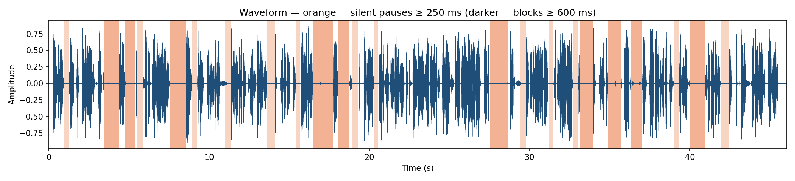
Figure 1. Waveform at 16 kHz. Orange = silent gaps ≥ 250 ms; darker orange = blocks ≥ 600 ms.
The gaps were found with energy-based voice activity detection: frames more than 35 dB below the peak count as silence (librosa.effects.split). The peak amplitude is 0.89 and the RMS is 0.150, so the signal is clean and loud. The silence is therefore the speaker's, not a recording artefact.

4. Feature extraction and the log-Mel spectrum
Feature extraction turns 736,640 samples into 4,605 frames of 80 log-Mel values each. Each frame describes 25 ms of sound the way the ear hears it. The steps were coded by hand:
1. Pre-emphasis. Boosts the high frequencies, which are weaker in voiced speech.
$$y[n]=x[n]−0.97x[n−1]$$
2. Framing. 25 ms windows (400 samples) with a 10 ms hop (160 samples). Over 25 ms, speech is approximately stationary.
3. Windowing. A Hamming window tapers the frame edges and reduces spectral leakage.
4. Power spectrum. A 512-point FFT of each frame.
$$P_{k}=\frac{1}{N}{\left|\sum_{n=0}^{N−1}{y}[n]w[n]e^{−j2πkn/N}\right|}^{2}$$
5. Mel filterbank. 80 triangular filters, evenly spaced on the Mel scale. They are narrow at low frequencies and wide at high ones, like the cochlea.
$$m=2595\log_{10}\left(1 + \frac{f}{700}\right)$$
6. Log compression. 10·log₁₀ of each filter energy, in dB, because perceived loudness is roughly logarithmic.
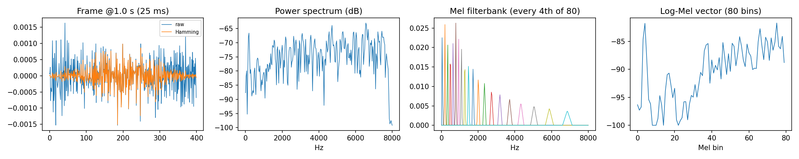
Figure 2. Left to right: one 25 ms frame, raw and after the Hamming window; its power spectrum; the Mel filterbank (every 4th filter shown); the resulting 80-value log-Mel vector.
Stacking the frame vectors over time gives the log-Mel spectrogram (Figure 3). Speech shows as bright vertical stripes, with harmonics and formants below about 1 kHz. The blocks show as dark vertical bands with no energy in any band, for example at 16.5–17.7 s and 27.5–28.7 s. This is the time–frequency view of the stutter. MFCCs are the discrete cosine transform of the log-Mel vector. They are shown below it, normalised per coefficient.
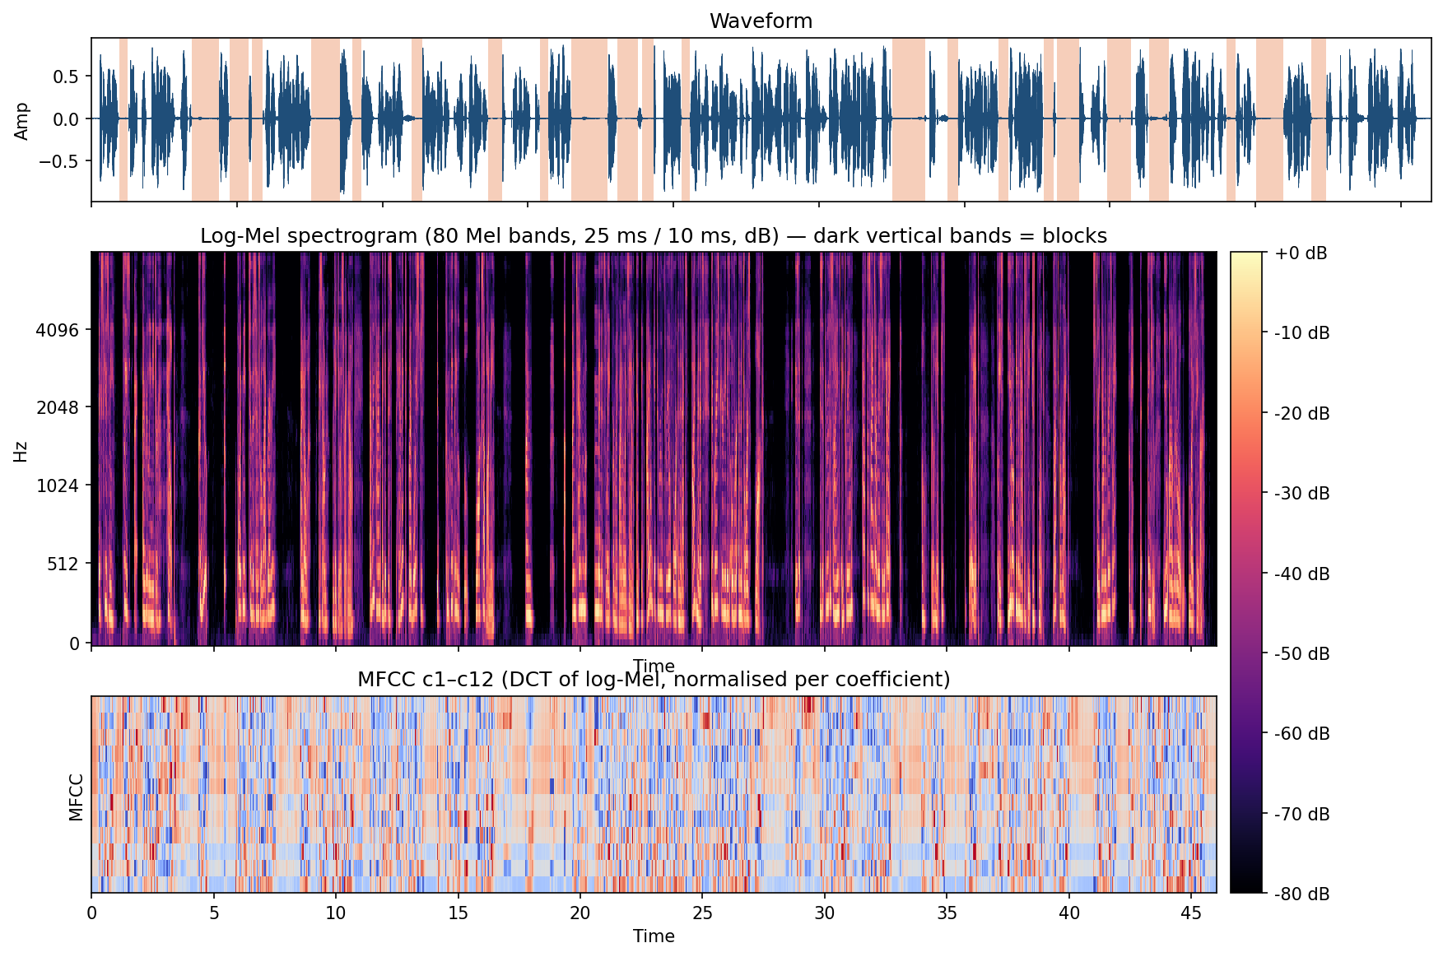
Figure 3. Waveform (top), log-Mel spectrogram, 80 bands, 25 ms / 10 ms (middle), MFCC c1–c12 (bottom).

5. Disfluency analysis
The speaker is silent for 38% of the 46 s: 28.4 s of speech against 17.6 s of silence. Of 23 pauses of 250 ms or more, 10 are blocks of 600 ms or more, adding up to 8.8 s. A block at a sentence boundary can be a normal breath. A block in the middle of a phrase is the stutter.
Block | Start (s) | Duration (s) | Context (… = the block) | Position
1 | 3.46 | 0.91 | "need your help. … Could you" | sentence boundary
2 | 4.75 | 0.64 | "Could you … point me" | mid-phrase
3 | 7.54 | 0.99 | "central library? … I know" | sentence boundary
4 | 16.50 | 1.25 | "locks up on me. … I'm" | sentence boundary
5 | 18.08 | 0.69 | "I'm … I'm ten minutes" (two aborted onsets inside) | mid-phrase + repetition
6 | 27.52 | 1.14 | "the doors lock. … Is it" | sentence boundary
7 | 33.17 | 0.78 | "missing and I … oh" (phrase abandoned) | mid-phrase
8 | 34.91 | 0.82 | "oh, brilliant, just … brilliant" | mid-phrase
9 | 36.34 | 0.69 | "just brilliant. … Please" | sentence boundary
10 | 40.02 | 0.94 | "left or right? … Straight" | sentence boundary

Energy-based detection finds 4 mid-phrase blocks. Word-level forced alignment (Section 8) finds 8. The extra four (before "completely", "locks", "minutes" and the second "is it") are stretches that are low in energy but not silent: hesitations and breathy onsets that VAD counts as speech. The speaking rate is 147 words per minute including the blocks. Removing the 8.8 s of blocks gives about 182 wpm, so the speaker talks quickly between lock-ups. This burst–block pattern is typical of anxiety-related stuttering.

6. ASR architecture
The two model families differ in one decisive place: how the output text is produced. The CTC model labels every 20 ms frame independently. Whisper writes the text token by token, and every token depends on the ones before it.
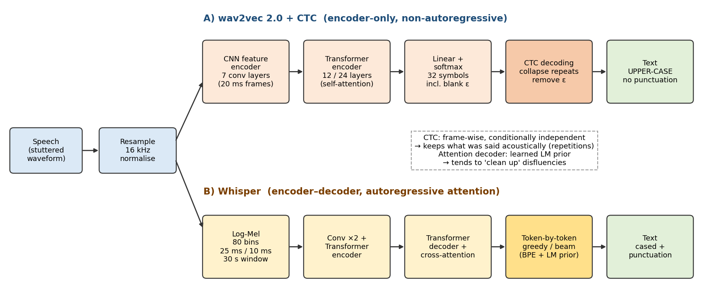
Figure 4. ASR architecture. A: wav2vec 2.0 + CTC. B: Whisper encoder–decoder.
A. wav2vec 2.0 + CTC (Baevski et al., 2020)
- Input: the raw waveform. A 7-layer CNN feature encoder learns its own filterbank and outputs one 512-dimensional vector every 20 ms (stride 320 samples).
- Context: a Transformer encoder (12 layers in base, 24 in large) adds context from the whole utterance through self-attention.
- Output: a linear layer + softmax over 32 symbols: the 26 letters, apostrophe, the word separator |, the CTC blank ε, and special tokens.
- Training: self-supervised pre-training on unlabelled audio, then fine-tuning with CTC loss on 960 h of LibriSpeech.
B. Whisper (Radford et al., 2022)
- Input: an 80-band log-Mel spectrogram over 30 s windows, computed exactly as in Section 4.
- Encoder: 2 convolution layers, then a Transformer encoder.
- Decoder: an autoregressive Transformer decoder that reads the encoder output through cross-attention and emits byte-pair-encoded tokens, with punctuation and capitals.
- Training: 680,000 h of weakly supervised web audio and transcripts. The decoder therefore behaves like a strong language model.
The consequence for stuttering is the hypothesis this activity tests. A CTC model has no internal language model and no memory of what it has already emitted, so it should transcribe what is acoustically present, repetitions included. Whisper's decoder has learned that fluent text is far more likely, so it should tend to "repair" the disfluency.

7. ASR output: four transcripts
Both CTC models wrote "I'M I'M" and "IS IT IS IT". Whisper-small wrote neither. The disfluent parts are in bold; the other errors are listed in Section 9.
Reference, verbatim (what was said, 113 words)
excuse me please i really need your help could you point me to the central library i know i sound ridiculous right now every time i get this panicked my voice just completely locks up on me i'm i'm ten minutes late for my final exam and if i don't get to room three oh four in the next five minutes the grace period is over and the doors lock is it is it through the science atrium half the signs are missing and i oh brilliant just brilliant please you don't even have to speak just point left or right straight down the breezeway okay thank you you are a literal lifesaver
The intended (fluent) reference is the same text with the two repetitions removed (110 words).
wav2vec2-base-960h (CTC, 94 M parameters)
EXCUSE ME PLEASE I REALLY NEED YOUR HELP COULD YOU POINT ME TO THE CENTRAL LIBRARY I KNOW I SOUND RIDICULOUS RIGHT NOW EVERY TIME I GET THIS PANIC MY VOICE JUST COMPLETELY LOCKS UP ON ME I'M I'M TEN MINUTES LATE FOR MY FINAL EXAMINE AND IF I DON'T GET TO ROOM THREE OR FOUR IN THE NEXT FIVE MINUTES THE GREACE PERIOD IS OVER AND THE DOORS LOCK IS IT IS IT THROUGH THE SCINS ATRIUM HALF THE SCIGNS ARE MISSING AND I OH BRILLIANT JUST BRILLIANT PLEASE YOU DON'T EVEN HAVE TO SPEAK JUST POINT LEFT A RIGHT STRAIGHT DOWN THE RACEWAY THANK YOU YOU ARE A LITERAL LIFE SAVOR
wav2vec2-large-960h-lv60-self (CTC, 315 M)
EXCUSE ME PLEASE I REALLY NEED YOUR HELP COULD YOU POINT ME TO THE CENTRAL LIBRARY I KNOW I SOUND RIDICULOUS RIGHT NOW EVERY TIME I GET THIS PANICD MY VOICE JUST IT COMPLETELY LOCKS UP ON ME I'M I'M TEN MINUTES LATE FOR MY FINAL EXAM AND IF I DON'T GET TO ROOM THREE O FOUR IN THE NEXT FIVE MINUTES THE GRACE PERIOD IS OVER AND THE DOORS LOCK IS IT IS IT THROUGH THE SINS ATRIUM HALF THE SIGNS ARE MISSING AND I OH BRILLIANT JUST BRILLIANT PLEASE YOU DON'T EVEN HAVE TO SPEAK JUST POINT LEFT OR RIGHT STRAIGHT DOWN THE RAESEWAY OK THANK YOU YOU ARE A LITERAL LIFE SAVER
whisper-base (attention, 73 M)
Excuse me, please, I really need your help. Could you point me to the central library? I know, I sound ridiculous right now. Every time I get this panic, my voice just completely locks up on me. I'm... I'm 10 minutes late for my final exam. And if I don't get to Room 304 in the next 5 minutes, the Grace period is over and the doors lock. Is it through the science atrium? Half the signs are missing and I... Oh, brilliant. Just brilliant. Please, you don't even have to speak. Just point. Left or right? Straight down the breezeway? Okay. Thank you. You are a literal lifesaver.
whisper-small (attention, 242 M)
Excuse me, please, I really need your help. Could you point me to the central library? I know, I sound ridiculous right now. Every time I get this panicked, my voice just completely locks up on me. I'm ten minutes late for my final exam, and if I don't get to room 304 in the next five minutes, the grace period is over and the doors lock. Is it through the signs, Atrium? Half the signs are missing and I... Oh, brilliant, just brilliant. Please, you don't even have to speak, just point. Left or right? Straight down the breezeway? Okay, thank you. You are a literal lifesaver.
Before scoring, every output is normalised the same way: lower case, punctuation removed, digits written out ("304" → "three oh four", "10" → "ten"), "OK" → "okay". Without this, Whisper would be penalised for formatting rather than recognition.

8. Connectionist Temporal Classification (CTC)
CTC lets a network learn speech-to-text without knowing which frame belongs to which letter. It does this by adding up the probability of every possible alignment. On this recording it also explains why the CTC models keep the stutter.

8.1 The problem
The encoder emits T = 2,301 frames (one per 20 ms) for 46 s of audio. The verbatim transcript has U = 574 characters. T is much larger than U, and the frame-to-character alignment is unknown, so ordinary per-frame cross-entropy cannot be used.

8.2 The method
1. Blank symbol. A special symbol ε means "no new character here". At each frame the network outputs a probability distribution pₜ over {ε, A–Z, ', |}.
2. Collapse function B. A frame-level path π becomes text in two steps: (a) merge consecutive repeated symbols, then (b) delete every ε. A blank between two identical letters is what keeps a real double letter, as in "LL".
3. Sum over alignments. The probability of a transcript y is the sum over every path that collapses to it:
$$P(y∣x)=\sum_{π∈ℬ^{−1}(y)}{\prod_{t=1}^{T}{p_{t}}}(π_{t})$$
4. Forward algorithm. The sum is computed efficiently by dynamic programming over the extended label sequence ε y₁ ε y₂ … ε y_U ε, which has 2U + 1 states, in O(T · U) time.
$$α_{t}(s)=\left(α_{t−1}(s)+α_{t−1}(s−1)+δ_{s}α_{t−1}(s−2)\right)p_{t}(l_{s})$$
Here δₛ = 1 when lₛ ≠ ε and lₛ ≠ lₛ₋₂ (a skip over the blank is allowed), and 0 otherwise.
5. Loss and decoding. The training loss is −log P(y | x). Decoding is either greedy (take the most likely symbol per frame, then apply B) or a beam search, optionally with a language model.

8.3 CTC on the stutter: the collapse rule on real frames
The notebook takes the frame-by-frame argmax of wav2vec2-base over 15.6–20.2 s, which covers "locks up on me | I'm … I'm | ten":
1) raw frame argmax : _________LL__OCC_K_SS||__UP_||__ON_||M__E_|||______…______I__'M_||______…______I_'M__||_T____ENN____||||
2) merge repeats : _L_OC_K_S|_UP_|_ON_|M_E_|_I_'M_|_I_'M_|_T_EN_|
3) drop blanks (_) : LOCKS UP ON ME I'M I'M TEN

64% of all frames are blank. The 1.8 s block between the two "I'm"s is about 90 consecutive ε frames: it collapses to nothing and leaves no trace in the text. The repetition is two separate runs of spikes with blanks between them, so B keeps both copies. Merging only happens between adjacent identical symbols.
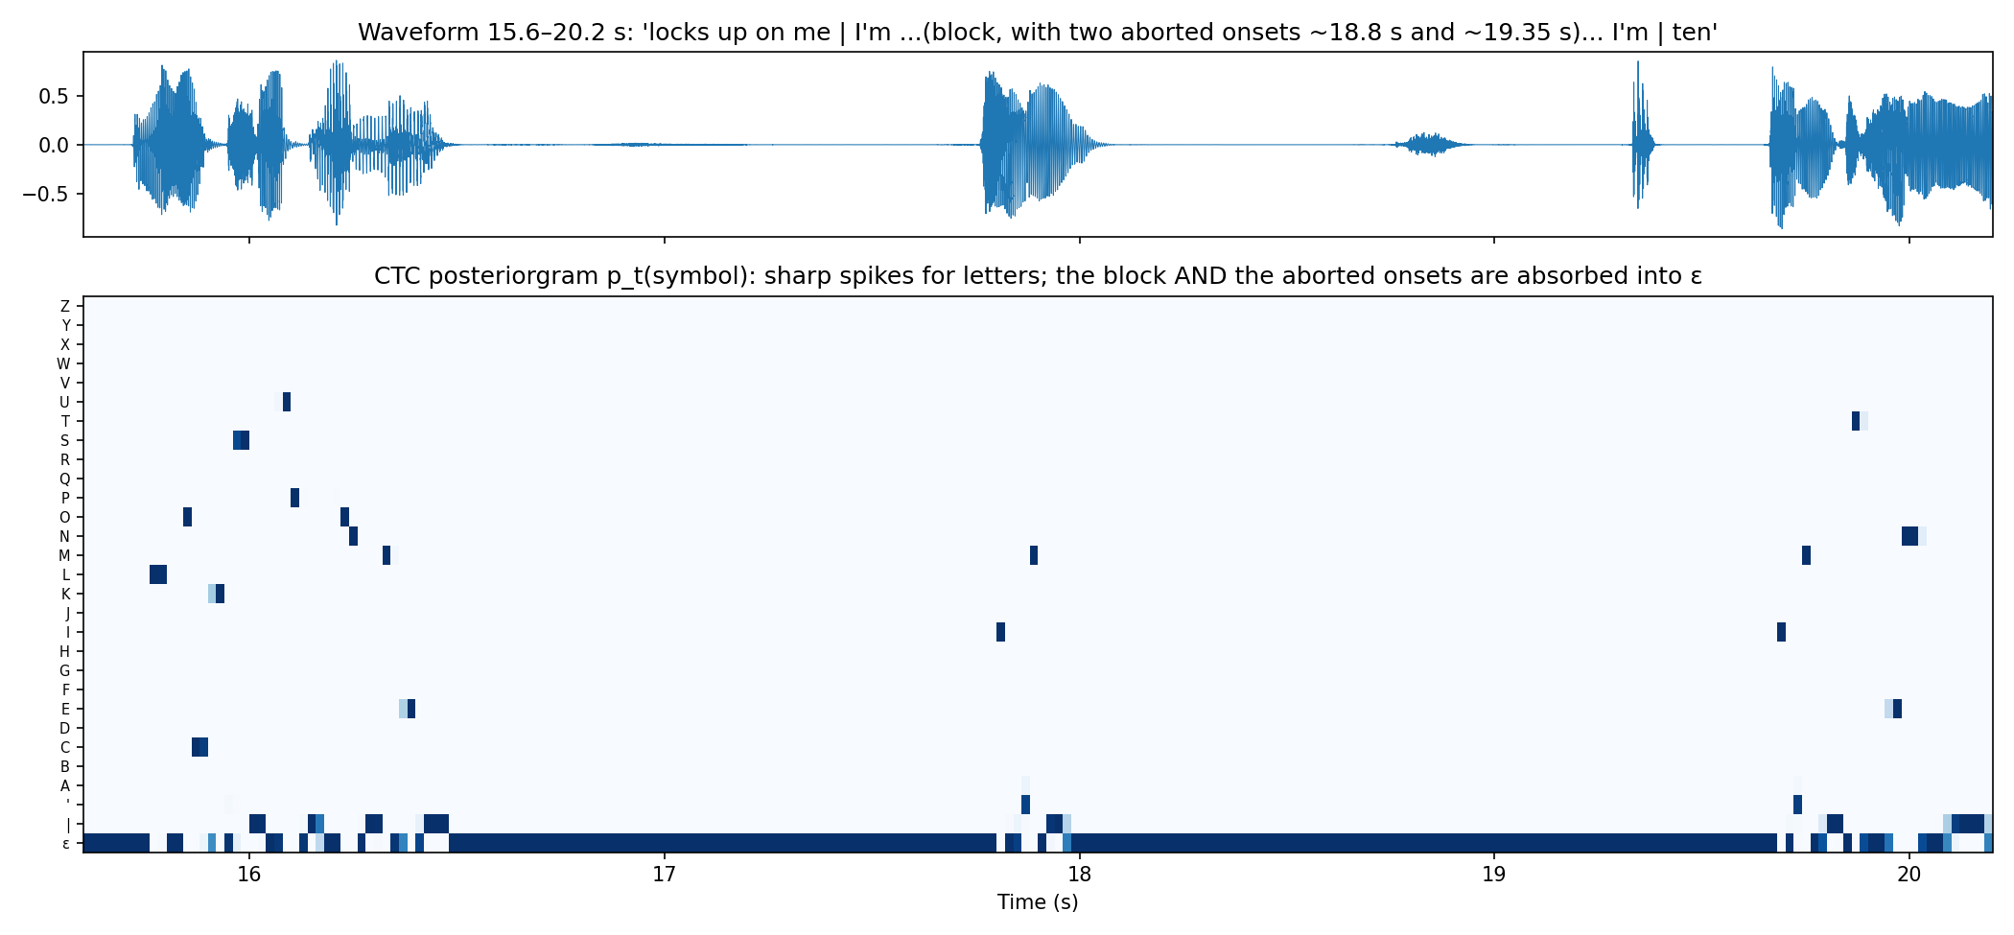
Figure 5. CTC posteriorgram pₜ(symbol), 15.6–20.2 s. Letters appear as one- or two-frame spikes. The block, and the two aborted onsets at about 18.8 s and 19.35 s, are absorbed into ε.
The aborted onsets matter. They are audible bursts that never become a full syllable, and the model gives them no letter. This is a known limitation: CTC removes sound and part-word repetitions ("p-p-point"), but keeps whole-word repetitions.

8.4 CTC loss: which transcript does the acoustic model believe?
The same wav2vec2-base outputs were scored against three transcripts with torch.nn.functional.ctc_loss (−log P(y | x), summed over all alignments):
Transcript scored | Labels U | −log P(y | x) (nats) | Per label
Model's own greedy output | 567 | 31.5 | 0.056
Verbatim reference (with repetitions) | 574 | 86.4 | 0.151
Intended / fluent reference | 564 | 156.3 | 0.277

Removing the repetitions makes the transcript 70 nats less likely, which is a likelihood ratio of about e⁷⁰. In other words, the acoustic model is certain that the repetitions were spoken. Any "clean-up" therefore has to come from a language model, not from the acoustics.

8.5 Forced alignment: word timestamps from CTC
A Viterbi pass over the same trellis keeps only the single best path for the verbatim transcript (a max instead of a sum). This gives start and end times for every word. Gaps of 0.6 s or more before a word that does not follow punctuation are the mid-phrase blocks:
- before "point": 1.34 s
- before "completely": 0.92 s
- before "locks": 0.84 s
- before the second "I'm": 1.78 s
- before "minutes": 0.70 s
- before the second "is": 0.78 s
- before "oh": 1.36 s
- before the second "brilliant": 0.96 s
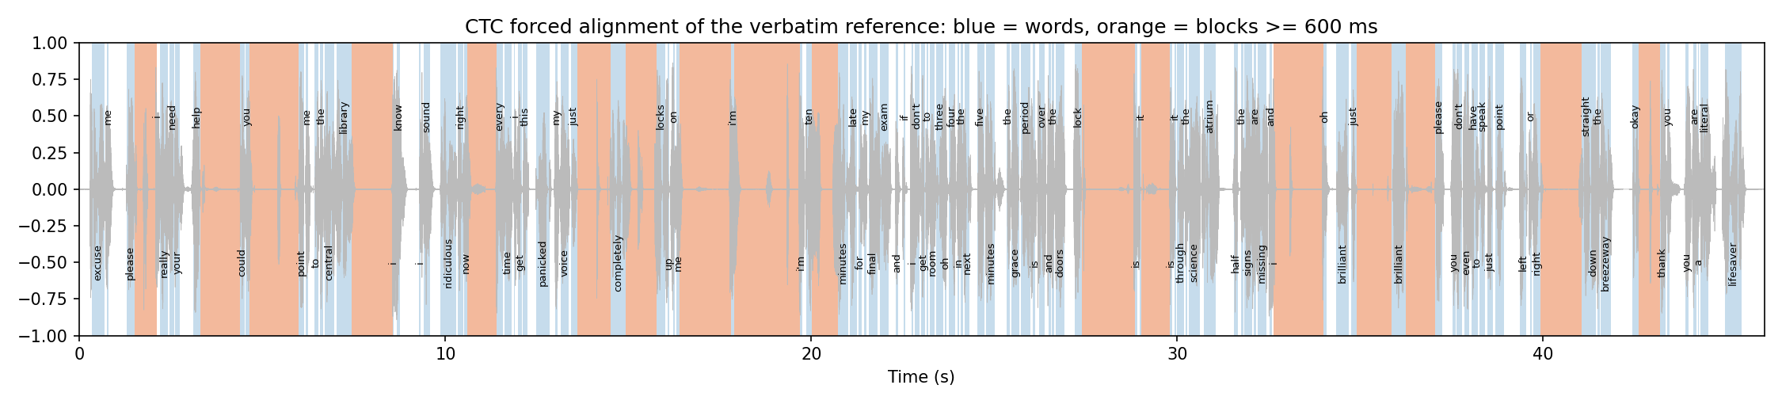
Figure 6. CTC forced alignment of the verbatim reference. Blue = aligned words; orange = gaps of 600 ms or more before a word.

9. WER calculation
wav2vec2-base scores 9.73% WER against the verbatim reference: 11 errors in 113 words. The hand-written dynamic program and jiwer give exactly the same number.
$$WER=\frac{S+D+I}{N}$$
S = substitutions, D = deletions, I = insertions, N = number of reference words. The counts come from the minimum word-level edit (Levenshtein) distance:
$$D(i,j)=min\left\{D(i−1,j−1)+\left[r_{i} ≠ h_{j}\right],D(i−1,j)+1,D(i,j−1)+1\right\}$$
The table is filled from D(0, j) = j and D(i, 0) = i. A backtrace from D(N, H) then labels each error. CER is the same calculation on characters.
Worked example: wav2vec2-base against the verbatim reference
# | Type | Reference | Hypothesis | Cause
1 | S | panicked | panic | weak word-final "-ed"
2 | S | exam | examine | no LM; acoustic over-segmentation
3 | S | oh | or | "three oh four" said fast
4 | S | grace | greace | character-level spelling, no LM
5 | S | science | scins | spelling
6 | S | signs | scigns | spelling
7 | S | or | a | reduced function word
8 | D | breezeway | — | merged with "okay" → "raceway"
9 | S | okay | raceway | (as above)
10 | I | — | life | compound split
11 | S | lifesaver | savor | (as above)

WER = (9 + 1 + 1) / 113 = 11 / 113 = 9.73%
None of the 11 errors is caused by the stutter. Both repetitions were matched correctly, and the blocks produced no spurious words. Every error is a spelling or word-boundary mistake that a language model would fix. This is the trade-off between CTC and attention seen in Section 10.

10. ASR comparison
Which model is "best" depends on the reference. Against what was said, whisper-base wins (2.7%). Against what was meant, whisper-small wins (0.9%). Only the CTC models keep both repetitions.
Model | Architecture | Params (M) | WER verbatim | S/D/I verbatim | WER fluent | S/D/I fluent | CER verbatim | Repetitions kept (of 2) | Punct. | RTF (CPU)
wav2vec2-base-960h | wav2vec2 + CTC (greedy) | 94 | 9.7% | 9/1/1 | 12.7% | 9/1/4 | 4.4% | 2 | no | 0.07
wav2vec2-large-960h-lv60-self | wav2vec2 + CTC (greedy) | 315 | 6.2% | 5/0/2 | 9.1% | 5/0/5 | 2.4% | 2 | no | 0.19
whisper-base | Whisper encoder–decoder | 73 | 2.7% | 1/2/0 | 1.8% | 1/0/1 | 1.6% | 1 | yes | 0.08
whisper-small | Whisper encoder–decoder | 242 | 3.5% | 1/3/0 | 0.9% | 1/0/0 | 2.4% | 0 | yes | 0.17

RTF = processing time ÷ audio duration on a laptop CPU; below 1 is faster than real time.
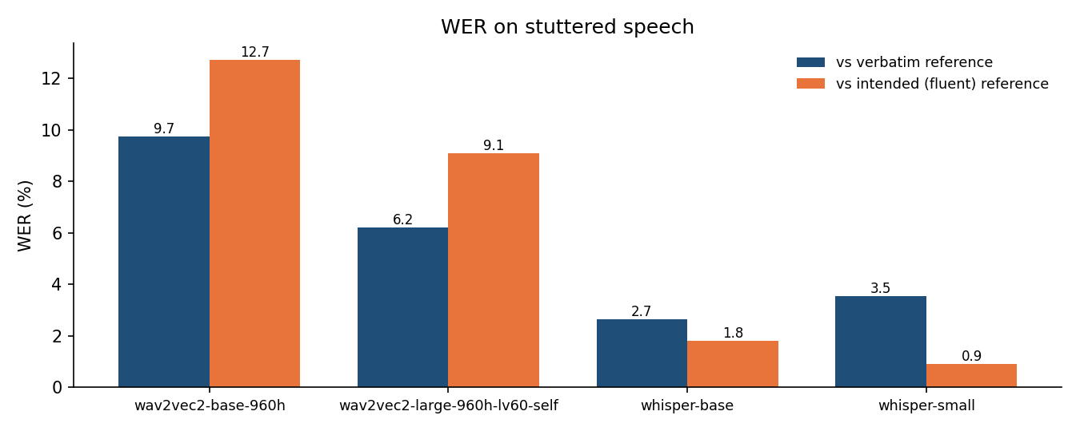
Figure 7. WER against the verbatim reference (blue) and the intended reference (orange).
How to read the table
- CTC models: verbatim WER is lower than fluent WER. Their fluent-reference errors include 3 extra insertions (base 4 vs 1, large 5 vs 2). Those insertions are exactly the repeated words "i'm", "is", "it". The models are right about the audio and are penalised only because the reference left the repetitions out.
- Whisper: the opposite. whisper-small's verbatim deletions (D = 3) are exactly the three repeated words it dropped. Its decoder's language model rewrote "I'm I'm" as "I'm". whisper-base kept the first repetition ("I'm... I'm") and dropped the second. The "clean-up" is therefore probabilistic, not guaranteed.
- Language model vs acoustics. All of Whisper's other errors are tiny ("panic" for "panicked", "signs, Atrium" for "science atrium"). wav2vec2's errors are spellings ("SCIGNS", "GREACE") that no LM corrected. Scaling wav2vec2 from base to large (3.4× the parameters) cut verbatim WER from 9.7% to 6.2%.
- Speed. All four run 5–14× faster than real time on CPU. The base-size models are about 2.5× faster than the larger ones.
Which to use. For clinical stuttering assessment (counting repetitions and blocks), use CTC: it is faithful to the acoustics. For captions or voice assistants, where the user wants the intended message, use Whisper: its language model repairs the disfluency. A single WER number hides this difference, so disfluent speech should always be scored against both references.

11. Text → TTS → Speech
The re-synthesised speech keeps the message and loses the stutter: 0 mid-phrase blocks and 0 repetitions, against 8 and 2 in the original. Played back through ASR, it is recognised at 7.3% WER.
The whisper-small transcript (best fluent WER, with punctuation) was fed to the offline Windows SAPI5 engine through pyttsx3, using the Microsoft Zira voice at 165 words per minute. The output is saved as outputs/tts_output.wav. A SAPI5 voice is a concatenative/parametric system, not a neural one. It reads the text with fixed prosody rules: a pause at each comma and full stop, and none anywhere else.
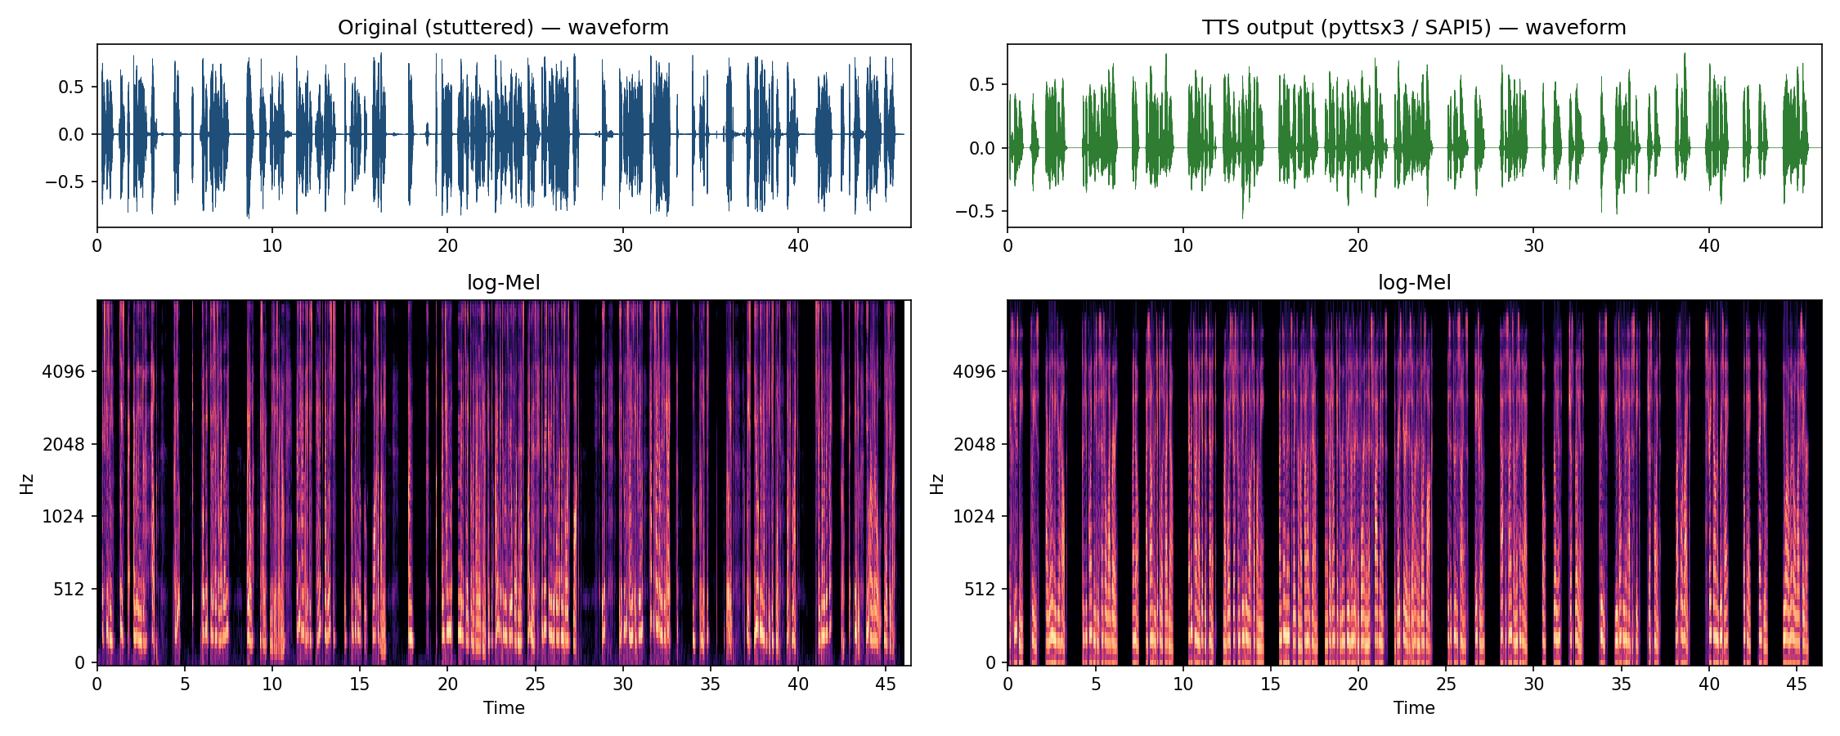
Figure 8. Original stuttered speech (left) vs TTS output (right): waveforms (top) and log-Mel spectrograms (bottom), on the same time scale.
Measure | Original (stuttered) | TTS output
Duration | 46.0 s | 46.4 s
Speaking rate | 147 wpm | 142 wpm
Silence ratio | 38% | 33%
Pauses ≥ 600 ms at punctuation (grammatical) | 9 | 14
Pauses ≥ 600 ms mid-phrase (blocks) | 8 | 0
Word repetitions | 2 | 0

The two recordings last almost the same time, but the silence sits in different places. The TTS voice puts all of its pauses at punctuation, and the stutter's 8 mid-phrase blocks are gone. In the spectrogram, the TTS output has regular, evenly spaced bursts with steady formants. The original has irregular bursts and long dark blocks.
Round trip. The TTS audio was passed back through wav2vec2-base: Text → TTS → Speech → ASR. The result is 7.3% WER against the text it was made from (S = 6, D = 0, I = 2, N = 110). That is lower than the 9.7% on the original speech. The remaining errors come from the TTS engine's own text normalisation (it read "304" as "three hundred and four") and from synthetic vowels ("breezeway" → "briesway"). None of them come from disfluency.
The round trip shows the main limitation of this pipeline. ASR followed by TTS produces fluent speech, but loses information. The speaker's identity, voice quality, emotional state (panic) and timing pattern are all gone. Only the words survive. That is useful for assistive communication, where a person who stutters may want a fluent voice. But a clinician analysing the stutter would need the original audio.

12. Discussion and conclusion
Stuttering is visible at every stage of the pipeline. What happens to it depends on whether the decoder has a language model.
Stage | What happened to the stutter | Evidence
Waveform | Blocks visible as flat silence | 10 blocks ≥ 600 ms, 38% silence (Fig. 1)
Log-Mel | Blocks are dark, energy-free columns | Fig. 3
CTC acoustic model | Blocks → runs of ε. Whole-word repetitions kept. Aborted onsets dropped. | 64% blank frames; repetitions kept 2/2 (Fig. 5)
CTC loss | Acoustics strongly prefer the verbatim text | 86.4 vs 156.3 nats
Attention decoder (Whisper) | Repetitions removed, though not always | whisper-small 0/2 kept, whisper-base 1/2
TTS | All disfluency removed; prosody becomes rule-based | 0 mid-phrase blocks, round trip 7.3% WER

Conclusions
1. The log-Mel representation exposes blocks clearly as energy-free time regions. A simple energy-based detector found all 10 long blocks. Forced alignment refined this to 8 mid-phrase disruptions.
2. CTC is acoustically faithful. Its conditionally independent frame outputs, with the blank symbol, absorb silence without inserting words, and keep whole-word repetitions. Its weakness is spelling, because it has no language model (9.7% → 6.2% WER from base to large).
3. Attention models normalise disfluency through their learned language prior. They score better against the intended message (0.9%), but erase evidence of the stutter, and not consistently.
4. WER must be reported against both references for disfluent speech. The same output can be "wrong" or "right" depending on whether the task is transcription or understanding.
5. ASR → TTS works as a fluency-restoring channel (7.3% round-trip WER). It discards speaker identity, emotion and timing.
Limitations
- There is one recording and one speaker. The voice may itself be synthetic, so these figures illustrate behaviour and are not population statistics.
- The verbatim reference was reconstructed from the four model outputs, not from a human transcription. "Science atrium" vs "signs, atrium" and "panicked" vs "panic" are the least certain words.
- Greedy CTC decoding was used, with no external language model. A CTC + n-gram LM beam search would sit between the two families.
- Sound and part-word repetitions ("p-p-") cannot be scored with word-level WER. They would need a phone-level reference.
Future work. Fine-tune a CTC model on a stuttering corpus such as SEP-28k or FluencyBank, adding disfluency tokens ([BLOCK], [REP]), so that it transcribes the words and labels the disruption.

13. Three-minute demonstration script
The demo runs the notebook live, section by section. Each step gives the time, what to show on screen and what to say.
Time | Show on screen | Say
0:00–0:20 | Title cell; play the original audio | "This is a 46-second recording of a panicked student whose voice keeps locking up. Our goal: follow it from speech to text and back to speech."
0:20–0:45 | Fig. 1 waveform, Fig. 3 log-Mel | "Look at the waveform: 10 silent blocks over 600 ms, 38% silence. In the log-Mel spectrogram the blocks are these dark columns with no energy at all."
0:45–1:05 | Fig. 2 feature steps | "Features: pre-emphasis, 25 ms Hamming frames every 10 ms, FFT, 80 Mel filters, log. That gives 4,605 frames of 80 numbers."
1:05–1:25 | Fig. 4 architecture | "Two families. wav2vec2 labels every 20 ms frame and decodes with CTC. Whisper is an encoder–decoder with a built-in language model."
1:25–2:05 | Collapse printout, Fig. 5 posteriorgram, CTC loss table | "CTC adds a blank symbol. Merge repeats, drop blanks. The 1.8-second block is 90 blank frames and vanishes, but 'I'm I'm' are separate spikes, so both survive. The CTC loss confirms the model is sure the repetition was spoken: 86 versus 156."
2:05–2:35 | WER worked example, comparison table, Fig. 7 | "WER is (S + D + I) / N. wav2vec2-base: 11 errors in 113 words, 9.7%. Every error is spelling, none is the stutter. Whisper-small scores 0.9% against the intended text, because it deleted the repetitions. CTC is faithful; Whisper cleans up."
2:35–3:00 | Play the TTS audio; Fig. 8; TTS table | "Finally, TTS. Same message, same length, but zero mid-phrase blocks. Run back through ASR it scores 7.3% WER. The words survive; the voice, the panic and the stutter do not."

Before presenting: run the whole notebook once, so the models are cached and every figure is visible. Have outputs/tts_output.wav ready to play.

References
1. Graves, A., Fernández, S., Gomez, F., & Schmidhuber, J. (2006). Connectionist Temporal Classification: Labelling unsegmented sequence data with recurrent neural networks. Proc. ICML, 369–376.
2. Baevski, A., Zhou, H., Mohamed, A., & Auli, M. (2020). wav2vec 2.0: A framework for self-supervised learning of speech representations. Advances in NeurIPS 33. arXiv:2006.11477
3. Radford, A., Kim, J. W., Xu, T., Brockman, G., McLeavey, C., & Sutskever, I. (2022). Robust speech recognition via large-scale weak supervision (Whisper). arXiv:2212.04356
4. Panayotov, V., Chen, G., Povey, D., & Khudanpur, S. (2015). LibriSpeech: An ASR corpus based on public domain audio books. Proc. ICASSP, 5206–5210.
5. Davis, S., & Mermelstein, P. (1980). Comparison of parametric representations for monosyllabic word recognition in continuously spoken sentences. IEEE Trans. ASSP, 28(4), 357–366.
6. Lea, C., Mitra, V., Joshi, A., Kajarekar, S., & Bigham, J. P. (2021). SEP-28k: A dataset for stuttering event detection from podcasts with people who stutter. Proc. ICASSP.
7. Jurafsky, D., & Martin, J. H. (2024). Speech and Language Processing (3rd ed. draft), Ch. 16: Automatic Speech Recognition and Text-to-Speech.
8. McFee, B. et al. librosa: Audio and music signal analysis in Python. librosa.org
Submission files: Activity_Unit3_ASR_TTS.ipynb (notebook, executed) · outputs/ (Figures 1–8, CSV tables, tts_output.wav) · campus-voice-kore.wav (input).

