EXPT NO:5 | DASHBOARD DESIGNING
DATE: 24.01.2026

PRE-LAB QUESTIONS

- How do dashboards support strategic decision-making?
Dashboards transform complex and large datasets into clear, summarized information that decision-makers can understand quickly. By revealing trends, patterns, and potential problem areas, they support timely and well-informed strategic decisions. This reduces reliance on intuition and encourages data-driven planning.

- What role do dashboards play in AI monitoring systems?
Dashboards serve as a bridge between AI systems and users by presenting AI outputs in an understandable form. They allow continuous monitoring of predictions, system performance, and anomalies. This improves transparency and helps ensure AI systems operate as intended.

- Why is interactivity essential in modern dashboards?
Interactivity enables users to explore data according to their specific needs through filtering and drill-down actions. It removes the need for multiple static reports while allowing deeper analysis. This adaptability enhances understanding and supports more effective decision-making.

- What cognitive overload issues exist in dashboards?
Cognitive overload arises when users are exposed to excessive information, such as too many metrics, colors, or visuals at once. This can distract attention from key insights and reduce comprehension. Well-designed dashboards prioritize clarity, simplicity, and focus.

- How are KPIs derived from raw data?
KPIs are created by cleaning, aggregating, and transforming raw data into meaningful performance measures. Common methods include calculating averages, totals, and percentages. These indicators are aligned with organizational objectives to measure progress and outcomes effectively.

OBJECTIVE: To design an interactive analytical dashboard for monitoring key metrics.
SCENARIO: An AI-based smart campus system requires a dashboard to monitor attendance, academic performance, and resource utilization in real time.
IN-LAB TASKS (Using PowerBI)
• Design KPI cards for attendance and performance
• Implement filters by department and semester
• Link multiple views for drill-down analysis

DASHBOARD

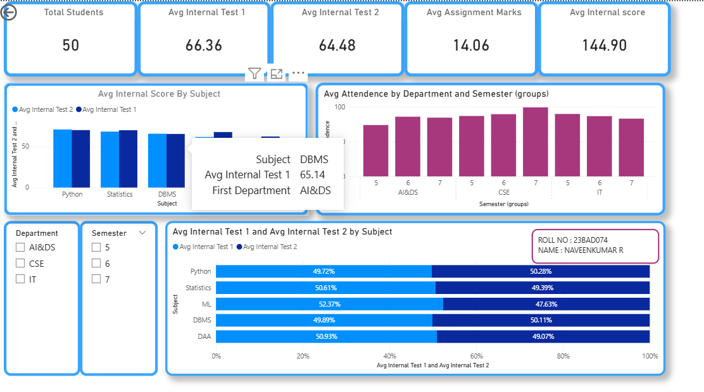

POST-LAB QUESTIONS

- How does interactivity improve analytical depth?
Interactivity allows users to filter and explore data dynamically based on department, semester, and subject. This helps users move from an overall view to detailed performance analysis without cluttering the dashboard. As a result, patterns and issues become easier to identify.

- Which KPIs are critical for academic monitoring?
Key KPIs include average attendance, internal test averages, assignment marks, and overall internal score. These indicators help monitor student engagement and academic performance together. Tracking them enables timely academic interventions.

- What design principles prevent information overload?
A structured layout, limited number of KPI cards, and consistent color schemes reduce visual complexity. Related information is grouped logically, and interactive filters replace excessive charts. This keeps the dashboard clear and easy to understand.

- How can dashboards be integrated with AI alerts?
Dashboards can be connected with AI models to identify abnormal trends such as low attendance or falling internal scores. Automated alerts or highlighted visuals can notify administrators instantly. This supports early intervention and data-driven decision-making.

- How do dashboards enhance transparency in institutions?
Dashboards provide real-time visibility into academic and attendance performance for all stakeholders. This shared access encourages accountability and informed decisions across departments. Transparent reporting helps institutions continuously improve academic outcomes.

LEARNING OUTCOME: Students understand dashboard design for AI-driven environments.

ASSESSMENT
Description | Max Marks | Marks Awarded
Pre Lab Exercise | 5
In Lab Exercise | 10
Post Lab Exercise | 5
Viva | 10
Total | 30
Faculty Signature

