EXPT NO:6 | IMPLEMENTATION OF MULTIVARIATE DISPLAYS
DATE: 24.01.2026

PRE-LAB QUESTIONS
- Why are multivariate displays important in AI analytics?
Answer: Multivariate displays allow analysts to visualize relationships, correlations, and interactions between three or more variables simultaneously. In AI, this is critical for Feature Selection (identifying which variables matter) and for understanding high-dimensional decision boundaries that a model might be learning.
- How do parallel coordinates differ from scatter plots?
Answer: A scatter plot typically visualizes the relationship between two variables (X and Y axes) using points. A parallel coordinate plot visualizes many variables by placing axes parallel to each other vertically; a single data point is represented as a line connecting values across these parallel axes.
- What challenges exist in interpreting multivariate plots?
Answer:
- Clutter (Overplotting): When there are too many data points, lines or bubbles can overlap, making patterns distinguishable.
- Scale Differences: If variables have vastly different units (e.g., "Profit" in thousands vs. "Customer Count" in single digits), the visualization can be skewed unless data is normalized.
- Cognitive Load: It is harder for the human brain to process simultaneous interactions between 4+ variables than simple 2D relationships.
- Where are trellis displays commonly used?
Answer: Trellis displays (also known as small multiples or faceting) are commonly used when you need to compare the same relationship (e.g., Sales vs. Profit) across different categorical subsets (e.g., by Region or Customer Segment) side-by-side to spot conditional patterns.
- How does multivariate visualization aid model evaluation?
Answer: It helps in diagnosing model bias and variance. By visualizing prediction errors against multiple input features simultaneously, you can see if the model underperforms in specific "regions" of the data (e.g., low accuracy only when both 'Price' is high and 'Region' is West).

OBJECTIVE: To implement advanced multivariate displays for complex data analysis.

SCENARIO A retail analytics firm studies sales, profit, customer segment, and region to optimize business strategy.

IN-LAB TASKS (Using R Language) • Create parallel coordinate plots • Generate bubble charts • Implement trellis displays by region

Code:

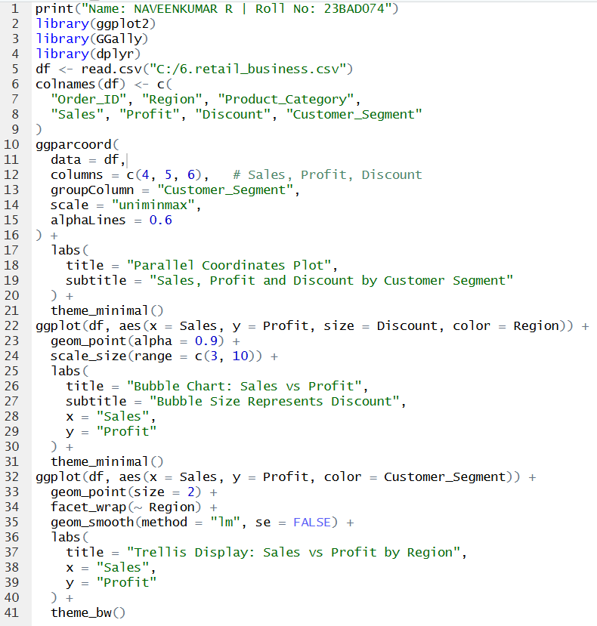

Output:

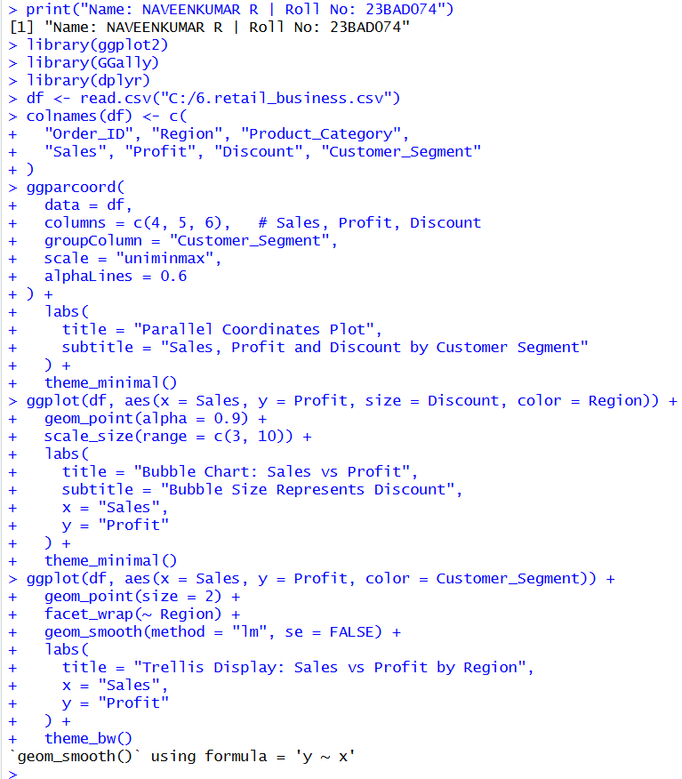

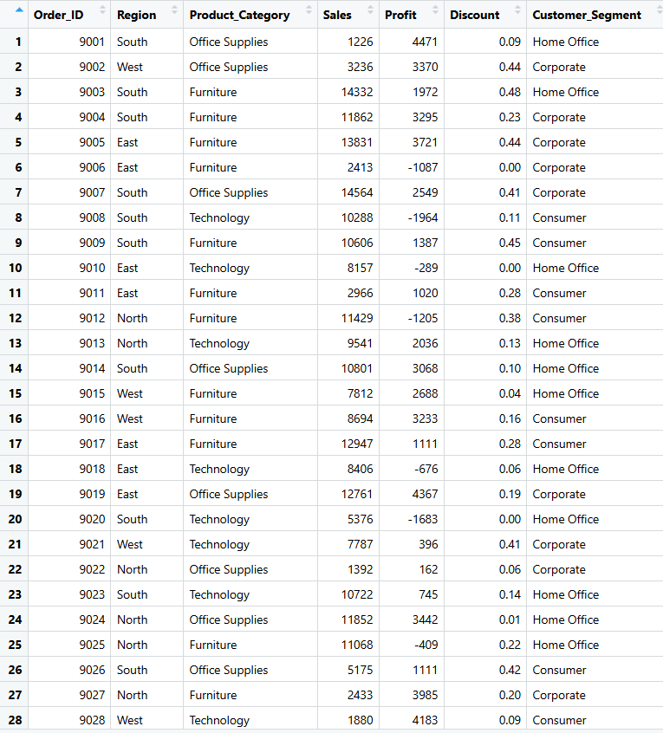
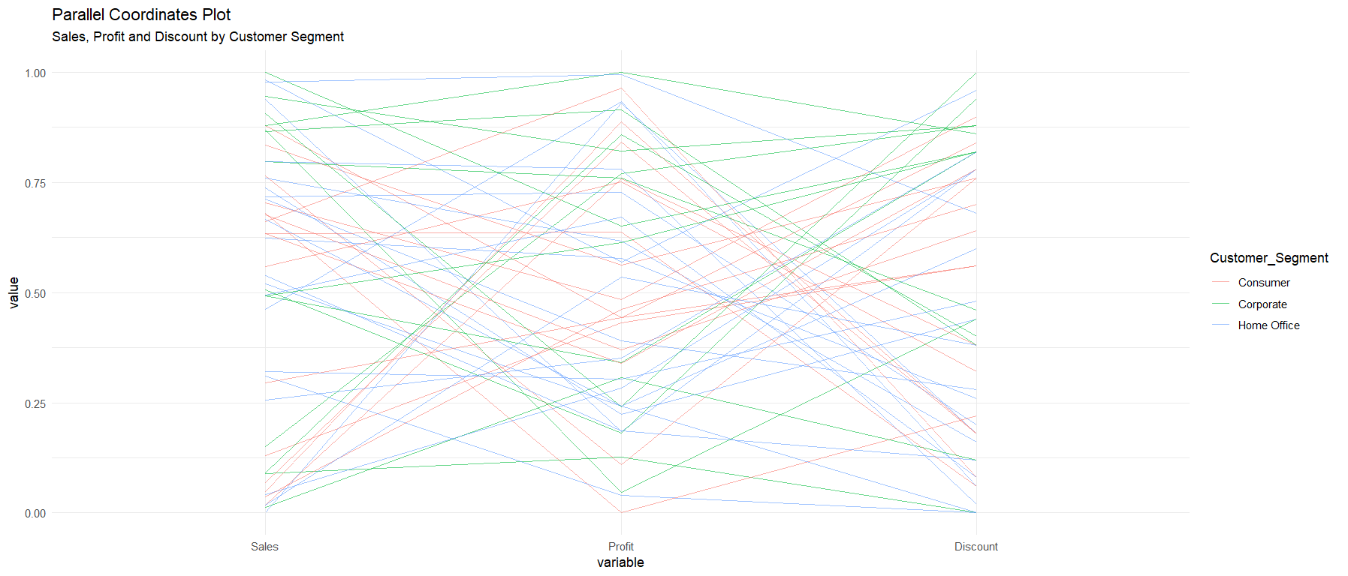
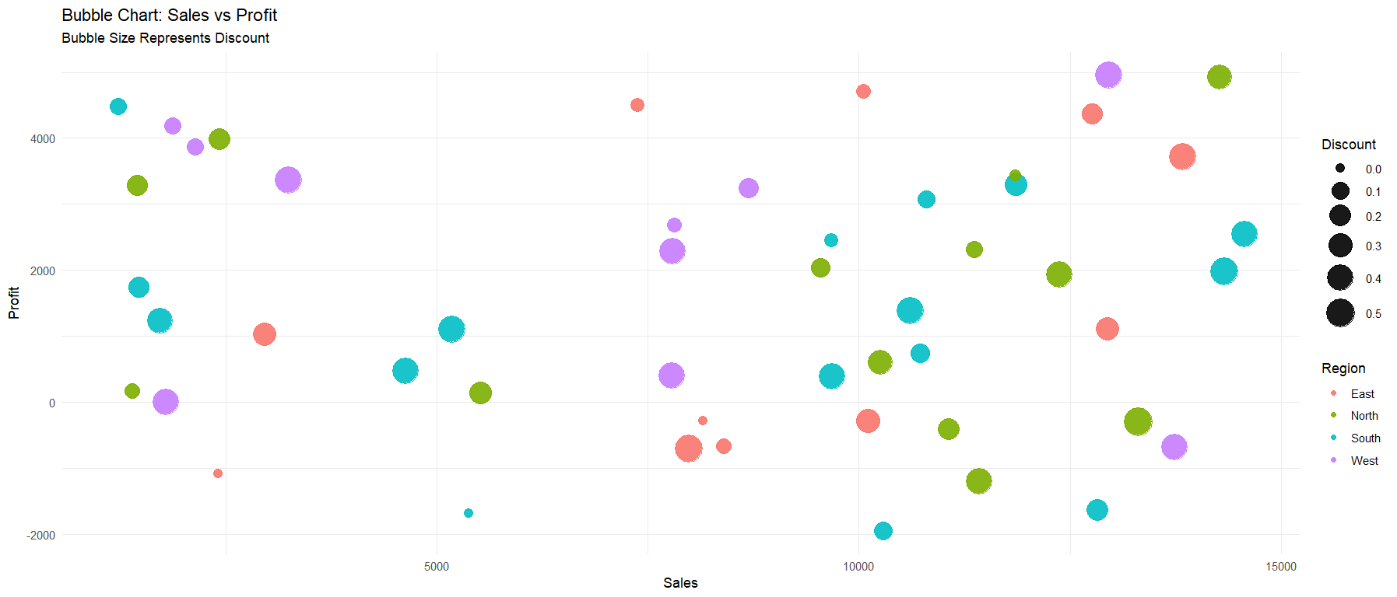

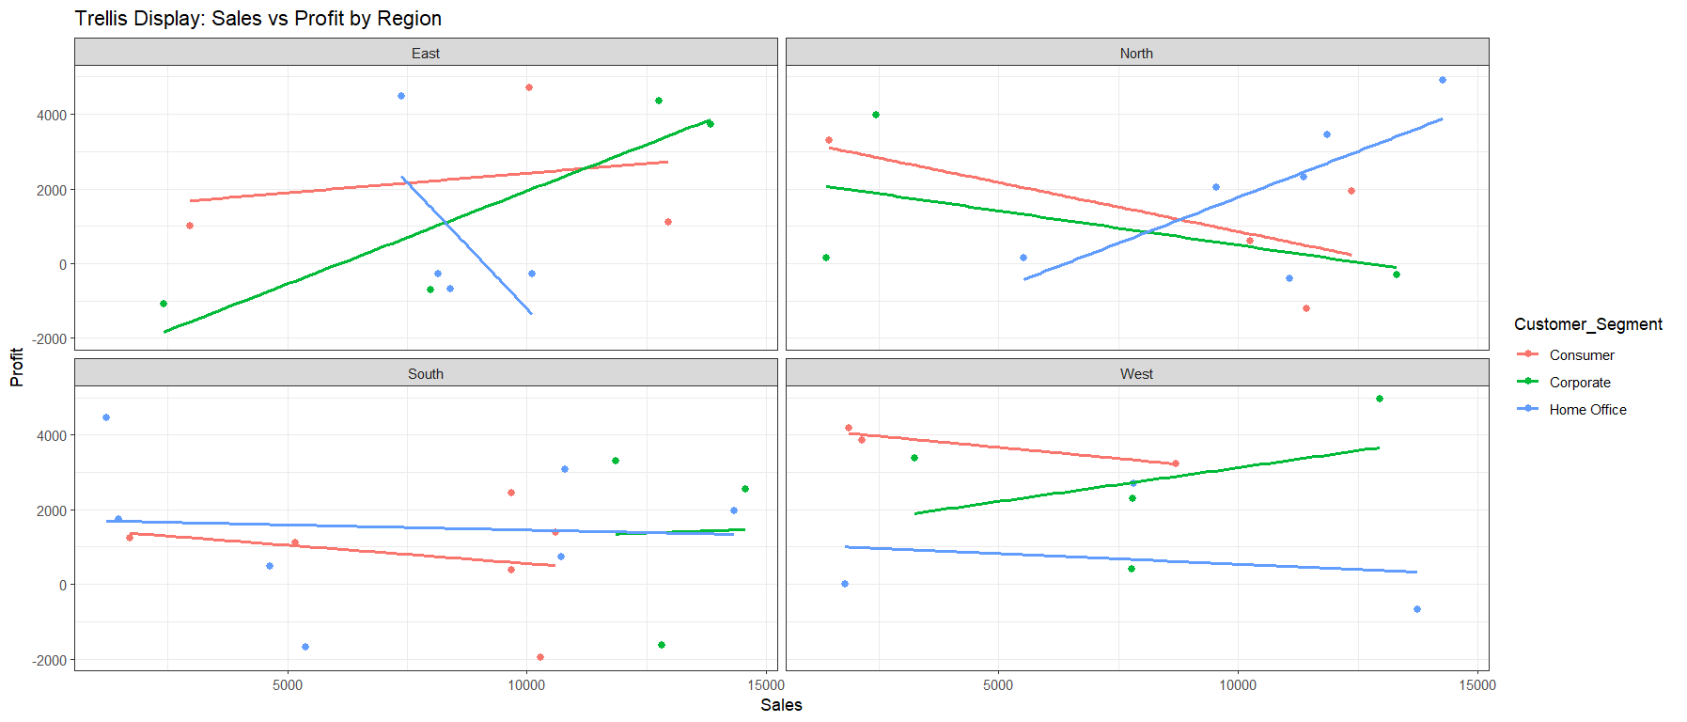

POST-LAB QUESTIONS
- What insights are gained from parallel coordinates?
Answer: The parallel coordinate plot provided clear visibility into inverse correlations and multidimensional outliers. Specifically, the visualization highlighted a "crossing" pattern between the Discount and Profit axes, indicating that higher discount rates generally correlate with reduced profitability. Furthermore, the normalized scales allowed for the direct comparison of relative magnitudes between disparate variables like Sales (currency) and Discount (percentage).
- How does faceting simplify complex data?
Answer: Faceting (Trellis display) simplifies complex data by isolating subsets based on categorical variables, thereby revealing local trends that are often masked in global aggregations. In this experiment, faceting by Region revealed distinct performance heterogeneities; for instance, the East region exhibited a positive correlation between Sales and Profit for the Corporate segment, whereas the North region showed a negative trend for the Consumer segment.
- What limitations exist in bubble charts?
Answer: Bubble charts present significant limitations regarding occlusion and perceptual precision. In dense areas of the dataset, larger bubbles overlap and obscure smaller data points, leading to data loss in the visualization. Additionally, human perception is less precise when judging differences in area (bubble size) compared to judging position along an axis, making it difficult to discern subtle differences in the third variable (Discount).
- How can these display support AI-driven recommendations?
Answer: These displays support AI development by informing feature engineering and constraint definition. The clear variance in trends across regions suggests that 'Region' is a critical predictive feature that must be included in any machine learning model. Additionally, the observed profit erosion at high discount levels can be used to set deterministic constraints (or "guardrails") for AI pricing recommendation engines.
- Suggest improvements for large multivariate datasets.
Answer: For larger datasets, static multivariate plots become illegible due to overplotting. Improvements include:
- Interactive Brushing and Linking: Allowing users to highlight a subset of data in one view to see its propagation across other views.
- Density/Contour Plots: Replacing individual points with 2D density heatmaps to visualize data concentration.
- Dimensionality Reduction: Utilizing techniques such as PCA (Principal Component Analysis) or t-SNE to project high-dimensional data into viewable 2D or 3D clusters before plotting.

LEARNING OUTCOME: Students apply multivariate visualization for business intelligence.

ASSESSMENT
Description | Max Marks | Marks Awarded
Pre Lab Exercise | 5
In Lab Exercise | 10
Post Lab Exercise | 5
Viva | 10
Total | 30
Faculty Signature

