EXPT NO:1 | Implementation of data charts
DATE: 06.01.2026

PRE-LAB QUESTIONS (PROVIDE BRIEF ANSWERS TO THE FOLLOWING QUESTIONS)

- How can visualization help an academic institution improve student outcomes?
Visualization turns large sets of student marks into easy-to-understand visual patterns. It allows institutions to quickly detect students who may need additional support, identify subjects where many students are underperforming, and monitor performance trends over time to evaluate the effectiveness of teaching methods.

- Which chart types are suitable for comparing subject-wise performance?
- Bar charts are useful for comparing average marks across multiple subjects in a clear, side-by-side manner.
- Box plots are effective for displaying the distribution of marks within each subject, including the median, range, and any outliers present.

- What type of data scale is used for student marks?
Student marks are represented using a ratio scale because the values have a meaningful order, equal spacing between scores, and a true zero point. A score of zero indicates the complete absence of marks, which satisfies the properties of a ratio scale.

- Why should raw academic data be cleaned before visualization?
Raw academic data needs to be cleaned before visualization because it may contain missing values, duplicate records, or invalid entries such as marks exceeding the maximum limit. If these issues are not corrected, the resulting visualizations can be misleading and lead to incorrect interpretations of student performance.

- How does visualization support evidence-based decision making?
Visualization helps support evidence-based decision making by simplifying complex datasets into clear visual insights. This makes it easier to objectively identify strengths and weaknesses, allowing decisions to be based on actual data patterns rather than assumptions and ensuring resources are allocated effectively.

IN-LAB EXERCISE:
OBJECTIVE:
To design appropriate data charts to analyze and compare academic performance indicators.
SCENARIO:
An autonomous engineering college wants to analyze internal assessment performance of first-year students across five subjects to identify difficult courses and improve teaching strategies.
IN-LAB TASKS (Using R Language)
- Load required R libraries (ggplot2, dplyr)
- Import dataset using read.csv()
- Perform basic data preprocessing
- Create bar chart for subject-wise average marks
- Generate line chart for performance trend across tests
- Plot pie chart for grade distribution

(CODE: CONATAINS STUDENT ROLL NOS
SCREENSHOT OF CODE
SCREENSHOT OF OUTPUT)

CODE:
#LAB EXPERIMENT - 1
print("ROLL NO: 23BAD074")
library(ggplot2)
library(dplyr)
library(tidyr)

student_data <- read.csv("C:/EDA_LAB_EXERCISE/1.student_performance.csv")

str(student_data)
summary(student_data)

student_data <- student_data %>%
mutate(Average_Internal = (Internal_Test1 + Internal_Test2) / 2)

subject_summary <- student_data %>%
group_by(Subject) %>%
summarise(Mean_Internal = mean(Average_Internal))

ggplot(subject_summary, aes(x = Subject, y = Mean_Internal, fill = Subject)) +
geom_bar(stat = "identity") +
theme_minimal() +
labs(title = "Average Internal Marks by Subject",
x = "Subject",
y = "Mean Marks") +
theme(legend.position = "none")

trend_summary <- student_data %>%
group_by(Subject) %>%
summarise(Test_One = mean(Internal_Test1),
Test_Two = mean(Internal_Test2)) %>%
pivot_longer(cols = c(Test_One, Test_Two),
names_to = "Test_Type",
values_to = "Marks")

ggplot(trend_summary, aes(x = Test_Type, y = Marks, group = Subject, color = Subject)) +
geom_line(linewidth = 1) +
geom_point(size = 3) +
theme_minimal() +
labs(title = "Internal Test Performance Trend",
x = "Test",
y = "Average Marks")

grade_summary <- student_data %>%
count(Final_Grade) %>%
mutate(percentage = n / sum(n) * 100) %>%
mutate(label_position = cumsum(percentage) - 0.5 * percentage)

ggplot(grade_summary, aes(x = "", y = percentage, fill = Final_Grade)) +
geom_bar(stat = "identity", width = 1) +
coord_polar("y") +
theme_void() +
labs(title = "Final Grade Distribution") +
geom_text(aes(y = label_position,
label = paste0(round(percentage, 1), "%")),
color = "white",
size = 5)

SCREENSHOT OF THE CODE:
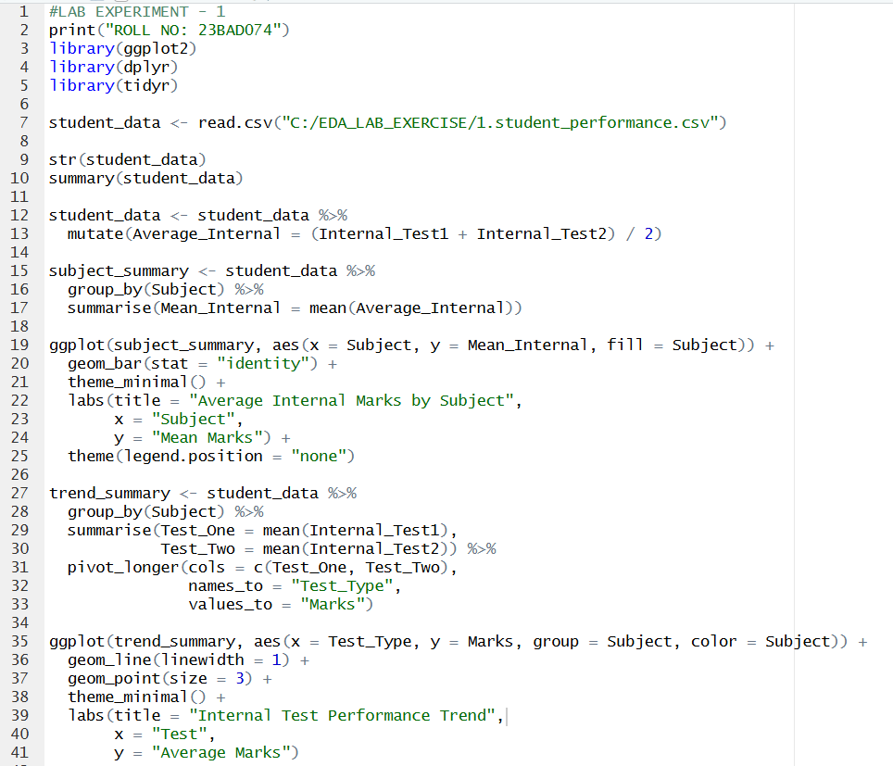
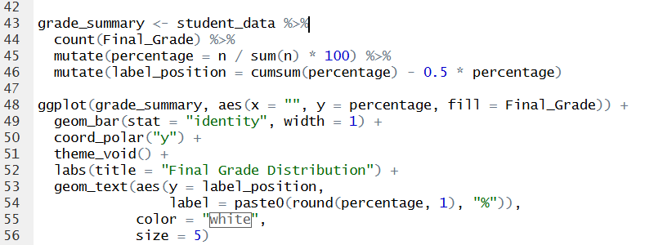

OUTPUT
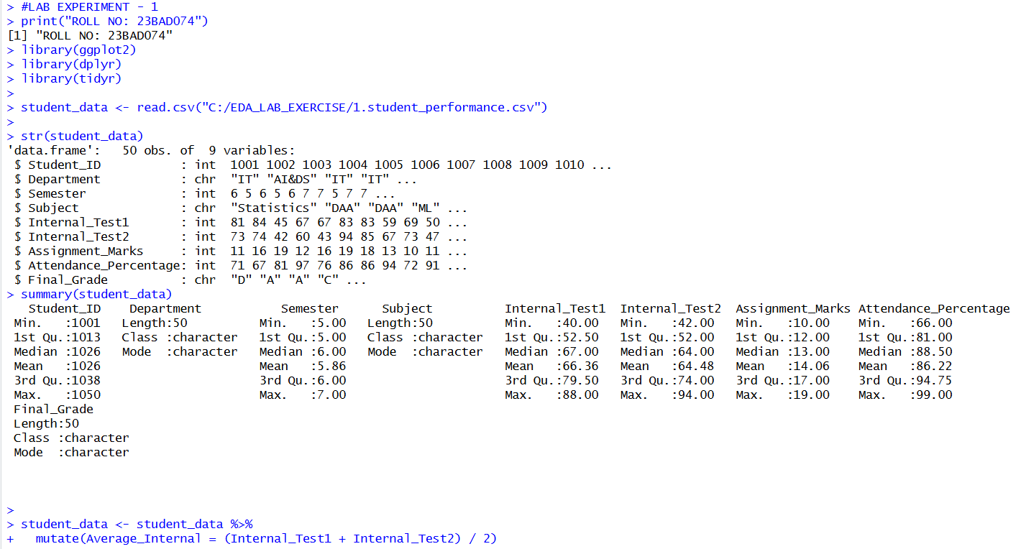
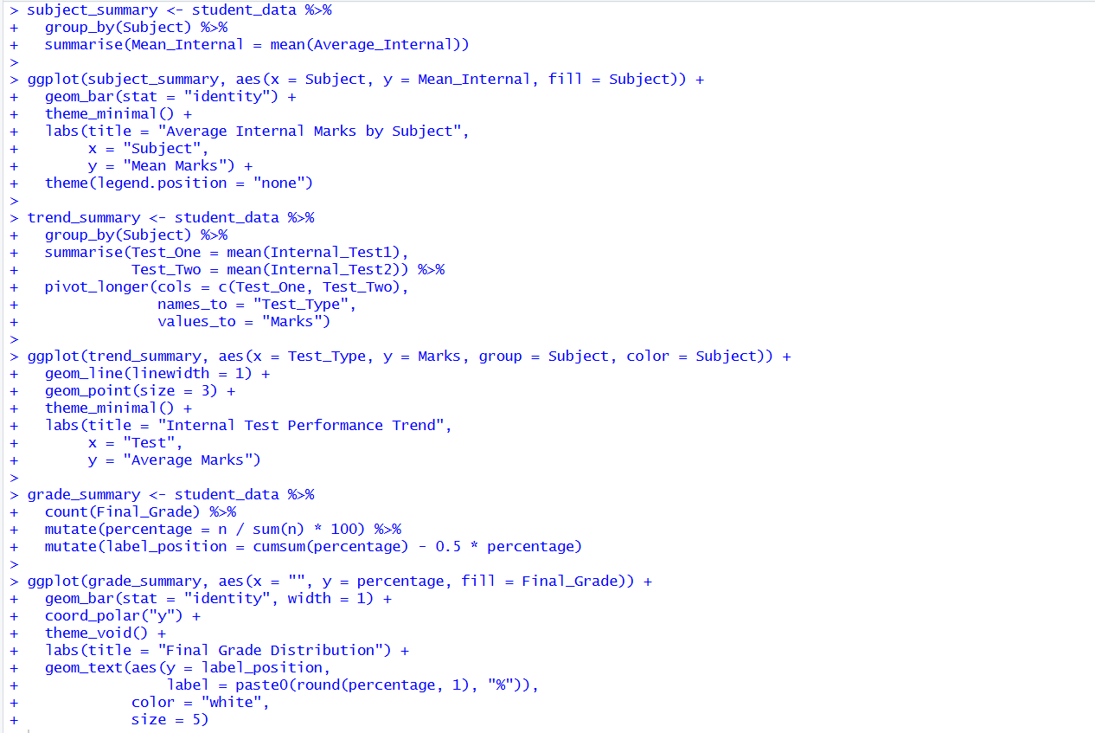
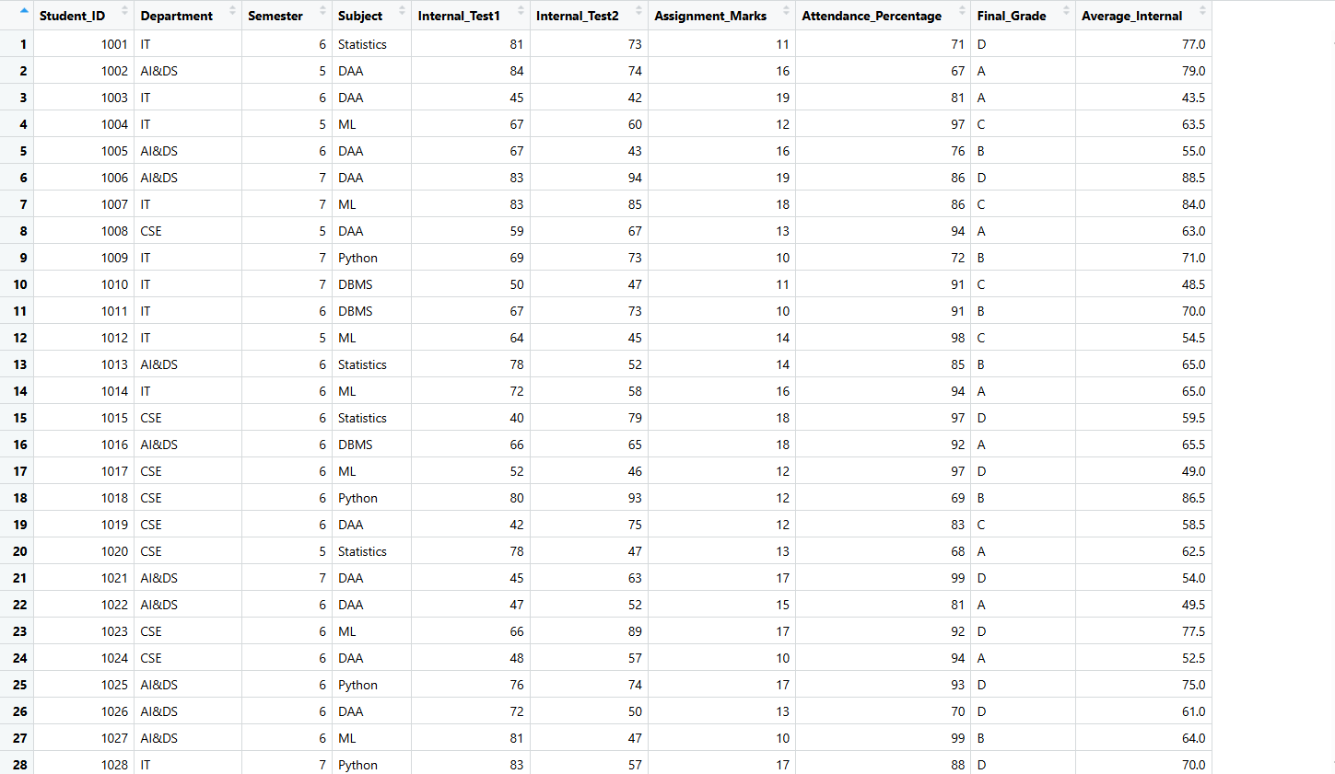
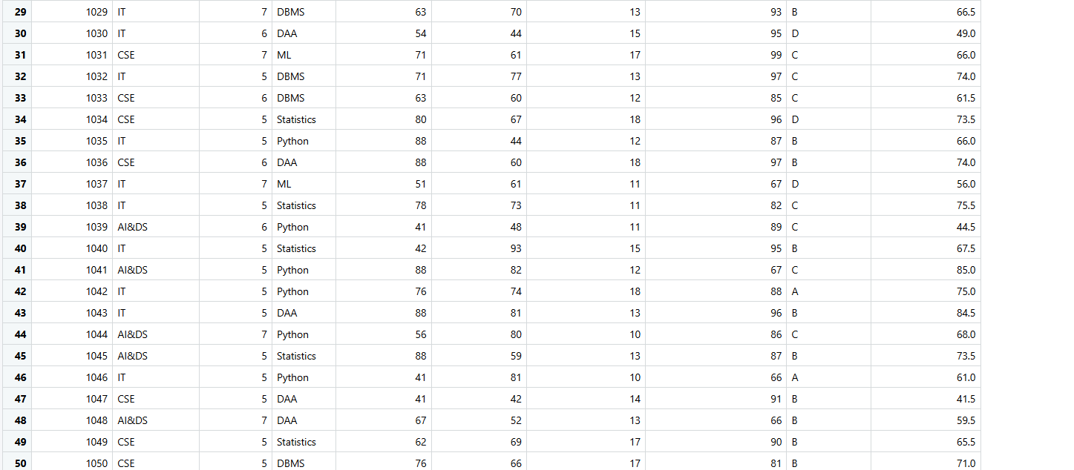
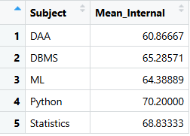
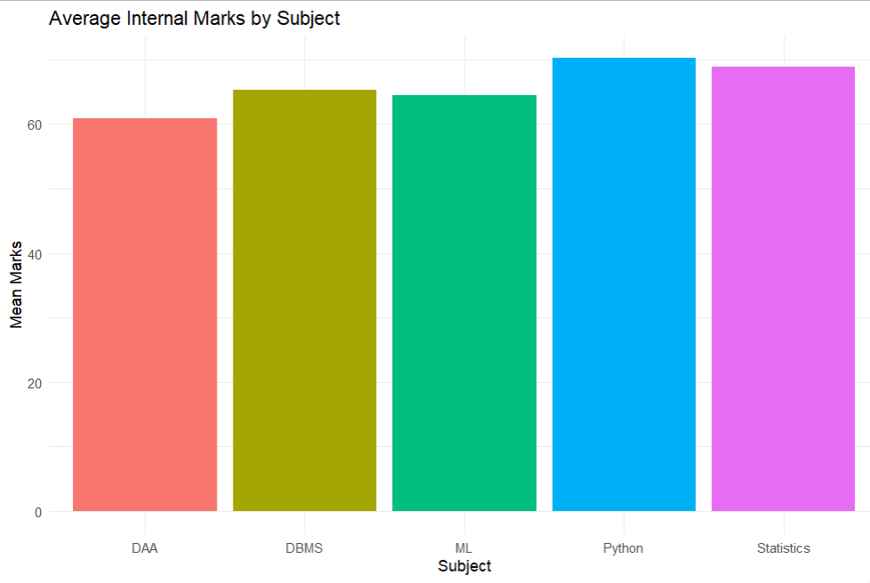
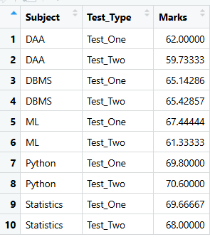
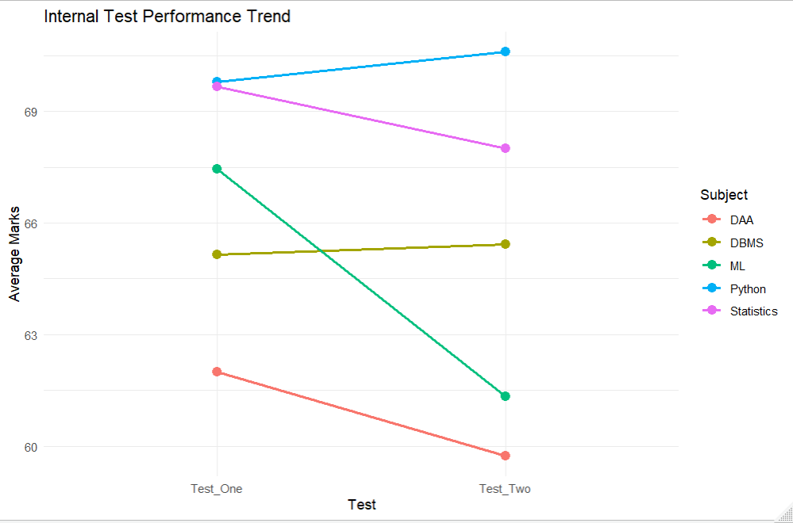
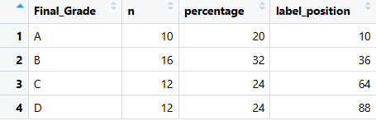
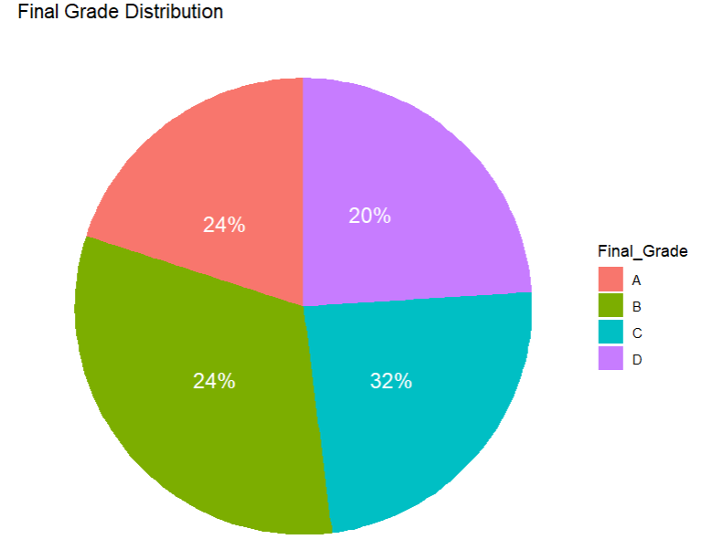

POST-LAB QUESTIONS (PROVIDE BRIEF ANSWERS TO THE FOLLOWING QUESTIONS)

- Which subject shows consistently low performance and why?
DAA shows consistently low performance because it records the lowest overall average score and performs poorly across multiple assessments. For example, its average drops across Internal Test 1 and Internal Test 2, indicating a persistent performance issue rather than a one-time dip.

- Why is a line chart suitable for trend analysis?
A line chart is suitable for trend analysis because it visually links data points, making changes over time easy to observe. For example, a line chart clearly shows whether average marks increase or decrease from Test 1 to Test 2 through the slope of the line.

- What limitations does a pie chart have in analytics?
Pie charts have limitations in analytics because they make it hard to compare similar values, do not show trends over time, and become cluttered with many categories. For example, distinguishing between slices representing 24% and 26% is visually difficult.

- How can this analysis help curriculum planning?
This analysis supports curriculum planning by helping institutions identify weak areas and adjust resources accordingly. For example, if DAA shows poor results, additional tutorial sessions can be introduced to improve student understanding.

- How can such visualizations be integrated into AI-driven academic analytics
Such visualizations can be integrated into AI-driven academic analytics as early warning tools to identify potential academic risks. For example, an AI system can analyze performance data and display visual alerts on a teacher’s dashboard for students likely to fail.

ASSESSMENT
Description | Max Marks | Marks Awarded
Pre Lab Exercise | 5
In Lab Exercise | 10
Post Lab Exercise | 5
Viva | 10
Total | 30
Faculty Signature

