EXPT NO:2 | Implementation of data visualization techniques
DATE: 06.01.2026

PRE-LAB QUESTIONS (PROVIDE BRIEF ANSWERS TO THE FOLLOWING QUESTIONS)

- Why is exploratory data analysis critical before model building?
Exploratory Data Analysis is important before model building because it helps identify missing values, spot unusual patterns, and understand the overall structure of the dataset. If EDA is ignored, the model may learn incorrect patterns instead of meaningful relationships, for example when missing values distort the final predictions.

- How do distributions influence algorithm selection in ML?
Data distributions influence algorithm selection because many machine learning models make assumptions about how data is spread. If the data is highly skewed or non-linear, different algorithms or transformations are required, for example using a Decision Tree instead of Linear Regression when the data does not follow a normal distribution.

- What insights can outliers provide in business data?
Outliers provide valuable insights by revealing abnormal behaviour that may indicate important business events. Example, an unusually high transaction amount may point to a potential fraudulent activity that needs immediate investigation.

- Why are visual summaries preferred over raw tables?
Visual summaries are preferred over raw tables because they make it easier to quickly identify trends and patterns that are hard to notice in numerical form. For example, a line chart can clearly show seasonal sales trends that would be difficult to detect in a table of numbers.

- How does visualization improve business intelligence?
Visualization improves business intelligence by presenting complex data in a simple and understandable way for decision-makers. Example, a dashboard displaying a sudden drop in sales helps managers take immediate corrective action.
IN-LAB EXERCISE:
OBJECTIVE:

To explore data distribution and variability using advanced visualization techniques.
SCENARIO:
A startup analyzes e-commerce transaction data to understand customer spending behavior and detect abnormal purchase patterns.

IN-LAB TASKS (Using R Language)
- Plot histogram of transaction amounts
- Use boxplot to detect outliers
- Create heatmap of monthly sales intensity

(CODE: CONATAINS STUDENT ROLL NOS
SCREENSHOT OF CODE
SCREENSHOT OF OUTPUT)

CODE:
#LAB EXPERIMENT -2
print("ROLL NO: 23BAD074")
library(ggplot2)
library(dplyr)
library(lubridate)

ecom_data <- read.csv("C:/EDA_LAB_EXERCISE/2.ecommerce_transactions.csv")

ecom_data$Trans_Date <- as.Date(ecom_data$Transaction_Date)

ggplot(ecom_data, aes(x = Transaction_Amount)) +
geom_histogram(bins = 20, fill = "blue", color = "black") +
labs(title = "Distribution of Transaction Amounts",
x = "Transaction Amount",
y = "Frequency") +
theme_minimal()

ggplot(ecom_data, aes(y = Transaction_Amount)) +
geom_boxplot(fill = "slateblue", color = "darkblue") +
labs(title = "Boxplot of Transaction Amounts",
y = "Transaction Amount") +
theme_minimal()

heatmap_summary <- ecom_data %>%
mutate(Month = month(Trans_Date, label = TRUE, abbr = FALSE)) %>%
group_by(Product_Category, Month) %>%
summarise(Total_Sales = sum(Transaction_Amount), .groups = 'drop')

ggplot(heatmap_summary, aes(x = Month, y = Product_Category, fill = Total_Sales)) +
geom_tile(color = "white") +
scale_fill_gradient(low = "lightyellow", high = "orange") +
labs(title = "Monthly Sales Intensity Heatmap",
x = "Month",
y = "Product Category",
fill = "Total Sales") +
theme_minimal()

SCREENSHOT OF THE CODE:
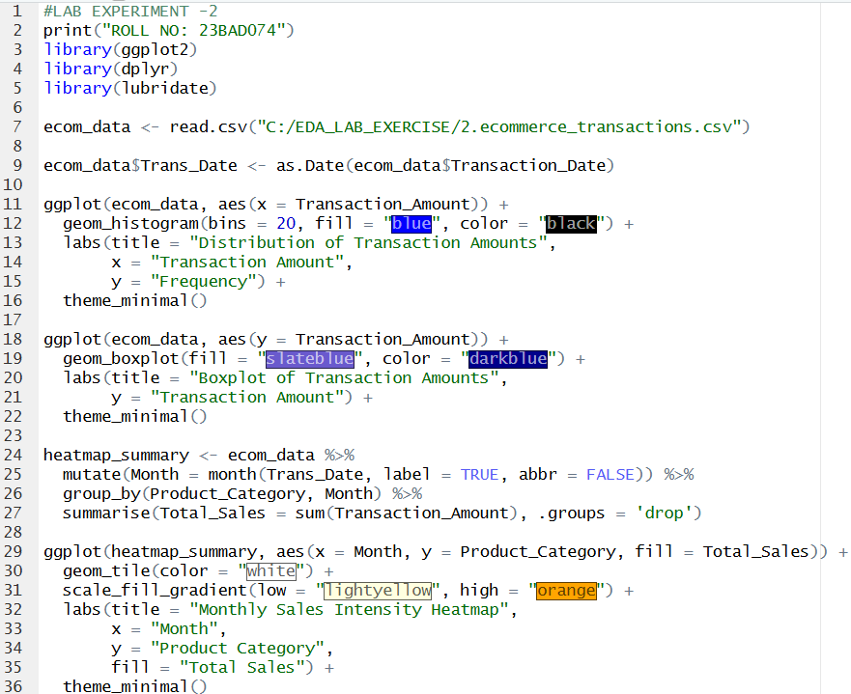

OUTPUT:
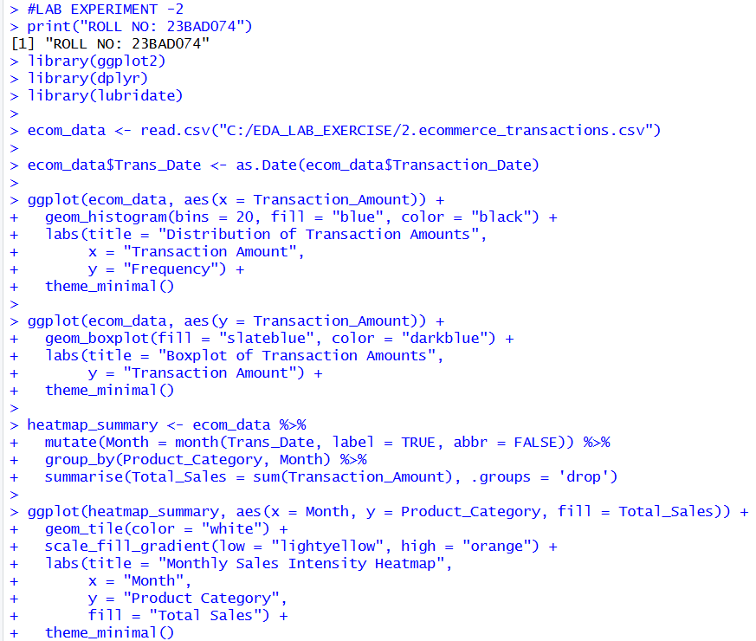

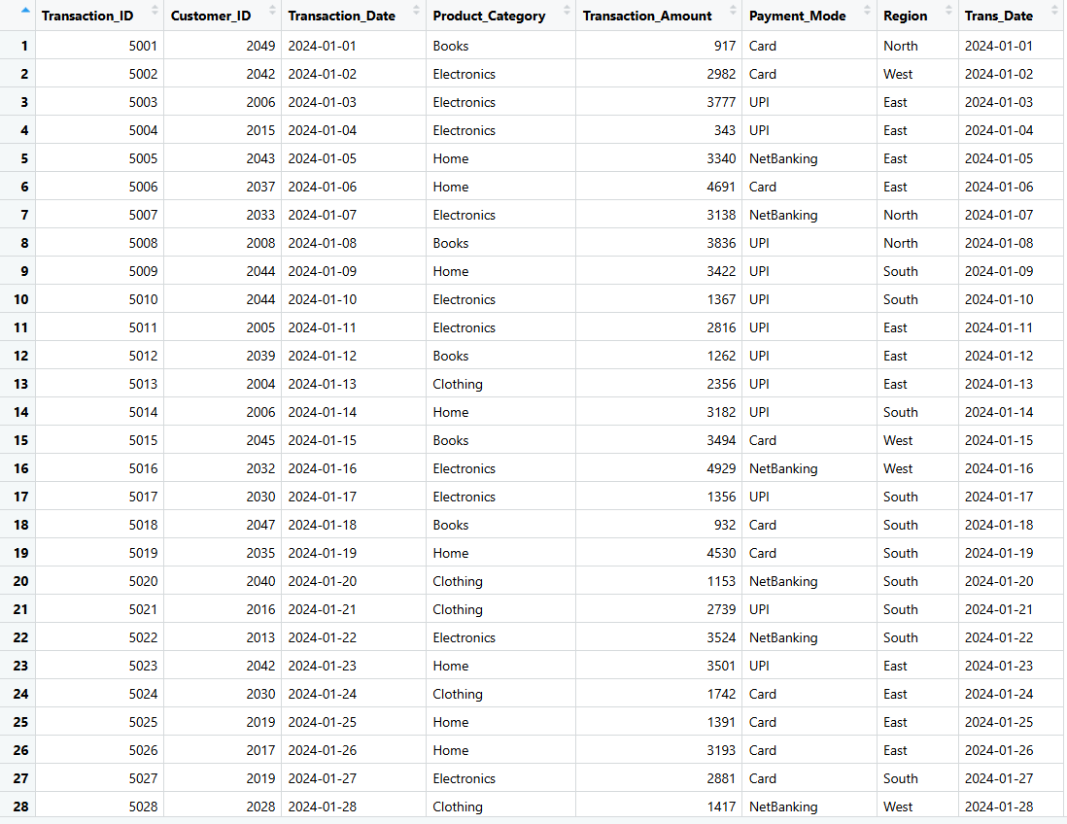

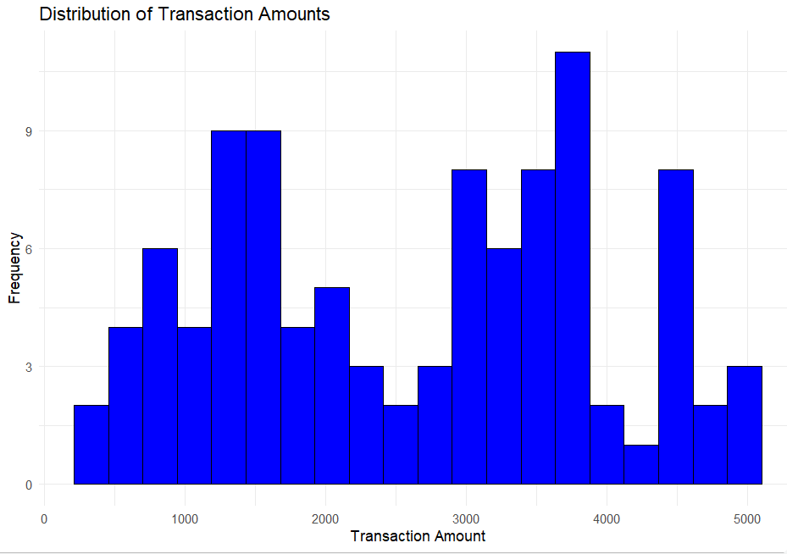

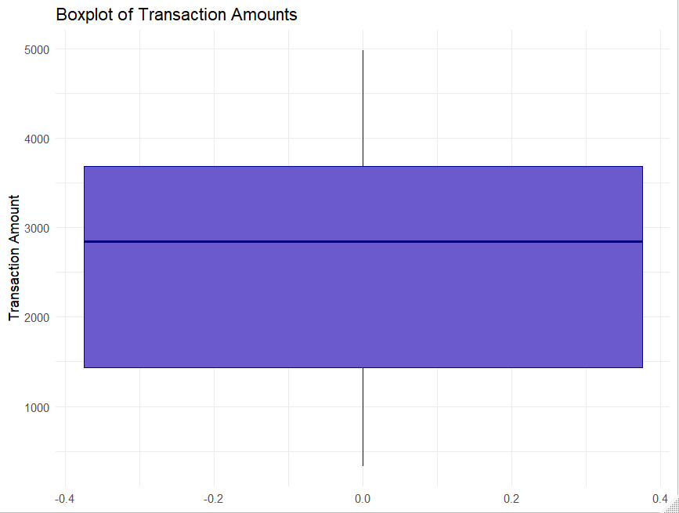

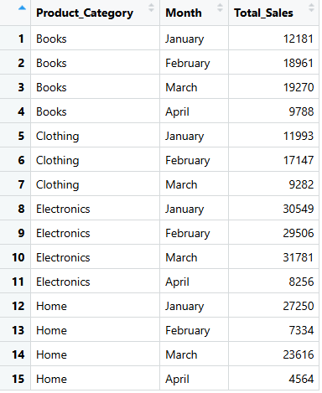
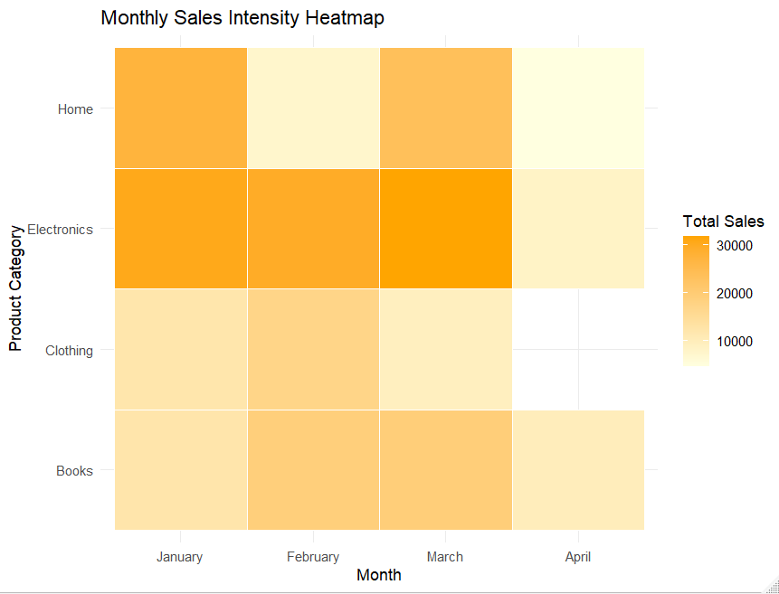

POST-LAB QUESTIONS (PROVIDE BRIEF ANSWERS TO THE FOLLOWING QUESTIONS)

- What does right-skewed distribution indicate about customer behaviour?
A right-skewed distribution indicates that the majority of customers make small to medium-sized purchases, while only a very small number of customers make extremely high-value purchases.

- How can detected outliers impact business decisions?
Detected outliers influence business decisions by forcing organizations to decide whether extreme values should be removed or analyzed further. Studying these values can reveal important insights such as unusually high revenue opportunities or serious issues like fraudulent activities that need immediate action.

- Which visualization best supports anomaly detection?
The Boxplot is the best tool for anomaly detection. It statistically defines "normal" data within the Interquartile Range (IQR) and visually isolates anomalies as individual dots outside the whiskers, making them impossible to miss.

- How does EDA improve AI model accuracy?
EDA improves AI model accuracy by ensuring the data used for training is reliable and well understood. Identifying problems such as class imbalance or highly correlated features in advance allows proper data cleaning and model selection, reducing the chances of learning incorrect patterns.

- How can visualization guide feature engineering?
Visualization guides feature engineering by revealing patterns and relationships that are not obvious from raw data. For instance, observing a curved trend in a scatter plot can suggest the need for creating a non-linear feature to better represent the data.

ASSESSMENT
Description | Max Marks | Marks Awarded
Pre Lab Exercise | 5
In Lab Exercise | 10
Post Lab Exercise | 5
Viva | 10
Total | 30
Faculty Signature

