EXPT NO:7 | OVER-PLOTTING REDUCTION TECHNIQUES
DATE: 09.02.2026

PRE-LAB QUESTIONS

- Why is over-plotting common in big data visualization?
Answer:
Over-plotting is common because big data contains a very large number of observations plotted within a limited visual space. Many points fall on the same or nearby coordinates, causing overlap. This makes individual data points difficult to see and interpret clearly.

- How does data density affect perception?
Answer:
High data density leads to overlapping points, which hides important patterns and relationships. Dense regions appear darker or cluttered, making it hard to identify trends, clusters, or outliers. This reduces the accuracy of human visual interpretation.

- What trade-offs exist between detail and clarity?
Answer:
Displaying all individual data points provides maximum detail but results in visual clutter. Techniques like aggregation and binning reduce clutter and improve clarity but may hide fine-grained information. Analysts must choose the right balance based on the objective of analysis.

- How do AI datasets increase visualization complexity?
Answer:
AI datasets are typically very large, multi-dimensional, and continuously updated. They contain multiple variables, interactions, and patterns that must be shown together. This increases overlap, noise, and difficulty in visual interpretation.

- Why is over-plotting a serious analytical risk?
Answer:
Over-plotting can conceal important insights such as trends, clusters, and anomalies. It may lead analysts to misunderstand the data or miss critical patterns. As a result, incorrect conclusions and poor decision-making can occur.

OBJECTIVE : To apply techniques that reduce visual clutter in large-scale datasets.

SCENARIO A social media analytics company visualizes millions of user interactions to study engagement patterns.

IN-LAB TASKS (Using R Language) • Apply alpha blending • Implement jittering techniques • Use aggregation and binning

Github Link:https://github.com/naveenkumar-2412/23BAD074_U18AII5202L.git

CODE:

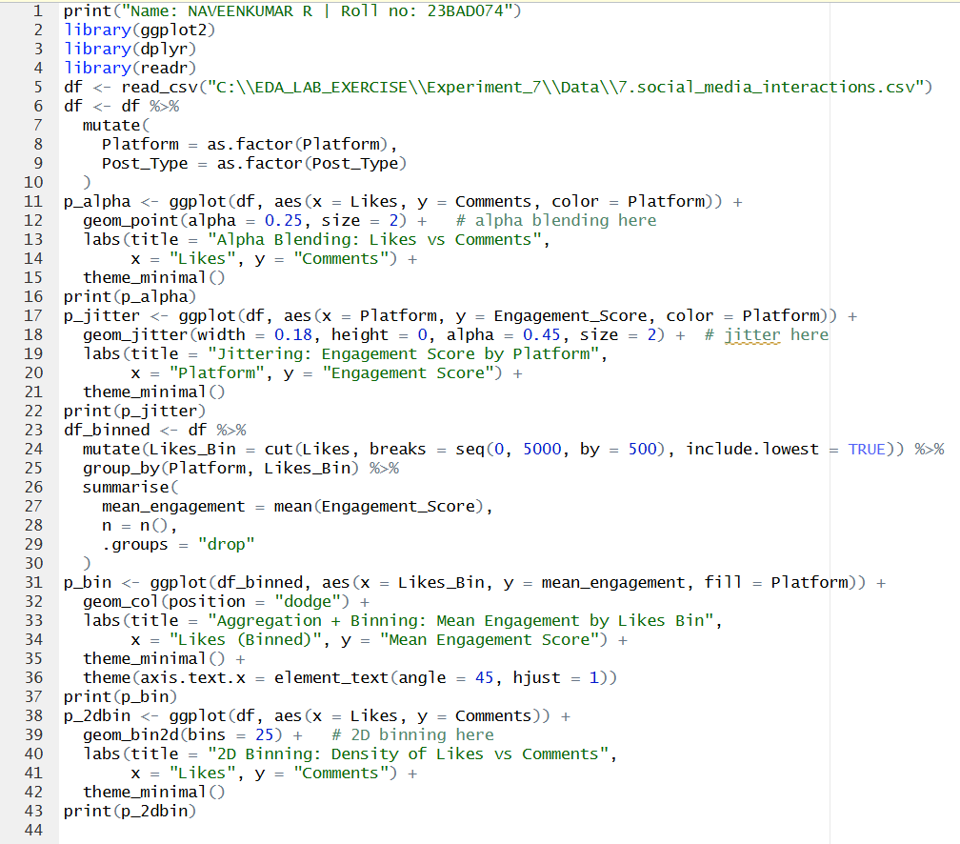

OUTPUT:

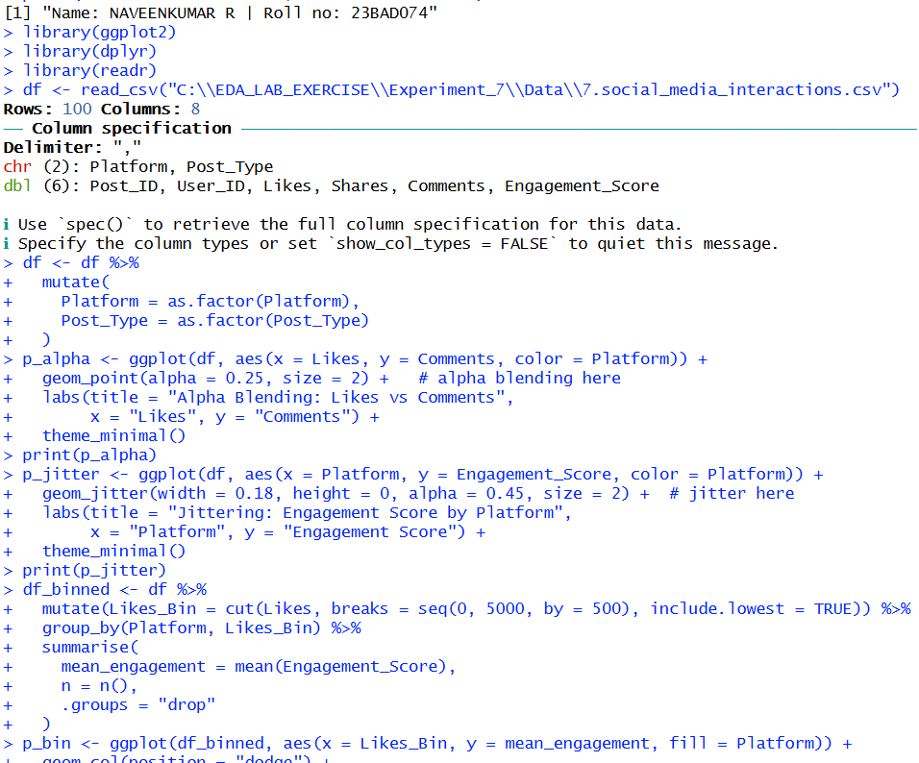

PLOTS:
Alpha Blending:

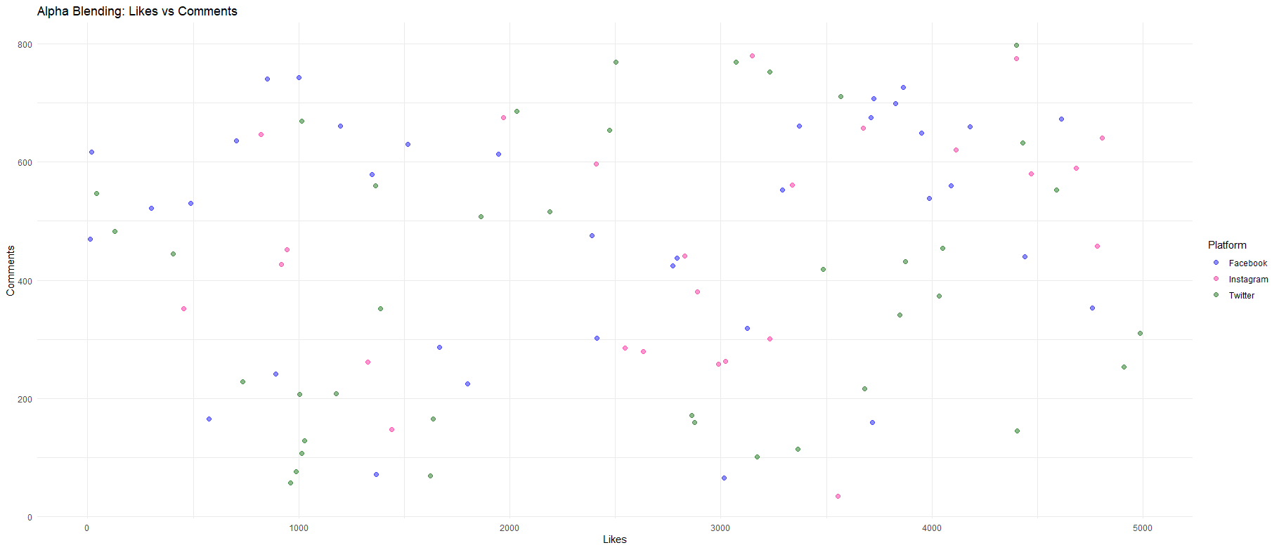

Jittering:

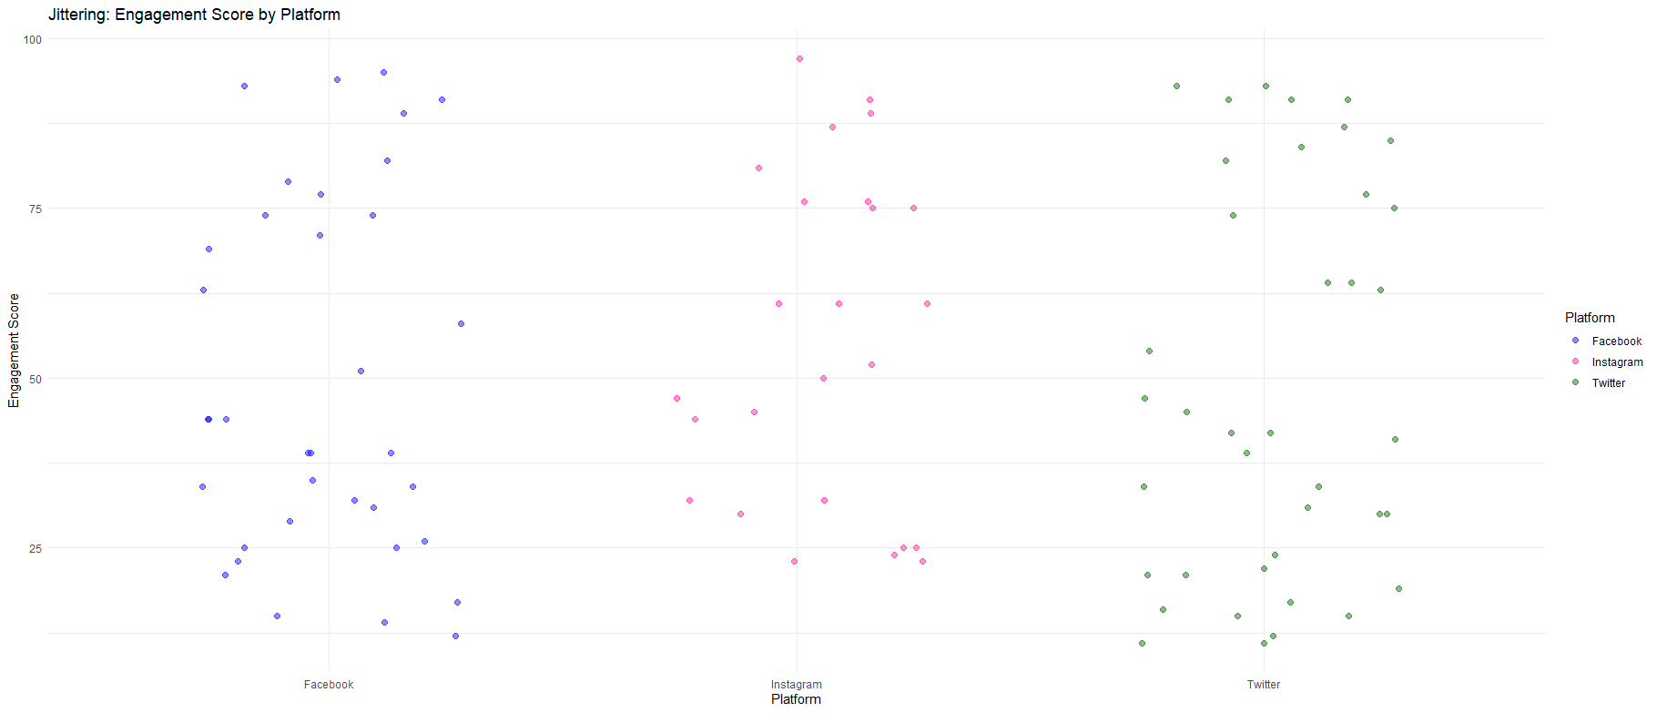
2D Binning:

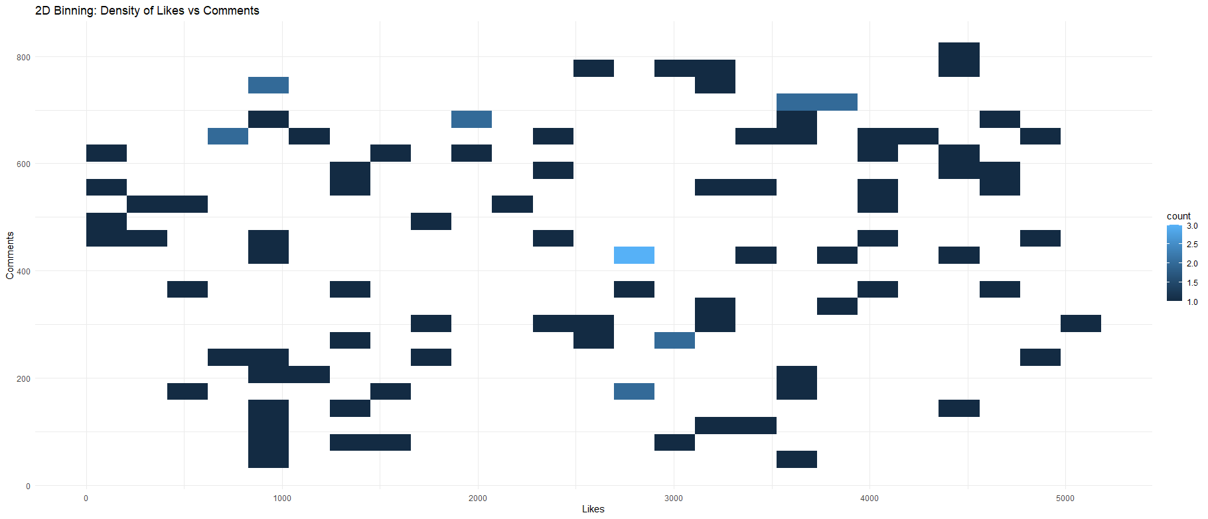

Aggregation + Binning:

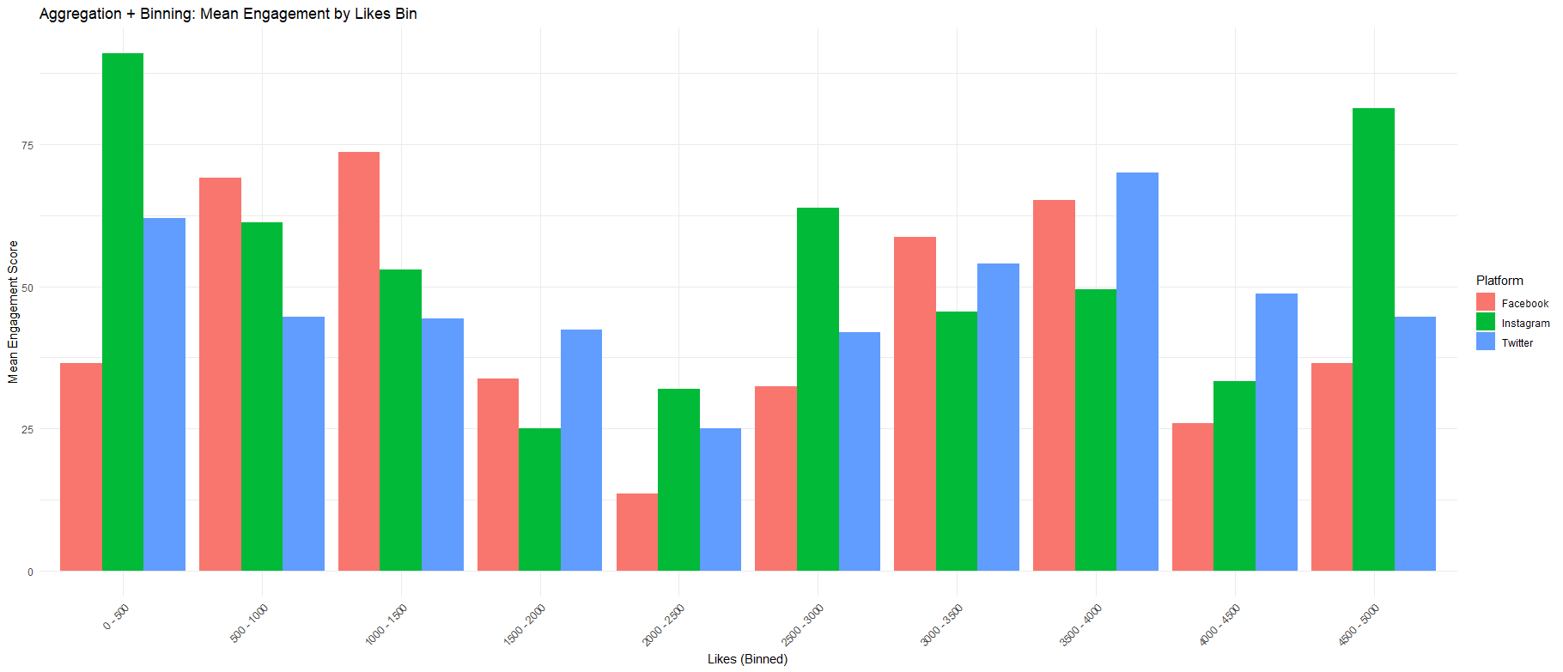

POST-LAB QUESTIONS

- Which technique provided the best clarity and why?
Answer:
Aggregation and binning provided the best clarity because it summarizes large volumes of data into meaningful groups. Instead of plotting every point, it highlights overall trends and comparisons clearly. This greatly reduces visual clutter and improves interpretability.

- How does over-plotting distort analytical conclusions?
Answer:
Over-plotting hides data patterns such as clusters and outliers due to overlapping points. Important trends may appear weaker or completely invisible. This can mislead analysts into drawing incorrect or incomplete conclusions.

- When should aggregation be preferred over raw plotting?
Answer:
Aggregation should be preferred when dealing with large-scale or dense datasets. It is useful when the goal is to understand overall patterns rather than individual data points. This approach improves clarity and analytical efficiency.

- How do these techniques support scalable AI analytics?
Answer:
These techniques reduce visual complexity while preserving essential information. They enable analysts to interpret massive AI-generated datasets efficiently. This makes visualization scalable even as data volume grows.

- Explain real-world consequences of ignoring over-plotting.
Answer:
Ignoring over-plotting can result in missed trends, hidden risks, and incorrect insights. In real-world applications, this may lead to poor business decisions or faulty AI model evaluation. Ultimately, it can reduce trust in data-driven systems.

LEARNING OUTCOME: Students master over-plotting reduction for big data visual analytics.

ASSESSMENT
Description | Max Marks | Marks Awarded
Pre Lab Exercise | 5
In Lab Exercise | 10
Post Lab Exercise | 5
Viva | 10
Total | 30
Faculty Signature

