PROBLEM STATEMENT - 2

NAME : R.D.NAVEENKUMAR
REGISTER NO. : 1833030
SOCIAL NETWORK ADS PREDICTION

Social Network Ads Prediction: Project Overview

- Created a model that estimates whether a person will make purchase or not by the ads displayed to them to help marketers to display the ads according to the age category, so that they can increase their sales
- Tested the data with popular models and find accuracy for every model
- Compared the models accuracy and find the most suitable one.
- Optimized XGBoost using RandomizedsearchCV to reach the best model.
The code is implemented in Python and different classification models are applied.

I have tried four different models and evaluated them using their accuracy by comparing the y_test values with the predicted values of x_test.

- •Logistic Regression – Because of the binary dependent variable, I thought that it may get fit.
- •Support Vector Machine – Because of the sparse data I thought SVM classifier would be effective.
- •Random Forest – Again, with the sparsity associated with the data, I thought that this would be a good fit.
- •XGBoost - Because it is scalable and can provide more hyperparameters, I though that it may get work.

1. IMPORT LIBRARIES
I imported several libraries for the project:
- numpy: To work with arrays
- pandas: To work with csv files and dataframes
- matplotlib: To create charts using pyplot, define parameters using rcParams
- train_test_split: To split the dataset into training and testing data
- StandardScaler: To scale all the features, so that the Machine Learning model better adapts to the dataset
Next, I imported all the necessary Machine Learning algorithms.

2. DATA CLEANING :

After reading the data, I needed to clean it up so that it was usable for our model. I made the following changes and created the following variables

- Checked whether there any null was present
- After I have checked for the missing Values.

- DATA DESCRIPTION :
data.describe()

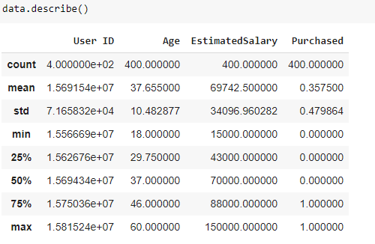

After that I have Calculated the correlation and visualized it using heatmap
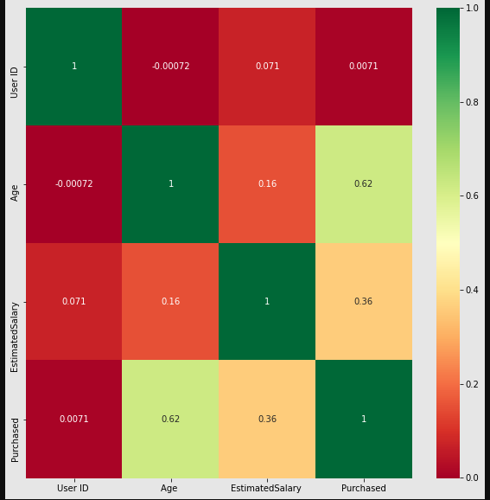

- SPLITTING THE DATA :
I split the data into train and tests sets with a test size of 25%.

Now I’ve Trained various Classification Models on the Training set & I analyzed which yields the highest accuracy. I will compare the accuracy of Logistic Regression, XGBoost Classification , SVM (Support Vector Machine) Random Forest Classification
- APPLYING ALGORITHMS :
After that I have started to apply the algorithms.

MODEL 1: RANDOM FOREST CLASSIFICATION

Initially I have applied Random Forest Classification by importing the Random Forest Classifier. I fitted X-train and y_train with this classifier.
After that Obtaining its accuracy by comparing the y_test and predicted_y from the x_test

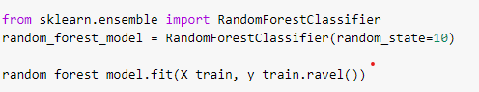
ACCURACY
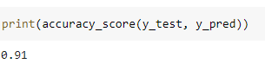

MODEL 2: XGBOOST CLASSIFICATION

Then I have applied XGBoost Classification by importing the xgboost. I fitted X-train and y_train with this classifier. I have also used hyperparameterized here with RandomizedSearchCV to obtain the optimum accuracy
After that Obtaining its accuracy by comparing the y_test and predicted_y from the x_test

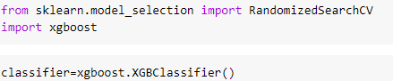

ACCURACY
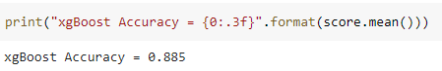

MODEL 3: LOGISTIC REGRESSION

Then I have applied Logistic Regression by importing the Logistic Regression. I fitted X-train and y_train with this classifier.
After that Obtaining its accuracy by comparing the y_test and predicted_y from the x_test

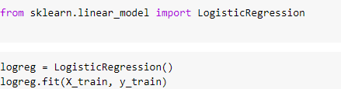

ACCURACY
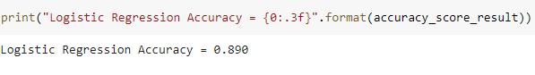

MODEL 4: SUPPORT VECTOR MACHINE

Then I have applied Support Vector Machine by importing the SVC. I fitted X-train and y_train with this classifier.
After that Obtaining its accuracy by comparing the y_test and predicted_y from the x_test

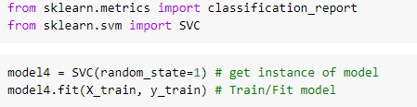

ACCURACY
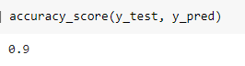

- COMPARING THE ACCURACY :
And Finally I have compared the 4 model’s accuracy using the bar plot

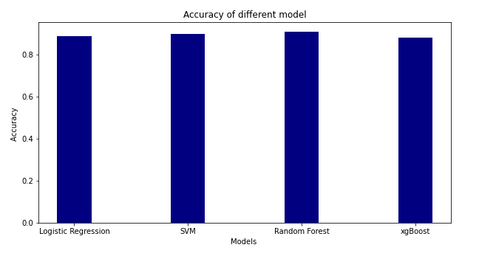
- CONCLUSION :
From this barplot it has been observed that Random Forest has the highest compared to the remaining three. Therefore, we have conclude that Random forest classification model is the most suitable one

- DATA VISUALIZATION USING RANDOM FOREST CLASSIFICATION :

I TRAINIG SET :
Here, First I have created two 2 dimensional array with age and Estimated salary using meshgrid after that I have filled the plotted points using contourf function with color map of red and green. Finally, I have made scatter plot of puchased or not over age and estimated salary for the training set.

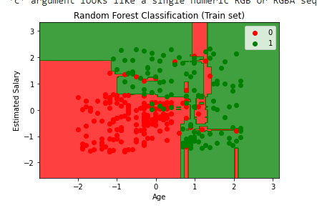
II TEST SET :

Here, First I have created two 2 dimensional array with age and Estimated salary using meshgrid after that I have filled the plotted points using contourf function with color map of red and green. Finally, I have made scatter plot of puchased or not over age and estimated salary for the test set.
