EXERCISE NO: 1 REGISTER NO: 1518102081
DATE: 16.10.2020

AIM:
To print the calendar of a given month and year.

PROGRAM:
import calendar
year=int(input())
month=int(input())
if(year<10000 and year>999 and month < 13 and month>0):
print(calendar.month(year,month))
else:
print("Invalid input")

LINK:
http://103.53.53.18/mod/vpl/forms/edit.php?id=229&userid=1692

OUTPUT:
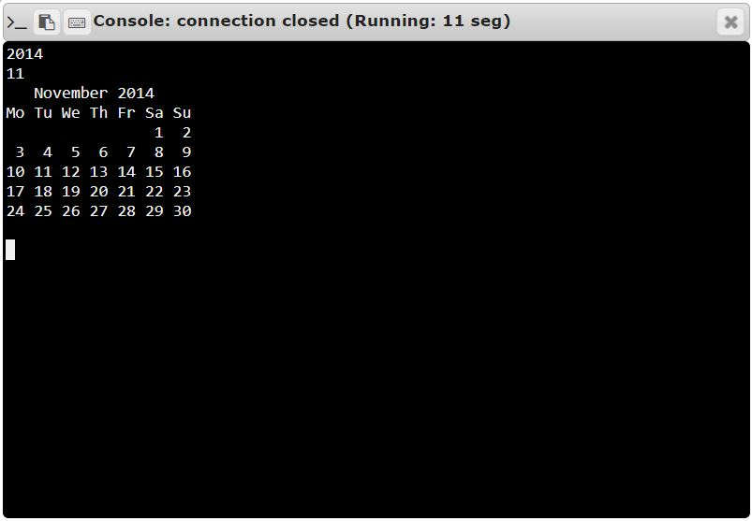
RESULT:
Thus, the code has been successfully executed and output is verified.

