EXERCISE NO: 2 REGISTER NO: 1518102081
DATE: 16.10.2020

AIM:
To print the count number x in a given list of numbers.

PROGRAM:
def countX(lst,x):
c=0
for i in range(len(lst)):
if (lst[i]==x):
c+=1
return c
lst=[]
n=int(input())
for i in range(n):
ele=int(input())
lst.append(ele)

x=int(input())

c=countX(lst,x)
print(c)

LINK:
http://103.53.53.18/mod/vpl/forms/edit.php?id=230&userid=1692

OUTPUT:

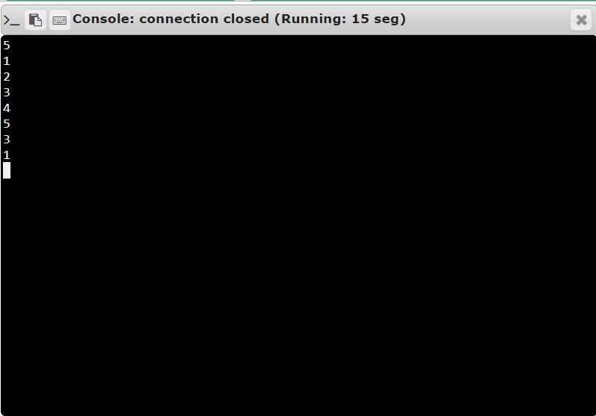

RESULT:
Thus, the code has been successfully executed and output is verified.

