EXERCISE NO: 3 REGISTER NO: 1518102081
DATE: 16.10.2020

AIM:
To remove and print every second number from a list of numbers until the list becomes empty.

PROGRAM:
def removeThirdNumber(lst):
lst1=[]
pos=1
s=0
for i in range(0,len(lst)):
s=(pos+s)%len(lst)
el=lst.pop(s)
lst1.append(el)
return lst1

n=int(input("Enter number of elements: "))
int_list=[]
for i in range(0,n):
e=int(input())
int_list.append(e)
p=removeThirdNumber(int_list)
print(p)

LINK:
http://103.53.53.18/mod/vpl/forms/edit.php?id=231&userid=1692

OUTPUT:

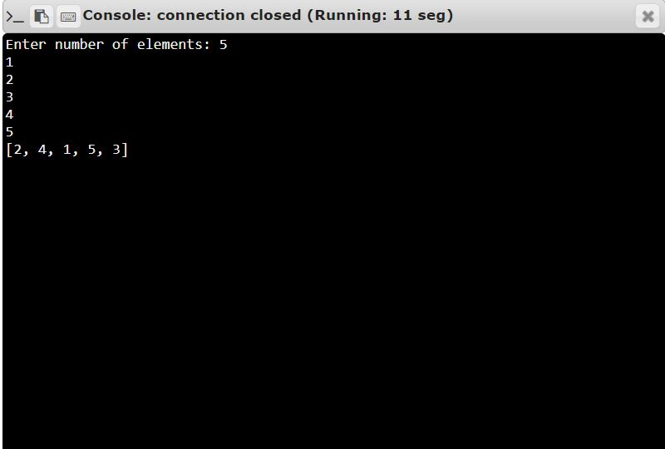

RESULT:
Thus, the code has been successfully executed and output is verified.

