EXERCISE NO: 4 REGISTER NO: 1518102081
DATE: 16.10.2020

AIM:
To print a single string from two set of strings received from user and swap the first two characters of each string.
PROGRAM:
def swap(s):
new=""
for x in s:
new+=x
return new
char1=input()
char2=input()
a=char1.strip()
b=char2.strip()
if(len(a)>=2 and len(b)>=2):
t1=list(a)
t2=list(b)
c1=t1[0]
c2=t1[1]
t1[0]=t2[0]
t1[1]=t2[1]
t2[0]=c1
t2[1]=c2
a=swap(t1)
b=swap(t2)
print(a," ",b)
else:
print("Invalid")

LINK:
http://103.53.53.18/mod/vpl/forms/edit.php?id=234&userid=1692

OUTPUT:
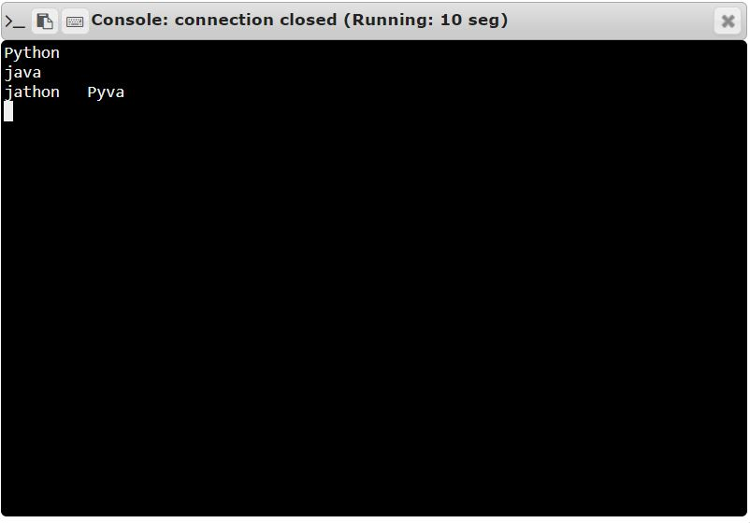

RESULT:
Thus, the code has been successfully executed and output is verified.

