EXERCISE NO: 5 REGISTER NO: 1518102081
DATE: 16.10.2020

AIM:
To print the missing characters to make string pangram.

PROGRAM:
a=input()
a=set(a.strip())
a.remove(chr(32))
b="abcdefghijklmnopqrstuvwxyz"
b=set(b)
b=b.difference(a)
b=list(b)
b.sort()
print("".join(b))

LINK:
http://103.53.53.18/mod/vpl/forms/edit.php?id=235&userid=1692

OUTPUT:
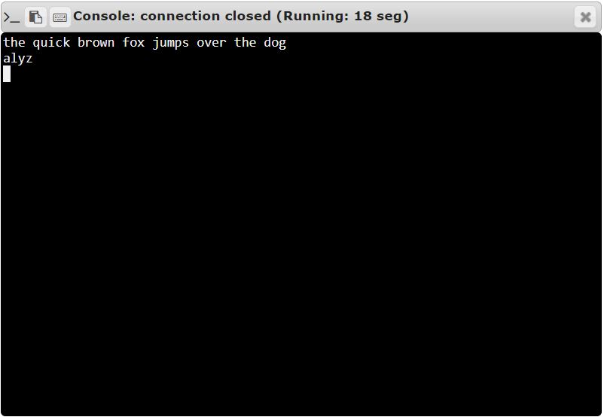

RESULT:
Thus, the code has been successfully executed and output is verified.

