SecureClaims

AI-Powered Insurance Fraud Detection System

Project Documentation

1. PROBLEM STATEMENT

Insurance fraud is a significant challenge in the Indian automotive insurance
industry, causing billions of rupees in losses annually. Traditional fraud
detection systems rely on rigid rule-based approaches that:

• Fail to detect sophisticated fraud patterns
• Generate high false-positive rates, delaying legitimate claims
• Lack transparency in decision-making
• Cannot adapt to evolving fraud techniques
• Provide no explanation for their decisions

The core problem: How can insurance companies efficiently and accurately detect
fraudulent vehicle insurance claims while minimizing false positives and
providing transparent, explainable decisions?

2. SOLUTION
SecureClaims is a hybrid AI-powered fraud detection system that combines:

1. MACHINE LEARNING CLASSIFICATION
- Random Forest model trained on insurance claim data
- Analyzes 14+ features including customer demographics, vehicle info,
claim details, and historical patterns
- Provides fraud probability and confidence scores

2. RETRIEVAL-AUGMENTED GENERATION (RAG)
- Vector database containing insurance policy documents
- Semantic search to retrieve relevant policy clauses
- Ensures decisions are grounded in actual policy terms

3. LARGE LANGUAGE MODEL (LLM) ANALYSIS
- Provides detailed reasoning and explanation
- Analyzes claims against retrieved policy documents
- Generates human-readable recommendations

4. CONFIDENCE-BASED ESCALATION
- High confidence (≥70%): ML decision used directly
- Low confidence (<70%): LLM provides additional analysis
- Final decision combines both ML and LLM insights

KEY BENEFITS:
• Accurate fraud detection with explainable decisions
• Reduced false positives through policy-aware analysis
• User-friendly web interface for claim analysts

3. TECH STACK
BACKEND:
• FastAPI - High-performance async REST API framework

MACHINE LEARNING:
• Scikit-learn - Random Forest classification
• Pandas - Data manipulation and feature extraction
• Joblib - Model serialization and loading

RAG & EMBEDDINGS:
• Qdrant Cloud - Vector database for semantic search
• BAAI/bge-small-en-v1.5 - Embedding model (384 dimensions)

LLM INTEGRATION:
• Groq API - Fast LLM inference
• Kimi-k2-instruct - Language model for reasoning

FRONTEND:
• HTML - Page structure
• CSS - Styling and responsive design
• JavaScript - Client-side logic and API calls

DATA:
• Faker - Synthetic data generation

4. ARCHITECTURE

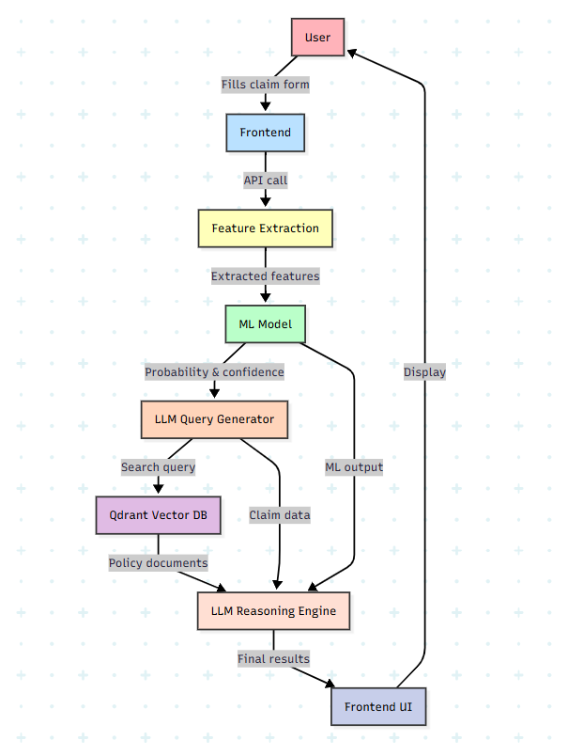
DATA FLOW:

1. User submits claim → Frontend validates → POST /api/detect-fraud
2. API extracts features → ML model predicts → Returns probability & confidence
3. LLM Generate search query → Retrieve policy docs from Qdrant
4. LLM analyzes claim + policy docs + ML prediction → Generates reasoning
5. Final decision extracted → Response sent to frontend → Results displayed

5. MODULES

MODULE 1: MACHINE LEARNING MODULE
Purpose: Train and serve the fraud detection ML model
Features Analyzed:
• Customer: age, tenure_months
• Vehicle: age_years, IDV (Insured Declared Value)
• Claim: amount, repair_estimate
• Incident: accident_type, damage_type, police_report_filed
• History: previous_claims_count
• Add-ons: engine_guard, tyre_rim
Output: Fraud/Not Fraud prediction with probability and confidence score

MODULE 2: RAG MODULE
Purpose: Enable policy-aware fraud detection through document retrieval
Components:
• Semantic Chunker: Splits policy documents into 800-token chunks
• Chunk Loader: Uploads embeddings to Qdrant vector database
• Query Generator: LLM creates targeted search queries
• Retriever: Fetches top-3 relevant policy clauses
Data Source: SBI General Insurance Policy

MODULE 3: API BACKEND MODULE
Purpose: Orchestrate the fraud detection pipeline via REST API
Endpoints:
• GET / - Serve frontend application
• POST /api/detect-fraud - Main fraud detection endpoint

MODULE 4: FRONTEND MODULE
Purpose: User interface for claim submission and result display
Components:
• Claim Form: Input fields for all claim attributes
• Results Display: ML prediction, confidence, LLM analysis
• Visual Indicators: Color-coded fraud probability
Features:
• Responsive design
• Real-time validation

MODULE 5: DATA PROCESSING MODULE
Purpose: Generate training data and manage policy documents
Synthetic Data Features:
• 10,000 insurance claims
• Realistic fraud patterns with noise injection
• Configurable risk scoring system
Fraud Risk Factors:
• No police report: +30 risk
• 4+ previous claims: +25 risk
• Claim > 70% of IDV: +20 risk
• Theft without police report: +40 risk

IMPLEMENTATION:
