**# OPEN BELOW LINK AND COMPLETE BELOW TASKS**

<https://testpages.herokuapp.com/styled/basic-html-form-test.html>

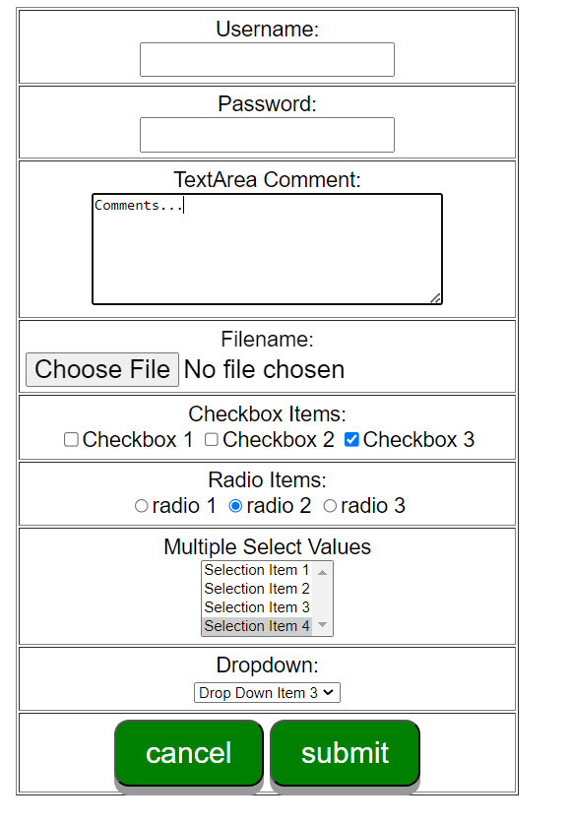

**## PLEASE COMPLETE BELOW STEPS USING PYTHON SELENIUM MODULE AND ROBOT FRAMEWORK SELENIUM LIBRARY**

1. **ENTER USERNAME**
2. **ENTER PASSWORD**
3. **REMOVE EXISTING TEXT FROM TEXT AREA COMMENT AND THEN ENTER NEW COMMENT**
4. **UPLOAD ANY FILE**
5. **SELECT CHECK BOX 1 AND 3**
6. **SELECT RADIO BUTTON 3**
7. **SELECT Selection Item 1 and Selection Item 3 FROM MULTIPLE SELECT VALUES**
8. **SELECT Drop Down Item 4 from DROPDOWN BOX**
9. **THEN CLICK ON SUBMIT BUTTON**