## What is Selenium?

Selenium is an open-source tool for automate web applications across different browsers and platforms.

## Selenium has four components.

* Integrated Development Environment (IDE)
* Remote Control (RC)
* **WebDriver**
* Selenium Grid

## Selenium IDE

* Selenium IDE is primarily a record and run tool for automate web applications.
* Work only on Firefox

## Selenium Remote Control (Selenium RC)

* This is the first automated web testing tool that allowed users to use a programming language.
* Faster execution than IDE

RC can support the following programming languages:

* [Java](https://www.guru99.com/java-tutorial.html)
* Python
* [C#](https://www.guru99.com/c-tutorial.html)
* [PHP](https://www.guru99.com/php-tutorials.html)
* Perl
* Ruby

## WebDriver

* The WebDriver is better than both Selenium IDE and Selenium RC in many aspects.
* It implements a more modern and stable approach in automating the browser's actions.

The supported languages are the same as those in Selenium RC.

* Java
* Python
* C#
* PHP
* Perl
* Ruby

**Selenium Grid**

Selenium Grid is a tool used to run parallel tests across different machines and different browsers all at the same time.

**🡺 INSTALL selenium in python**

**python -m pip install selenium**

**HTML**

HTML stands for Hyper Text Markup Language

HTML is used for creating Web pages

An HTML code is a **collection of Elements**

**What is HTML Element**

An HTML element is an **individual component** of an HTML document.

HTML elements are written with a start tag and an end tag, with content in between. Elements can also contain **attributes** that defines its additional properties.

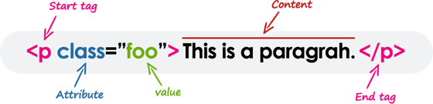

## SUMMARY

**Sample HTML code**

<!DOCTYPE html>  
<body>  
 **<h1 id="myHeader" name="kumar">Sriram</h1>**

</body>  
</html>

**Sample Element**

<h1 id="myHeader" name="kumar">Sriram</h1>

h1 🡪 It is a starting tag

id and name 🡪 Attributes

Sriram 🡪 Content

/h1 🡪 It is an ending tag

**What are Attributes**

* Attributes provide **additional information** about elements
* Attributes are always specified in **the start tag**
* Attributes usually come in name/value pairs like **name="value"**

**Locators: -** Locators are used to find elements in a web page.

<https://selenium-python.readthedocs.io/locating-elements.html>

**Locater Types:**

1. Locate Element by **ID**

2. Locate Element by **XPath**

3. Locate Element by Link Text

4. Locate Element by Partial Link Text

5. Locate Element by Name

6. Locate Element by CSS Selector

7. Locate Element by Tag name

8. Locate Element by Class name

**TO FIND CHROME BROWSER VERSION**

**CLICK THREE DOTS 🡪 HELP 🡪 ABOUT GOOGLE CHROME**

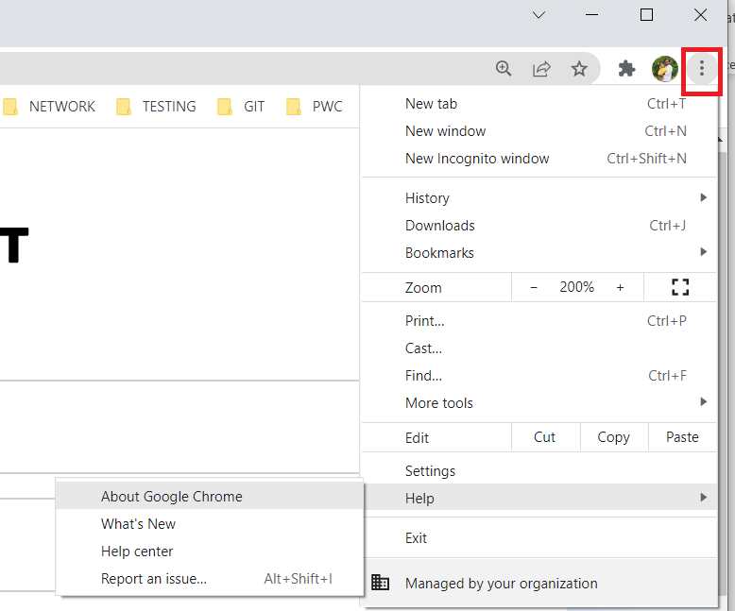

**TO FIND XPATH**

**RIGHT CLICK ON HIGHLIGHTED ELEMENT 🡪 COPY 🡪 COPY XPATH**

