STREAMFLIX
Shared VPC on Google Cloud Console - Step-by-Step Demo Guide
Build the 3-tier StreamFlix demo (web, app, data) across 1 host project + 3 service projects using only the Google Cloud Console (no gcloud).
Item | Value
Region / Zone | asia-south1 (Mumbai) / asia-south1-a
VPC | streamflix-shared-vpc (custom mode)
Subnets | web 10.10.1.0/24, app 10.10.2.0/24, data 10.10.3.0/24
VMs | sf-web 10.10.1.10, sf-app 10.10.2.10, sf-db 10.10.3.10
Project IDs (example) | streamflix-network-nr01, streamflix-web-nr01, streamflix-app-nr01, streamflix-data-nr01
Note | Project IDs are global. Replace "nr01" with your own unique suffix everywhere.

How to use the screenshot boxes: each step has a dashed box. Take the screenshot described in it (Windows: Win+Shift+S, Mac: Cmd+Shift+4), paste it into the box, then delete the box text. Console labels can shift slightly between releases; follow the field names and values.
Traffic flow: Internet -> sf-web:80 -> sf-app:5000 -> sf-db:5432. Each hop is allowed only from the previous subnet.

Step 0 - Prerequisites
- Open https://console.cloud.google.com and sign in.
- Click the project picker (top bar) and confirm your Organization appears. Shared VPC does not work without an Organization.
- In the picker select the Organization, then go to IAM & Admin > IAM > Grant access.
- Add your own email with roles: Project Creator, Billing Account User, Shared VPC Admin. Click Save.
- Have a billing account ready (Navigation menu > Billing).
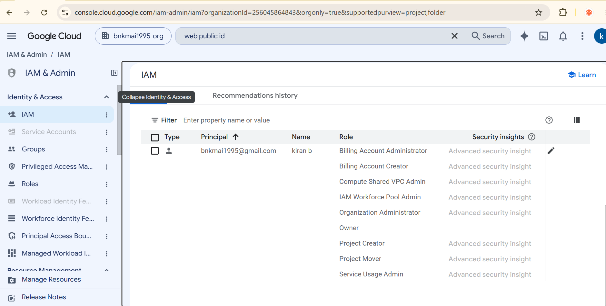

Expected: Your user has the 3 roles at organization level.

Step 1 - Create the 4 projects
Working in project: Project picker > New project
- Click the project picker (top bar) > New project.
- Enter Project name and click Edit to set the Project ID as in the table.
- Under Location choose your Organization. Click Create.
- Repeat until all 4 projects exist.

Role | Project ID
Host (owns network) | streamflix-network-nr01
Service - web | streamflix-web-nr01
Service - app | streamflix-app-nr01
Service - data | streamflix-data-nr01

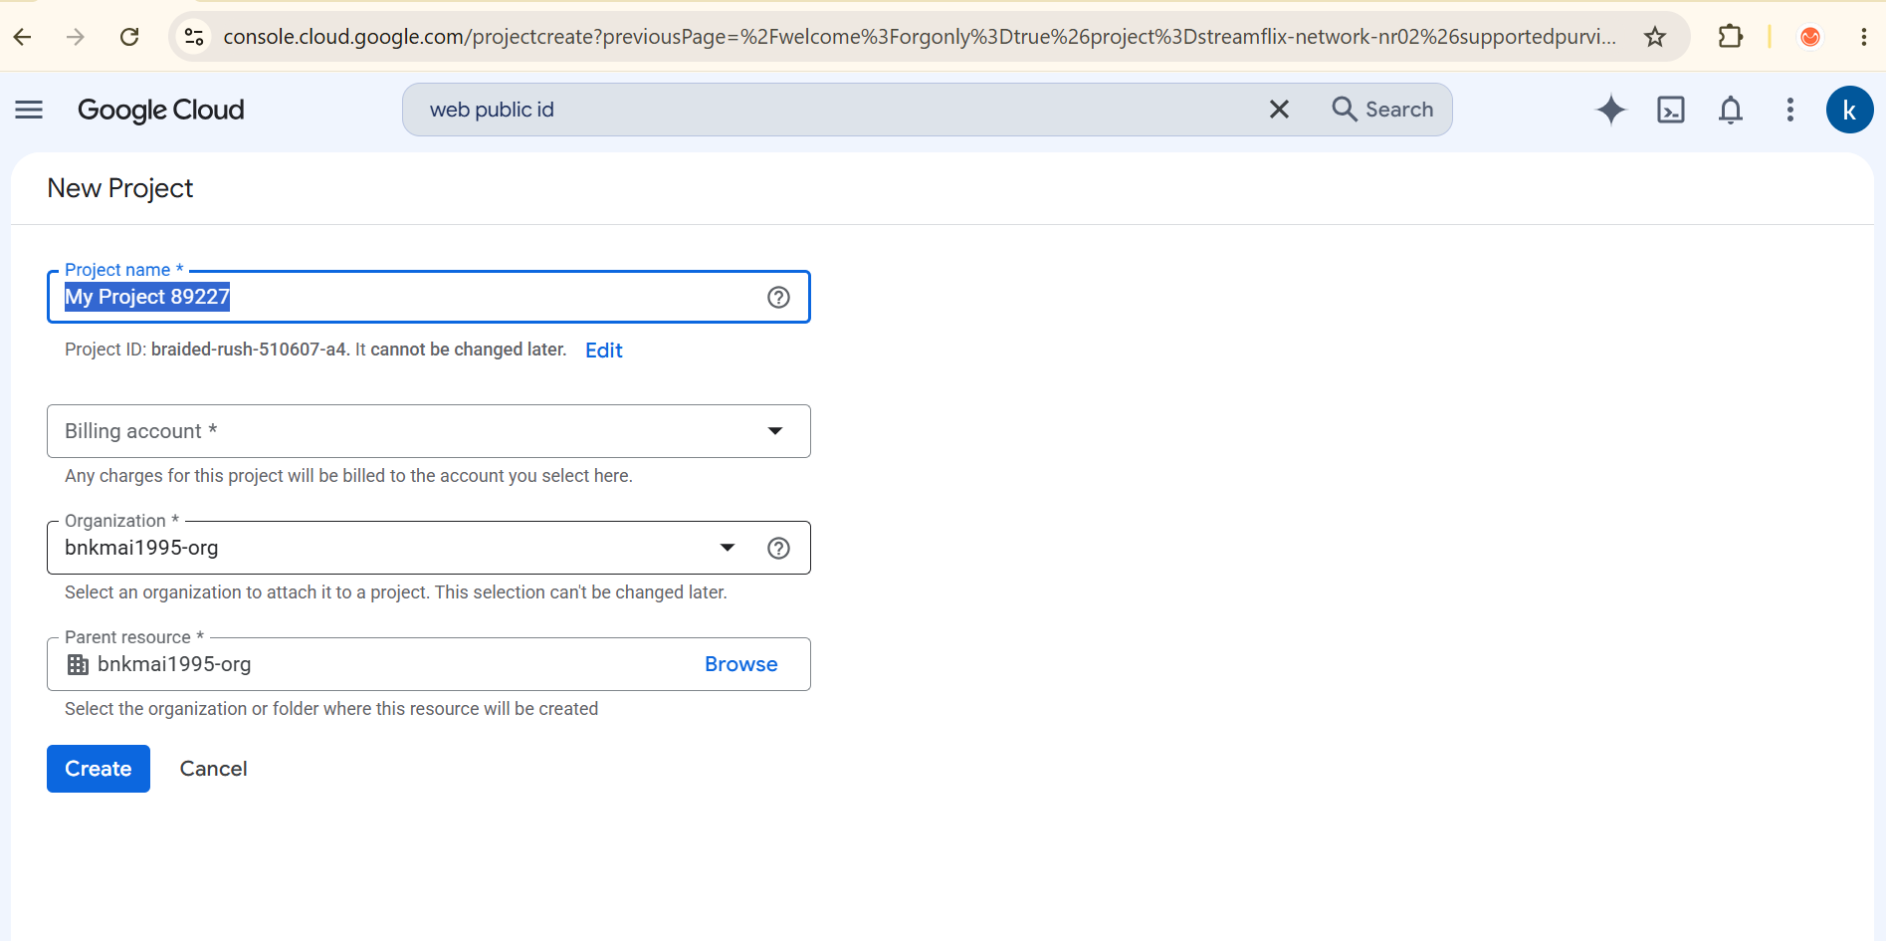

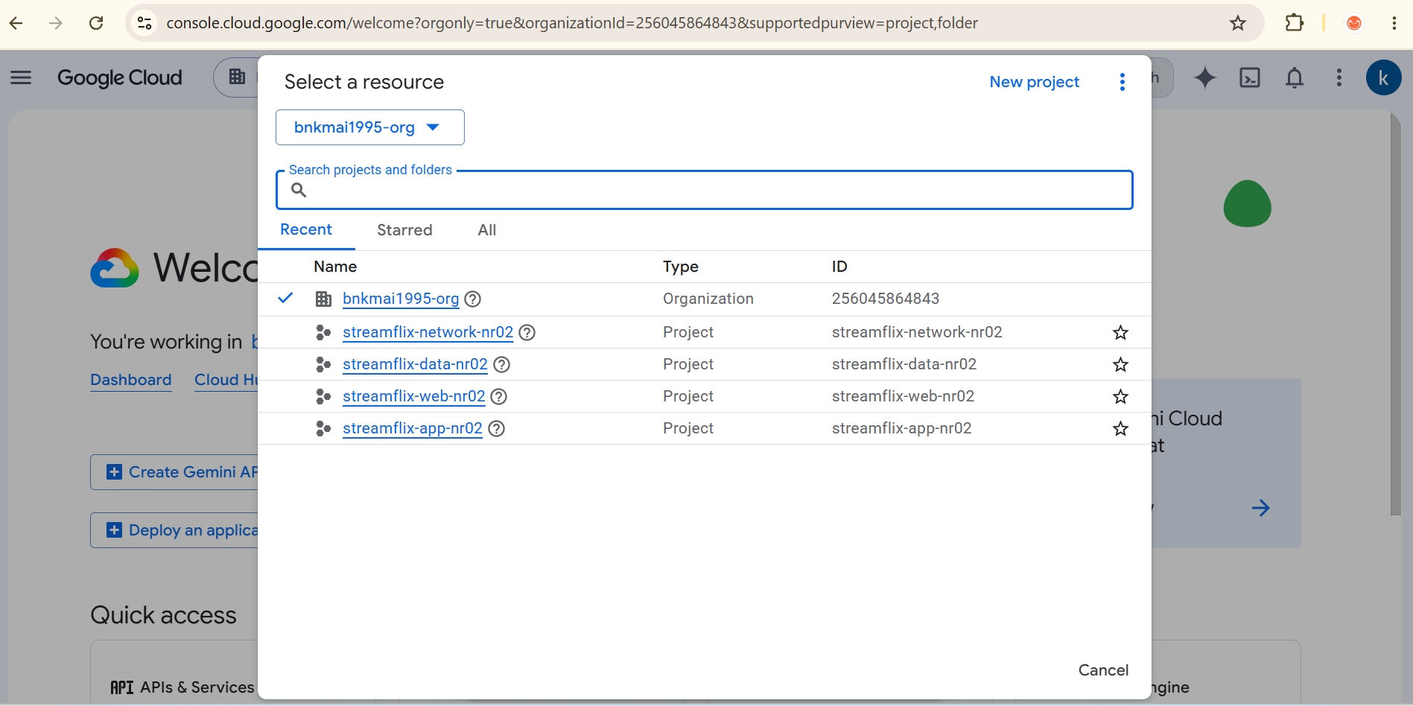

Expected: 4 projects created under the organization.

Step 2 - Link billing to each project
Working in project: Navigation menu > Billing
- Open Billing, select your billing account.
- Go to Account management (or My projects).
- For each of the 4 projects: Actions (three dots) > Change billing > select your account > Set account.
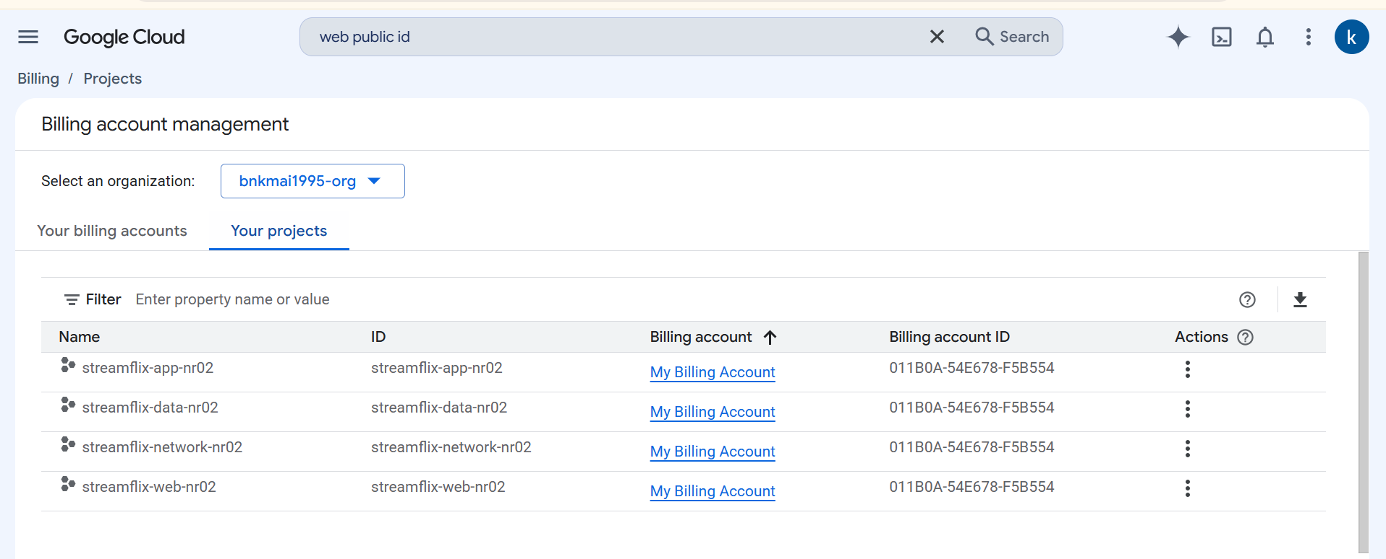

Expected: All 4 projects show your billing account.

Step 3 - Enable the Compute Engine API (4 times)
Working in project: Repeat in each of the 4 projects
- Select the project in the picker.
- Navigation menu > APIs & Services > Library.
- Search Compute Engine API > open it > Enable (takes ~1 minute).
- Repeat for the other 3 projects.
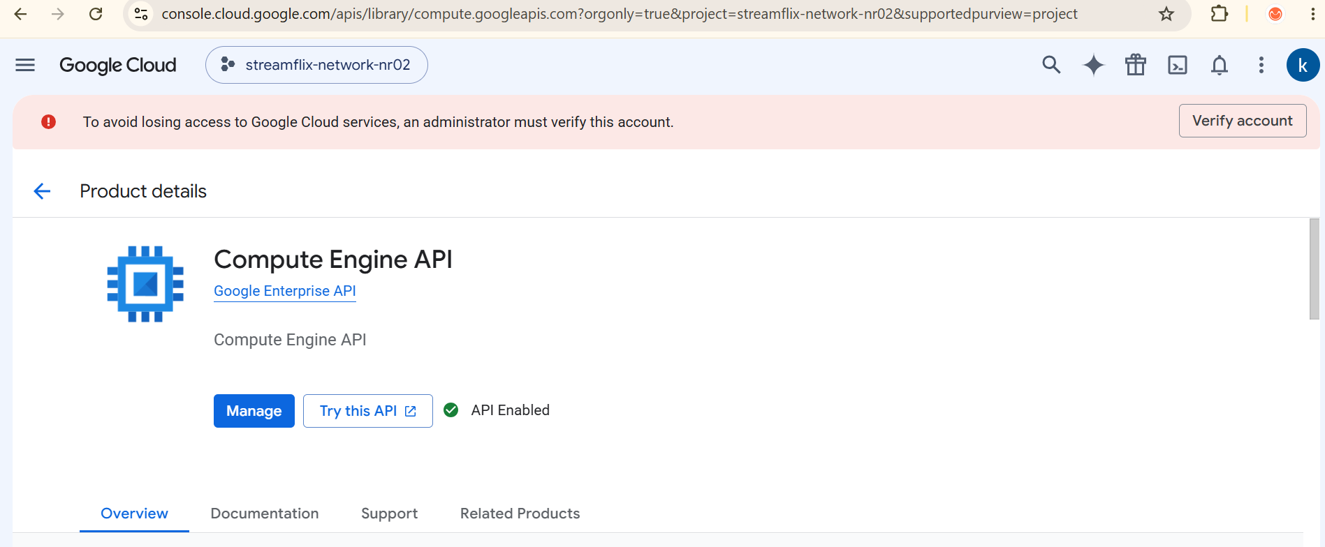

Expected: Compute Engine API enabled in host and all service projects.

Step 4 - Create the VPC and 3 subnets
Working in project: Project: streamflix-network-nr01
- Switch to the host project.
- Navigation menu > VPC network > VPC networks > Create VPC network.
- Name: streamflix-shared-vpc. Subnet creation mode: Custom.
- Under New subnet enter the first subnet from the table, click Done, then Add subnet for the other two. Keep Private Google Access Off, Flow logs Off.
- Leave Firewall rules untouched (we add our own in Step 9). Dynamic routing mode: Regional. Click Create.

Subnet name | Region | IPv4 range
web-subnet | asia-south1 | 10.10.1.0/24
app-subnet | asia-south1 | 10.10.2.0/24
data-subnet | asia-south1 | 10.10.3.0/24

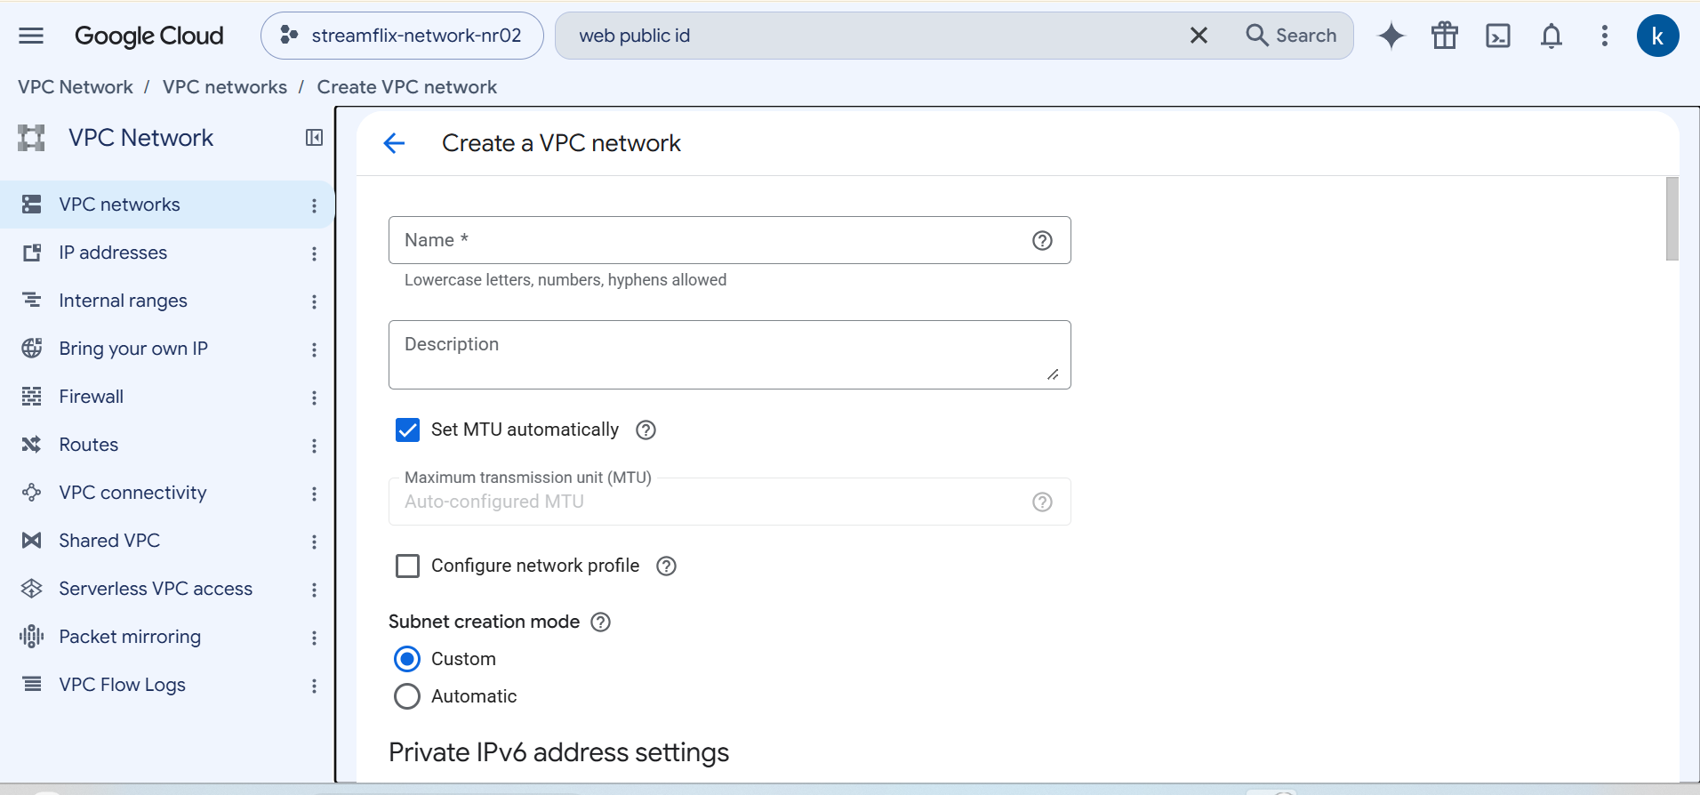

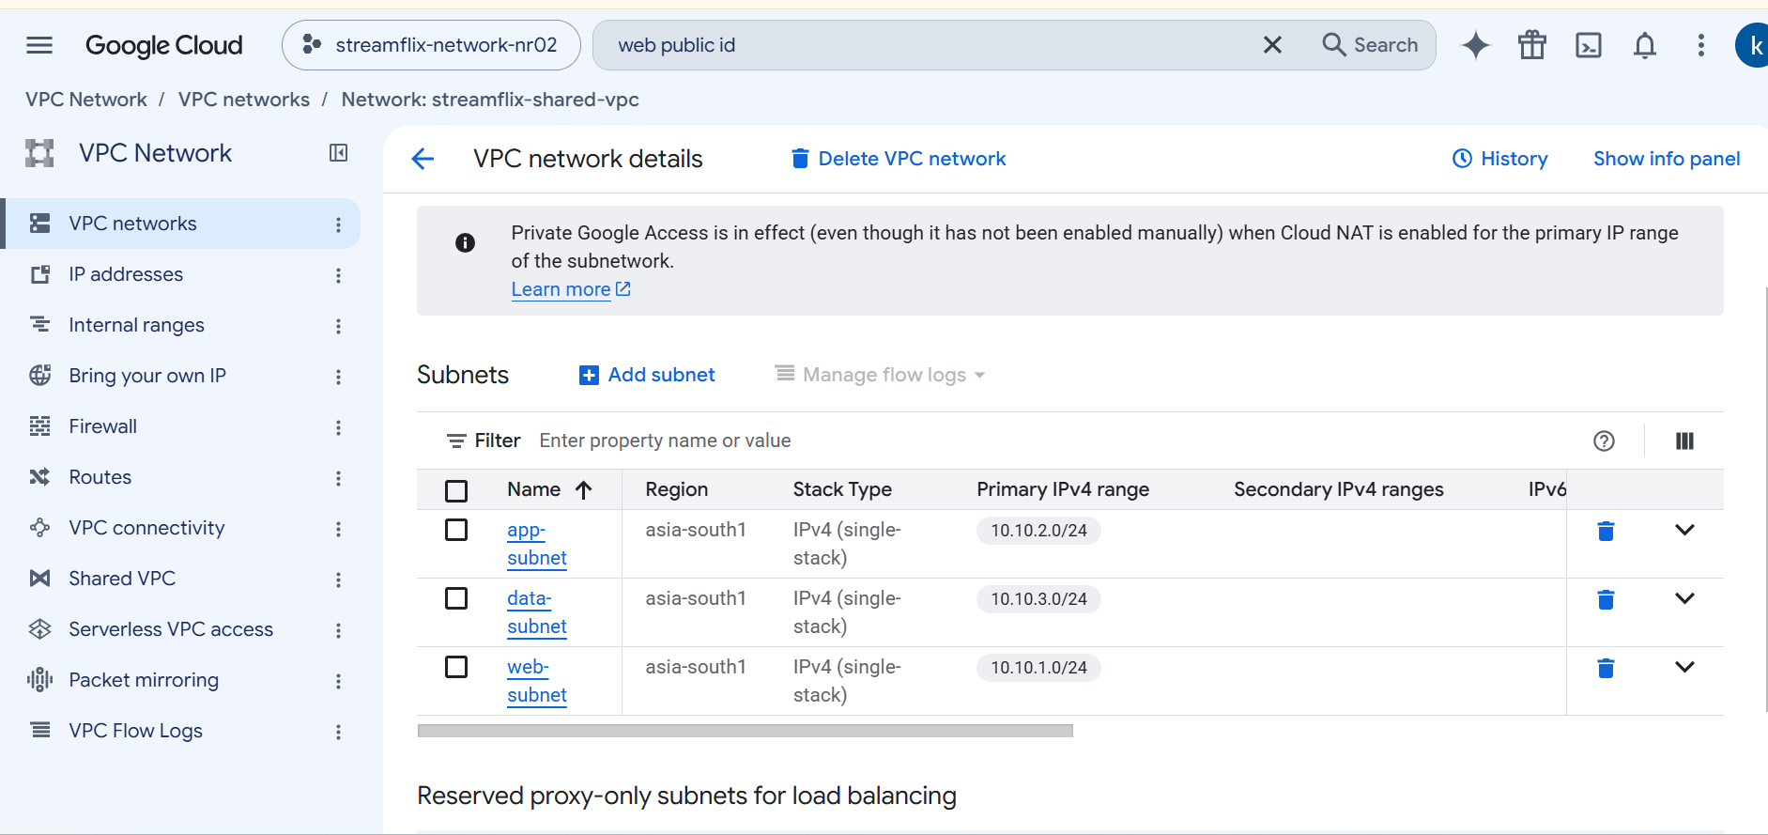

Expected: VPC streamflix-shared-vpc with 3 subnets in asia-south1.

Step 5 - Enable the host project
Working in project: Project: streamflix-network-nr01
- Navigation menu > VPC network > Shared VPC.
- Click Set up Shared VPC.
- On "Enable host project" click Save and continue.
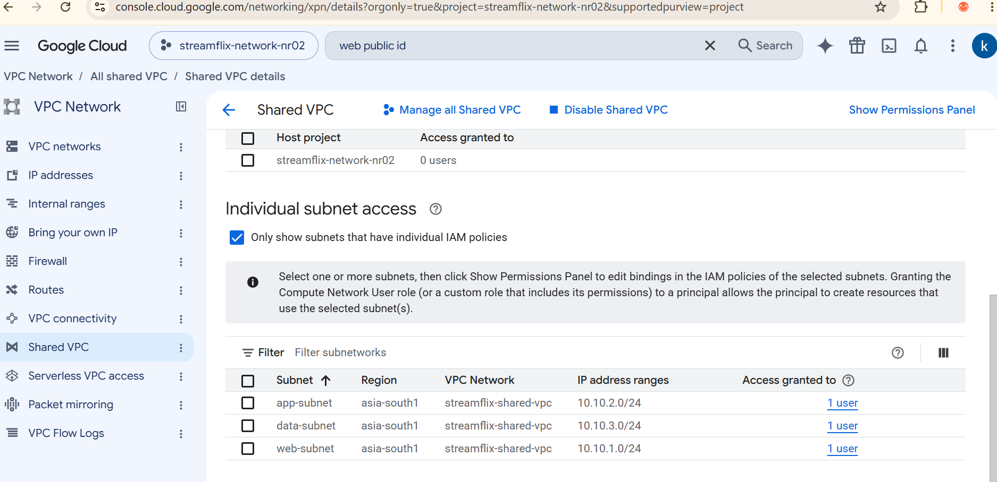

Expected: The wizard moves to the "Select subnets" screen.

Step 6 - Share subnets and attach service projects
Working in project: Project: streamflix-network-nr01
- Sharing mode: choose Individual subnets (subnet-level permissions).
- Under Subnets to share select web-subnet, app-subnet, data-subnet. Click Continue.
- On "Give permissions": under Select projects to attach click Attach projects and tick the 3 service projects.
- Under Select users by role (Compute Network User) add your user email (in real life, a team group). Click Save.
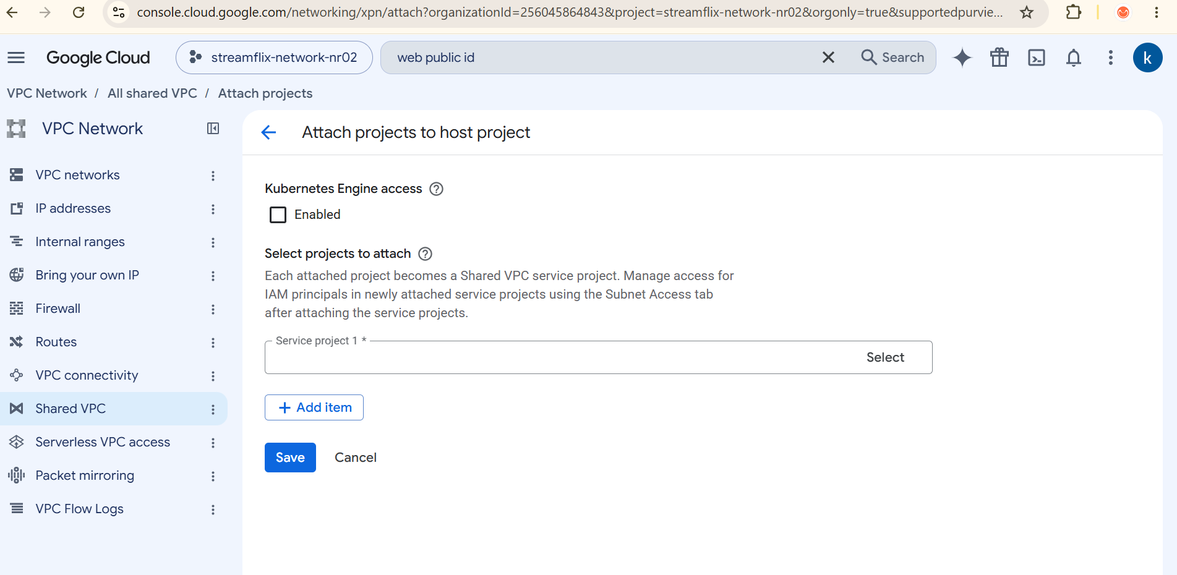

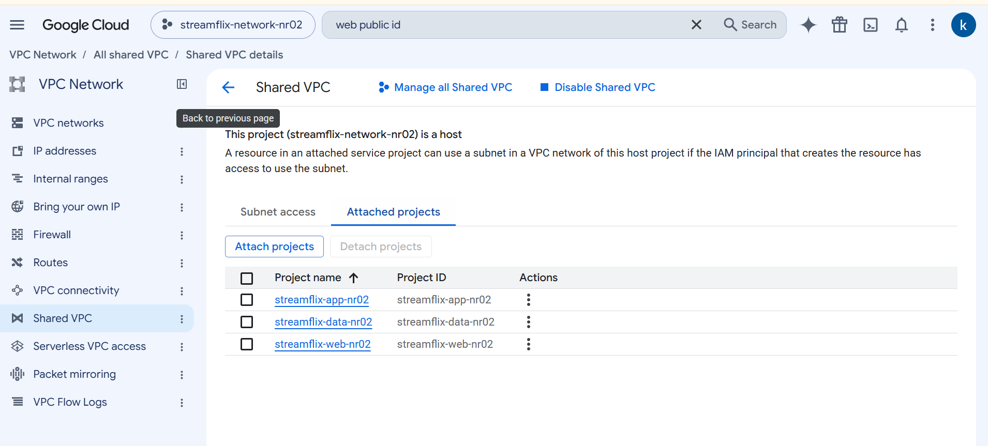

Expected: Shared VPC page > **Attached projects** tab lists the 3 service projects.

Step 7 - Give yourself VM rights in the service projects
Working in project: Repeat in WEB, APP and DATA projects
- Select a service project in the picker.
- IAM & Admin > IAM > Grant access.
- Principal: your email. Role: Compute Instance Admin (v1). Save.
- Repeat for the other 2 service projects. (Skip if you are already Owner of these projects.)
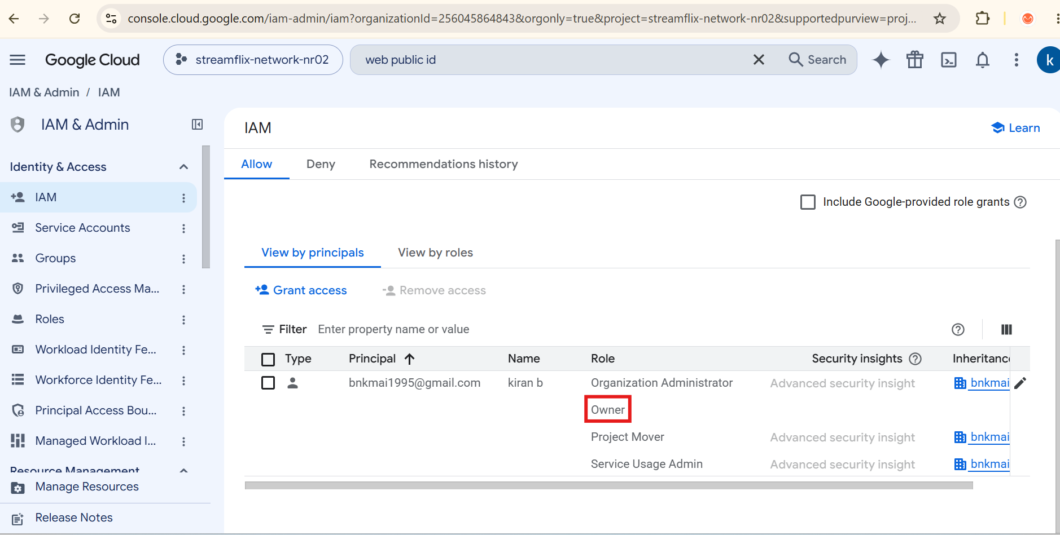

Expected: You can create VMs in all 3 service projects.

Step 8 - Create the 4 firewall rules
Working in project: Project: streamflix-network-nr01
- Switch to the host project. VPC network > Firewall > Create firewall rule.
- Common fields for all 4 rules: Network streamflix-shared-vpc, Priority 1000, Direction Ingress, Action Allow, Targets Specified target tags, Source filter IPv4 ranges.
- Use the table for the name, target tags, source range and protocol. Choose Specified protocols and ports > TCP and enter the port. Click Create.
- Repeat for each rule.

Name | Target tags | Source IPv4 range | TCP port
sf-allow-web | web | 0.0.0.0/0 | 80
sf-allow-app | app | 10.10.1.0/24 | 5000
sf-allow-db | db | 10.10.2.0/24 | 5432
sf-allow-iap | web,app,db | 35.235.240.0/20 | 22

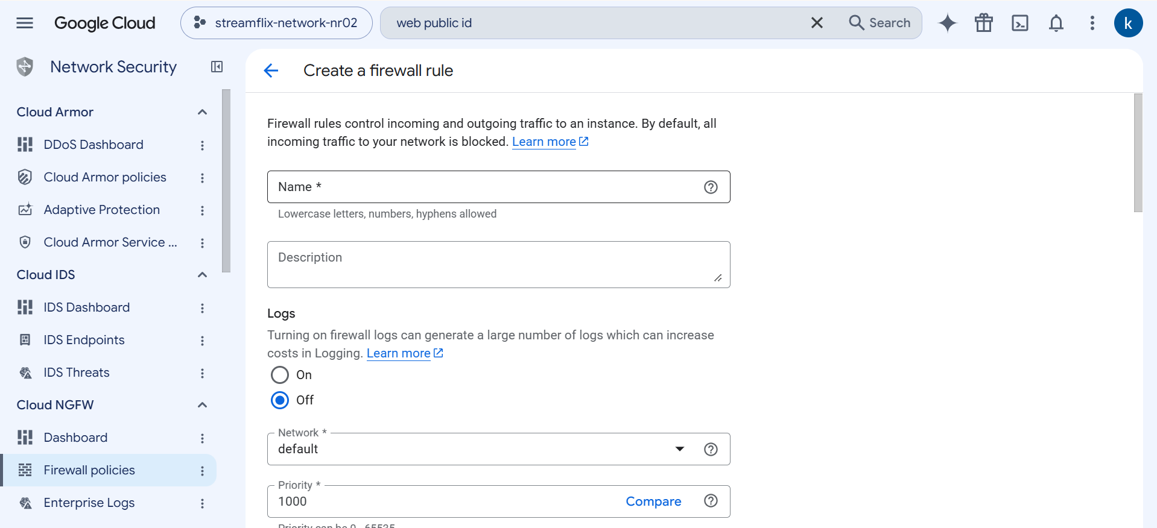

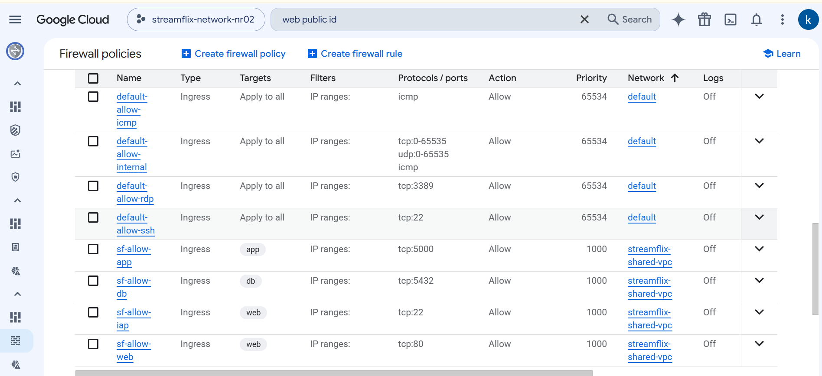

Expected: 4 rules visible in the Firewall list.

Step 9 - Create Cloud NAT
Working in project: Project: streamflix-network-nr01
- Navigation menu > Network services > Cloud NAT > Create Cloud NAT gateway.
- Gateway name sf-nat, NAT type Public, Network streamflix-shared-vpc, Region asia-south1.
- Cloud Router: Create new router, name sf-router, click Create.
- NAT mapping Source: All subnet IP ranges (default). Click Create.
- Why: app and db VMs have no public IP but need internet once to install packages.
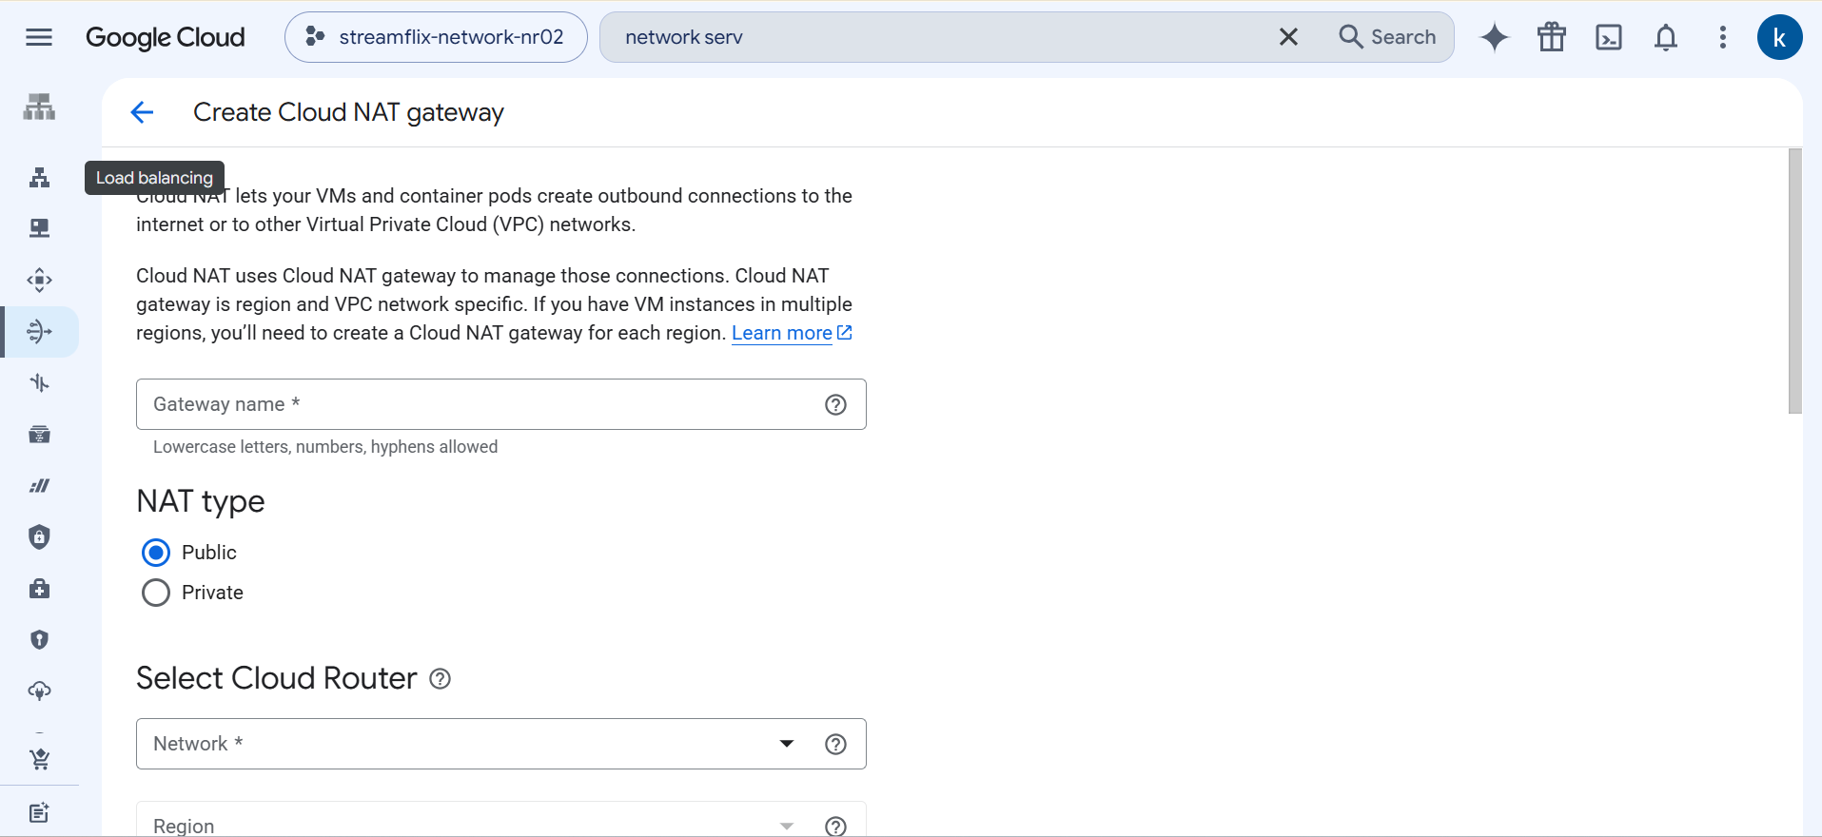

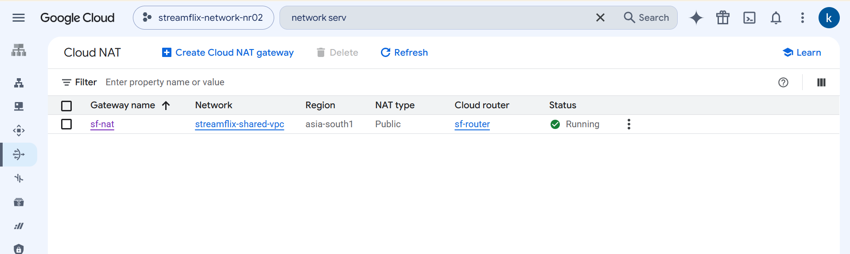

Expected: sf-nat created in asia-south1.

Step 10 - Create the database VM (Tier 3)
Working in project: Project: streamflix-data-nr01
- Switch to project streamflix-data-nr01. Compute Engine > VM instances > Create instance.
- Name sf-db, Region asia-south1, Zone asia-south1-a, Machine type e2-small (E2 series).
- Left menu OS and storage > Change: Operating system Debian, Version Debian GNU/Linux 12 (bookworm), Select.
- Left menu Networking: in Network tags type db and press Enter.
- Under Network interfaces click the default interface to edit. Choose Networks shared with me (from host project: streamflix-network-nr01) and select subnet data-subnet.
- Primary internal IPv4 address: choose Ephemeral (Custom) and enter 10.10.3.10.
- External IPv4 address: None (private VM). Click Done.
- Open Advanced > Management. In Automation > Startup script paste the full text of scripts/db-startup.sh (Appendix B1).
- Under Metadata > Add item: Key init-sql, Value = full text of database/init.sql (Appendix B2).
- Click Create.

Field | Value
Subnet | data-subnet (shared from host)
Internal IP | 10.10.3.10
External IP | None
Network tag | db
Metadata key | init-sql

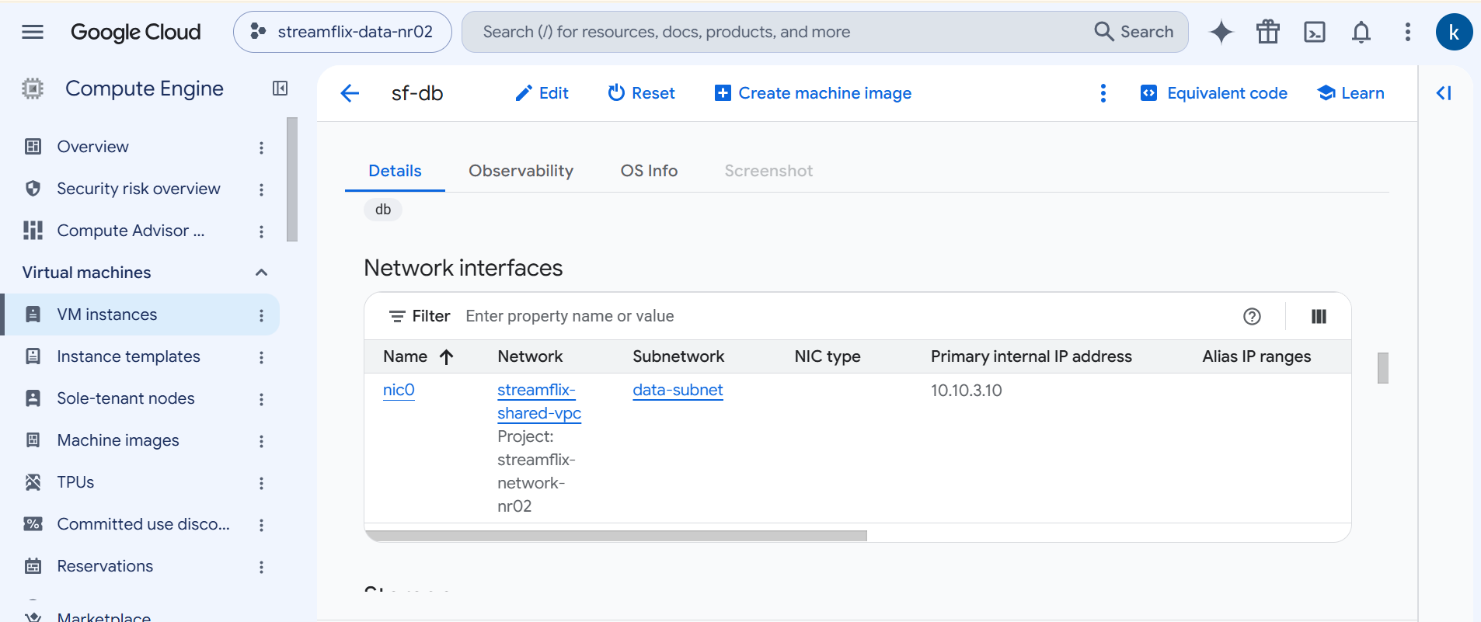

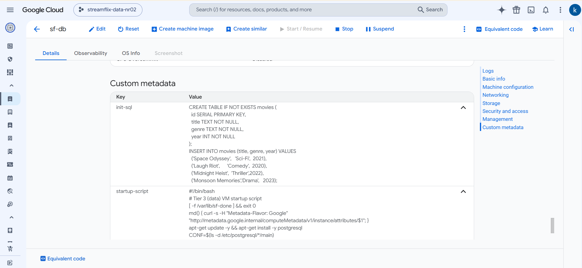

Expected: sf-db running with internal IP 10.10.3.10 (no external IP).

Step 11 - Create the backend VM (Tier 2)
Working in project: Project: streamflix-app-nr01
- Switch to project streamflix-app-nr01. Compute Engine > VM instances > Create instance.
- Name sf-app, Region asia-south1, Zone asia-south1-a, Machine type e2-small (E2 series).
- Left menu OS and storage > Change: Operating system Debian, Version Debian GNU/Linux 12 (bookworm), Select.
- Left menu Networking: in Network tags type app and press Enter.
- Under Network interfaces click the default interface to edit. Choose Networks shared with me (from host project: streamflix-network-nr01) and select subnet app-subnet.
- Primary internal IPv4 address: choose Ephemeral (Custom) and enter 10.10.2.10.
- External IPv4 address: None (private VM). Click Done.
- Open Advanced > Management. In Startup script paste scripts/app-startup.sh (Appendix B3).
- Under Metadata > Add item: Key app-py, Value = full text of backend/app.py (Appendix B4).
- Click Create.

Field | Value
Subnet | app-subnet (shared from host)
Internal IP | 10.10.2.10
External IP | None
Network tag | app
Metadata key | app-py

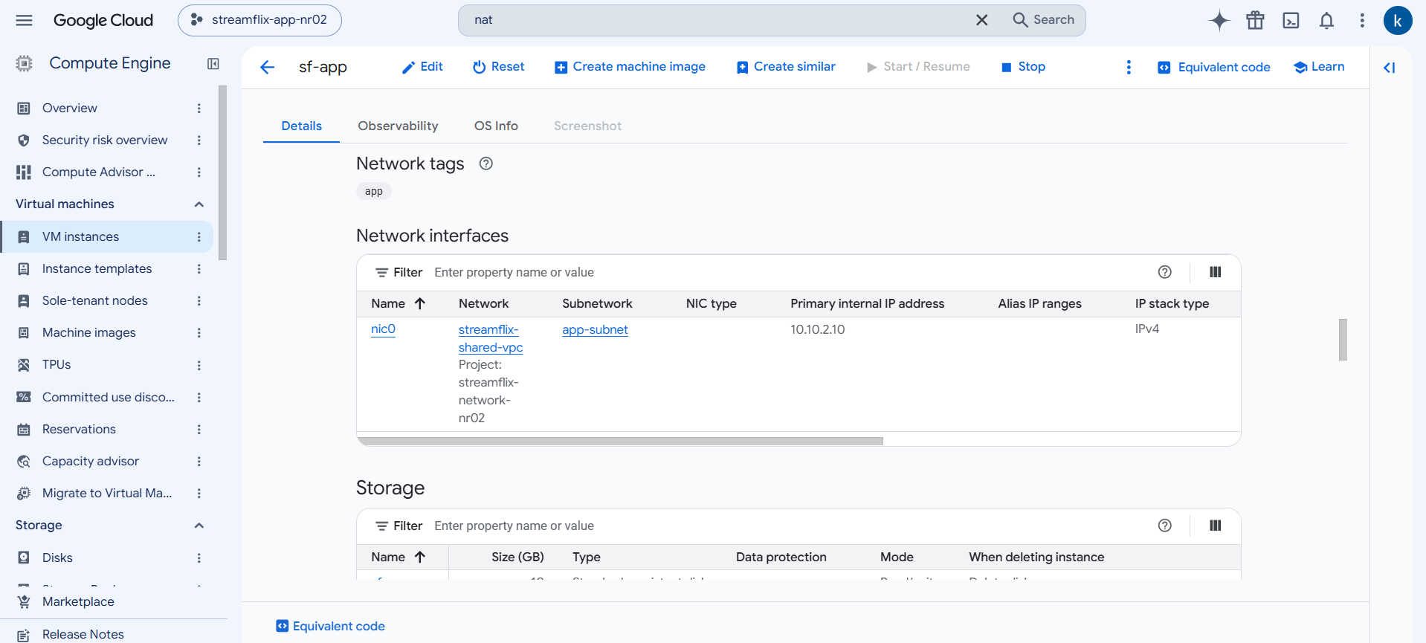

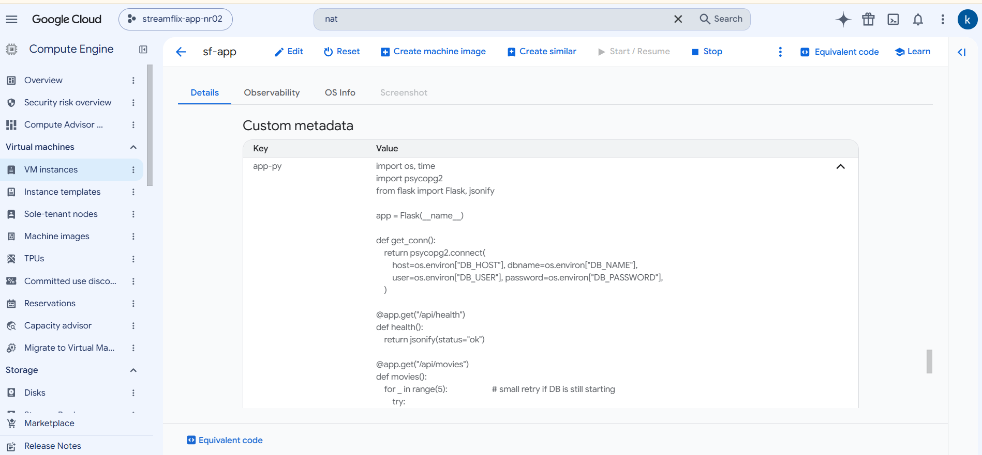

Expected: sf-app running with internal IP 10.10.2.10.

Step 12 - Create the frontend VM (Tier 1)
Working in project: Project: streamflix-web-nr01
- Switch to project streamflix-web-nr01. Compute Engine > VM instances > Create instance.
- Name sf-web, Region asia-south1, Zone asia-south1-a, Machine type e2-small (E2 series).
- Left menu OS and storage > Change: Operating system Debian, Version Debian GNU/Linux 12 (bookworm), Select.
- Left menu Networking: in Network tags type web and press Enter.
- Under Network interfaces click the default interface to edit. Choose Networks shared with me (from host project: streamflix-network-nr01) and select subnet web-subnet.
- Primary internal IPv4 address: choose Ephemeral (Custom) and enter 10.10.1.10.
- External IPv4 address: Ephemeral (public IP). Click Done.
- Do NOT tick "Allow HTTP traffic" (our firewall rule in the host project handles it).
- Open Advanced > Management. In Startup script paste scripts/web-startup.sh (Appendix B5).
- Under Metadata > Add item add two items: index-html = full text of frontend/index.html (B6) and nginx-conf = full text of frontend/nginx.conf (B7).
- Click Create. Wait about 3 minutes for all three startup scripts to finish.

Field | Value
Subnet | web-subnet (shared from host)
Internal IP | 10.10.1.10
External IP | Ephemeral
Network tag | web
Metadata keys | index-html, nginx-conf

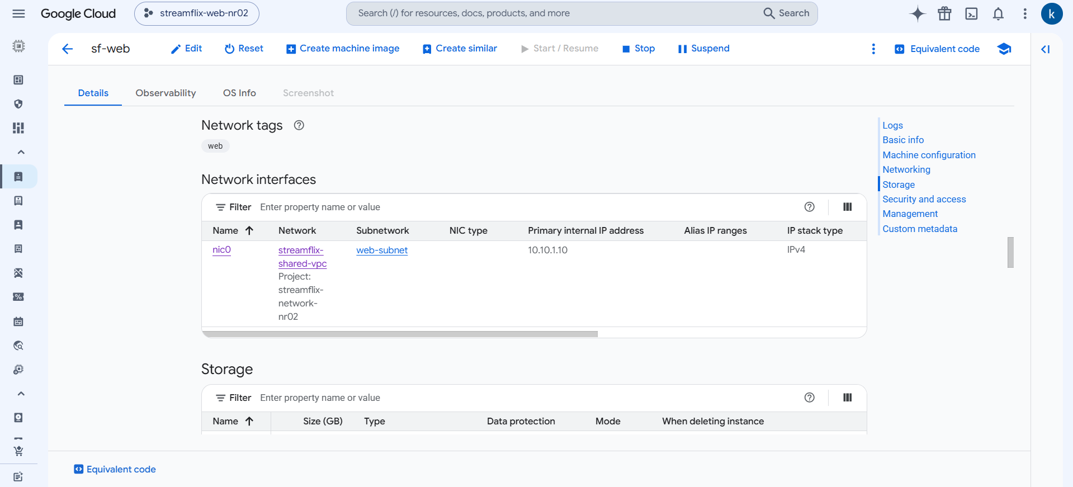

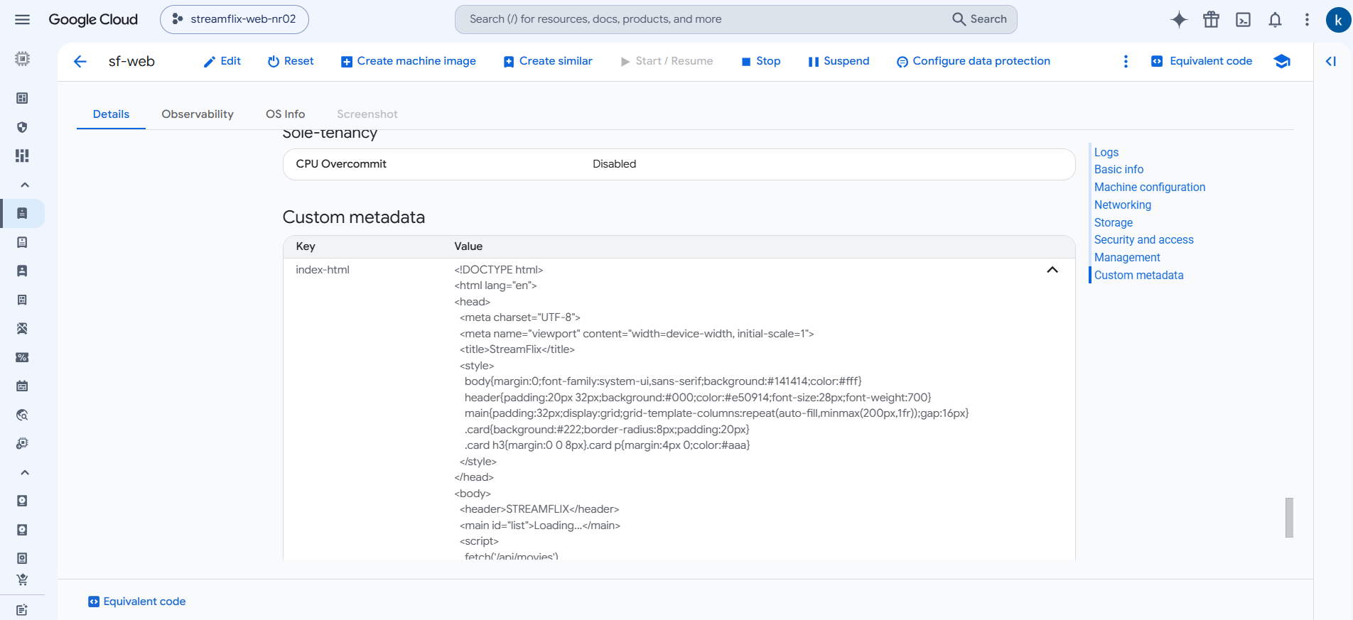

Expected: sf-web running with internal 10.10.1.10 and a public IP.

Step 13 - Verify the Shared VPC behaviour
Working in project: Check all 4 projects
- In each service project open VM instances: note the Internal IP is 10.10.x.x although the VM is in a different project from the network.
- Switch to the host project > VPC network > VPC networks > streamflix-shared-vpc and open a subnet: it shows the shared status and attached projects.
- Host project > VPC network > IP addresses: the internal IPs of the 3 VMs are listed here too.
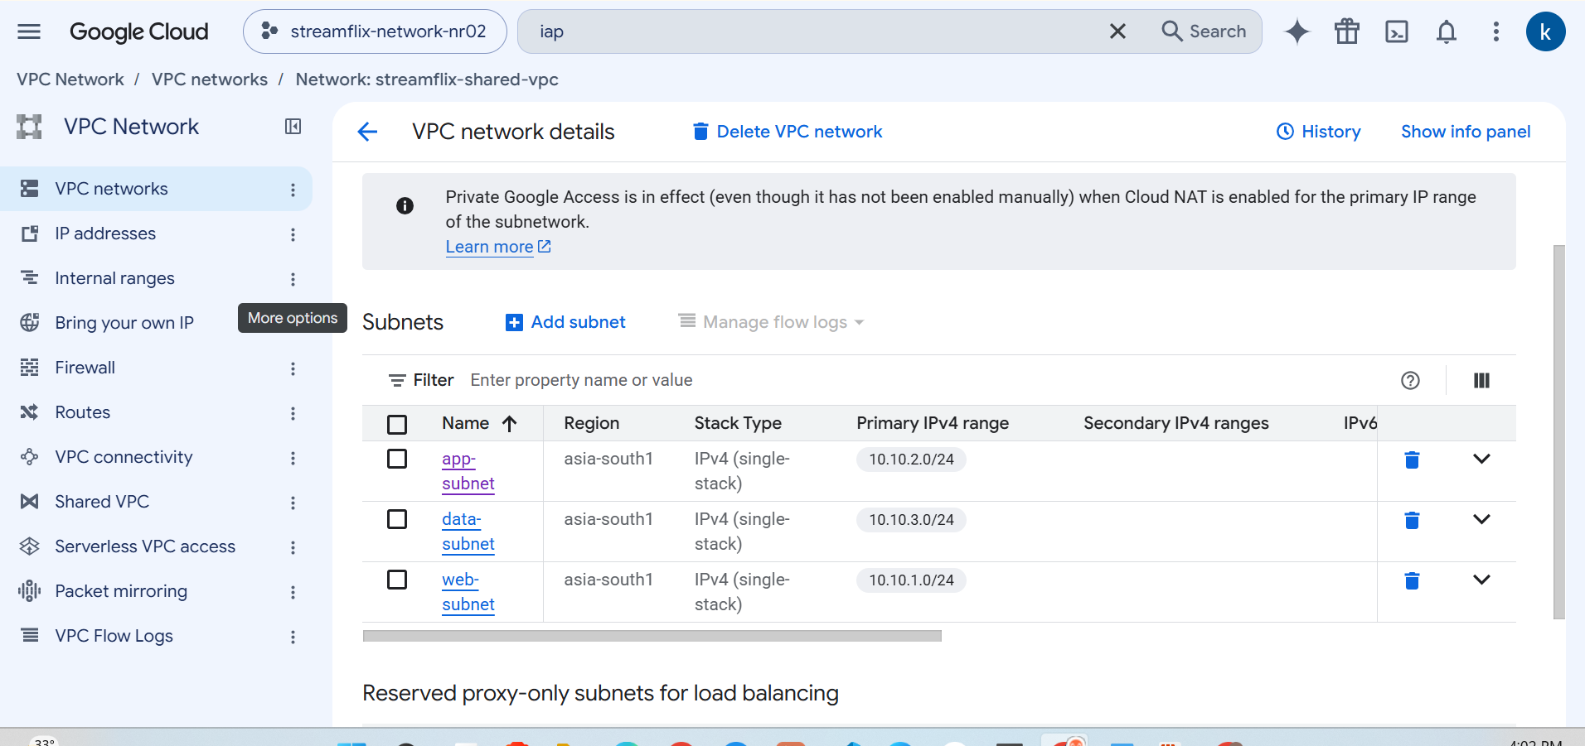

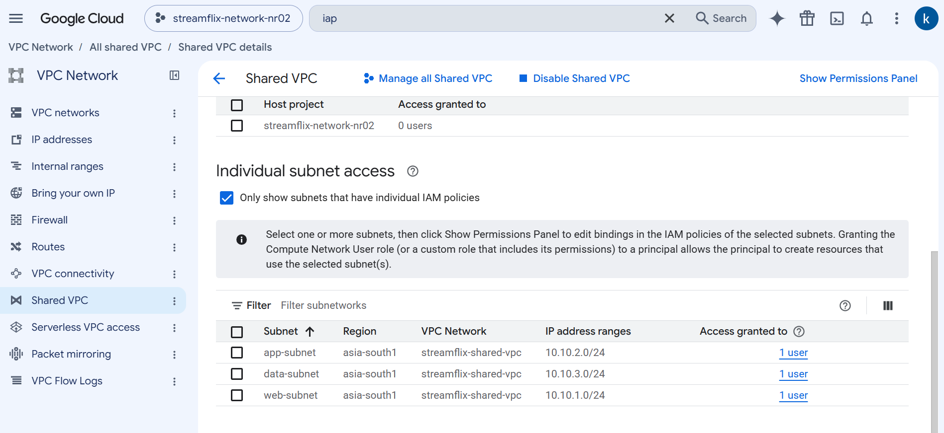

Expected: Three VMs in three projects, all using IPs from the host project subnets.

Step 14 - Test the application
Working in project: Web project
- In VM instances (web project) copy the External IP of sf-web.
- In your browser open http://EXTERNAL_IP (use http, not https). The StreamFlix page with 4 movie cards should appear.
- Open http://EXTERNAL_IP/api/health - should show {"status":"ok"} (web to app).
- Open http://EXTERNAL_IP/api/movies - JSON with 4 movies (web to app to db).
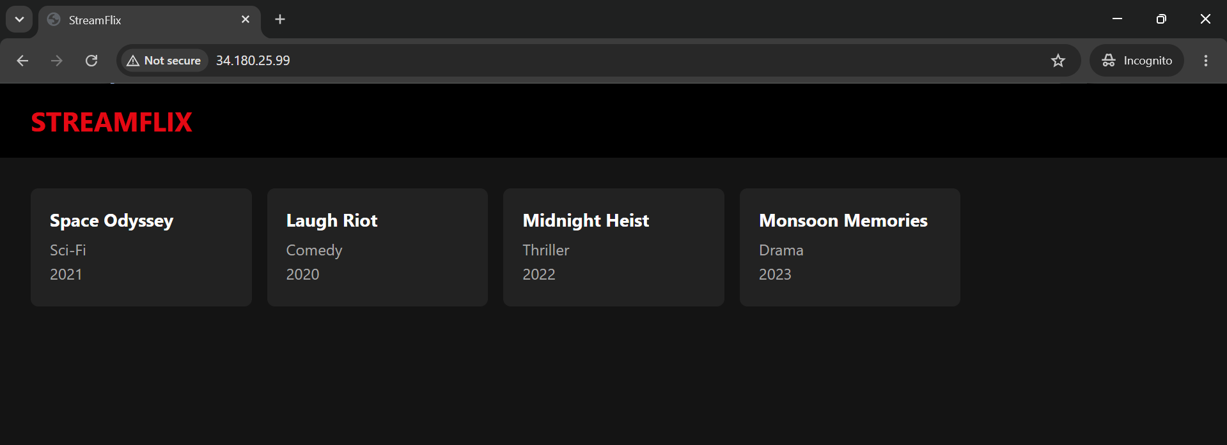

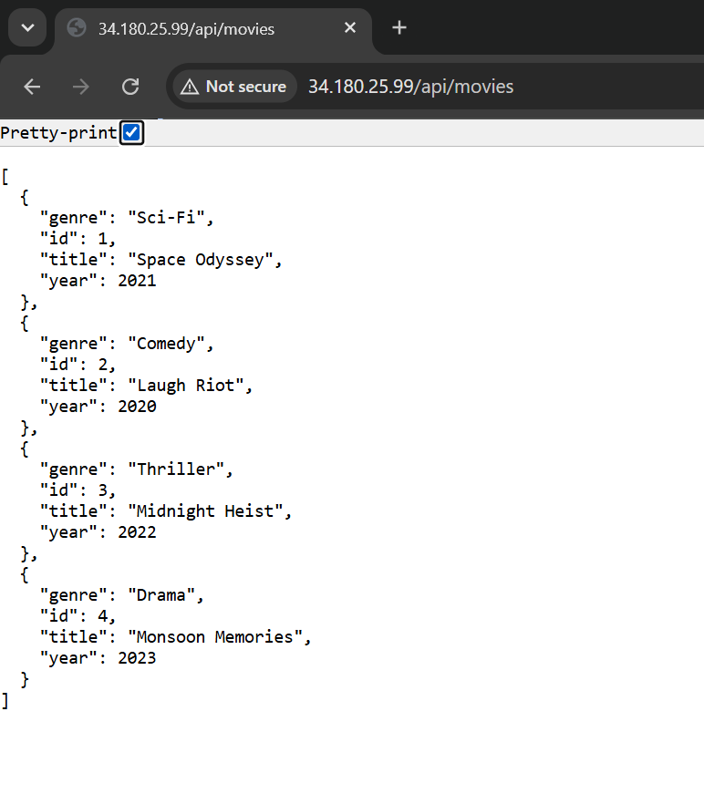

Expected: Full web -> app -> db chain works across 3 projects.

Step 15 - Prove tier isolation (optional)
Working in project: App and web projects
- App project > VM instances > sf-app > SSH button (opens browser SSH through IAP).
- Run: timeout 5 bash -c "</dev/tcp/10.10.3.10/5432" && echo OPEN || echo BLOCKED -> expect OPEN (app is allowed to reach db).
- Web project > sf-web > SSH, run the same command -> expect BLOCKED (web may not reach db).
- If SSH to sf-web times out, edit rule sf-allow-iap and temporarily add your public IP as /32 in the source ranges.
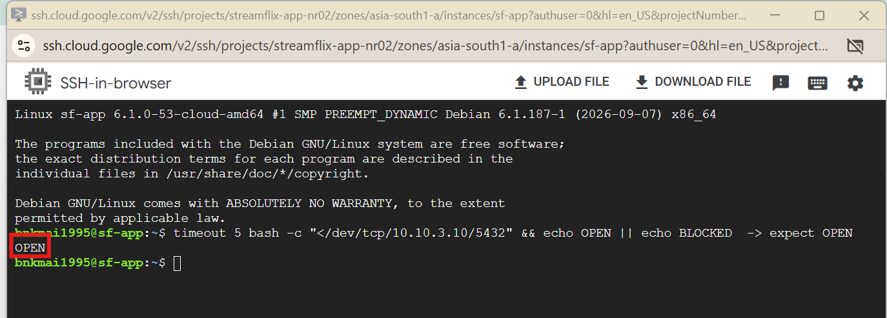

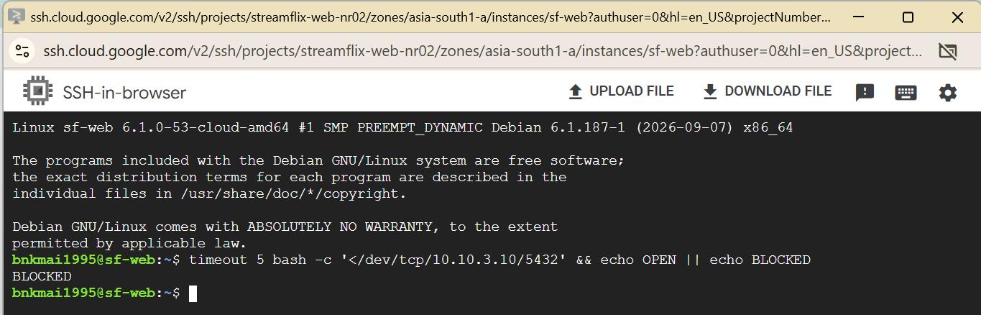

Expected: OPEN from the app VM, BLOCKED from the web VM.

Step 16 - Cleanup (avoid charges)
Working in project: Order matters
- Delete VMs: in each service project VM instances > select VM > Delete.
- Host project: Network services > Cloud NAT > delete sf-nat. Then Cloud Routers > delete sf-router.
- Host project: VPC network > Firewall > delete the 4 sf-allow-* rules.
- Host project: Shared VPC > Attached projects > select all > Detach. Then Disable Shared VPC.
- VPC networks > open streamflix-shared-vpc > Delete VPC network (deletes subnets).
- For each of the 4 projects: IAM & Admin > Settings > Shut down, type the Project ID to confirm.
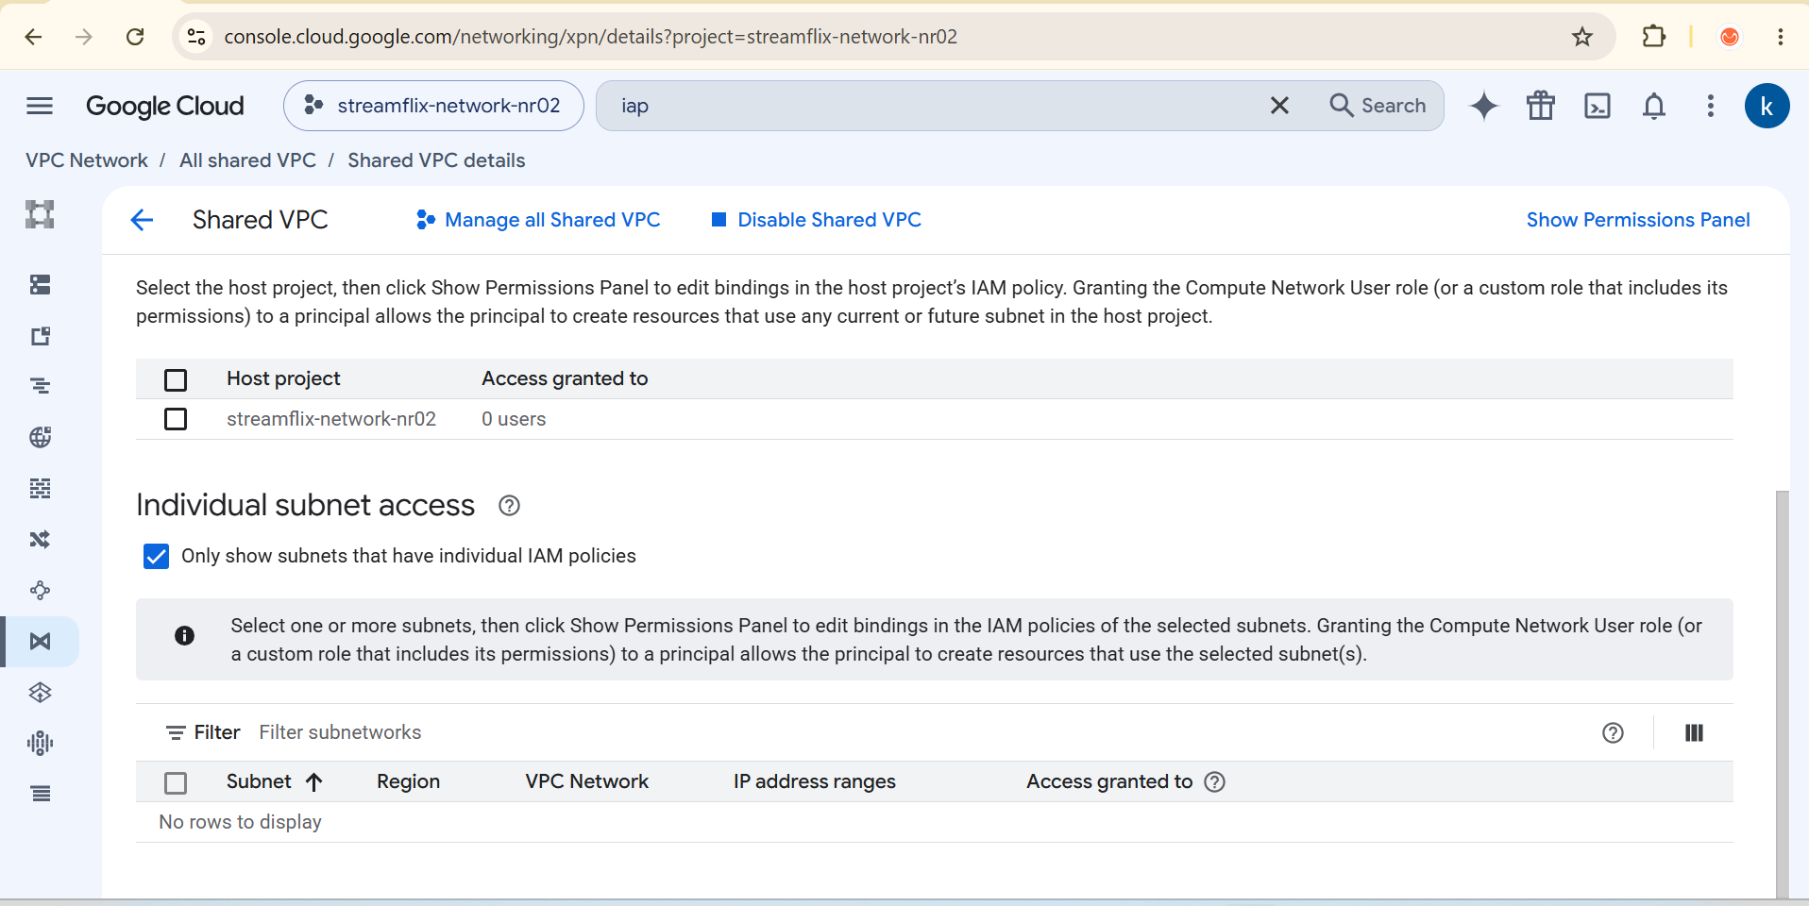

Expected: No billable resources remain.

Appendix A - Troubleshooting
Symptom | Fix
Shared VPC menu missing / cannot enable | Project not under an Organization, or missing Shared VPC Admin role (Step 0).
Shared subnets not listed when creating VM | Subnet not shared, or you lack Compute Network User on it (Step 6). Check you chose "Networks shared with me".
Cannot select external IP | Org policy compute.vmExternalIpAccess blocks it; ask admin to allow for sf-web.
Page not loading | Wait 3 min; use http://; check sf-allow-web tag "web" matches the VM tag.
/api/movies shows 503 | DB not ready. Open sf-db > Logs / Serial port 1 and check the startup script finished; confirm rule sf-allow-db.
Startup script did not run | VM > Logs > Serial port 1 (console). Fix script, then Stop/Start VM after deleting /var/lib/sf-done.

Appendix B - Files to paste into the VM metadata
Copy each block exactly (they are also in the project zip).

B1. scripts/db-startup.sh (sf-db startup script)
#!/bin/bash
# Tier 3 (data) VM startup script
[ -f /var/lib/sf-done ] && exit 0
md() { curl -s -H "Metadata-Flavor: Google" "http://metadata.google.internal/computeMetadata/v1/instance/attributes/$1"; }
apt-get update -y && apt-get install -y postgresql
CONF=$(ls -d /etc/postgresql/*/main)
echo "listen_addresses='*'" >> $CONF/postgresql.conf
echo "host streamflix streamflix 10.10.2.0/24 scram-sha-256" >> $CONF/pg_hba.conf # only app-subnet
systemctl restart postgresql
sudo -u postgres psql -c "CREATE USER streamflix WITH PASSWORD 'streamflix123';"
sudo -u postgres createdb -O streamflix streamflix
md init-sql > /tmp/init.sql
PGPASSWORD=streamflix123 psql -h 127.0.0.1 -U streamflix -d streamflix -f /tmp/init.sql
touch /var/lib/sf-done

B2. database/init.sql (sf-db metadata key init-sql)
CREATE TABLE IF NOT EXISTS movies (
id SERIAL PRIMARY KEY,
title TEXT NOT NULL,
genre TEXT NOT NULL,
year INT NOT NULL
);
INSERT INTO movies (title, genre, year) VALUES
('Space Odyssey', 'Sci-Fi', 2021),
('Laugh Riot', 'Comedy', 2020),
('Midnight Heist', 'Thriller',2022),
('Monsoon Memories','Drama', 2023);

B3. scripts/app-startup.sh (sf-app startup script)
#!/bin/bash
# Tier 2 (app) VM startup script
[ -f /var/lib/sf-done ] && exit 0
md() { curl -s -H "Metadata-Flavor: Google" "http://metadata.google.internal/computeMetadata/v1/instance/attributes/$1"; }
apt-get update -y && apt-get install -y python3-flask python3-psycopg2
mkdir -p /opt/streamflix
md app-py > /opt/streamflix/app.py
cat > /etc/systemd/system/streamflix.service <<UNIT
[Unit]
Description=StreamFlix API
After=network.target
[Service]
Environment=DB_HOST=10.10.3.10 DB_NAME=streamflix DB_USER=streamflix DB_PASSWORD=streamflix123
ExecStart=/usr/bin/python3 /opt/streamflix/app.py
Restart=always
[Install]
WantedBy=multi-user.target
UNIT
systemctl daemon-reload
systemctl enable --now streamflix
touch /var/lib/sf-done

B4. backend/app.py (sf-app metadata key app-py)
import os, time
import psycopg2
from flask import Flask, jsonify

app = Flask(__name__)

def get_conn():
return psycopg2.connect(
host=os.environ["DB_HOST"], dbname=os.environ["DB_NAME"],
user=os.environ["DB_USER"], password=os.environ["DB_PASSWORD"],
)

@app.get("/api/health")
def health():
return jsonify(status="ok")

@app.get("/api/movies")
def movies():
for _ in range(5): # small retry if DB is still starting
try:
with get_conn() as conn, conn.cursor() as cur:
cur.execute("SELECT id, title, genre, year FROM movies ORDER BY id")
rows = cur.fetchall()
return jsonify([dict(id=r[0], title=r[1], genre=r[2], year=r[3]) for r in rows])
except psycopg2.OperationalError:
time.sleep(2)
return jsonify(error="database unavailable"), 503

if __name__ == "__main__":
app.run(host="0.0.0.0", port=5000)

B5. scripts/web-startup.sh (sf-web startup script)
#!/bin/bash
# Tier 1 (web) VM startup script
[ -f /var/lib/sf-done ] && exit 0
md() { curl -s -H "Metadata-Flavor: Google" "http://metadata.google.internal/computeMetadata/v1/instance/attributes/$1"; }
apt-get update -y && apt-get install -y nginx
md index-html > /var/www/html/index.html
md nginx-conf | sed -e 's#http://backend:5000#http://10.10.2.10:5000#' \
-e 's#/usr/share/nginx/html#/var/www/html#' > /etc/nginx/sites-available/default
systemctl restart nginx
touch /var/lib/sf-done

B6. frontend/index.html (sf-web metadata key index-html)
<!DOCTYPE html>
<html lang="en">
<head>
<meta charset="UTF-8">
<meta name="viewport" content="width=device-width, initial-scale=1">
<title>StreamFlix</title>
<style>
body{margin:0;font-family:system-ui,sans-serif;background:#141414;color:#fff}
header{padding:20px 32px;background:#000;color:#e50914;font-size:28px;font-weight:700}
main{padding:32px;display:grid;grid-template-columns:repeat(auto-fill,minmax(200px,1fr));gap:16px}
.card{background:#222;border-radius:8px;padding:20px}
.card h3{margin:0 0 8px}.card p{margin:4px 0;color:#aaa}
</style>
</head>
<body>
<header>STREAMFLIX</header>
<main id="list">Loading...</main>
<script>
fetch('/api/movies')
.then(r => r.json())
.then(movies => {
document.getElementById('list').innerHTML = movies.map(m =>
`<div class="card"><h3>${m.title}</h3><p>${m.genre}</p><p>${m.year}</p></div>`).join('');
})
.catch(() => document.getElementById('list').textContent = 'Could not load movies');
</script>
</body>
</html>

B7. frontend/nginx.conf (sf-web metadata key nginx-conf)
server {
listen 80;
root /usr/share/nginx/html;
index index.html;

location /api/ {
proxy_pass http://backend:5000/api/;
}
}

